Assignment-13

Q1> Create a union of two queries that shows the names , cities , and ratings of all customers.Those with rating of 200 or greater will also have the word “High Rating”,while the others will have the words “Low Rating”.
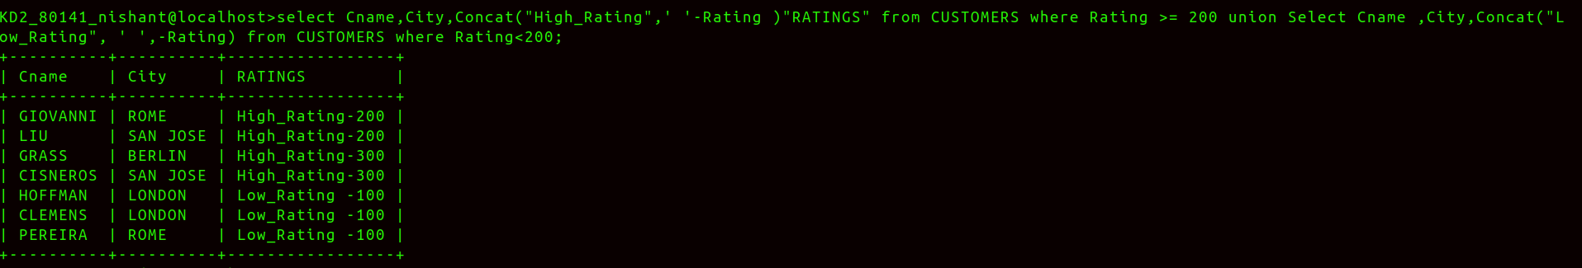
Ans>

Q2> Write a command that produces the name and number of each salesperson and each customer with more than one current order.Put the result in alphabetical order.
Ans>
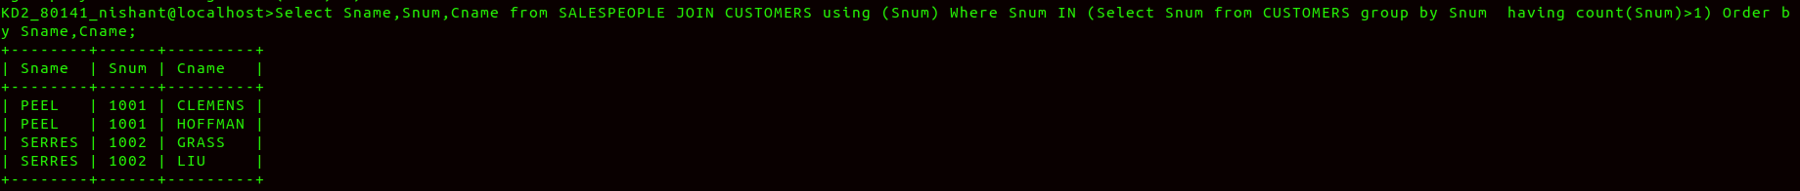
Q3>
Ans>
