Assignment – 7

Q1> Write a query that counts all the orders for October 3.
Ans> Select count(*) from ORDERS where Odate='1990-10-03';
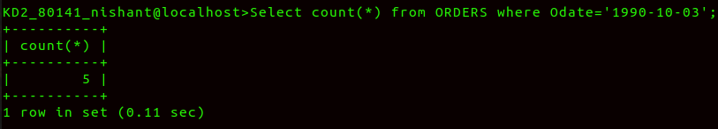
Q2> Write a query that counts the number of diffrent non-Null city values in the Customers table.
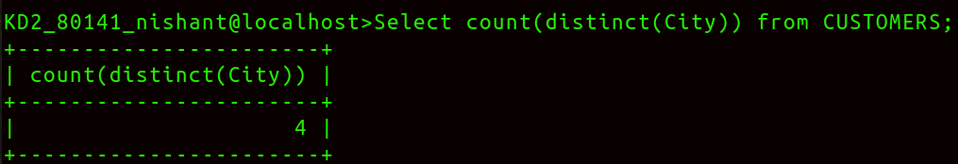
Ans>

Q3> Write a query that selects each customers smallest order.
Ans>
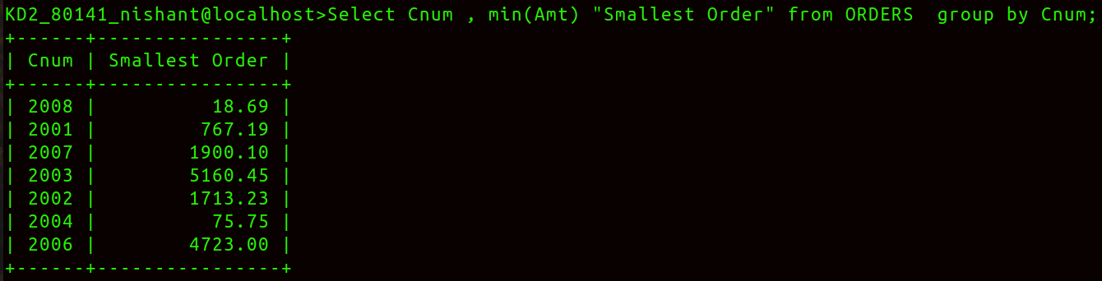
Q4> Write a Query that selects the first customer in alphabetical order,whose name begins with G.
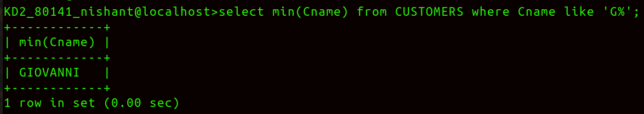
Ans>
Q5> Write a query that selects the highest rating in each city.
Ans>
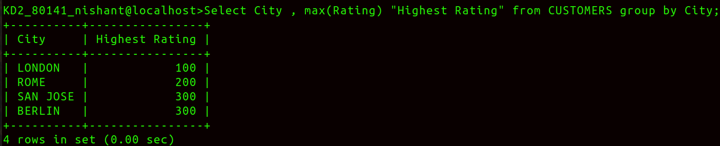
Q6> Write a query that counts the number of salespeople registering orders for each day.(If a salesperson has more than one order on a giveday,he or she should be counted only once.)
