Assignment-14

Q1> Write a command that puts the following values,in tje given order , into the salesperson table: City-San jose,name- Blanco ,comm-Null,Cnum-1100.
Ans>
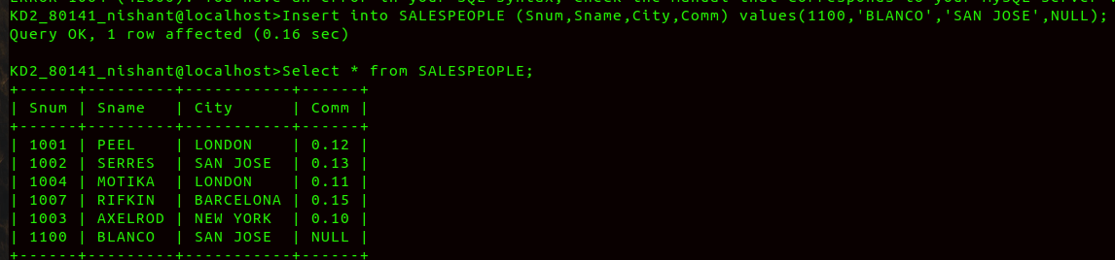
Q2> Write a command that removes all orders from Customer Clemens from ORDER table.
Ans>
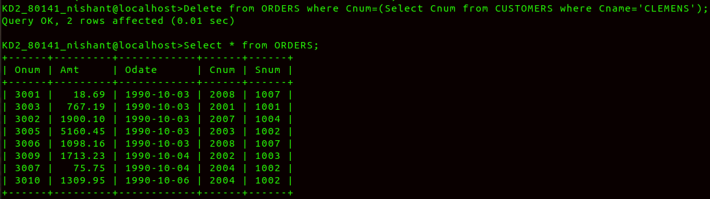
Q3> Write a command that increases the rating of all CUSTOMERS in Rome by 100.
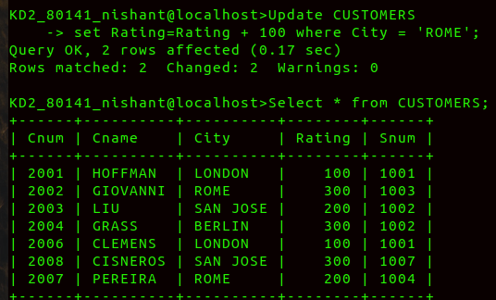
Ans>
Q4>SALESPERSON Serres has left the company .Assign her customers to MOTIKA.
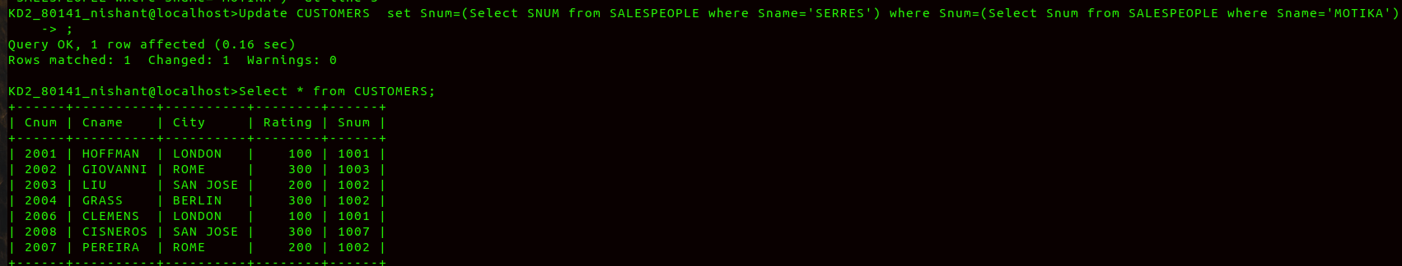
Ans>

