Assignment 6

Q4 > Write a query that selects all the customers whose names begin with the letter ‘C’.

Ans>Select * from CUSTOMERS
-> where Cname like 'C%';

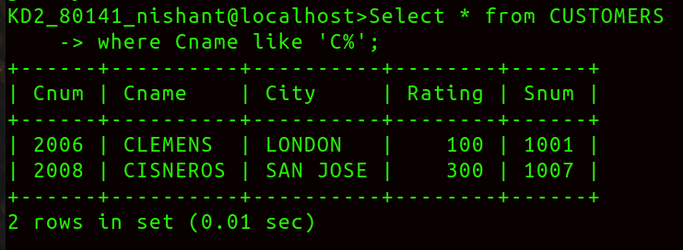

Q1> Write two diffrent queries that would produce all orders taken on October 3rd or 4th,1990.

Ans> Query 1-> Select * from ORDERS
-> where Odate in('1990-10-03','1990-10-04');

Query2-Select * from ORDERS
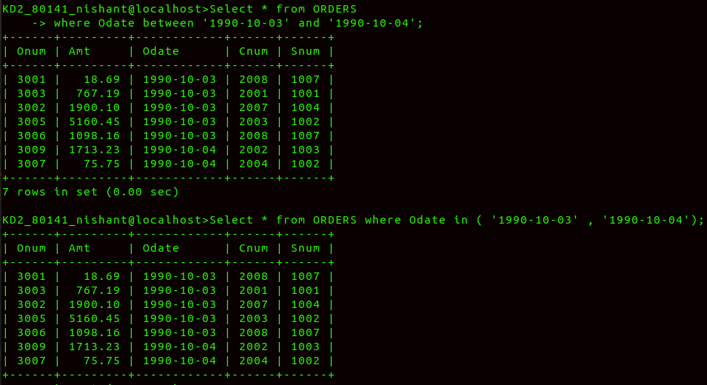
where Odate between '1990-10-03' and Odate = '1990-10-04';

Q3> Write a query that will produce all the customers whose names begins with a letter from ‘A’ to ‘G’.

ANS>
Select * from CUSTOMERS
where Cname like 'A%' or Cname like 'B%' or Cname like 'C%' or Cname like 'D%' or Cname like 'E%' or Cname like 'F%' or Cname like 'G%';

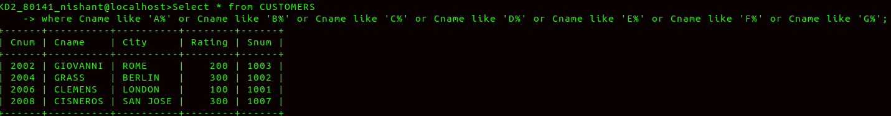

Q5> Write a query that selects all the Orders excepts those with
zeros or nulls in the amt field.

Ans> >Select * from ORDERS
-> where AMT != 0 or AMT != 'NULL';

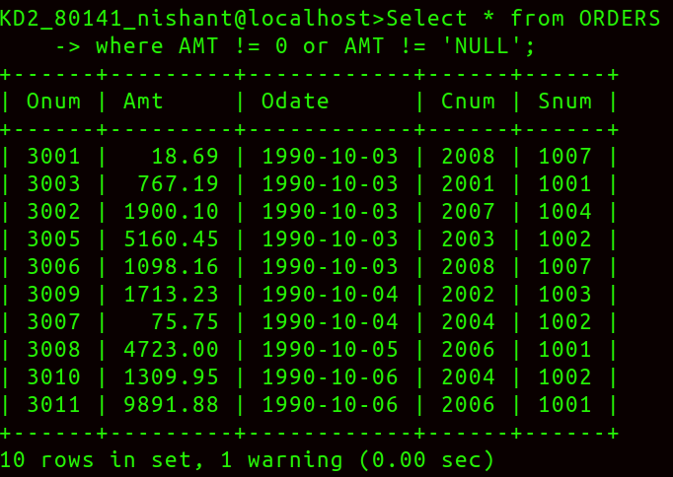
Q2>Write a query that selects all of the customers serviced by Peel or Motika.
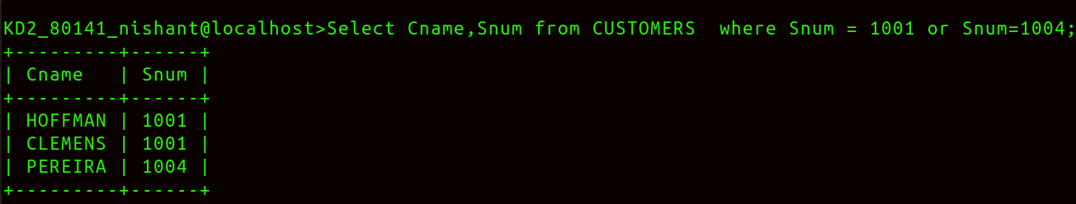
Ans>

