Assignment -8

Q1> Assume each salesperson has a 12% commision . Write a query on the order table that will produe the order number , the salesperson number , and the amount of the salesperson’s commision for that order.
Ans>
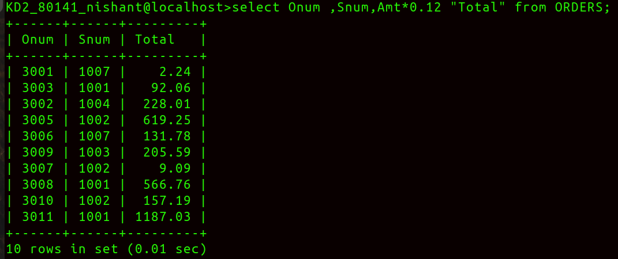
Q2> Write a query on Customers Table that will find the highest rating in each city.Put the outout in this form:
Ans>
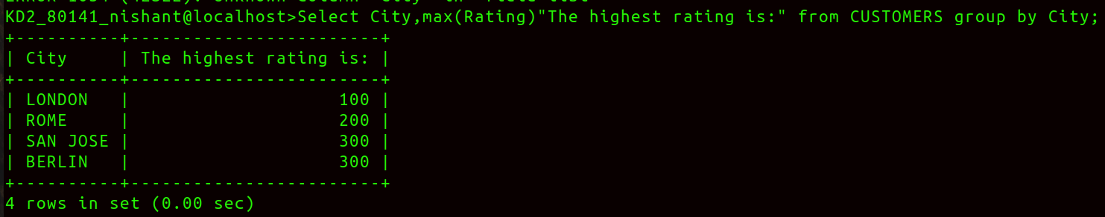
Q3> Write a query that lists customers in descending order of rating . Output the rating field first , followed by the customers’s name and number.
Ans>
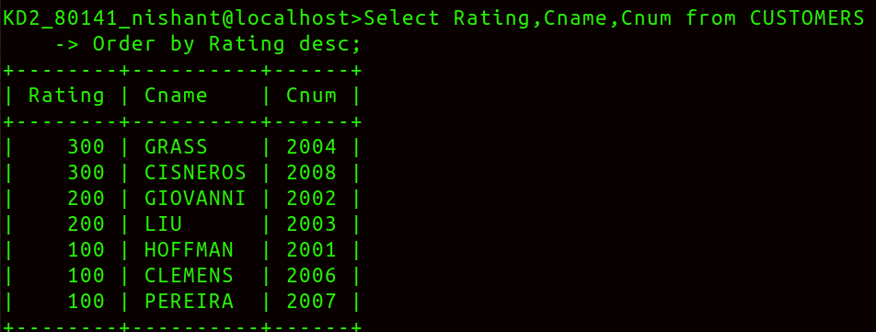
Q4> Write a query that totals the orders for each day and place the result in the descending order.
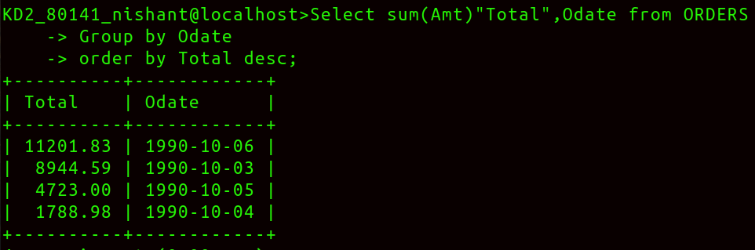
Ans>

