RESUME

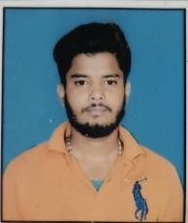

# Nishant kumar

**Email id**: [**nishantrajyadav196@gmail.com**](mailto:nishantrajyadav196@gmail.com) **Mobile : +91 8544092192**

**Address : Mokimpur, po- Suitha,**

**Ps-Parsa Bazar,Patna,Bihar 804453.**

**objective**

Seeking innovation and challenging career in a growing organization which gives me an opportunity to utilize my skills & knowledge and provides me an opportunity for career growth

**Academic profile**

* BCA from B.D college in 2025
* Intermediate BSEB from SMD college in 2022
* 10 CBSE from Annie Besant International school in 2020

**Technical Expertise:**

* Tally ERP
* MS Excel, word and PowerPoint

**Skill**

* Good communication skill
* Quick learner
* Ability to work independently

**Personal Information**

Father’s name : Nand Kishor Singh Date of birth : 10 september 2005 Gender : Male

Marital status : Unmarried

Nationality : Indian Languages known : English and Hindi Hobbies : Reading book

**Declaration:** all the above information is correct up to my knowledge and I bear the responsibility of the correctness.

**Place :**

**Date : Nishant kumar**