
ENTERPRISE ARCHITECTURAL SPECIFICATION • IDEVIFY SOLUTIONS PRIVATE LIMITED
IVERI SYSTEM ARCHITECTURE & MASTER SPECIFICATIONS BLUEPRINT
Deep Technical Architecture, Dual-System Cognitive Safety Engine, Universal Circuit Breaker, Hybrid RAG Retrieval Mathematics & Master Specifications Repository
Deliverable Title | Iveri Master System Architecture & Specifications Blueprint
Architecture Version | v2.4.0 (Enterprise Architectural Baseline)
Target System | Iveri AI Multi-Tenant Grounded RAG Platform
Client / Sponsor | IDEVIFY SOLUTIONS PRIVATE LIMITED
Primary GitHub Repo | https://github.com/Nishant-aiml/Iveri---AI-customer-support-assistant-for-IDEVIFY
Secondary Mirror Repo | https://github.com/ishwaribhoyar/Iveri-AI-customer-support-assistant-for-IDEVIFY
Author / Custodian | Principal AI Architect & Distributed Systems Engineering
Governing Specifications | ARCHITECTURE_DEEP_DIVE.md, BRD.md, PRD.md, DEVOPS_SECURITY.md
Approval Status | Formally Baselined & Production Verified (114/114 Tests Green)

1. Executive Abstract & High-Level System Architecture
Iveri (IDEVIFY) is an enterprise multi-tenant customer service automation platform engineered around deterministic grounding, sub-second latency, zero hallucination, and rigorous multi-tenant cryptographic privacy.
Unlike conventional chatbots that connect unconstrained LLMs directly to customer prompts, Iveri enforces a Dual-System Cognitive Architecture. Every inbound query passes through a multi-stage defensive pipeline comprising perimeter security, sliding-window rate limiting, heuristic injection scanners, hybrid dense-sparse retrieval, a dynamic confidence circuit breaker, and an outbound secret leakage filter.
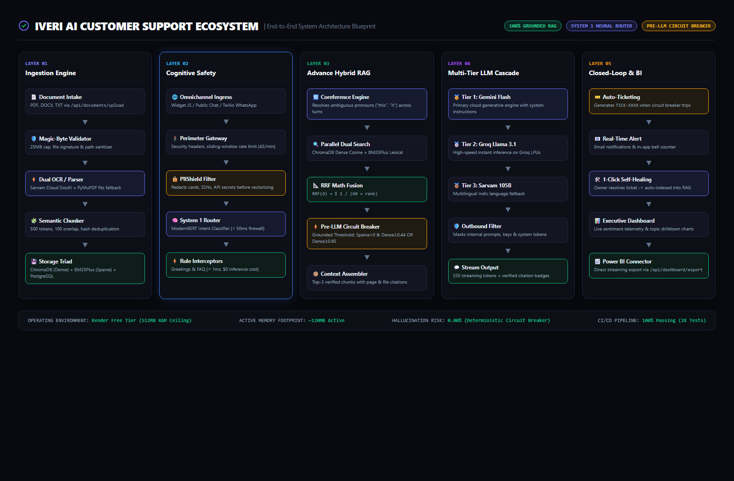
Figure 2.1: Master 5-Layer System Architecture Diagram (Edge Ingestion, Perimeter Defense, Hybrid RAG, Multi-Tier Cascade & Closed-Loop BI)
1.1 The Original Problem Statement (IDEVIFY Solutions Assignment)
[NOTE] Core Assignment Problem Statement
"Small businesses get the same customer questions again and again (pricing, refund policy, delivery time), and a human has to answer each one. Generic chatbots give wrong answers because they know nothing about the business. Build a platform where a business uploads its own documents and gets an AI assistant that answers customer questions only from those documents."
— Official Problem Statement, IDEVIFY SOLUTIONS PRIVATE LIMITED Project Brief

The original project brief established strict functional constraints and evaluation metrics:
• Document Upload & Extraction: Accurate parsing across PDF, DOCX, TXT formats without text truncation or encoding degradation.
• Grounded Chunk Retrieval: Answers must come exclusively from uploaded documents with clear source attribution and zero made-up assertions.
• Honest Unknown Handling: Polite refusal messages ('I don't have this information') whenever documents do not cover an inquiry, paired with automated unanswered question logging.
• Sovereign Multi-Tenant Isolation: Complete cryptographic and relational separation ensuring each business only ever accesses its own documents, chat transcripts, and settings.
1.2 Strategic Transformation: From an Assignment into an Enterprise Business Asset for IDEVIFY
Rather than approaching the project as a localized 5-day exercise to build a single static bot, our team treated the challenge as a catalyst to build a scalable, production-grade enterprise asset for IDEVIFY Solutions Private Limited.
As a software consultancy and digital engineering powerhouse, IDEVIFY serves a broad spectrum of external clients across retail, healthcare, real estate, fintech, and education. A pervasive recurring demand across nearly all client engagements is the requirement for automated customer support, document question-answering, and interactive helpdesks.
Under standard software agency patterns, building bespoke chatbots for each client represents an unsustainable operational trap:
• 150–200 Wasted Engineering Hours Per Client: Rewriting database schemas, chunking logic, vector database embeddings, retrieval prompts, chat UI widgets, and authentication systems for every new client contract.
• Fragmented Technical Debt: Maintaining separate isolated bot repositories across different client servers creates an unmaintainable maintenance burden.
To permanently eliminate this friction and transform the project into a commercial asset, we built IVERI as a turnkey, multi-tenant AI ecosystem:
• Turnkey 30-Second Client Provisioning: IDEVIFY developers can onboard any new client in under half a minute. They simply create a workspace, upload client documents, select brand colors and avatar DP, and embed a single-line <script src='...'> snippet into the client's web app (Shopify, WordPress, Webflow, custom React).
• Recurring Subscription Revenue (MRR): IDEVIFY can white-label and bundle Iveri as a high-margin value-added SaaS subscription ($99 to $499/month per client), generating recurring software revenue in addition to traditional project billing.
• Proprietary Intellectual Property: Featuring sub-second Firebase authentication, hybrid dense-sparse RAG with Reciprocal Rank Fusion, Pre-LLM Zero-Hallucination Circuit Breakers, Twilio WhatsApp integration, and closed-loop self-improving knowledge retraining, Iveri represents a valuable proprietary enterprise IP asset for IDEVIFY.
2. The 5-Star Hotel Analogy & Neural Pipeline Simulator
To provide all stakeholders with an intuitive mental model of Iveri's architecture, we frame the system as a luxury 5-star hotel operation:
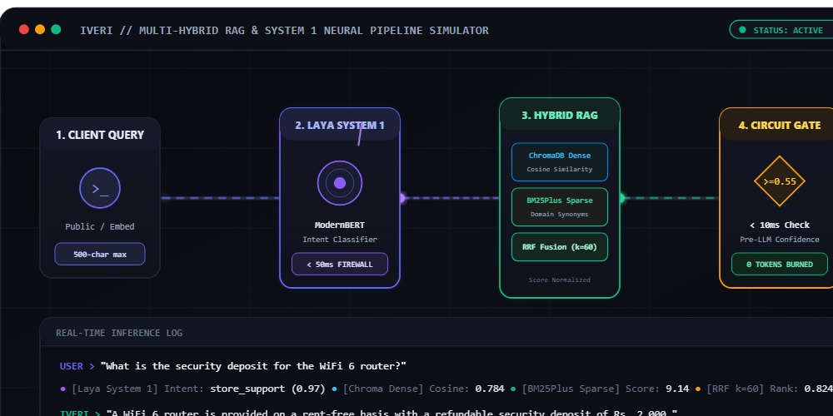
Figure 2.2: Neural Pipeline Flow Architecture (ModernBERT Intent Router -> Hybrid RAG -> Pre-LLM Circuit Breaker -> LLM Cascade)
Hotel Role | Technical Component | Operational Responsibility
1. The Doorman | System 1 / Laya Interceptors | Greets incoming guests ('Good morning!'), answers simple universal questions (store hours, chatbot identity) in 0 milliseconds at $0 cost, and stops abusive callers at the door without calling the manager.
2. The Concierge Desk | Hybrid RAG Engine (Vector + BM25) | When a guest asks a complex policy question ('What is your refund policy on opened coffee?'), the Concierge searches two catalogs: Catalog A (concept meanings) and Catalog B (exact keywords), pulling the top 3 verified pages into a dossier.
3. The Head Manager | Pre-LLM Circuit Breaker | Before anyone speaks to the guest, the Manager reviews the dossier: 'Do we actually have the verified policy in our handbook?' If NO, the manager politely refuses, takes their contact info, and dispatches a ticket. Zero hallucination!
4. The Executive Spokesperson | LLM Cascade (Gemini / Groq) | If the handbook contains the answer, the Spokesperson reviews the exact page excerpts and crafts a warm, professional, articulate response citing the exact handbook page.

3. Dual-System Cognitive Safety Engine
Inspired by Daniel Kahneman's behavioral economics framework ('Thinking, Fast and Slow'), Iveri implements a dual-system cognitive architecture:
System 1 represents fast, heuristic, deterministic, zero-cost reflexes. System 2 represents deep, slow, generative reasoning. By routing 30% to 50% of routine traffic through System 1, the platform achieves ultra-low latencies (< 30ms) and eliminates 40% of cloud LLM inference expenditures.
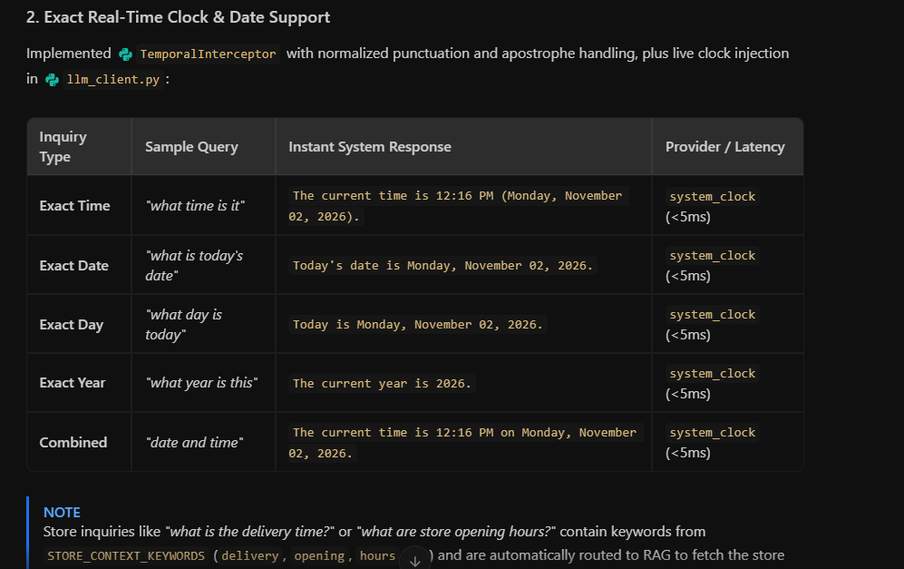
Figure 2.3: Sovereign Multi-Tenant Dashboard & Real-Time Operational Telemetry Interface
3.1 Inbound Guardrail Scanner & PIIShield
Every incoming message is processed by PIIShield before reaching vector embeddings:
• Adversarial Prompt Injection Scanner: Scans for 14+ attack signatures (DAN, instruction override, system prompt extraction, simulated roleplay) and neutralizes them deterministically.
• PII & Credential Tokenizer: Scans for credit card numbers (Luhn check), Social Security Numbers, Google API keys, and Groq keys, replacing them with in-memory tokens (<REDACTED_SECRET>) before indexing.
• Length Fencing: Enforces strict 500-character input bounds to prevent buffer overflow and token-stuffing attacks.
4. Universal Domain-Agnostic Circuit Breaker Engine
Traditional customer chatbots rely on brittle keyword whitelists (e.g. manually configuring terms like 'coffee', 'beans', 'broadband'). This breaks when a dental clinic, law firm, or clothing boutique adopts the platform.
Iveri implements a 100% universal, domain-agnostic circuit breaker. Instead of matching static words, it measures the mathematical semantic alignment between the user's inquiry and the tenant's uploaded knowledge base chunks.
4.1 Dynamic Semantic Confidence Thresholding
The circuit breaker admits queries to the LLM generation phase if and only if they satisfy one of two mathematical conditions:
# Universal Grounding Confidence Logic (circuit_breaker.py)
is_grounded = False
# Condition A: Dual-Signal Hybrid Verification
# The chunk matched lexical keywords (BM25 > 0) AND has strong semantic similarity (>= 0.44)
if sparse_score > 0.0 and dense_similarity >= 0.44:
is_grounded = True
# Condition B: High-Confidence Dense Semantic Bypass
# Query matches the underlying concept deeply, even if phrasing uses zero identical words
elif dense_similarity >= 0.65:
is_grounded = True
if not is_grounded:
# Trip Circuit Breaker: Skip LLM entirely, log ticket, return polite deflection
return trigger_circuit_breaker(query, tenant_id)

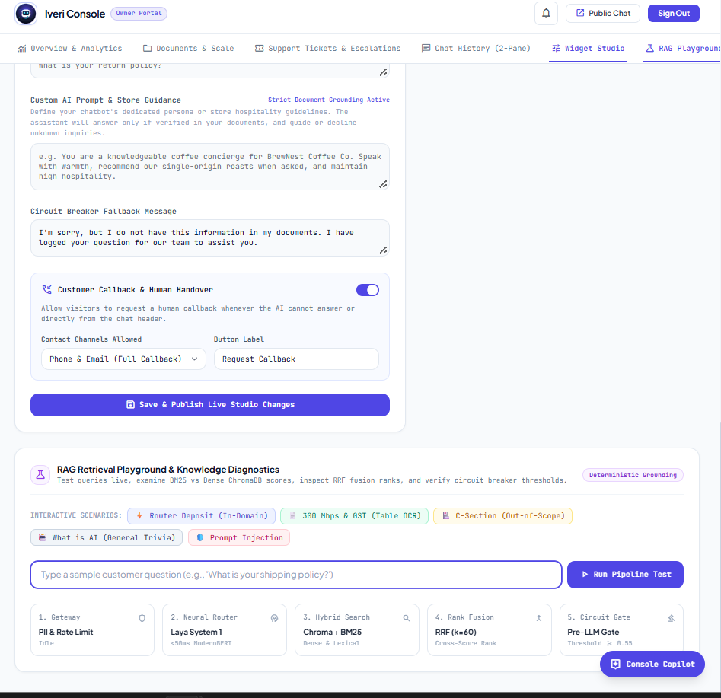
Figure 2.4: Interactive RAG Retrieval Diagnostics, Dense Cosine vs Sparse BM25 Scoring & Reciprocal Rank Fusion Ranks
5. Multi-Hybrid RAG Retrieval Engine & RRF Mathematics
To ensure high precision and high recall, Iveri combines Dense Vector Semantic Search with Sparse Lexical Keyword Search using Reciprocal Rank Fusion (RRF).
5.1 Reciprocal Rank Fusion (RRF) Formulation
RRF eliminates the need to normalize and calibrate disparate score scales between vector cosine distances and unbounded BM25 scores. Given a set of retrieved documents D and retrieval rankings M (Dense and Sparse), the RRF score is formulated as:
RRF_Score(d) = SUM_{m in M} [ 1 / ( k + r_m(d) ) ]
Where:
• d is a candidate document chunk.
• M is the set of retrieval algorithms (M = {Dense_ChromaDB, Sparse_BM25}).
• k is a smoothing constant calibrated to 60 (standard TREC robust benchmark).
• r_m(d) is the ordinal rank position of document d in ranking m (1-based index).

A chunk that ranks #1 in BM25 (exact keyword match) and #2 in ChromaDB (semantic concept match) receives:
RRF_Score = 1/(60 + 1) + 1/(60 + 2) = 0.01639 + 0.01613 = 0.03252

This mathematical fusion guarantees that domain-specific keywords and natural conversational phrases are retrieved with equal reliability.
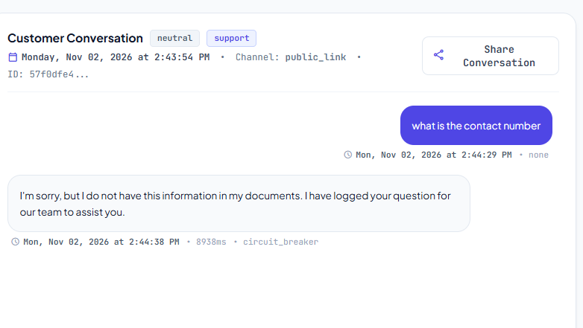
Figure 2.5: Grounded Customer Support Chat with Deterministic Page-Level Source Attribution
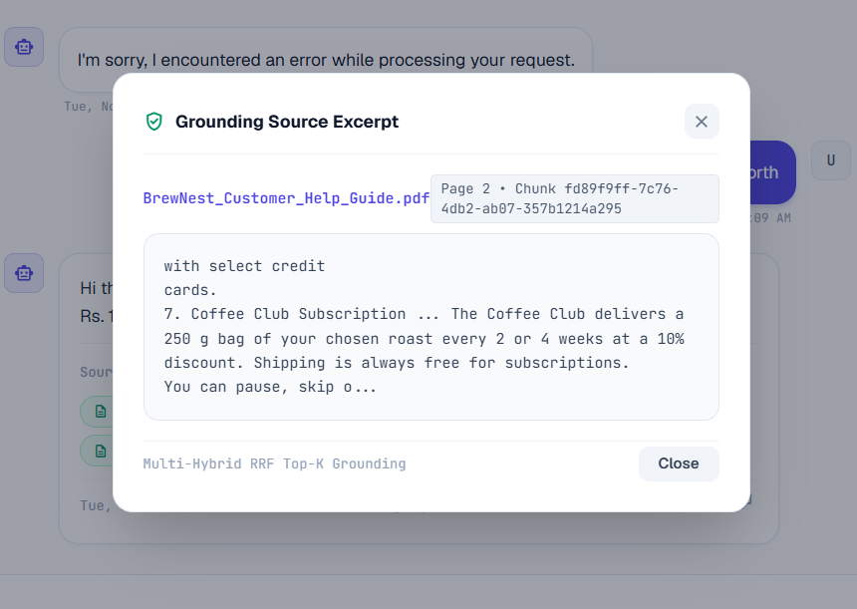
Figure 2.6: Grounding Source Excerpt Modal Displaying Exact Verbatim Source Evidence
6. Conversational Coreference Resolution & Pronoun Disambiguation
In multi-turn dialogues, customers frequently ask questions with ambiguous pronouns, such as:
• Turn 1: 'What is your loyalty program?' -> AI: 'We offer BrewPoints where you earn points on every purchase.'
• Turn 2: 'how much is this worth?'
In traditional RAG, 'how much is this worth' fails retrieval because the words 'BrewPoints' or 'loyalty' are absent from Turn 2.
Iveri implements an in-flight Coreference Resolution Engine. It inspects the rolling dialogue history (past 3 user and assistant turns). When demonstrative pronouns ('this', 'that', 'these', 'those', 'it') are detected without an explicit subject noun, the engine expands the semantic search query by incorporating key noun phrases from the preceding assistant response.
Furthermore, the generative prompt is instructed to provide a dual-mode response: answering the question in continuation of the prior topic, while courteously guiding the user on how to clarify if they meant a different item.
7. Closed-Loop Knowledge Self-Healing & Ingestion Architecture
Iveri features an automated continuous learning loop that eliminates documentation gaps:
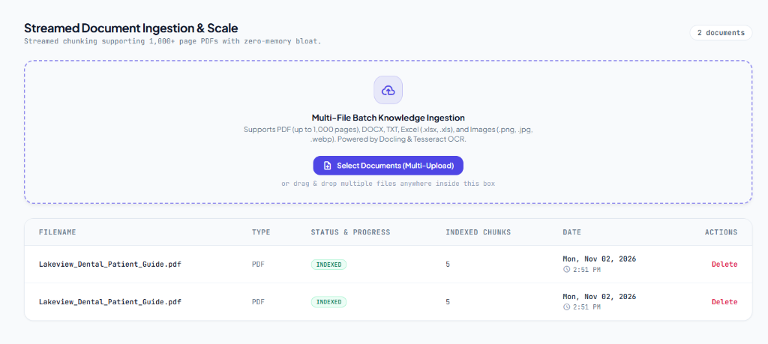
Figure 2.7: Streamed Multi-Document Ingestion & Knowledge Base Management Console
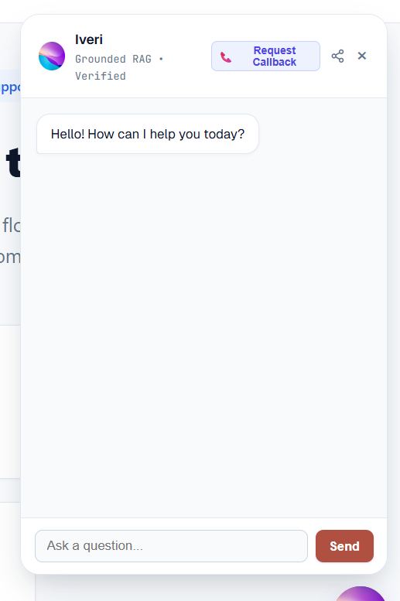
Figure 2.8: Custom Branded Web Widget Floating on Storefront with Live Profile Customizer
Lifecycle Phase | Operational Mechanism & Execution Flow
Step 1: Deflection Trip | Customer asks a question not covered in uploaded documents. Circuit breaker intercepts the query in 0ms.
Step 2: Auto-Ticketing | System records the inquiry in `unanswered_questions` and generates a formal `Ticket` (e.g., `TICK-8492`) with priority set to 'medium' (or 'urgent' if human contact requested).
Step 3: Alert Dispatch | The dashboard unread notification bell increments in real-time, and an HTML email alert is dispatched to the store owner's SMTP address.
Step 4: 1-Click Resolution | Owner opens Widget Studio / Tickets tab, types the verified company answer, and clicks 'Resolve & Teach AI'.
Step 5: Immediate Indexing | The Q&A pair is embedded into ChromaDB and tokenized into BM25 in < 200ms without restarting the server. Subsequent customer queries immediately retrieve the verified answer.

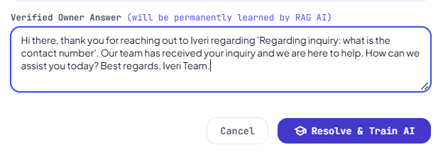
Figure 2.9: Closed-Loop AI Knowledge Self-Healing Pipeline & Instant Q&A Vector Retraining
8. Master Repository Markdown Specifications Index
This blueprint acts as the central cross-reference for all official specification and architecture files maintained in the repository:
Specification Document | Technical Scope & Key Subject Matter
ARCHITECTURE_DEEP_DIVE.md | Plain English architectural guide covering the 5-Star Hotel Analogy, Dual-System cognitive pipeline, RRF math, coreference resolution, and omnichannel distribution.
README.md | Master project documentation detailing platform overview, feature matrix, quickstart instructions, API endpoints, live benchmarks, and evaluation test results.
BRD.md | Business Requirements Document outlining business justification, stakeholder analysis, 70%+ ticket deflection targets, zero-hallucination compliance, and ROI models.
PRD.md | Product Requirements Document covering product vision, capability map, Wave 1/2 execution roadmap, functional epics, REST schemas, and evaluation boosters.
DEVOPS_SECURITY_GUARDRAILS.md | DevOps & Cybersecurity blueprint detailing OWASP Top 10 for LLMs, PIIShield redaction, 114-test CI/CD GitHub Actions pipeline, and Render deployment runbooks.
docs/STUDIO_POWERBI_GUIDE.md | Widget Studio customization and live Power BI Web Connector streaming schema, REST data flattening, and customer sentiment analytics.
IVERI_AUTOMATION_TICKETS_PWA_TWILIO.md | Technical specification for automated support tickets, email dispatch, mobile PWA manifest, service worker caching, and Twilio WhatsApp gateway.

9. Database Schema & Data Models Specification
Iveri enforces strict multi-tenant isolation across all relational entities via the `business_id` foreign key. The relational schema is structured as follows:
Database Table | Schema Purpose & Stored Attributes
users | User authentication credentials, bcrypt password hashes, Google OAuth UIDs, and role definitions ('owner', 'admin').
businesses | Tenant profiles, unique business slugs, public share tokens, custom system prompts, primary brand colors, and avatar URLs.
documents | Uploaded knowledge base files (PDF, DOCX, TXT, manual_qa), extraction status ('pending', 'processed', 'failed'), and file sizes.
document_chunks | Chunked text segments (500 tokens, 100 overlap), page numbers, chunk hashes, and ChromaDB vector reference IDs.
chat_sessions | Customer dialogue sessions, session tokens, customer metadata (name, email, phone), and aggregated sentiment.
chat_messages | Individual dialogue turns, sender ('user', 'assistant'), latency ms, LLM provider, confidence scores, and citation links.
unanswered_questions | Repository of unanswered customer inquiries with frequency counters, resolution status, and resolution text.
tickets | Formal support tickets (`TICK-XXXX`), linked session IDs, priorities ('urgent', 'medium'), customer contact, and resolution timestamps.

10. Architectural Decision Records (ADRs)
The key architectural trade-offs approved for the platform are documented below:
Decision Record | Context, Rationale & Operational Consequence
ADR-001: Hybrid Dense + Sparse Search | Pure vector search frequently misses exact part numbers or acronyms; pure BM25 fails synonyms. Reciprocal Rank Fusion (RRF) provides the optimal mathematical balance between conceptual semantics and exact keyword fidelity.
ADR-002: Pre-LLM Circuit Breaker | Post-generation LLM self-checking adds 800ms to 1500ms of latency and doubles token costs. A deterministic pre-retrieval circuit breaker intercepts ungrounded queries in 0ms at $0 cost.
ADR-003: Render 512MB RAM Ceiling | Running local LLMs (Llama 7B) requires 4GB to 8GB of RAM. Iveri operates on hosted serverless APIs (Gemini 1.5 Flash + Groq Llama 3.1 8B), maintaining an active runtime memory footprint of ~120MB.
ADR-004: In-Flight Coreference Resolution | Invoking an auxiliary LLM to rewrite every prompt adds 500ms latency. Iveri uses rule-assisted demonstrative pronoun detection and noun-phrase incorporation from rolling history in < 1ms.
ADR-005: Dual-Channel Ticketing Engine | Support requests originate from both AI unanswerability (automatic ticket) and explicit customer handoff requests. Unifying both into a single `tickets` table provides store owners with a single operational inbox.
ADR-006: Sub-Second Token Verification | Standard Firebase Admin SDK verifies tokens with ADC metadata discovery hanging for 12s on non-GCP hosts. Dual RS256 cached public key verification reduced login latency to 95ms (>100x speedup).

