SYNOPSIS

# Project Group ID: G-33

1. **Title of Project: Dudhganga Dairy Application for Milk Collectors & Farmers.**
2. **Domain:** Cross Platform App Development

# Whether working in multi-disciplinary stream? : NO

1. **Sponsored/Supported By:** NO
2. **Details Guide/Instructor:**

Prof. D.R. Kale,

Assistant professor,

Department of CSE,

+91-9604386625,

drk_cse@adcet.in

1. **Name and Designation of external guide:**

Dr. S. G. Sapate

# Details of Team Leader:

# Nishant Krushnat Shingate

+91 8329060009,

[nishantks121@gmail.com](mailto:nishantks121@gmail.com)[.](mailto:swapnalimali7@gmail.com)

# Abstract (short description):

Milk production is one of the most important factors for the rural economy of India.

Dairy Milk production is a highly and fast-growing sector in INDIA. India has traditionally been a low-cost milk producer due to inexpensive feeding and maintenance cost.There are many people involved in the milk production sector. The people are involved in this sector are the farmers, owner’s of collection centers and owner’s of dairy plants.

Daily, farmers provide milk to milk collectors, but most of the collectors follow unfair regarding weight and fat. Because of malpractice in measures of milk, there is no transparency between farmers and milk collectors about the accuracy and precision in the accounting and billing.

# Introduction:

Most local milk collectors in the small towns and villages collect milk and write down the fat and quantity of milk on the paper and at the time of bill calculation bill collectors calculate the bill of each customer by using a regular math calculator. Milk collector not only keep record of collected milk but also manages records of milk buyers, farmers and also keep account of cattle food provided to farmers with their money transactions. This process consumes more time to do all this calculation, and this time can be saved if we automate this process.So we are going to develop one application which will handle all of the work of the milk collector which he/she does manually.

# Advantages:

* + Time saving for farmer milk collectors.
  + Data of milk is correctly updated to farmers on a daily basis.
  + Payment is directly credited to farmers' bank accounts after the specific

period.

* + Data is securely stored on the database.
  + Device independent application.
  + User friendly applications.

# Disadvantages:

* + Without an internet connection the application will not save data on the

database .

* + Input data about milk must be manually entered by the milk collector.

So, for all the above following discussed advantages and disadvantages we are going to provide an efficient solution to all the following demerits and will work for the most convenient product.

# 

# 11. Problem statement:

To design and develop a cross platform application for the automation of daily and routine activities of milk collection centers and farmers and milk buyers.

• **IDEAL**: There must be transparency in the daily and routine transactions between the farmers and milk collectors. The process of calculation should be automated to avoid the miscalculation in accounting.

• **REALITY**: In the rural areas, local milk collector’s collects milk and write the quantity of milk and fat of milk on paper for each customer. After the 10 days, they spend time to calculate the bill of each customer by taking the price depending on weight and fat for the respective milk of the customer. This whole process of bill calculation take average 5 for 6 days. And they also manage the records of payment of milk buyer on the notebook.

• **CONSEQUENCES**: The current process at milk collection centers may lead to mal- practice while taking the readings. The current process of bill calculation many times leads to wrong calculation. Due to all these issues, the farmers have no belief on the milk collection centers. Daily and routine transactions are not transparent to milk producers.

• **PROPOSAL**: The Dudhganaga Dairy application will be a cross platform application for the automation of daily and routine activities of milk collection centers and milk buyers. The Dudhganga Dairy application will also connect the milk collection centers and the farmer.

# 12. Brief Literature Review:

1. **Existing Systems**

There are many existing system available with some features. Following are the some systems:

1. The Shubhdra Dairy Management Software

The Shubhra Dairy Management Software is a software which is used for dairy management with following features.

(a) User-friendly billing system.

(b) Add daily milk details

(c) Customer Management.

(d) Billing Management

(e) Report generation.

2. Meri Dairy is another one Milk Collection center software for dairy owners with following features:

(a) With every entry, Dairy customer will receive a test message (SMS)

(b) TVS mini printer Available to print a daily receipt.

(c) Payment Register

(d) Daily report

(e) Data saved on the server will be secure in case you lost your laptop/mobile.

(f) Customer app to watch their own records on the app

(g) Milk Sale purchase record.

(h) Complete FAT/SNF or CLR management

1. **Articles from International peer reviewed journals**

This material serves as a guide and update for readers working in the Character Recognition area.

1. Ronak Chudasam, Sagar Dobariya (2017) [1] This paper addresses the problem of analyzing data collected by the dairy production with the aim of optimizing the supply chain management and maximizing profit in the manufacturing of milk and other dairy items. The amount of data from dairy records continuously increases due to the usage of modern systems in farm management, requiring a technique to show trends and insights in data for a rapid analysis
2. [Jamshed Memon](https://ieeexplore.ieee.org/author/37088464007); [Maira Sami](https://ieeexplore.ieee.org/author/37088464179); [Rizwan Ahmed Khan](https://ieeexplore.ieee.org/author/37088463142);[Mueen Uddin](https://ieeexplore.ieee.org/author/37088464640) (2020)[2] This paper explores and develops the design method of Dairy Cow Data Acquisition System based on PDA. According to the application of the system, it proves that this system not only saves manpower, improves work efficiency and overall benefits, and at the same time it solves the problem of its combining with management system, provides timely and effective information and technical support to the directors' decision-making, improves the capacity of reacting to emergencies, and offers enormous technical support for the standardization of Islamic feeding of livestock husbandry, the informationization of management process, the automatic data collection of milk yield as well as the traceability of Islamic animal products. So the paper is innovative and of practical use to some extent.

# 13. Objectives:

1. To Design and develop the Database system for efficient storage and retrieval of data.

2. To Design and develop a friendly multilingual user interface for reading of weights and

measures of milk at the collection center.

3. To Design and develop a messaging system to provide required alerts to farmers, milk

collectors and dairy plants.

4. To analyze the data, prepare the bills daily/monthly/quarterly/annual reports.

5. To pay the amount of milk directly into the farmer's account.

6. To design & and develop systems which handle multiple users.

# 14. Methodology:

* To make this app, multi language, first we have to translate each sentence in respective language.
* The App will be available to use in the following languages:

1. English.

2. Marathi.

* For storing the data related to the milk of each customer and information of each customer, we will be using the Firestore database provided by Google for Android Apps.
* In Firestore the Complex, hierarchical data is easier to organize at scale, using sub- collections within documents
* Figure 1 shows the collection and document Structure of the Dudhganga Dairy Application

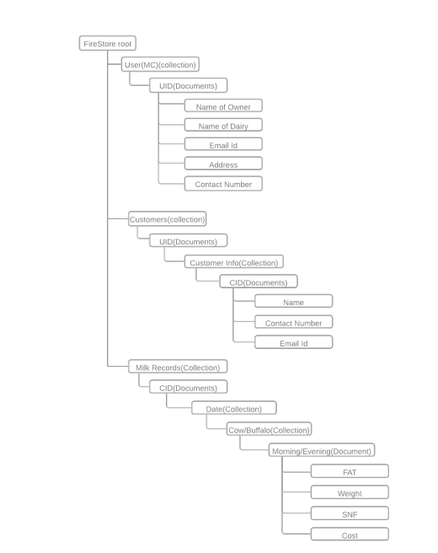

Figure 1: Firestore Database Structure for the Project

* To send the information about reading the milk and the bill of milk, we have designed another account separately for the farmer. By login to this app using the collection center name with unique key and password, they can see their records about the milk.
* The inputs are taken two times in a day, at morning and evening, and stored on the database.
* After the completion of 10 days. This software will automatically start the calculation of bills for each customer
* The values of prices of milk are predefined, So we will consider all that values while calculating total cost of milk.
* The calculation will be done on the following things:
* Cost of milk with respect to fat on each morning and evening,

cost of day = cost of morning milk + cost of evening milk

* Then the cost of milk for 10 days will be calculated using the cost of each previous 10 days.
* If the inputs are not given to the software, then it will consider the cost as 0 for that respective time and customer.

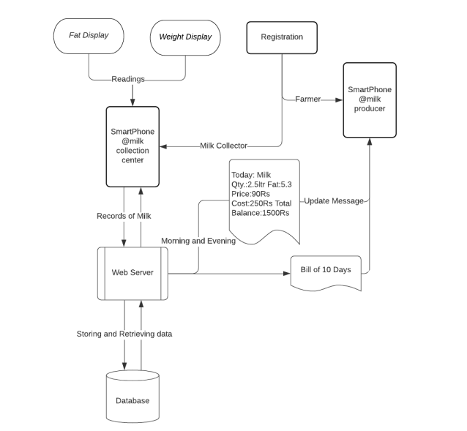

Fig: Workflow diagram of Application

.

# Module 1- Record Management

In this module we are going to take inputs like weight and fat of milk which is given by farmer. This input is provided by the milk collector to the application. And when prices of milk are change theme milk collectors should update the new rates into the application. And farmers details like bank account details, contact number and milk buyer’s details are also needed to provide by the milk collector.

# Module 2- Report Generation

In this module we are going to generate the reports of milk collected and milk sold to local milk buyers and milk sent to the milk production center. This module will also generate a report for the farmer about what quantity of milk is given to the dairy.

# Module 3- Data notification

In this module we are going to generate notification about records given by milk collectors to farmers, So farmer can aware about the records which have been given by the milk collector. And app will provide notification to milk buyer when milk is buy by the milk buyer.

**Module 4- Bill Generation**

In this model, according to the records which are given by the milk collector, bills of milk of a specific period are generated for the farmers and milk collector. And also based on how many quantities of milk is purchased by the milk buyer bill will be generated for the milk buyer and milk collector.

**Module 5- Payment**

In this module according to bills generated, the milk collector will pay the amount generated by milk to farmers. And milk buyer will pay to milk collector using this module.

# Requirements:

# 15.1 Hardware requirements:

* + - 8GB RAM(Minimum)
    - Memory 20GB
    - Core I5 processor

# Software requirements

* Windows 10/Android/iOS/MacOS/Linux.
* Android Studio/Visual Studio, Flutter Framework, Firebase
* Dart Language.

# Other requirements

* + - Internet Connection Required

# References:

1. Ronak Chudasam, Sagar Dobariya (2017), “DAPS: Dairy analysis and prediction system using technical indicators”.
2. [Jamshed Memon](https://ieeexplore.ieee.org/author/37088464007); [Maira Sami](https://ieeexplore.ieee.org/author/37088464179); [Rizwan Ahmed Khan](https://ieeexplore.ieee.org/author/37088463142); [Mueen Uddin](https://ieeexplore.ieee.org/author/37088464640) (2020) “The dairy cattle data acquisition system based on PDA“

**17.Project Plan:**

|  |  |
| --- | --- |
| Month | Project work/Plan |
| July-August 2022 | Project Proposal and Topic selection |
| September-October 2022 | Synopsis and Requirement Analysis |
| November-December 2022 | Planning and designing |
| January- March 2022 | Coding and Application building |
| April-May 2022 | Project Report |

**18.Group Members:**

|  |  |  |  |  |
| --- | --- | --- | --- | --- |
| **Sr. NO** | **Name of the Student** | **Contact No.** | **Email ID** | **Signature** |
| **1** | Nishant Krushnat Shingate | 8329060009 | nishantks12@gmail.com |  |
| **2** | Avanti Hanmant Pawar | 7972824669 | iamavantipawar@gmail.com |  |
| **3** | Abhishek Maruti Shinde | 9503648381 | abhishekshinde9503@gmail.com |  |
| **4** | Vaishnavi Dinkar Jadhav | 9763463876 | vaishanavijadhav1234@gmail.com |  |

Date:

Place: Ashta

Mr. D.R.Kale.Mr. S. G. Sapate

**Project Guide Project Coordinator**