**Module: 1 (SDLC)**

**Q1. What is software? what is software engineering?**

**Ans.**

* Software is a set of instruction, data, program used to operate computer and execute specific tasks.
* software is a collection of computer programs, procedures, rules, associated documents and concerned data with the operation of data processing system.
* Many programs functioning together to do a task make a software.
* software engineering is a work with the design, development, testing, deploying and maintenance of software applications.
* It is a technique through which we can developed or created software for computer systems and any other electronic devices.
* In software engineering is the development of software using well define scientific principle, method and procedures.
* Software engineers build these software and application by using designing and programming languages.

**Q2. Explain types of software.**

**Ans.**

There are several types of software based on their functionalities such as

1. System Software
2. Application Software
3. Driver Software
4. Middleware Software
5. Programming Software

**System Software**

* System software is a software platform to designed to provide a platform to other software.
* System software control and manage the operation of computer hardware.
* System software allows the user to ran computer software or hardware and is responsible for managing their interaction with each other.

Ex. Computer Operating System (Windows, Android, Ios. )

**Application Software**

* The software that helps you to do a specific type of works is called application software.
* Application software is a computer program that performs a specific function.
* It is also known as end user program.

Ex. Photoshop, Tally, Chrome Browser

**Driver Software**

* Software driver is a type of software program that controls a hardware device.
* Every device that is connected to a computer to perform their specific tasks.

**Middle Ware**

* Middleware software is different applications use to communicate with other.
* Middleware has become an important communication and data management tools in distributed system.

Ex. Device Engine, Middleware

**Programming**

* Computer programmers use programming software to write code.
* It is enable tools to develop, write, test other software programs.
* It is a tool for create computer code that allows computer software to operate.

Ex. Compiler, assembler

**Q3. What is SDLC? Explain each phase of SDLC.**

**Ans.**

* SDLC stands for “Software Development Life Cycle”.
* It is a collection of processes which are followed to develop a software.
* It is a methodology that defines some processes which are followed to develop a high quality software.
* The main aim of SDLC is to define all the tasks required for developing and maintaining software.

**Phase of SDLC**

1. **Planning**
2. **Analysis**
3. **Design**
4. **Coding**
5. **Testing**
6. **Deployment**
7. **Maintenance**

**Planning:**

* It is a first phase of SDLC in which all the necessary information is collected from the customer to develop the software as per their expectation.
* the main aim of this phase is to collect the details of each requirement of the customers so that the developers will clearly understand what they are developing and how to fulfil the customer requirements.

**Analysis**

* It is the second phase of SDLC in which an organization discusses about the cost and benefits of the software.
* After the feasibility study the project may be accepted with modifications or rejected.
* It measure how much beneficial the product is for the organization.

**Design**

* It is the third point in which architects start working on logical designing of the software.

**Coding**

* When the designing the software is completed, then a group of developers starts coding of the design using a programming language.
* This is longest phase in SDLC phase.
* This phase is consists of front end + middleware + back end.

**Testing**

* Once the software development is completed then it is sent to the tester. The testing team starts testing the functionality of the entire system.
* The software is thoroughly tested to ensure that it meets the requirements and correctly.
* In this phase the software is checked errors and bugs.
* If found any bug then the software is resent to the coder to fix it and then recheck it.

**Deployment**

* After completed successful testing phase then the software is deployed to a production environment.
* After deployment of the software if any bugs or errors are found then the software if redeveloped by the maintenance team with a new version.

**Maintenance**

* This team look over the software usage and feedbacks.
* For upgrade and enhancement of the software is looked over by the maintenance team.

**Q4. What is DFD? Create a DFD diagram on Flipkart.**

**Ans.**

* DFD stands for Data Flow Diagram.
* It is easy to understand and quite effective tool for communication when the required design is not clear.
* It gives an overview of what data a system processes, transformation is being performed, data are stored, results are produced and they flow.
* It shows the flow of data between various elements of a system in graphical form.

**0 Level DFD of Flipkart**

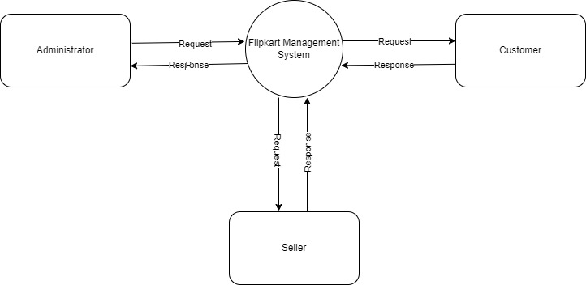

**1 Level DFD of Flipkart**

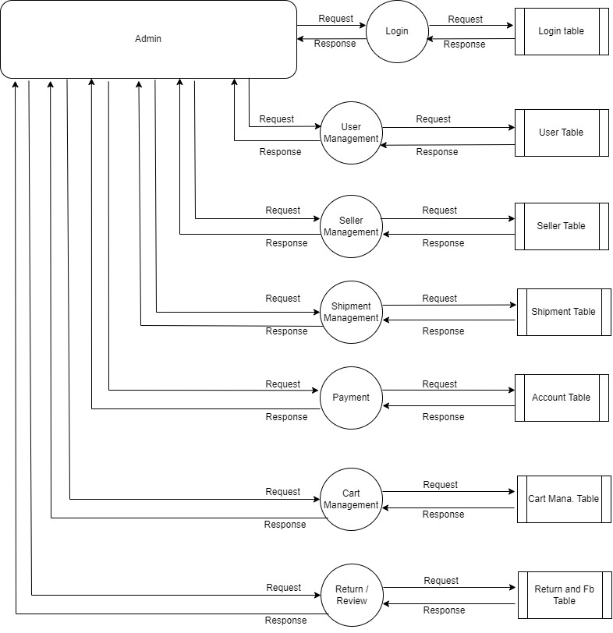

**2 Level DFD of Flipkart**

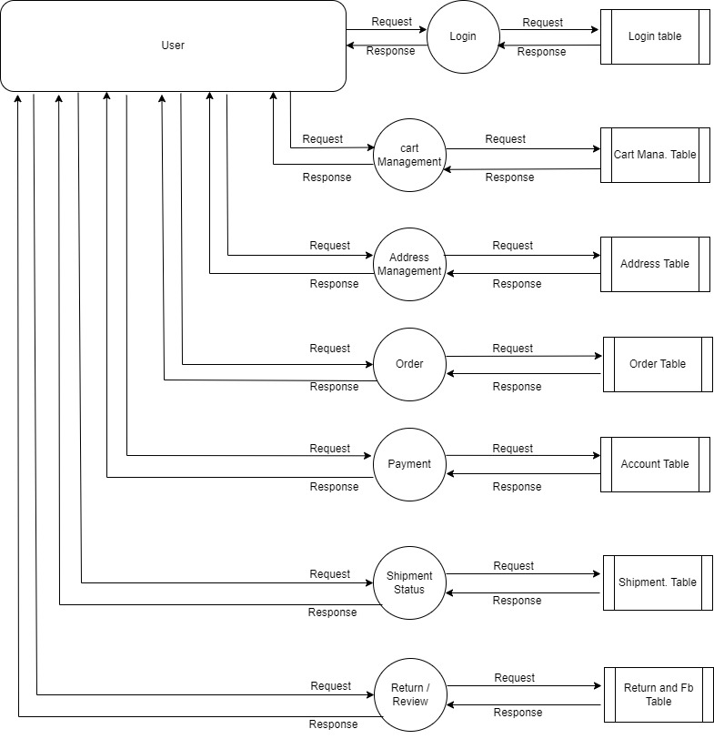

**Q5. What is Flow chart? Create a Flow chart to make addition of two numbers.**

**Ans.**

* A flow chart is a type of diagram that explains a process or workflow visually.
* It describes a process with a fixed sequence of steps and illustrates complex processes step by step in an understandable way.
* They help to identify the different elements of a process.

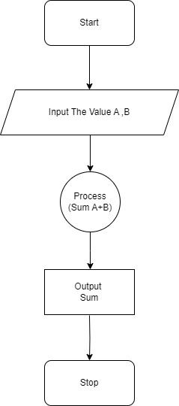

**Q6. What is use case diagram? Create a use-case on bill payment on paytm.**

**Ans.**

* A use case diagram is a graphical depiction of user’s possible interactions with a system.
* It is describe the high level functions and scope of system.
* It is Diagrams model the behaviour of a system.
* It is a methodology used in system analysis to identify, organize and clarify system requirement.

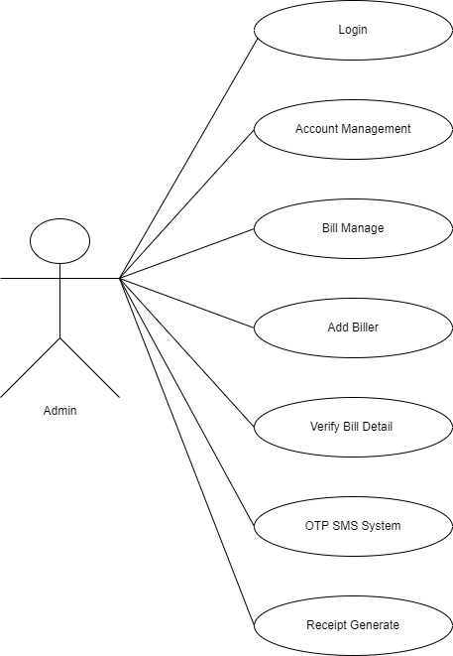

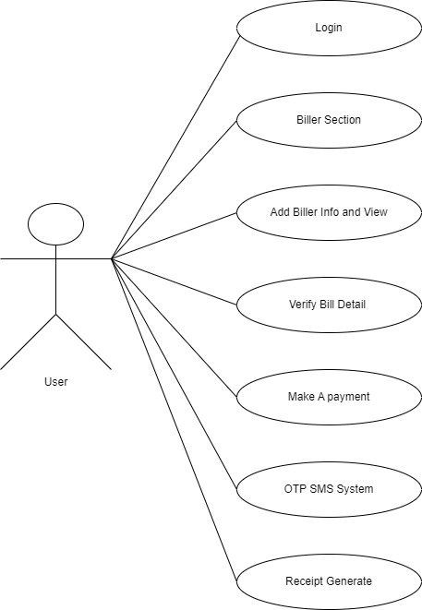

**Thank You.**