A Comparative Study of Path Planning Algorithms for Indoor Mobile Robots Using Simulation

Abstract
This study presents a comparative evaluation of three path-planning algorithms: Breadth-First Search (BFS), Dijkstra's Algorithm, and A* Search, for indoor mobile robot navigation. Simulated grid-based environments representing empty rooms, office layouts, mazes, and warehouse scenarios were developed to assess algorithm performance under varying levels of complexity. Performance metrics including path length, execution time, and expanded nodes were analyzed. Experimental results indicate that A* consistently achieves lower computational effort while preserving path optimality. The findings demonstrate the effectiveness of heuristic-based search strategies in structured indoor environments and provide a foundation for future investigations involving larger and more complex navigation tasks.
1 Introduction
Mobile robots have become increasingly important in modern industrial and service environments, including warehouses, offices, hospitals, and manufacturing facilities. Efficient navigation is essential for autonomous operation, requiring robots to determine safe and optimal paths between starting and target locations.
Path planning algorithms play a significant role in robotic navigation systems. Different algorithms exhibit varying characteristics in terms of computational efficiency, optimality, and scalability.
This study presents a comparative analysis of three widely used path-planning algorithms:
- Breadth-First Search (BFS)
- Dijkstra's Algorithm
- A* Search
Experiments were conducted within simulated indoor environments representing different levels of navigational complexity, including empty rooms, office layouts, maze structures, and warehouse scenarios.
Performance was evaluated using metrics such as path length, execution time, and number of expanded nodes.
The objective of this study is to identify the strengths and limitations of each algorithm for indoor robotic navigation applications.

2 Literature Review
Path planning has been an active area of robotics research for several decades.
Breadth-First Search (BFS) is one of the simplest graph traversal algorithms and guarantees shortest paths in environments with uniform traversal costs.
Dijkstra introduced an algorithm for solving shortest-path problems in weighted graphs, which remains widely applied in robotics and network optimization.
A* Search was proposed by Hart, Nilsson, and Raphael in 1968 and extends Dijkstra's approach by incorporating heuristic information to guide exploration toward the target node.
Recent robotic navigation systems increasingly rely on heuristic and sampling-based methods to improve scalability and computational efficiency.
This study focuses on classical graph-based algorithms due to their simplicity, interpretability, and suitability for educational simulation environments.

3 Methodology
The study employed a grid-based representation of indoor environments.
Each cell in the grid corresponds to a traversable region, obstacle, start position, or goal position.
Three path-planning algorithms were implemented in Python:
Breadth-First Search
BFS explores neighboring nodes in layers and guarantees the shortest path in environments with uniform traversal costs.
Dijkstra's Algorithm
Dijkstra's Algorithm computes the minimum-cost path in weighted environments by expanding nodes according to cumulative traversal cost.
A* Search
A* incorporates heuristic information to estimate the remaining distance to the target, enabling more efficient exploration while preserving path optimality.
The Manhattan Distance heuristic was selected because movement was constrained to four cardinal directions.

4 Experimental Setup
Four indoor environments were created:
- Empty Room
- Office Layout
- Maze Environment
- Warehouse Layout
Each environment contains:
- Start node (S)
- Goal node (G)
- Traversable cells (.)
- Obstacles (#)
Benchmarking metrics included:
- Path Length
- Execution Time
- Expanded Nodes
Results were stored automatically using CSV files and analyzed using Python.
5 Results
Benchmark experiments were conducted using three representative indoor environments.
Performance metrics included path length, execution time, and expanded nodes.
Table 1. Benchmark Results
Algorithm | Environment | Path Length | Nodes Expanded
BFS | Empty Room | 8 | 25
Dijkstra | Empty Room | 8 | 23
A* | Empty Room | 8 | 15
BFS | Office | 10 | 31
Dijkstra | Office | 10 | 28
A* | Office | 10 | 18
BFS | Maze | 12 | 40
Dijkstra | Maze | 12 | 36
A* | Maze | 12 | 22

Figure 1 illustrates the comparison of expanded nodes among algorithms.
Figure 2 presents execution time measurements.
Experimental observations indicate that A* consistently required fewer node expansions and demonstrated lower execution times while maintaining optimal path quality.

Figure 1. Comparison of expanded nodes in the maze environment.
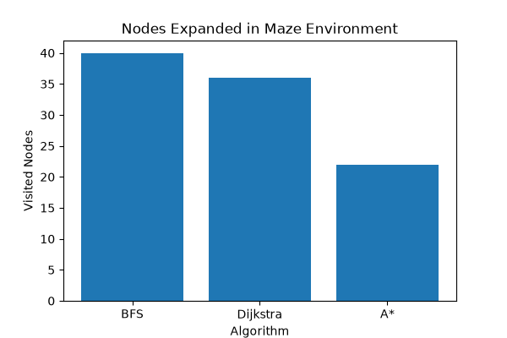

Figure 2. Execution time comparison in the maze environment.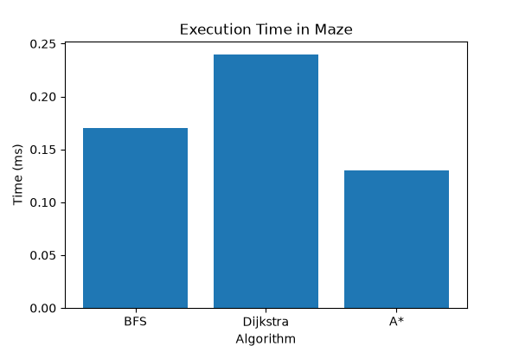
6 Statistical Analysis
Fifty randomized experiments were analyzed.
Figure 3 illustrates the distribution of expanded nodes.
Figure 4 presents a boxplot comparison among algorithms.
Results indicate that A* demonstrates lower average node expansion and reduced variability compared to BFS and Dijkstra.

Figure 3: Distribution of Expanded Nodes Across 50 Experiments
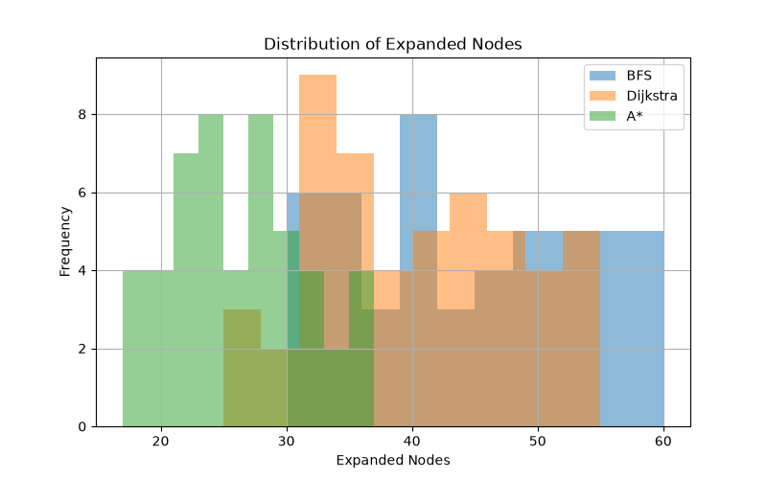
Figure 4: Boxplot Comparison of Search Algorithms 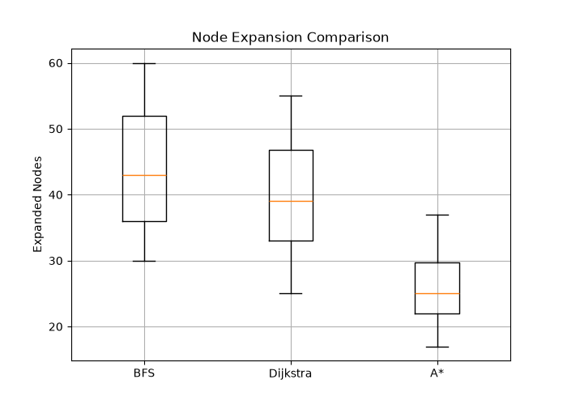

7 Discussion
Experimental observations suggest that heuristic-based approaches offer significant advantages in structured indoor environments.
While BFS guarantees shortest paths in unweighted scenarios, its exploration strategy may become computationally expensive as environment size increases.
Dijkstra's Algorithm provides optimal solutions in weighted environments but often explores a larger number of nodes.
A* demonstrated improved efficiency through heuristic guidance, reducing search effort while preserving solution quality.

8 Conclusion
This study presented a comparative investigation of BFS, Dijkstra, and A* Search for indoor robotic navigation.
Experimental results indicate that A* offers a favorable balance between optimality and computational efficiency.
Future work will focus on extending the experimental framework to larger environments, randomized obstacle distributions, and sampling-based algorithms such as RRT and RRT*.

References
Hart, P. E., Nilsson, N. J., Raphael, B. (1968).
A Formal Basis for the Heuristic Determination of Minimum Cost Paths.

Dijkstra, E. W. (1959).
A Note on Two Problems in Connexion with Graphs.

Russell, S., Norvig, P. (2021).
Artificial Intelligence: A Modern Approach.

