**Nepal – 5day(minimum)**

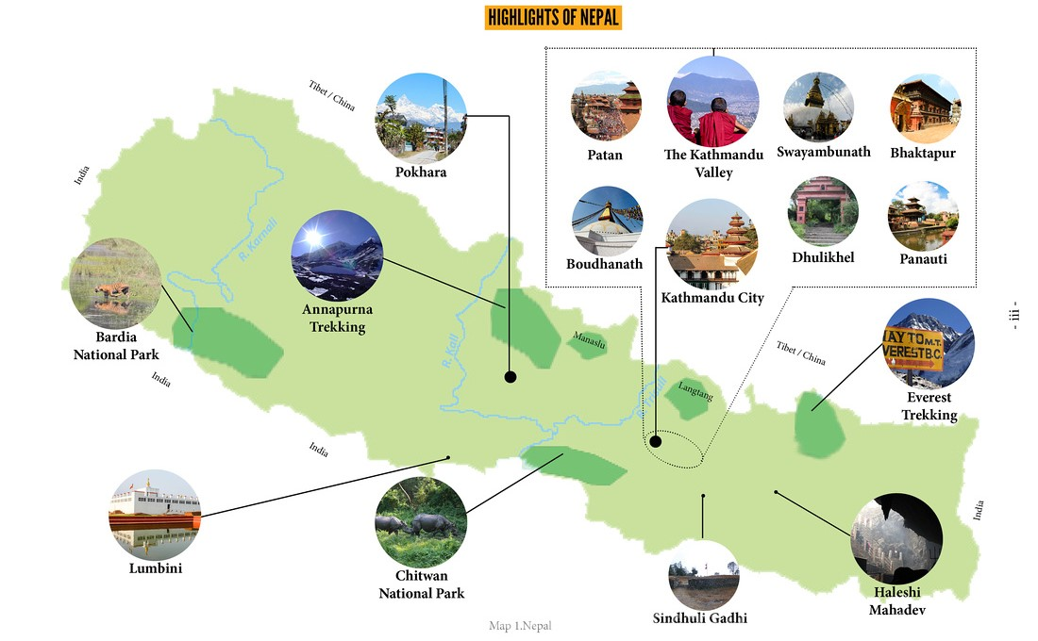

**New Delhi**



**Gorakhpur**

**Sunauli Border**

**Lumbini**

**Manokamna Mandir**

**Kathmandu**

**Pokhara**

771km

11h

103.6km

3h

184.7km

6.40h

141.6km

5h

265.9km

8h

31.1km

1h

288.9km

8h

201.2km

6h

**Sunauli Border**

201.2km

6h

**New Delhi**

875.4km

15h

208.6km

7h

Butwal (Madhu home)

Sunauli Border

Gorakhpur