* Jenkins is a Java Application hence it is platform independent.
* It is used for continuous integration and continuous delivery

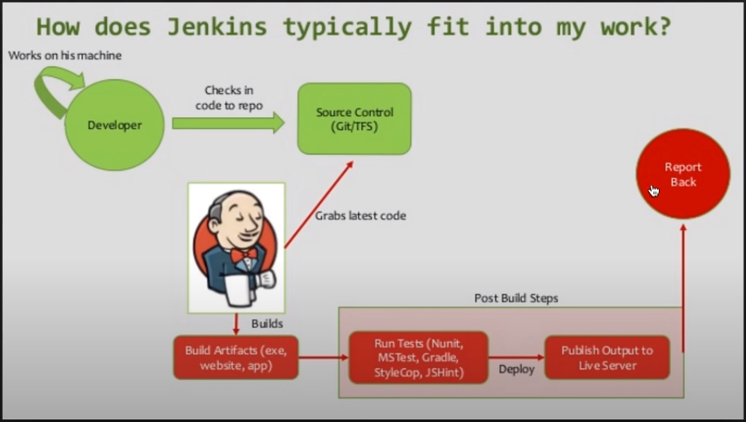

A soon as the developer pushes the code to Git, Jenkins will trigger a build to make sure there are no errors in latest commits. There can be post build steps like running junit ,etc so as to ensure the code committed does not break flow of application. We can get the report of that.

**Dowload Jenkins:**

1. **Go to Jenkins.io and download .war file**
2. **Place the dowloaded file in any location**
3. **Now go to folder where jenkins is present and open cmd. Then give command as**

**java –jar jenkins.war**

**Wait for 2 mins for jenkins to be fully up and running**

**Password for first time: 6aa03a95b53748c7a841b192db29c76e**

**Password recovery: C:\Users\HP\.jenkins\secrets\initialAdminPassword**

1. **Now go to browser and enter localhost:8080**

**(java –jar jenkins.war 🡪 To restart jenkins)**

**Now enter above saved password (6aa03a95b53748c7a841b192db29c76e)**

1. **Click on select plugins>>Click Install(Tick suggested plugins). Wait for few minutes for plugins to install.(All these plugins can be seen in user folder in c drive in .jenkins folder(hidden)**
2. In next page we can create a user or skip logging in as admin
3. Click on Start using Jenkins

**java –jar jenkins.war --httpPort=9090 (To change port)**

**ctrl+c >>> to shutdown Jenkins**

**How to change User Directory in Jenkins:**

**Open Jenkins(admin , 6aa03a95b53748c7a841b192db29c76e )>> Manage Jenkins >> Configure System >>> Will see users path .jenkins…. To change this folder path follow below steps.**

1. **Create a new folder wherever we want (F:\Jenkins)**
2. **Copy the files inside .jenkins folder in users folder in c drive and paste them in new folder**
3. **Now Change environment variables**

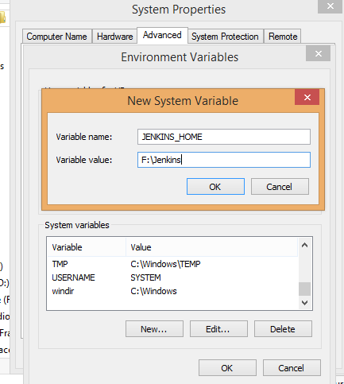

1. **Now restart Jenkins**

**Open Jenkins(admin , 6aa03a95b53748c7a841b192db29c76e )>> Manage Jenkins >> Configure System >>> New path will be displayed**

**How to Create New Users in Jenkins:**

**Manage Jenkins>>Manage Users>>Create User>>**

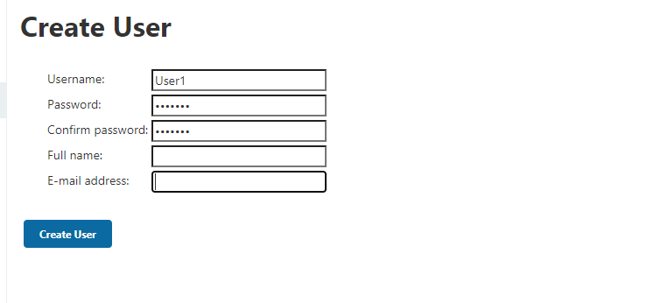

**Password: nishant,enter full name and password also**

**Upon clicking Create User , the user1 profile will be created**

**Now we can login with the newly created user.**

**Assign Roles:**

**For assigning role we should install a plugin called “**[Role-based Authorization Strategy](https://plugins.jenkins.io/role-strategy)**”**

**Manage Jenkins>>Manage plugins>>available>>** [Role-based Authorization Strategy](https://plugins.jenkins.io/role-strategy)>>Download now and install after restart

1. **Manage Jenkins>> Configure Global Security>>select Role based Strategy>>Apply>>Save**

**Now upon logging as User1 we will get error**

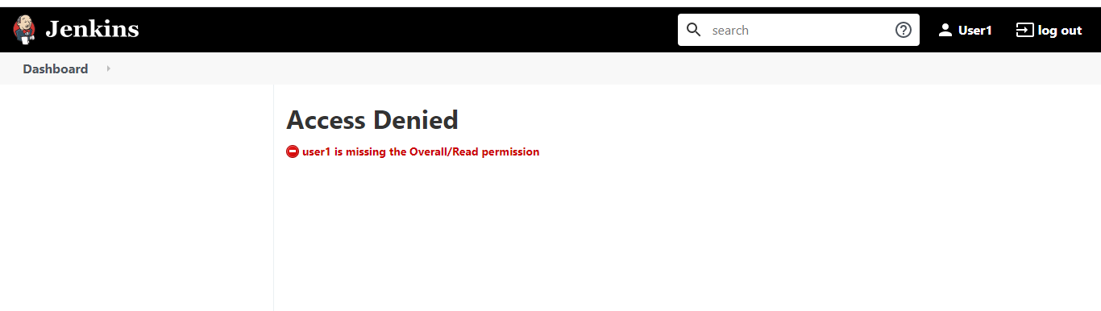

**Now to over come this issue….**

**Login as admin>>Manage Jenkins>>Manage and Assign Roles>>Manage Roles**

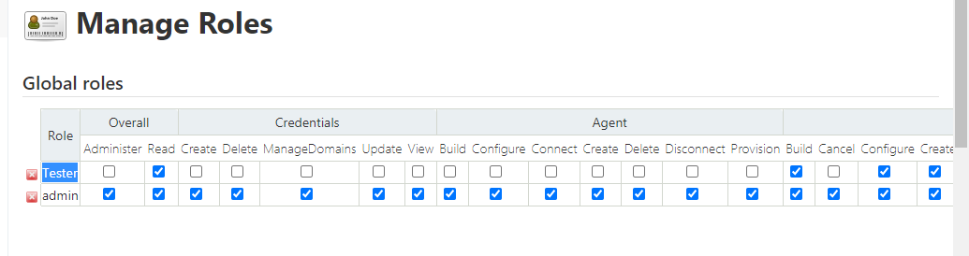

**Added Tester as gobal role with few access checked**

**Now got to assign role>> Add User1 and assign a role to him**

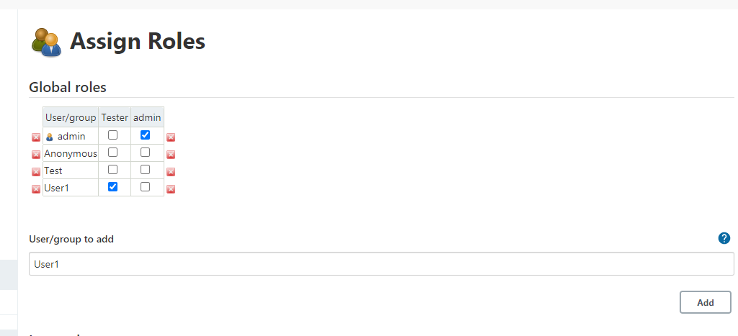

**How to create Jobs in Jenkins:**

**First add git plugin**

**New Item>>>Give some name >>> Free style project>>>Ok>>**

[**https://www.thegeekstuff.com/2016/10/jenkins-git-setup/**](https://www.thegeekstuff.com/2016/10/jenkins-git-setup/)