1. INTRODUCTION

This section gives a scope description and overview of everything included in this SRS document. Also, the purpose for this document is described and a list of abbreviations and definitions is provided.

* 1. Purpose

The purpose of this document is to give a detailed description of the requirements for the “Online Faculty Recruitment Portal” (OFRP) facility. It will illustrate the purpose and complete declaration for the development of system. It will also explain system constraints, interface and interactions with other external applications. This document is primarily intended to be proposed to a customer for its approval and a reference for developing the first version of the system for the development team.

* 1. Scope

The “Online Faculty Recruitment” is a web application provided by IIT Indore, which helps applicants to submit their application online. People related to the approval process, get informed about the applications for a specific position at IIT Indore. The application is free to every registered user.

The administrator uses the web portal in order to administer the system and keep the information accurate. Also the advertisements for any available positions are provided and managed by the administrator.

* 1. Definitions, acronyms and abbreviations

|  |  |
| --- | --- |
| TERM | DEFINITION |
| USER | Someone who visits the web application. |
| ADMIN/ ADMINISTRATOR | Web application manager who is given special permission for managing and controlling the system |
| REGISTERED USER | Someone who is registered in the users database |
| WEB - PORTAL | Web application which provides special facilities for admins. |
| STAKE-HOLDER | Any person who has interaction with the system who is not a developer |
| DESC | Description |
| RAT | Rational |
| DEP | Dependency |
| TAG | A unique, persistent identifier contained in a PLanguage statement [2] |
| GIST | A short, simple description of the concept contained in a PLanguage statement [2] |
| SCALE | The scale of measure used by the requirement contained in a PLanguage statement [2] |
| METER | The process or device used to establish location on a SCALE contained in a PLanguage statement [2] |
| MUST | The minimum level required to avoid failure contained in a PLanguage statement [2] |
| PLANNED | The level at which good success can be claimed contained in a PLanguage statement [2] |
| WISH | A desirable level of achievement that may not be attainable through available means contained in a PLanguage statement [2] |
| DEFINED | The official definition of a term contained in a PLanguage statement [2] |

* 1. References

[1] IEEE Software Engineering Standards Committee, “IEEE Std 830-1998, IEEE Recommended Practice for Software Requirements Specifications”, October 20, 1998.

[2] Feldt R,”re_lecture5b_100914”, unpublished. 3

[3] Davis M A, “Just Enough Requirements Management: Where Software Development Meets Marketing”, New York, Dorset House Publishing, 2005.

[4] Karlsson J, “A Cost-Value Approach for Prioritizing Requirements”, Norges Teknisk-Naturvitenskapelige Uni. 1997

* 1. Overview

1. OVERALL DESCRIPTION

This section will give an overview of the whole system. The system will be explained in its context to show how the system interacts with other systems and introduce the basic functionality of it. It will also describe what type of stakeholders that will use the system and what functionality is available for each type. At last, the constraints and assumptions for the system will be presented.

* 1. Product Perspective

This application mostly consists of two parts, the website and the web-portal. The website will be used for users to submit applications and receive information of the applications. The web-portal will be used to manage the data displayed on the website and also overall management of user accounts.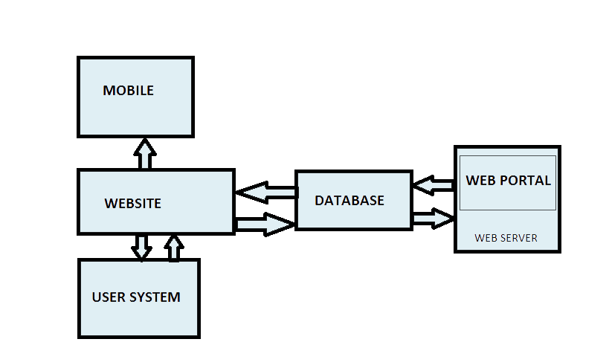

The user will need to communicate with the web application through world-wide web.