

**Online Optical Lens Delivery Service**

**CONCEPTUAL**

**MODEL**

**(**

**EER**

**AND**

**UML**

**MODEL)**

Group

2

Aditya

Kumar

Nishant Upadhyay

857

339

8150

857

351

8056

kumar.aditya1@northeastern.edu

upadhyay.nis@northeastern.edu

Percentage

of

Effort

Contributed

by

Student1

:

50

%

Percentage

of

Effort

Contributed

by

Student2

:

50

%

Signature

of

Student

1

:

Aditya Kumar

Signature

of

Student

2

:

Nishant Upadhyay

**EER Model for Online Optical Lens Delivery Service**

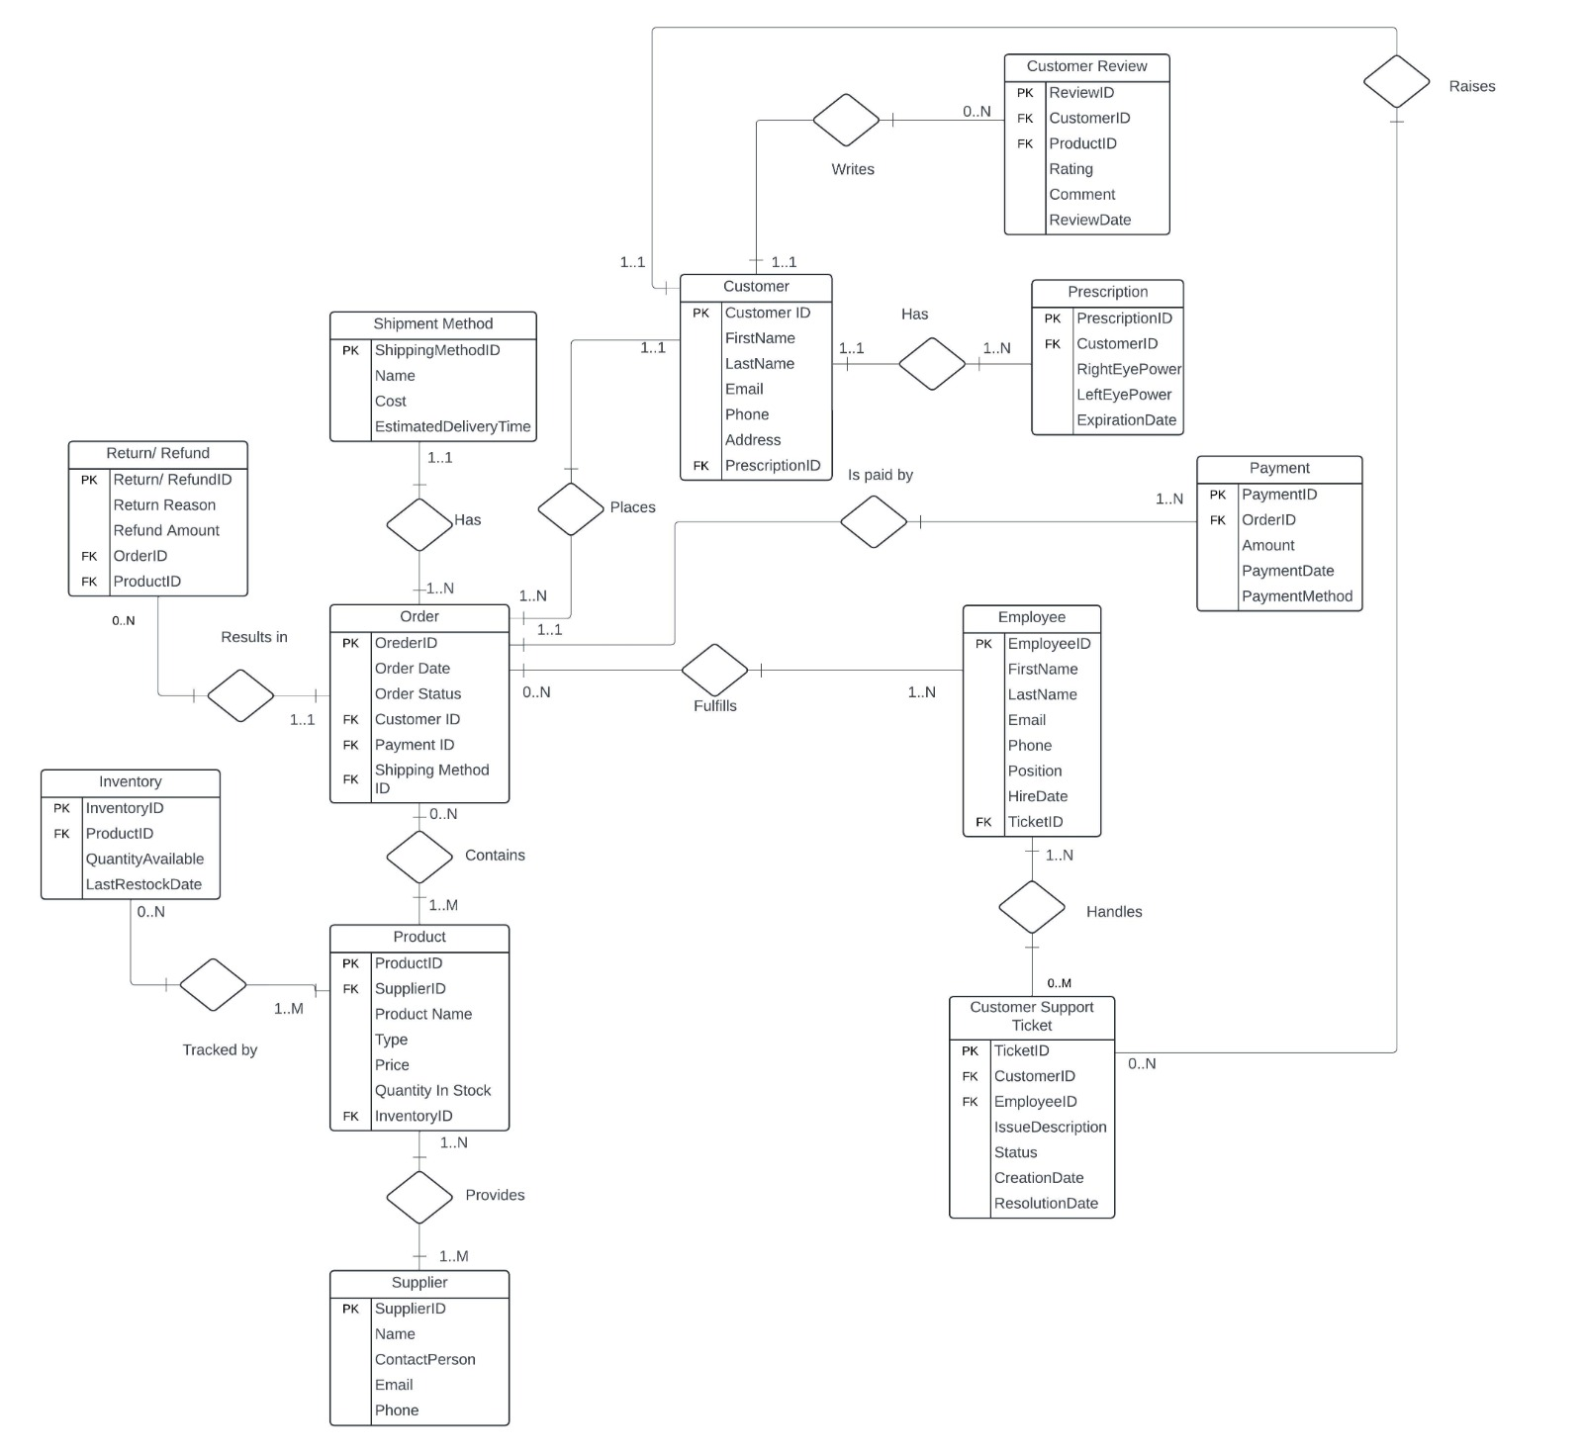

**Proposed Entities and Their Attributes**

**1. Order**

○ Attributes:

■ OrderID

■ OrderDate

■ OrderStatus

■ CustomerID

■ PaymentID

■ ShippingMethodID

○ Primary Key (PK): OrderID

1. **Customer**

○ Attributes:

■ CustomerID

■ First Name

■ LastName

■ Email

■ Phone

■ Address

■ PrescriptionID

* 1. Primary Key: CustomerID

1. **Employee**

○ Attributes:

■ EmployeeID

■ FirstName

■ LastName

■ Email

■ Phone

■ Position

■ HireDate

■ TicketID

* 1. Primary Key: EmployeeID

1. **Prescription**
   1. Attributes:

■ PrescriptionID

■ CustomerID

■ RightEyePower

■ LeftEyePower

■ ExpirationDate

○ Primary Key: PrescriptionID

1. **Payment**

○ Attributes:

■ PaymentID

■ OrderID

■ Amount

■ PaymentDate

■ PaymentMethod

* 1. Primary Key: PaymentID

1. **Inventory**

○ Attributes:

■ InventoryID

■ ProductID

■ QuantityAvailable

■ LastRestockDate

* Primary Key: InventoryID

1. **ShipmentMethod**

○ Attributes:

■ ShipmentMethodID

■ Name

■ Cost

■ EstimatedDeliveryTime

* 1. Primary Key: ShipmentMethodID

1. **Supplier**

○ Attributes:

■ SupplierID

■ Name

■ Contact

■ Email

■ Phone

* 1. Primary Key: ShippingMethodID

1. **Product**

○ Attributes:

■ ProductID

■ SupplierID

■ ProductName

■ Type

■ Price

■ QuantityInStock

■ InventoryID

* 1. Primary Key: ProductID

1. **CustomerReview**

○ Attributes:

■ ReviewID

■ CustomerID

■ ProductID

■ Rating

■ Comment

■ ReviewDate

* 1. Primary Key: ReviewID

1. **CustomerSupportTicket**

○ Attributes:

■ TicketID

■ CustomerID

■ EmployeeID

■ IssueDescription

■ Status

■ CreationDate

■ ResolutionDate

* 1. Primary Key: TicketID

1. **Return/Refund**

○ Attributes:

■ Return/RefundID

■ Return Reason

■ Refund

■ OrderID

■ ProductID

* 1. Primary Key: Return/RefundID

**UML Model for Online Optical Lens Delivery Service**

