

# EER Model for Online Optical Lens Delivery Service

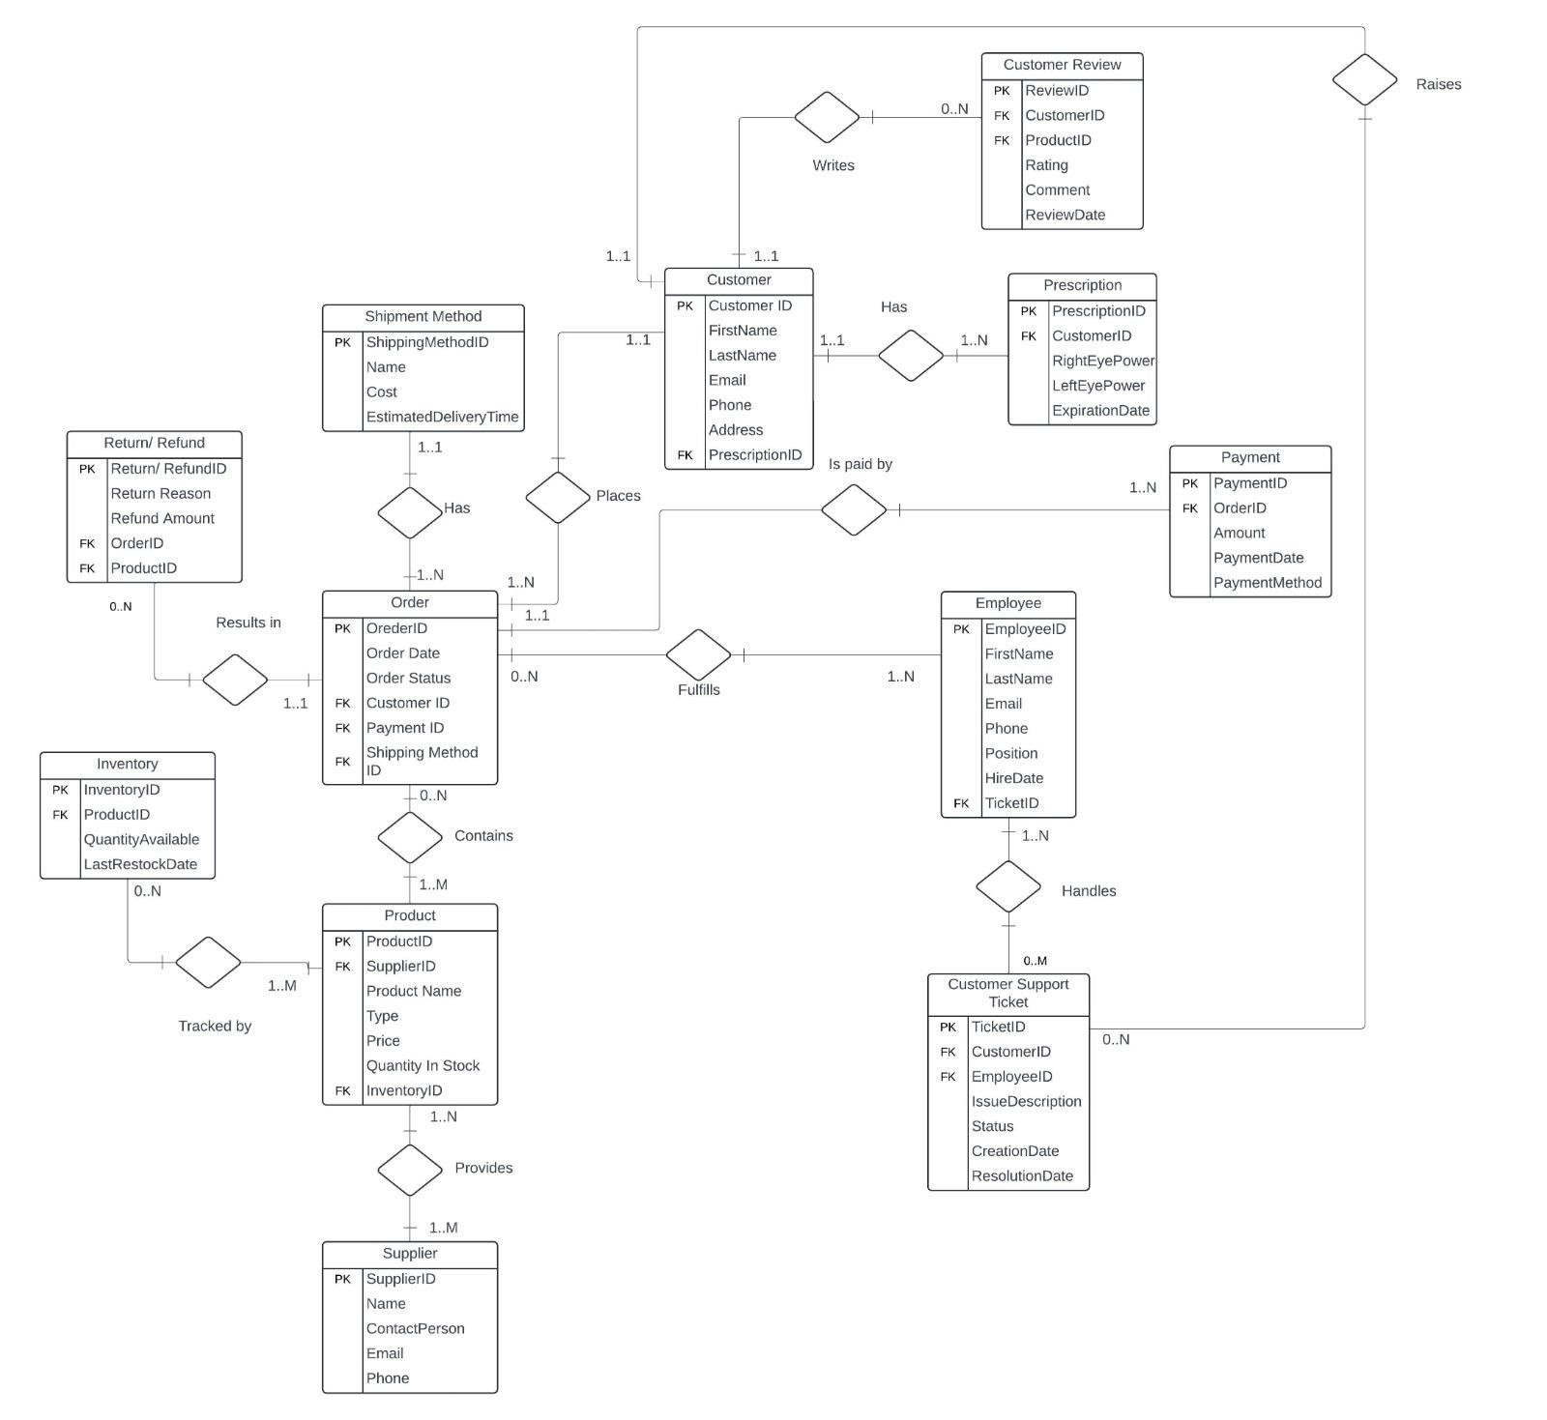

**Proposed Entities and Their Attributes**

**1. Order**

○ Attributes:

■ OrderID

■ OrderDate

■ OrderStatus

■ CustomerID

■ PaymentID

■ ShippingMethodID

○Primary Key (PK): OrderID

1. **Customer**
   1. Attributes:

■ CustomerID

■ FirtName

■ LastName

■ Email

■ Phone

■ Address

■ PrescriptionID

* + 1. Primary Key: CustomerID

1. **Employee** 
   1. Attributes:

■ EmployeeID

■ FirstName

■ LastName

■ Email

■ Phone

■ Position

■ HireDate

■ TicketID

* + 1. Primary Key: EmployeeID

1. **Prescription**

○ Attributes:

■ PrescriptionID

■ CustomerID

■ RightEyePower

■ LeftEyePower

■ ExpirationDate

○ Primary Key: PrescriptionID

1. **Payment**
   1. Attributes:

■ PaymentID

■ OrderID

■ Amount

■ PaymentDate

■ PaymentMethod

* + 1. Primary Key: PaymentID

1. **Inventory**
   1. Attributes:

■ InventoryID

■ ProductID

■ QuantityAvailable

■ LastRestockDate

Primary Key: InventoryID

1. **ShipmentMethod**
   1. Attributes:

■ ShipmentMethodID

■ Name

■ Cost

■ EstimatedDeliveryTime

* + 1. Primary Key: ShipmentMethodID

1. **Supplier** 
   1. Attributes:

■ SupplierID

■ Name

■ Contact

■ Email

■ Phone

* + 1. Primary Key: SupplierID

1. **Product** 
   1. Attributes:

■ ProductID

■ SupplierID

■ ProductName

■ Type

■ Price

■ QuantityInStock

■ InventoryID

* + 1. Primary Key: ProductID

1. **CustomerReview**  ○ Attributes:

■ ReviewID

■ CustomerID

■ ProductID

■ Rating

■ Comment

■ ReviewDate

○ Primary Key: ReviewID

1. **CustomerSupportTicket**  ○ Attributes:

■ TicketID

■ CustomerID

■ EmployeeID

■ IssueDescription

■ Status

■ CreationDate

■ ResolutionDate

○ Primary Key: TicketID

1. **Return/Refund**  ○ Attributes:

■ Return/RefundID

■ Return Reason

■ Refund

■ OrderID

■ ProductID

○ Primary Key: Return/RefundID

# UML Model for Online Optical Lens Delivery Service

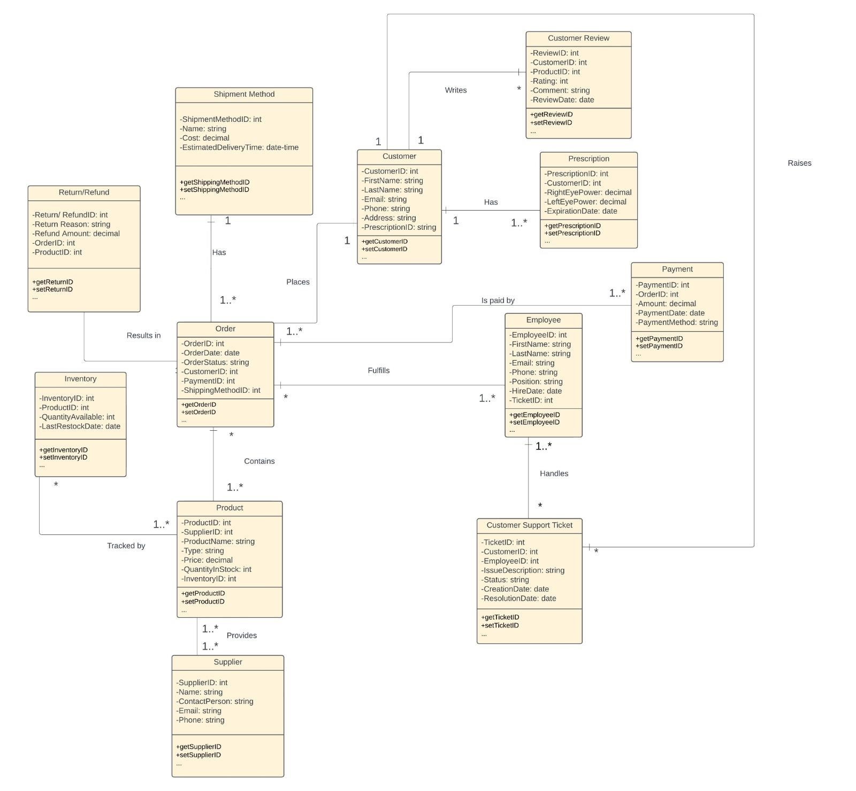

**Relational Model**

1. **Order(OrderID,** OrderDate, OrderStatus, CustomerID, PaymentID, ShippingMethodID**)**

* Primary Key: OrderID
* Foreign Keys:
* CustomerID (references Customer)
* PaymentID (references Payment)
* ShippingMethodID (references Shipment Method)

1. **Customer(CutsomerID,** FirstName, LastName, Email, Phone, Address, PrescriptionID)

* Primary Key: ProductID
* Foreign Keys:
* SupplierID (references Supplier)
* InventoryID (references Inventory)

1. **Employee(EmployeeID,** FirstName, LastName, Email, Phone, Position, HireDate, TicketID**)**

* Primary Key: EmployeeID
* Foreign Keys:
* TicketID (references CustomerSupportTicket)

1. **Prescription(PrescriptionID,** CustomerID, RightEyePower, LedtEyePower, ExpirationDate**)**

* Primary Key: PrescriptionID
* Foreign Keys:
* CustomerID (references Customer)

1. **Payment(PaymentID,** OrderID, Amount, PaymentDate, PaymentMethod**)**

* Primary Key: PaymentID
* Foreign Keys:
* OrderID (references Order)

1. **Inventory(InventoryID,** ProductID, QuantityAvailable, LastRestockDate**)**

* Primary Key: InventoryID
* Foreign Keys:
* ProductID (references **Product**)

1. **ShippingMethod(ShipmentMethodID,** Name, Cost, EstimatedDeliveryTime**)**

* Primary Key: ShippingMethodID

1. **Supplier(SupplierID,** Name, Contact, Email, Phone**)**

* Primary Key: SupplierID

1. **Product(ProductID,** SupplierID, ProductName, Type, Price, QuantityInStock, InventoryID**)**

* Primary Key: ProductID
* Foreign Keys:
* SupplierID (references Supplier)
* InventoryID (references Inventory)

1. **CustomerReview(ReviewID,** CustomerID, ProductID, Rating, Comment, ReviewDate**)**

* Primary Key: ReviewID
* Foreign Keys:
* CustomerID (references Customer)
* ProductID (references Product)

1. **CustomerSupportTicket(TicketID,** CustomerID, EmployeeID, IssueDescription, Status, CreationDate, ResolutionDate**)**

* Primary Key: TicketID
* Foreign Keys:
* CustomerID (references Customer)
* EmployeeID (references Employee)

1. **Return/Refund(Return/RefundID,** ReturnReason, Refund, OrderID, ProductID**)**

* Primary Key: Return/RefundID
* Foreign Keys:
* OrderID (references Order)
* ProductID (references Product)

1. **Contains(OrderID, ProductID)**

Relation between Order and Product

* Primary Key: (OrderID, ProductID) {composite key}
* Foreign Keys:
* OrderID (references Order)
* ProductID (references Product)

1. **Provides(SupplierID, ProductID)**

Relation between Product and Supplier

* Primary Key: (SupplierID, ProductID) {composite key}
* Foreign Keys:
* SupplierID (references Supplier)
* ProductID (references Product**)**

1. **Handles(EmployeeID, TicketID)**

Relation between Employee and CustomerSupportTicket

* Primary Key: (EmployeeID, TicketID) {composite key}
* Foreign Keys:
* EmployeeID (references Employee)
* TicketID (references CustomerSupportTicket**)**

1. **TrackedBy(InventoryID, ProductID, Quantity, LastRestockDate)**

Relation between Product and Inventory

* Primary Key: (InventoryID, ProductID) {composite key}
* Foreign Keys:
* InventoryID (references Inventory)
* ProductID (references Product**)**

1. **Fulfills(OrderID,EmployeeID)**

Relation between Employee and Order

* Primary Key: (OrderID,EmployeeID) {composite key}
* Foreign Keys:
* OrderID (references Relation Order)
* EmployeeID (references Relation Employee**)**