

**Balkumari, Kathmandu**

**A**

**Project On**

**“Student Management System”**

**Submitted by:**

**Nishant Bhandari-KIC078BEI015**

**Bishal Humagain-KIC078BEI010**

**Sabin Silwal-KIC078BEI017**

**Submitted To:**

**Department of Electronics and Computer engineering.**

**FALGUN, 2079**

**BALKUMARI, NEPAL**

**INTRODUCTION:**

The Student Management System (SMS) is a basic necessity of educational establishments or Industries to manage student data and manage many other students related information needed in an educational institution. StudentManagement System is a basic C++ program for educational institutions to manage student data. Student Management Systems provide capabilities for entering student test and other assessment scores, build student schedules, and manage many other student-related data needs in a school. This system was created to make it easier for administrative staff and parents to track information.

The Student Management System's primary function is to keep track of student profiles. It records all data pertaining to profiles such as their name, age, gender, address, contact number, faculty, and their id. Professor’s duties are made simpler by student management systems, which make information retrieval efficient and easier. In this SMS Project, we can add student details, view student details, edit student Details and search for student details and even delete those records.

This program deals with storing the student’s name, student’s age, student’s gender, student’s address, student’s mobile number, student’s faculty and lastly student’s id for further use.

**PROBLEM STATEMENT:**

For an educational institute like a college or university the number of students will be in larger amount So, it is difficult to record all the data of students in written format as there are chances of data loss or record destroyed in some incidents which are some of the common problems faced by educational institutes. This causes problems in monitoring the student’s profile and it creates problem to monitor the student’s activities efficiently. Keeping their record safe is the common duty of educational institute and with the advancement of technologies these existing system of recording student details are prone to less safety. Due to this lack of security, student records are vulnerable to losses.

This system is made to be completely efficient and easy to use. It is responsible for everything from taking in new students to keeping track of their information and to everything else needed to keep the school's administrative division running smoothly.

**OBJECTIVES:**

The main objective student management system is:

* To keep record of student safe.
* To monitor the student’s details regularly.
* To provide safer format for student’s details.
* To access student’s details efficiently.
* To organize student’s record on the basis of their information.
* To overcome the problems of existing system.

**METHODOLOGY:**

**WELCOME SCREEN**

**LOGIN SCREEN**

**MAIN MENU**

**ADD RECORDS**

**VIEW RECORDS**

**SEARCH RECORDS**

**MODIFY RECORDS**

**DELETE RECORDS**

**EXIT**

*Fig: block diagram of SMS*

In this system first of all ,the user is greeted with a welcome screen which is followed by a login screen, if the condition is true then main menu is encountered where the user can add ,view, search, modify and delete records and even exit from the system but if the condition is false and even after 2 attempts the user cannot provide the right condition then the system is forcefully closed and user is encountered with an exit screen.

**Tools Used:**

### 

### **Hardware:**

* Processor - minimum Pentium 4 2.4Ghz
* RAM- 1 GB
* Monitor /Mobile phone

### **Software:**

* For development:

Application software: IDE (Visual studio code and Dev C++)

Languages and frameworks: C++

* For user:

Suitable IDE and compiler to run C++ code

**RESULT AND DISCUSSION:**

We were able to develop the program as we had expected. The main component used in this program was the concept of file handling. File was used as a base for storing data and it helped us in storing data of student for even future use. The main objective of the system was to track and provide security to record of student and this objective was clearly achieved from the result. Similarly, concept related to structure, switch statement, loops, functions etc were also used in this system. We were able to add, view, search, edit and delete the record as per our need and we finally achieved the main objective of the project.

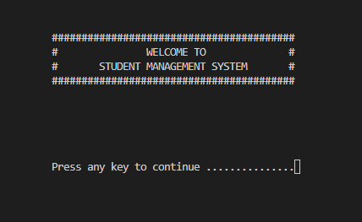Some of the screenshots of the results we obtained are:

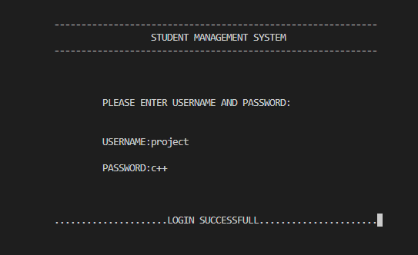

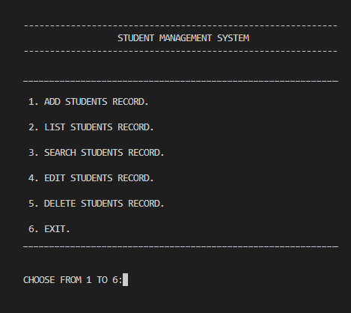

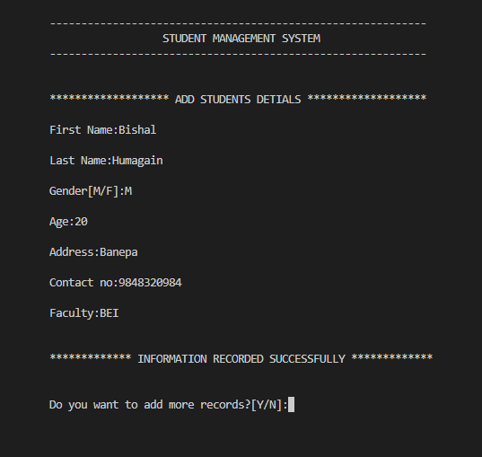

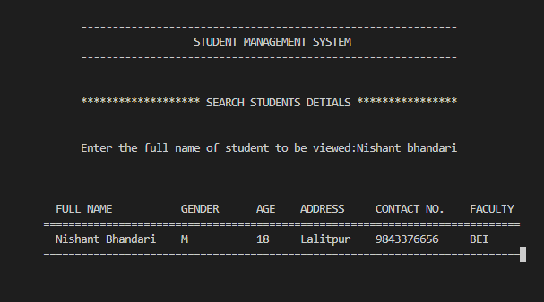**CONCLUSION:**

Our project is made to fulfil the needs of an educational institute to record the data of the student in proper and systematic manner. Thus, this project is not least but can provide the basic requirements and knowledge on how a student management system can overcome the problems of existing record keeping system.

The project was a success and we got fruitful result. This project not only did help us in an educational way but also taught us about team work, time management, discipline, hard work etc. It also helped us to know about the importance of teamwork and also developed the social characteristics.