**LP-II : CC Ass.3 : 29_Samruddhi Khairnar 20/5**

**Creating an Application in SalesForce.com using Apex programming Language.**

**Code and Output :**

**1. Insert New Records :**

**public class CCL_3_TE_29 {**

**public static void insertion()**

**{**

**Account acc = new Account(Name='Samruddhi',**

**Phone='0987654321');**

**insert acc;**

**Account acc1 = new Account(Name='Siddhi',**

**Phone='1234567890');**

**Account acc2 = new Account(Name='Shrushti',**

**Phone='6554323456');**

***// Add Multiple Records :***

**List <Account> accs = new List <Account>();**

**accs.add(acc1);**

**accs.add(acc2);**

**insert accs;**

**System.debug([Select count(Name) from Account]);**

**}**

**}**

To run all the methods, Debug -> Anonymous Window -> Type the method’s name.

To view the inserted records, go to the Sales Console and select Accounts (or any other sObject). 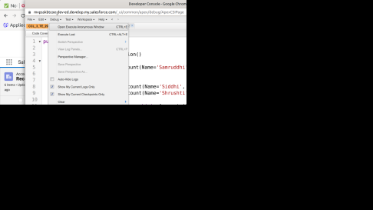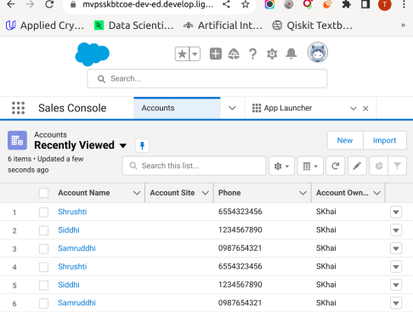

**2. Delete Existing Records :**

**public class CCL_3_TE_29 {**

**public static void deletion()**

**{**

**List <Account> accs = [Select Name,Phone from Account**

**where Name='Samruddhi'];**

**delete accs;**

**System.debug([Select count(Name) from Account]);**

**}**

**}**

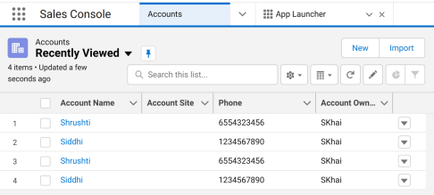

**3. Update Existing Records :**

**public class CCL_3_TE_29 {**

**public static void updation(String n)**

**{**

**List <Account> accs = [Select Name,Phone from Account]; for (Account acc: accs)**

**{**

**acc.Name = n;**

**}**

**update accs;**

**System.debug([Select count(Name) from Account]);**

**}**

**}**

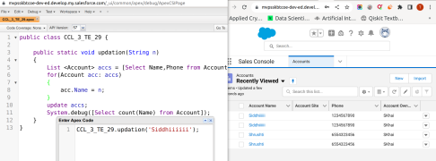

**4. Working with Custom Object Records** (add __c) **:**

**public class CCL_3_TE_29 {**

**public static void insertion()**

**{**

**Movie__c mov = new Movie__c();**

**mov.Name = '10';**

**mov.Theatre_Room_No__c = 2;**

**mov.Name__c = 'RRR';**

**mov.Date__c = DateTime.newInstance(2023,8,9,12,30,00);**

**insert mov;**

**System.debug([Select count(Id) from Movie__c]);**

**}**

**}**

**5.**

