# Introduction

As we observe, when we initiate a google search for some query we get over several links to a wide range of solutions. It is a rather a task to go through them to select the most appealing and accurate solution to our problem. Our project aims to help students with their coding doubts by creating a chatbot to avoid the tedious job of referencing multiple websites.

Stackoverflow is a website that serves as a platform for users to ask and answer questions, and, through membership and active participation, to vote questions and answers up or down and edit questions and answers. It serves as a reliable community for students to get dependable answers to their doubts with over 14 million registered users and 31 million answers to 21 million questions.

The chatbot will communicate and reply with the most appropriate link of a Stackoverflow website as a solution to the programming query. It can also build on a generic conversation for students just to communicate with.

# Problem Definition

A student in his professional technology course has to deal with various programming languages/ platforms and their own intricacies. He is bound to have doubts about the details and complexities of each hardware/software. There are tons of likeminded tech enthusiasts who come together over this platform Stackoverflow to discuss doubts ranging from the most basic level to the most advance ones.

A chatbot helps to ease various time consuming tasks. Likewise in this project we aim to reduce student effort of finding the most relevant and trustworthy solution to their query. Rather than surfing through multiple sites on Google before finding an answer, this conversational chatbot would directly send a link to the Stackoverflow solution.

It can also build a general conversation with the user which can help students to cope with any concerns or worries for time being.

# Literature Survey

While working on this project, we decided to work with the Amazon Web Services and use their virtual server called Amazon EC2 service. We referred to various resources as to why we should be using this web service for our chatbot.

Amazon Elastic Compute Cloud (Amazon EC2) is a web service that provides secure, resizable compute capacity in the cloud. It is designed to make web-scale cloud computing easier for developers. Amazon EC2’s simple web service interface allows you to obtain and configure capacity with minimal friction. It provides you with complete control of your computing resources and lets you run on Amazon’s proven computing environment.

Amazon EC2 offers the broadest and deepest compute platform with choice of processor, storage, networking, operating system, and purchase model. It offers the fastest processors in the cloud and it is the only cloud with 400 Gbps ethernet networking. It has the most powerful GPU instances for machine learning training and graphics workloads, as well as the lowest cost-per-inference instances in the cloud. More SAP, HPC, Machine Learning, and Windows workloads run on AWS than any other cloud.

Instance :

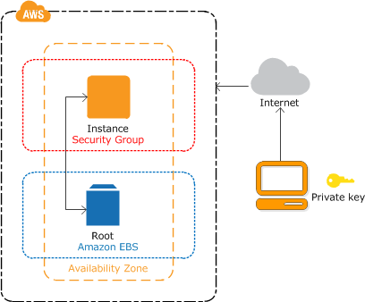

The instance is an Amazon EBS-backed instance (meaning that the root volume is an EBS volume). We can either specify the Availability Zone in which our instance runs, or let Amazon EC2 select an Availability Zone for us. When we launch our instance, we secure it by specifying a key pair and security group. When we connect to our instance, we must specify the private key of the key pair that we specified when launching our instance.

Advantages of Instances :

1. **Security:-** We can manage access to AWS resources and APIs using identity federation, IAM users, and IAM roles.
2. **Storage:-** We can use separate Amazon EBS volumes for the operating system versus your data also can use the instance store available for your instance to store temporary data.
3. **Resource management:-** We can use instance metadata and custom resource tags to track and identify your AWS resources.
4. **Backup and recovery:-** We can regularly back up our EBS volumes using Amazon EBS snapshots, and create an Amazon Machine Image (AMI) from our instance to save the configuration as a template for launching future instances.

## Docker :

Docker is a software platform that allows you to build, test, and deploy applications quickly. Docker packages software into standardized units called containers that have everything the software needs to run including libraries, system tools, code, and runtime. Using Docker, you can quickly deploy and scale applications into any environment and know your code will run.

Running Docker on AWS provides developers and admins a highly reliable, low-cost way to build, ship, and run distributed applications at any scale.

Docker works by providing a standard way to run your code. Docker is an operating system for containers. Similar to how a virtual machine virtualizes (removes the need to directly manage) server hardware, containers virtualize the operating system of a server. Docker is installed on each server and provides simple commands you can use to build, start, or stop containers.

AWS services such as AWS Fargate, Amazon ECS, Amazon EKS, and AWS Batch make it easy to run and manage Docker containers at scale

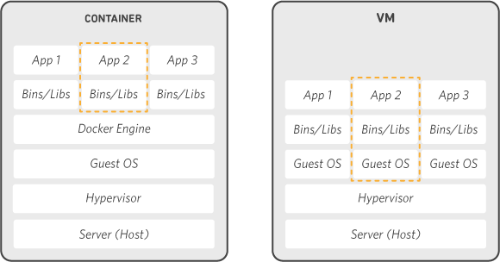

Advantages of docker :

Using Docker lets us ship code faster, standardize application operations, seamlessly move code, and save money by improving resource utilization. With Docker, we get a single object that can reliably run anywhere. Docker's simple and straightforward syntax gives you full control. Wide adoption means there's a robust ecosystem of tools and off-the-shelf applications that are ready to use with Docker.

# Proposed System

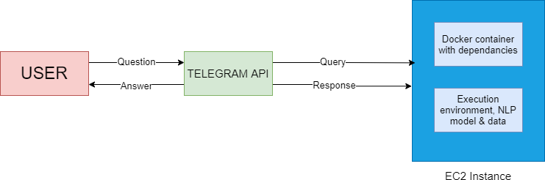

System Architecture

We create AWS EC2 instance using Ubuntu AMI. NLP model along with the data is uploaded on this instance over SCP protocol. The Docker container fulfills the software dependencies like Tensorflow, Data Science libraries, etc. that are required for the project.

Amazon EC2 provides different instance types to enable you to choose the CPU, memory, storage, and networking capacity that you need to run your applications.

Free tier EC2 Ubuntu instance comes with limited memory, 2GB RAM and 8GB storage. We have used the swap mechanism to allocate additional RAM which is partitioned from physical memory in order to satisfy the processing requirements.

We use tmux to keep our remote session running even if we disconnect from the machine, e.g. by closing our laptop.

The chatbot service is integrated with telegram API.

## Technology used :

AWS EC2 instance, Google Colab, Docker, Python, Tensorflow, Data Science libraries etc

NLP Model :

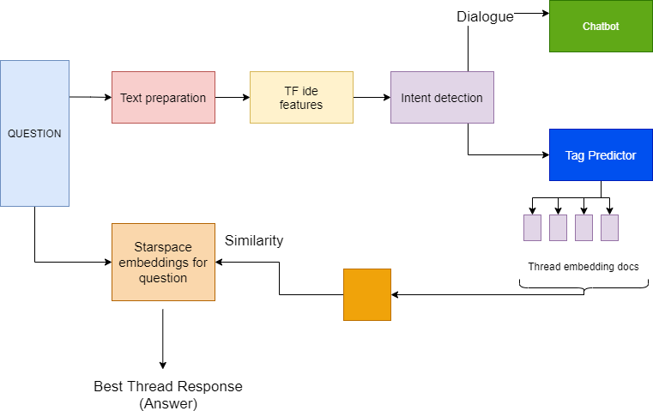

# Results

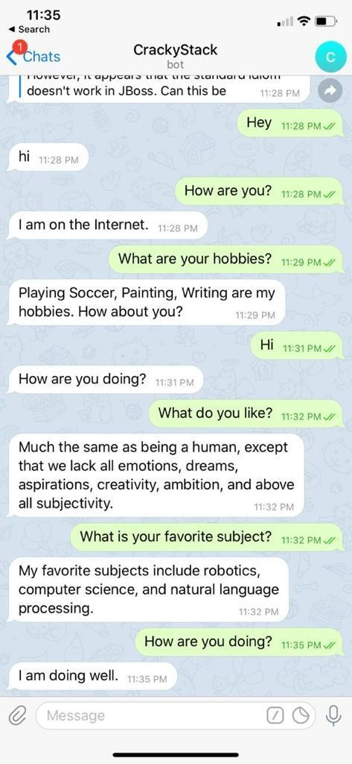

Generic conversation developed by the bot

Programming queries answered by the bot :

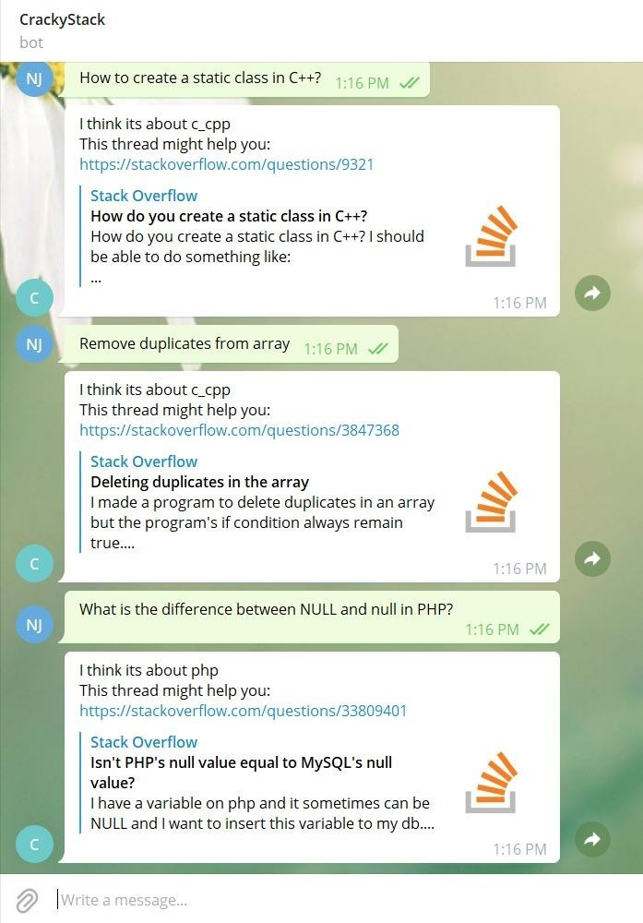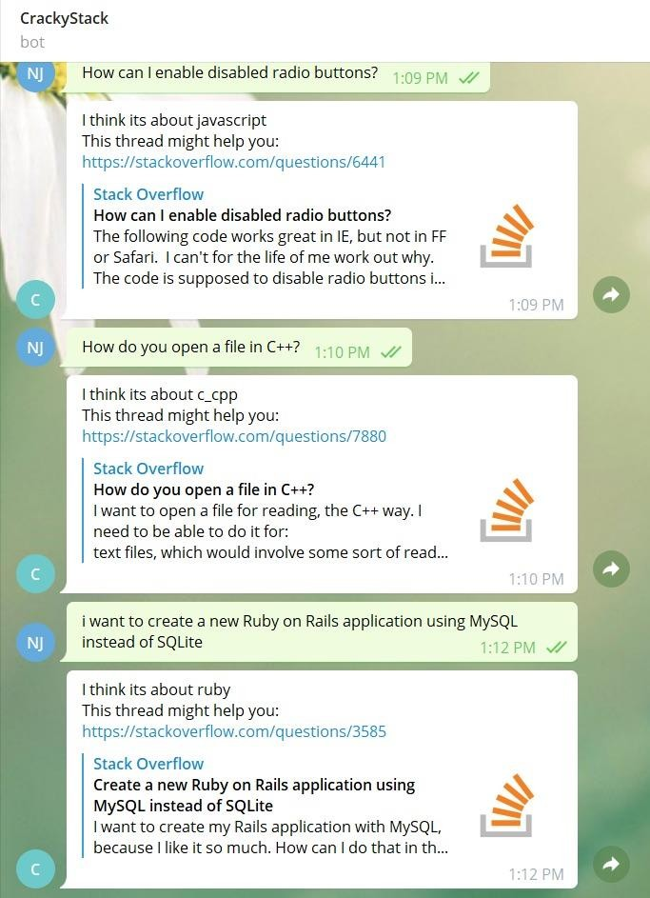

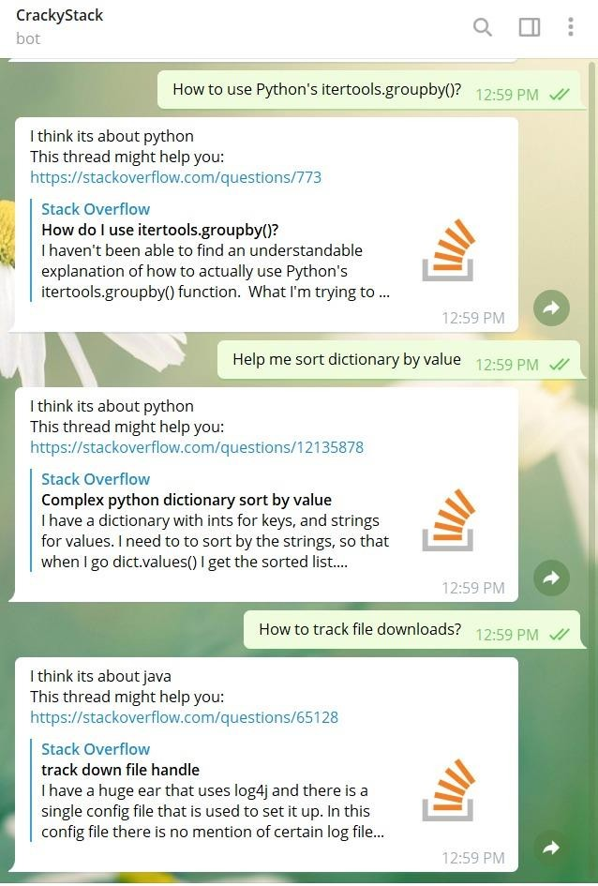

The Amazon EC2 instance running :

