**Position Control & Trajectory Tracking of Wheeled**

**Mobile Robot Using Fuzzy Logic Controller**

**Abstract: Trajectory tracking and set point tracking are the key components of autonomous mobile robot navigation. Trajectory-tracking control algorithms control the desired trajectory that is predetermined by the trajectory planning module. Being a trajectory-tracking key for safe mobile robot navigation, Fuzzy logic (FL) has been useful in tacking uncertainty and imprecision to realize robust and smooth trajectory tracking. In this paper, we present the Mamdani fuzzy Logic control for localization and trajectory tracking of differential non-holonomic two-wheeled mobile robots. The fuzzy algorithm is implemented on MATLAB, and performance is evaluated by tracking set-point trajectory, line trajectory, circular and Lissajous trajectory as the reference trajectory.**

**Keywords – Trajectory tracking, Wheeled Mobile Robot, Fuzzy Logic Controller**

**I. INTRODUCTION**

In recent years, the development of AI and robots is the foreground, and robots are used to execute from basic human needs to countless complex and autonomous tasks, so to perform some locomotive tasks, mobile robots are used on a large scale. Wheeled Mobile Robots can be used in numerous domestic applications such as food serving, floor cleaning, picking and placing things, etc. Therefore, for performing without human intervention many techniques are used like Neuro-fuzzy Controller [1][2], Neural network Technique [3], Hybrid Fuzzy Controller [4], Genetic Algorithm [5], Simulated annealing algorithm (SA) [6], Particle swarm optimization (PSO) [7] Adaptive Neuro-fuzzy (ANFIS) [8] by many researchers for trajectory tracking or static/dynamic obstacle avoidance.

Mobile robots are autonomous robots with complex dynamics capable of locomotion with the help of robotic elements such as wheels, legs, and tracks, not fixed to one physical location, and are known as wheeled mobile robots (WMRs). Wheeled Mobile Robots (WMRs) are very popular and helpful for applications with low energy consumption and less mechanical complexity. This paper discusses the movement of the robot on the given trajectory, but it can have other various attributes such as obstacle avoidance [9], speed control [10], autonomous driving [11], and people detection [12] and furthermore, it can be used for military and civilian applications, in automating offices, and hospitals, and particularly for fully autonomous applications.

This paper is about determining, controlling, and path-tracking the position of a Wheeled Mobile Robot (WMR) with the help of a fuzzy logic controller. This paper is about determining, controlling, and path-tracking the position of a Wheeled Mobile Robot (WMR) with the help of a fuzzy logic controller. Trajectory tracking can be done with the help of many other controllers, such as in [13], which Tracking-Error Learning Control (TELC) algorithm for accurate mobile robot path tracking, in [14], which consists of a model predictive control (MPC) unit and an active safety steering control unit, in [15] which is adaptive sliding mode path tracking for wheeled mobile robots with external disturbances and inertia uncertainties. In [16], the problem associated with accurate control of a two-wheel steering mobile robot following a path is addressed thanks to a backstepping control strategy, and in [17] in which, a design of a fuzzy-PID controller for trajectory tracking of a mobile robot with differential drive is proposed. But Fuzzy logic outperforms other controllers in non-linear, complex, and undefined problems. Fuzzy logic has an interesting approach that allows more advanced processing and a better combination of rule-based programming.

A WMR can have a different number of wheels depending on how easy it is to balance. Two-wheeled robots have a simple structure, having their wheels parallel to each other or one wheel in front of the other. The robot has the left and right wheels, comes with at least two sensors to know about the orientation and the position of the robot. Two-wheel robots are popular due to their small and efficient design, it just requires two motors and two wheels to move to the desired position, but it also has a drawback, Two-wheeled mobile robots are more challenging to balance than other types, they should keep moving to maintain its upright position.

So in this paper, we will be discussing a Three Wheeled Mobile Robot, which is very similar to the Two Wheeled, just an addition of a third wheel in front to control its direction and to balance it. Mobile Wheeled Robots have a drawback because of their size and less friction; they cannot be used on rocky terrain, sharp declines, or areas with low friction.

In this project, we do not require any odometry as we are not using any sensors. As in this, we are dealing with trajectory and not with obstacle avoidance. And For the initial position and orientation, we can take both zero. For position control, self-localization is a notably important feature of mobile robots. Without understanding its location, navigating the robot is impossible. There are many distinct methods to determine the robot’s current position, like visual-based localization, dead-reckoning method, and many more.

**II. KINEMATICS**

Our WMR has two powered wheels, one on each side of it. To understand the movement of the mobile robot, we will consider its movement in a curve. Since we are considering the movement of the robot for a brief period, we can scrutinize its movement in a circle. The center of this circle at any instant is known as the Instantaneous Center of Curvature (ICC).

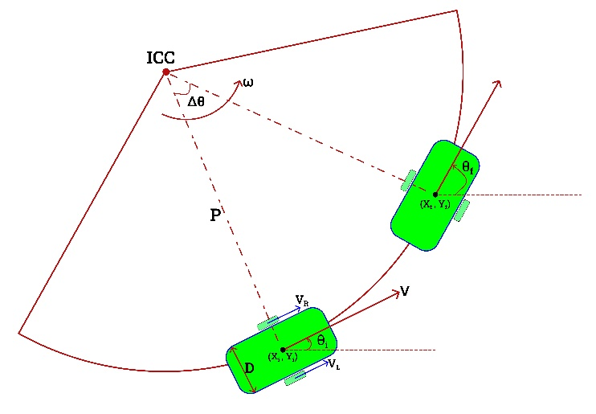

Fig.1 Movement of WMR in a circle

If the radius of the circle is P and D is the distance between the wheels of robot. VR and VL are the right and left wheel velocity respectively and. Then,

$$ω= \frac{V_{L}}{P- \frac{D}{2}} (1)$$

$$ω= \frac{V_{R}}{P+ \frac{D}{2}} (2)$$

$$V= \frac{V_{L}+ V_{R}}{2} (3)$$

Where, ω = Angular velocity of robot

V = Linear velocity of robot

Let θ be orientation of robot and $\dot{x}$ and $\dot{y}$ are linear velocities in x and y direction respectively. $\dot{θ}$ is angular velocity of robot. Then,

$$\dot{x}=Vcosθ (4)$$

$$\dot{y}=Vsinθ \left(5\right)$$

$$\dot{θ}= ω (6)$$

If (xi , yi) and (xf , yf)are initial and final coordinates of robot after Δt time period; θi and θf are initial and final orientations of robot. Then,

$$x_{f}=x_{i}+Vcosθ×∆t (6)$$

$$y_{f}=y_{i}+Vsinθ×∆t (7)$$

$$θ_{f}= θ_{i}+ω×∆t (8)$$

Writing our kinematic model in matrix form—

$$\left[\begin{aligned}\dot{x} \\ \dot{y} \\ \dot{θ}\end{aligned}\right]= \left[\begin{matrix}cosθ & 0 \\ sinθ & 0 \\ 0 & 1\end{matrix}\right]×\left[\begin{matrix}V \\ ω\end{matrix}\right]$$

Now in the hardware, we have two motors connected to both wheels of the robot. To move the robot according to the given V and ω we must determine the wheel's velocities individually. So, from equations (1), (2) and (3)

$$V_{L} =V-\frac{ωD}{2} (9)$$

$$V_{R} = V+\frac{ωD}{2} (10)$$

**III. FUZZY LOGIC CONTROLLER(FLC)**

The need of dealing with uncertainties in human-made environment was the introduction of fuzzy logic. The appearance of fuzzy logic theory solved various typical problems in robotics related to autonomous mobile robots. There are many areas in which autonomous robots can be used like Agriculture, Hospitals, House cleaning etc.

The use of fuzzy logic controllers can provide a flexible and robust approach to position control of wheeled mobile robots. By allowing for the representation of uncertainty and the use of fuzzy rules, these controllers can adapt to a wide range of environments and situations, making them well-suited for a variety of applications.

So, we suggest the use of fuzzy logic to incorporate expert knowledge on designing the controller that is why in this section we will describe the design and development of a fuzzy logic controller for the position control of our WMR.

There are three steps for designing a fuzzy controller:

**A.** *Fuzzification*

For fuzzification, we define our crisp input values into the fuzzy linguistic variables, which have a degree of membership values between 0 to 1. In our case, we have two inputs, d (distance between the desired position and current position of the robot) and θ (angle between desired angle and current orientation of the robot). For each input, we are using five triangular membership functions.

The fuzzy membership function is accustomed convert the crisp input values provided to the fuzzy inference system. Fuzzy logic itself is not fuzzy; rather, it handles the fuzziness in the data. And this fuzziness in the data is best expressed by the fuzzy membership function. Fuzzification is the first step in the Fuzzy Inference System. The fuzzy membership function is the graphical way of visualizing the degree of membership of any value in a given fuzzy set.

The fuzzification procedure maps the crisp input values to the fuzzy linguistic terms with the degree of membership values between 0 to 1. We use three membership functions for both error (ex or e𝜃) and change of error (dex or de𝜃)

The following diagrams represent the input membership functions: -

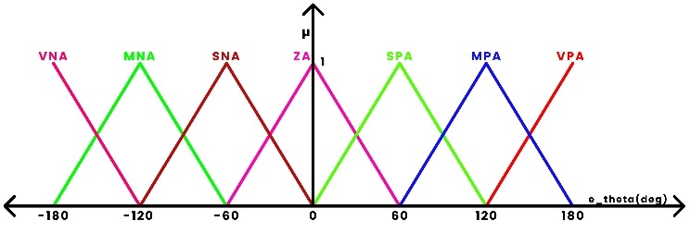

Fig2. Membership functions for input orientation(θ)

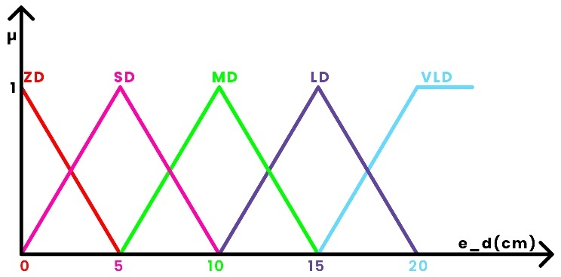

Fig3. Membership functions for input distance(d)

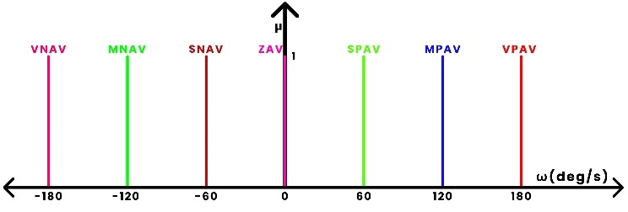

Fig4. Membership functions for output Angular Velocity(ω)

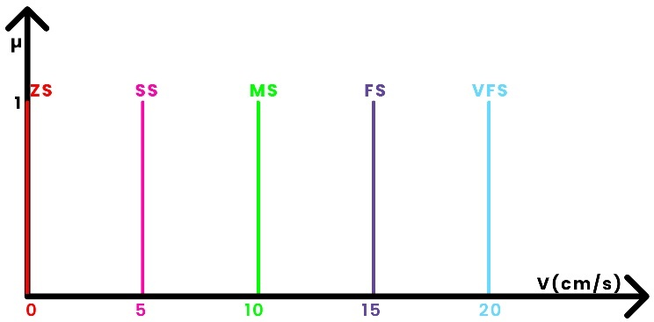

Fig5. Membership functions for output Linear Velocity(V)

***B.*** *Rule Base and Inference System*

A fuzzy inference system is the fundamental part of any fuzzy logic system. As we discussed a crisp value of distance and angle is given as input to fuzzy controller and these values will be mapped into the membership degree of their respective fuzzy sets. This process is done by a fuzzifier. After that the inference system process fuzzy data from each input into output in form of adjusting the linear velocity of the wheels on the left and right side of the robot correspond to the rule base.

A rule base is the collection of statements which relates the inputs to outputs in form of If Then rules. These rules are designed based on expert knowledge and testing.

In our problem we are using left and right wheels linear velocities (VL and VR) as our fuzzy controller’s output. For simplifying our reasoning, we are using five constant value membership function instead.

Based on our knowledge we have 25 rules:

|  |  |  |  |  |  |  |  |  |
| --- | --- | --- | --- | --- | --- | --- | --- | --- |
| ed(cm) ↓ | eθ(deg)→ | ZA | SPA | SNA | MPA | MNA | LPA | LNA |
| ZD | | ZS, ZAV | ZS, SPAV | ZS, SNAV | ZS, MPAV | ZS, MNAV | ZS, LPAV | ZS, LNAV |
| SD | | SS, ZAV | SS, SPAV | SS, SNAV | SS, MPAV | SS, MNAV | SS, LPAV | SS, LNAV |
| MD | | MS, ZAV | MS, SPAV | MS, SNAV | MS, MPAV | MS, MNAV | MS, LPAV | MS, LNAV |
| LD | | FS, ZAV | FS, SPAV | FS, SNAV | FS, MPAV | FS, MNAV | FS, LPAV | FS, LNAV |
| VLD | | VFS, ZAV | VFS, SPAV | VFS, SNAV | VFS, MPAV | VFS, MNAV | VFS, LPAV | VFS, LNAV |

**C.** *Defuzzification*

Defuzzification is the process of converting the output of a fuzzy logic system from a fuzzy set to a single, precise value. Fuzzy logic systems operate on fuzzy sets, which are values that have a degree of membership in a given set. For example, a fuzzy set might represent the temperature in a room, with some values having a high degree of membership (indicating that they are very likely to be the temperature of the room) and others having a low degree of membership (indicating that they are less likely to be the temperature of the room).

The rule base stores the rules governing the input-output relationship of the FLC. The inference engine is responsible for decision-making in the control system using approximate reasoning. The process of defuzzification converts this fuzzy set of values into a single, precise value that can be used by the system. This is typically done using a method called centroid defuzzification, which calculates the center of mass of the fuzzy set and uses that as the defuzzified output value. Other methods for defuzzification may also be used, depending on the specific application and the requirements of the system.In this we will be using Centre of Gravity (CoG) method and the formula for CoG can be written as

$$z_{crisp}= \frac{\int{µ(z)×z dz}}{\int{µ\left(z\right) dz}}$$

**V. RESULTS AND DISCUSSION**

In order to show the effectiveness and performance of position control of the wheeled mobile robot, trajectory and error graphs are drawn with the help of simulation in MATLAB. The following graphs show errors in trajectories or the trajectories themselves. Figure 6(a) shows the error in the distance of a set point trajectory which means reaching from one initial point to one final point. We can see in 50 seconds error in distance decreases to zero. Figure 6(b) shows the error in the orientation of the robot by considering desired orientation as the slope from the current position to the final desired position. And we can see in figure 6(b) error in angle decreases to zero just in 5 seconds. Figure 6(c) shows the actual set-point trajectory of the robot.

Figure 7(a) shows the desired Circular trajectory as well as the actual Circular trajectory of the robot, and just after that, in figure 7(b) we can see the error between these two, and this error is the error between the desired and actual points in the trajectory.

And similarly, Figure 8(a) shows the desired Lissajous trajectory and the actual Lissajous trajectory of the robot. We have shown a Lissajous trajectory because it is a complex path for the robot to track, as it has to take some sharp U-turns. Then figure 8(b) shows the error in desired and actual trajectory, and in it, we can see the maximum error we are having is somewhere around 0.55 cm which is very low as the body of the robot itself is about 16 cm long and 10 cm wide.16 cm long and 10 cm wide. 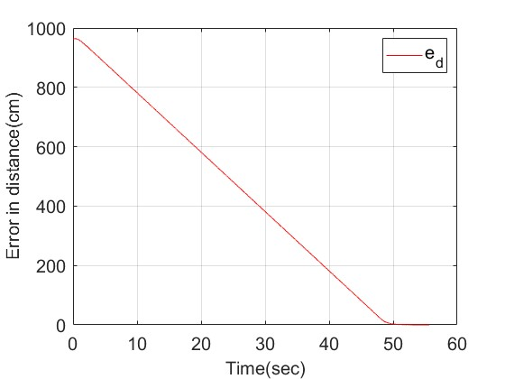

Fig.6(a) Error in distance of set point trajectory

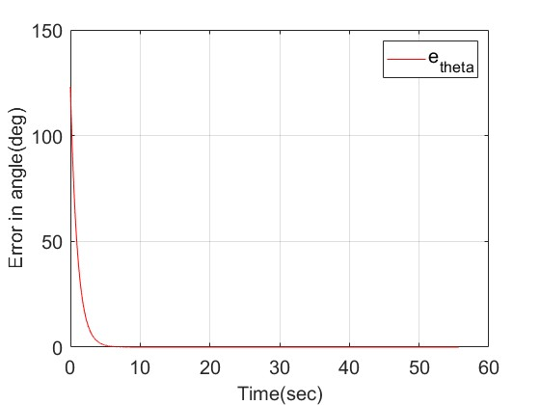

Fig.6(b) Error in angle of set point trajectory

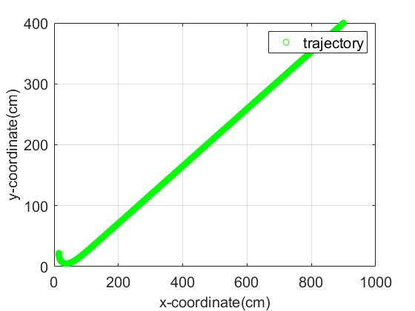

Fig.6(c) Set-point Trajectory

Fig.7(a) Circle Trajectory

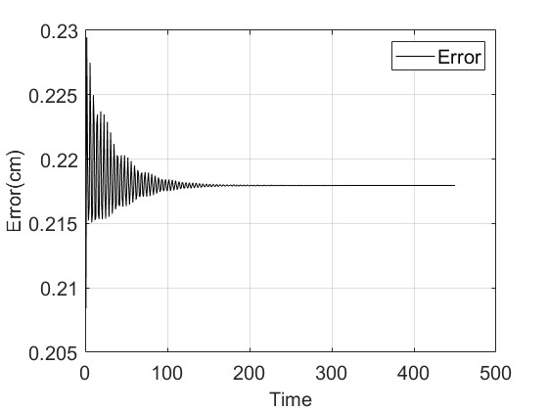

Fig.7(b) Error in actual and desired circle trajectory

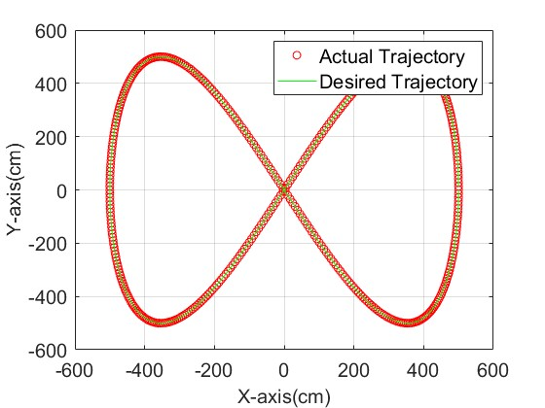

Fig.8(a) Lissajous trajectory

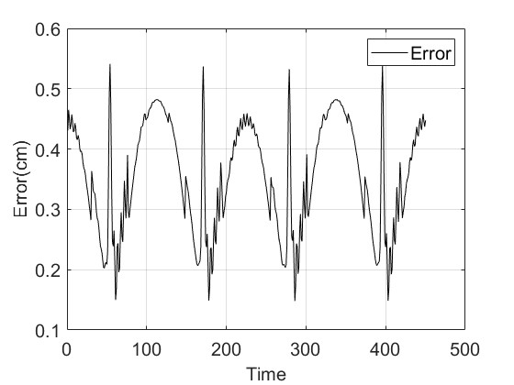

Fig.8(b) Error in actual and desired Lissajous trajectory

**VI. CONCLUSION**

The conclusion of the report on the position control of mobile wheeled robots using a fuzzy logic controller is that the fuzzy logic controller was able to effectively control the position of the mobile robot. The controller was able to maintain the robot's position within a specified tolerance range, demonstrating its ability to effectively control the robot's movement. The results of the study indicate that fuzzy logic controllers have the potential to be a valuable tool for controlling the position of mobile robots. Further research may be needed to improve the controller's performance and to explore its potential for use in other applications.

**REFERENCES:**

[1] A. Alsharkawi, M. Al-Fetyani, E. M. Ijaabo and H. Khasawneh, "Adaptive Neuro-Fuzzy Inference System for a Three-Wheeled Omnidirectional Mobile Robot," 2020 3rd International Conference on Applied Engineering (ICAE), 2020, pp. 1-6, doi: 10.1109/ICAE50557.2020.9350379.

[2] M. H. Haider et al., "Autonomous Mobile Robot Navigation using Adaptive Neuro Fuzzy Inference System," 2022 International Conference on Innovations and Development of Information Technologies and Robotics (IDITR), 2022, pp. 93-99, doi: 10.1109/IDITR54676.2022.9796495.

[3] M. Asai, G. Chen and I. Takami, "Neural network trajectory tracking of tracked mobile robot," 2019 16th International Multi-Conference on Systems, Signals & Devices (SSD), 2019, pp. 225-230, doi: 10.1109/SSD.2019.8893152.

[4] T. -Y. Wang and C. -D. Chang, "Hybrid Fuzzy PID Controller Design for a Mobile Robot," 2018 IEEE International Conference on Applied System Invention (ICASI), 2018, pp. 650-653, doi: 10.1109/ICASI.2018.8394340.

[5] T. -Y. Chang and C. -D. Chang, "Genetic Algorithm Based Parameters Tuning for the Hybrid Intelligent Controller Design for the Manipulation of Mobile Robot," 2019 IEEE 6th International Conference on Industrial Engineering and Applications (ICIEA), 2019, pp. 810-813, doi: 10.1109/IEA.2019.8715227.

[6] J. Cheng and B. Wang, "Flocking Control of Mobile Robots via Simulated Annealing Algorithm," 2020 39th Chinese Control Conference (CCC), 2020, pp. 3931-3935, doi: 10.23919/CCC50068.2020.9188714.

[7] S. I. A. Meerza, M. Islam and M. M. Uzzal, "Q-Learning Based Particle Swarm Optimization Algorithm for Optimal Path Planning of Swarm of Mobile Robots," 2019 1st International Conference on Advances in Science, Engineering and Robotics Technology (ICASERT), 2019, pp. 1-5, doi: 10.1109/ICASERT.2019.8934450.

[8] Y. -H. Chen and C. -D. Chang, "An intelligent ANFIS controller design for a mobile robot," 2018 IEEE International Conference on Applied System Invention (ICASI), 2018, pp. 445-448, doi: 10.1109/ICASI.2018.8394280.

[9] A. K. Kashyap, K. Pirewa Lagaza and A. Pandey, "Dynamic Path Planning for Autonomous Mobile Robot using Minimum Fuzzy Rule Based Controller with Avoidance of Moving Obstacles," 2018 International Conference on Recent Innovations in Electrical, Electronics & Communication Engineering (ICRIEECE), 2018, pp. 3330-3335, doi: 10.1109/ICRIEECE44171.2018.9009120.

[10] A. Najmurrokhman, Kusnandar, U. Komarudin, Sunubroto, E. C. Djamal and F. Taufik, "Speed Control and Obstacle Avoidance of A Hexapod Mobile Robot using Mamdani type Fuzzy Logic Controller," 2019 6th International Conference on Instrumentation, Control, and Automation (ICA), 2019, pp. 199-202, doi: 10.1109/ICA.2019.8916714.

[11] A. Moran and M. Nagai, "Autonomous Driving of Truck-Trailer Mobile Robots with Linear-Fuzzy Control for Trajectory Following," 2020 IEEE International Conference on Fuzzy Systems (FUZZ-IEEE), 2020, pp. 1-8, doi: 10.1109/FUZZ48607.2020.9177697.

[12] R. Prykhodchenko, R. P. Rocha and M. S. Couceiro, "People Detection by Mobile Robots Doing Automatic Guard Patrols," 2020 IEEE International Conference on Autonomous Robot Systems and Competitions (ICARSC), 2020, pp. 300-305, doi: 10.1109/ICARSC49921.2020.9096147.

[13] Kayacan, E., Chowdhary, G. Tracking Error Learning Control for Precise Mobile Robot Path Tracking in Outdoor Environment. *J Intell Robot Syst* **95**, 975–986 (2019).

[14] Cai, J., Jiang, H., Chen, L. *et al.* Implementation and Development of a Trajectory Tracking Control System for Intelligent Vehicle. *J Intell Robot Syst* **94**, 251–264 (2019).

[15] Jun-yong Zhai & Zhi-bao Song (2019) Adaptive sliding mode trajectory tracking control for wheeled mobile robots, International Journal of Control, 92:10, 2255-2262, DOI: 10.1080/00207179.2018.1436194

[16] Deremetz, Mathieu et al. “Path Tracking of a Two-Wheel Steering Mobile Robot: An Accurate and Robust Multi-Model Off-Road Steering Strategy.” 2018 IEEE International Conference on Robotics and Automation (ICRA) (2018): 3037-3044.

[17] Tiep, Do & Lee, Kinam & Im, Dae-Yeong & Kwak, Bongwoo & Ryoo, Young-Jae. (2018). Design of Fuzzy-PID Controller for Path Tracking of Mobile Robot with Differential Drive. INTERNATIONAL JOURNAL of FUZZY LOGIC and INTELLIGENT SYSTEMS. 18. 220-228. 10.5391/IJFIS.2018.18.3.220.