Q. Implement a web page index.htm for any client web site.
a. HTML syntax:heading tags, basic tags and attributes,frames, tables, images, lists, links for text andimages, forms etc.

<!DOCTYPE html>
<html>
<head>
<title>WTL_p2_2A</title>
</head>

<body>
<img src="Event-Pro-Directory-Logo-2021.jpg" alt="Our Logo" width="300" height="100">
<h2>Vendor Registration</h2>
<form action=" ">
<fieldset>
<legend>Account Details</legend>
<label for="VName">Business Name : </label>
<input type="text" id="VName" name="Vname" > <br><br>
<label for="email">Email:</label>
<input type="email" name="Email" id="Email"> <br><br>
<label for="password">Password :</label>
<input type="password" id="password" name="password">
</fieldset>
<br>
<fieldset>
<legend>Verfication</legend>
<input type="radio" name="Verfication"> I agree to the terms and services <br>
<input type="radio" name="newsletter"> I subscribe to the EventPro newsletter
</fieldset>
<br>
<fieldset>
<legend>Membership</legend>
Choose Membership Tier
<select name="teir" id="tier">
<option value="Gold_tier">Gold</option>
<option value="Platinum_tier">Platinum</option>
<option value="Diamond_tier">Diamond</option>
</select>
<br>
<p>For more Information about Tiers
<a href="membershipDetails.html">Click here</a>
</p>
</fieldset>
<br>
<input type="button" value="Submit">
</form>

</body>
</html>
Output : -

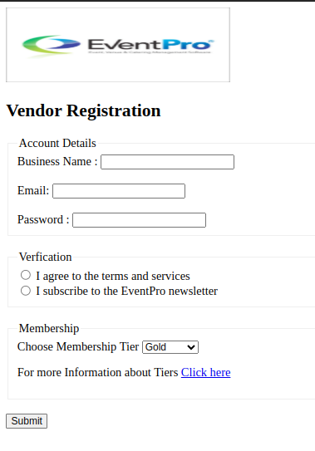

b. UseofInternal CSS,Inline CSS,External CSS.
HTML FILE
<!DOCTYPE html>
<html>
<head>
<title>WTL_p2_2B</title>
<style>
body{
background-color:blanchedalmond;
}
</style>
<link rel="stylesheet" href="styles.css">
</head>

<body>
<h1 style="text-align: center; font-family: Verdana, Geneva, Tahoma, sans-seri; font-size: 10vh; margin-top: 0%; color:firebrick;">Introduction</h1>
<p> Hi, My name is Nishant </p>

</body>
</html>

CSS FILE
p{
font-family: Arial, Helvetica, sans-serif;
font-size: xx-large;
color:coral;
}

OUTPUT

