Login to Auth0 web site

<http://auth0.com/>

Login using credential or create your own credential

Create your application, by clicking “Create Application” button

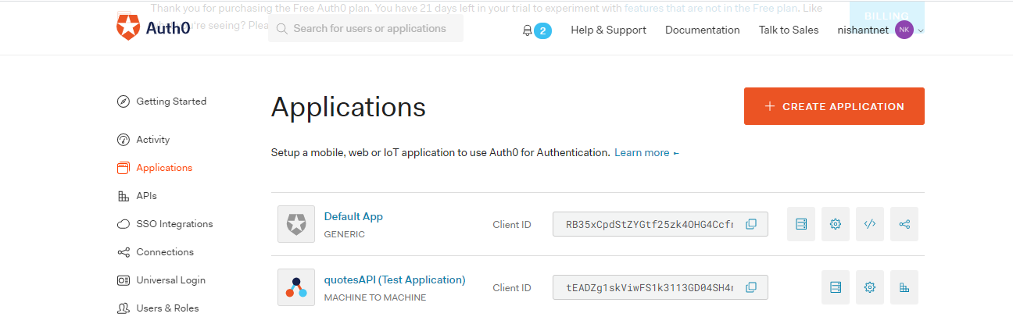

Get detail like “Client ID”, “Domain” of your application by just clicking your application like “quotesAPI”.

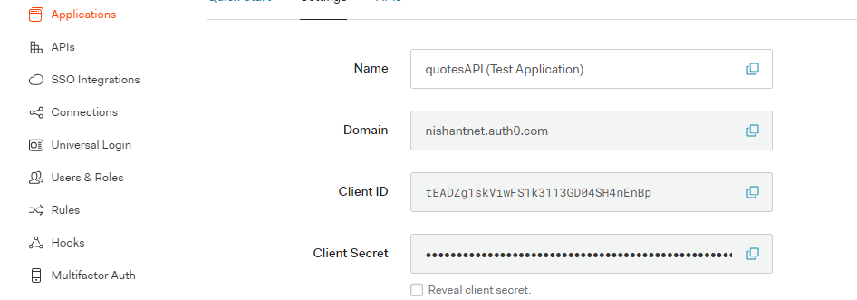

To integrate Auth0 with API, follow below steps:

* Go to APIs section

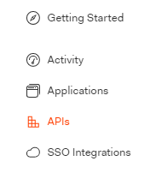

* Create API by clicking “Create API” button

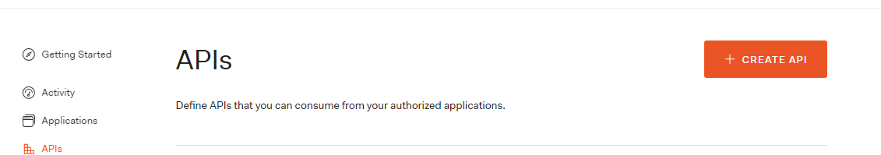

* While creating API always select “RS256” as signing algorithm and your API base URL as Identifier like “https://locaalhost:44395/”
* After creating API, it’s time to integrate it with your application, in this scenario its C#, select “Quick Start” tab and select language as “C#”
* Follow the steps given in this section to integrate it with .net core application and test it.

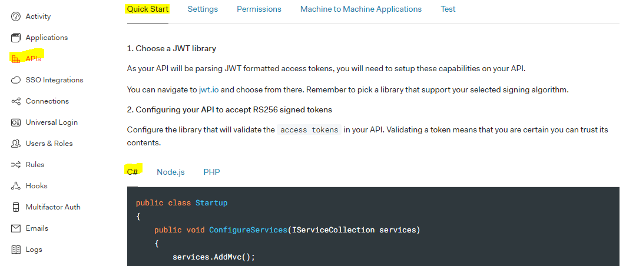

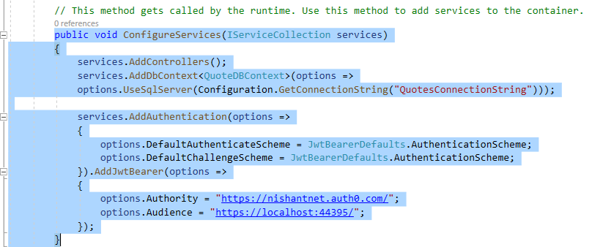

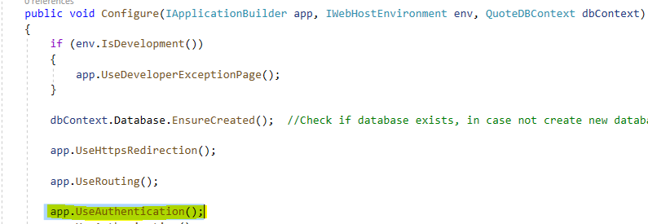

* After integration it’s time to test API, select “Test” tab. Select appropriate language, in this case its C#.

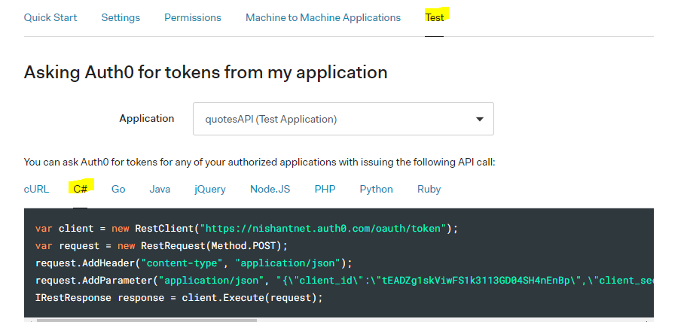

**Create Auth0 database**

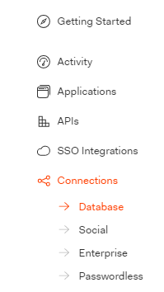

Associate Database with your application, select “Database”, go inside Tab “Application” and Enable application for which database is configured for.

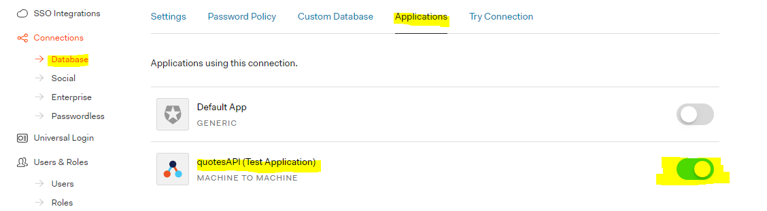

Now time to test Database and its connection with application; go to “Try Connection” tab

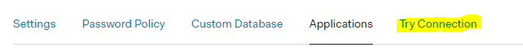

Create few test user and check whether Database is working or not and then verify those created user under “Users and Roles”.

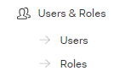

Now it’s time to integrate API like “Token Generation”, user creation APIs and others.

Go to Auth0 dashboard and select “Authentication API”.

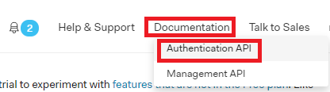

Scroll down the page and select “Run in Postman” to import all authentication APIs in Postman.

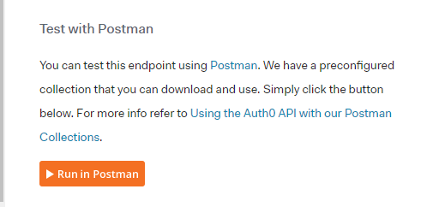

After importing all APIs it looks like, here we keep only two section i.e. “DB Connection” and “Get Access Token”

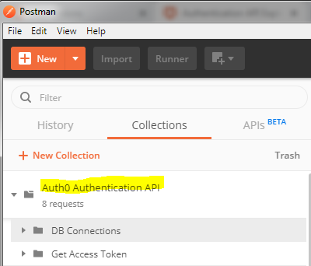

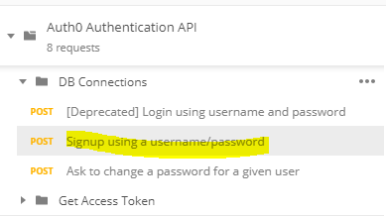

Now how do we post request, first you can see {{ auth0_domain}}, we can replace its value by common settings:

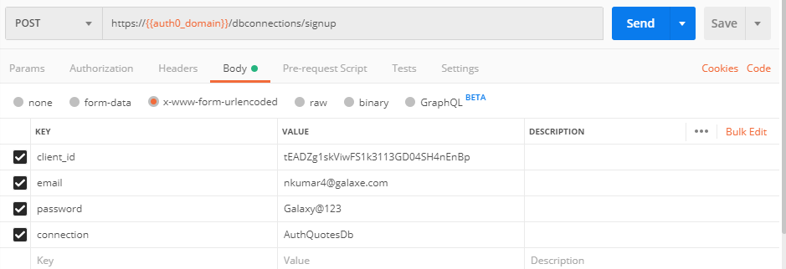

Click Settings button



Inside “Manage Environments” section click “Add”, Give user friendly “Environment Name”.

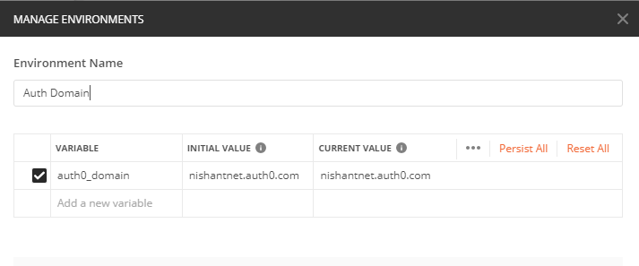

Value for Dynamic variable (auth0_domain) would be domain name of application which you get from Auth0

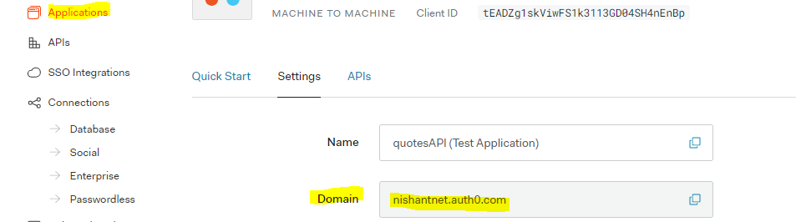

Finally select the newly created environment in Postmen prior to send any request through it.



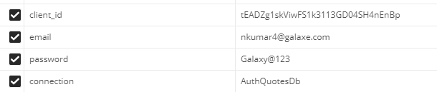

As part of “Sign up” request

**Client ID:**

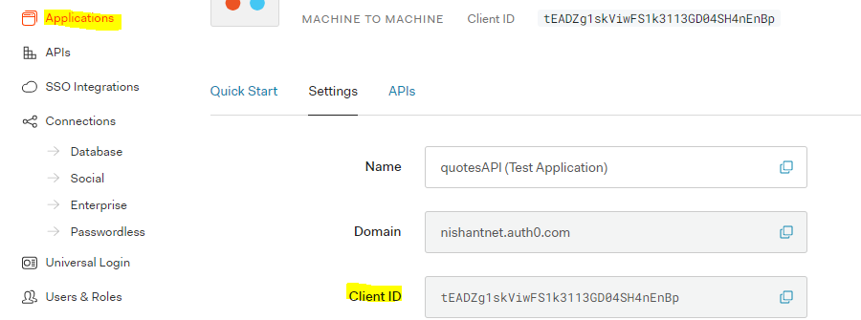

**Connection:**

 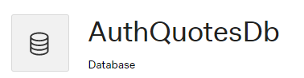

**Enable “Password” grant type**





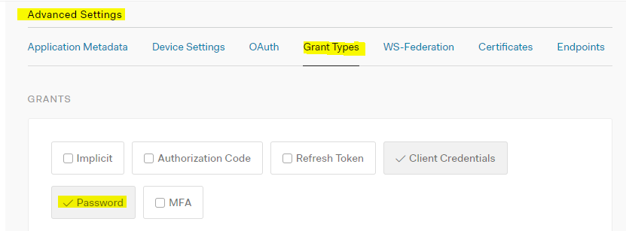

**Another Endpoint**

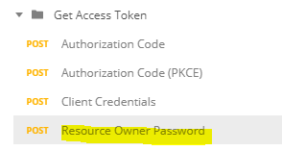

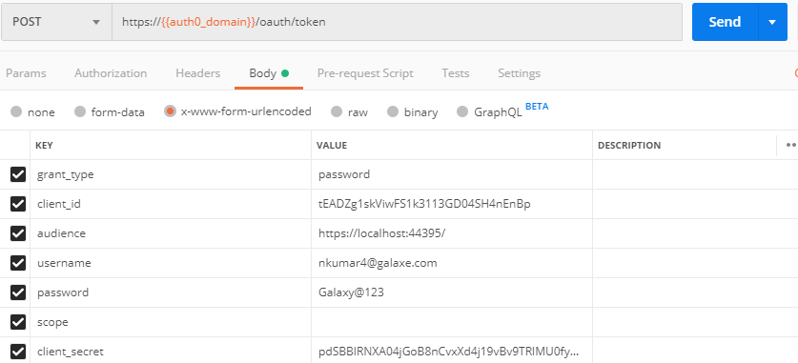

**Error:**

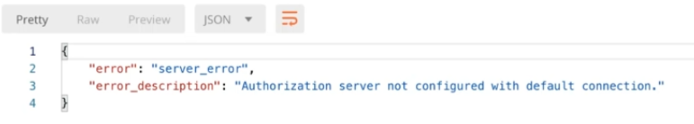

**Solution:**

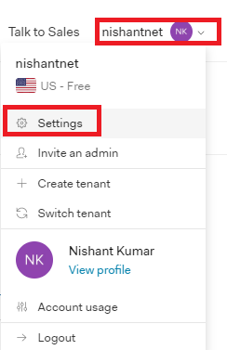

In “General” Tab give value of “Default Directory”, this is value of Database name configured for application. Save the changes and try.

