Department of Computer Science & Engineering.
Meerut Institute of Engineering & Technology
Ref No: Projects,01-Nov0516 Date: 05/11/16
All students of final year Computer Science & Engineering are hereby informed that their final project presentation for semester VII will be held from Nov 12,2016 to Nov 18,2016 . The respective guides will evaluate your progress to their satisfaction w.r.t
- Understanding of Domain (Problem Statement)
- Inclusion of comments & suggestion of the Approval committee.
- Use case diagram, DFD, E-R Diagrams, Human Interface, Identification of API to be used, Identification of Cloud to be used (for cloud based project) .
- Registration on Git Hub ( done or not for sharing of Codes)
- Review literature for research based project.
- Module design & Identification of Modules for Hardware based Projects
(Note:Projects under guidance of Prof. Palak Gupta are transferred to Prof. Anjali Sharma. (Cabin No. 416))
You are expected to come prepared for the same with a report (spiral) and PPT. The report should constitute (not limited to) the following :
- Title page
- Abstract
- Table of Contents
- Introduction (problem statement)
- Software Requirement Specification (for development based project for a problem or a domain)/ Synopsis for research oriented project
- Software Design Document.
- Test cases (if feasible for you at this juncture)
- Guides Comments
The text processing information, format of the Title page, the contents (sample page is attached separately) & the Guide’s comment page follows here below.

An Interim Report On
<Project Title>

Submitted for evaluation of the Project Progress in Semester VII
of
B. Tech
(Computer Science & Engineering) /
(Information Technology)

by:
<Student Name1> < (Roll No)>
<Student Name2> < (Roll No)>

Under the guidance of
<Supervisor Name>
< (Designation, Department)>


Department of Computer Science & Engineering
MEERUT INSTITUTE OF ENGINEERING & TECHNOLOGY
Meerut – 250005

Approved by A.I.C.T.E.
Affiliated to Dr.A.P.J.Abdul Kalam Technical University, Lucknow
(Batch 2013 – 2017)

Guide’s Comment

Signature of the Guide

Date: Name of the Guide

TEXT PROCESSING INFORMATION

It is important to note that type format of all reports should be uniform. So there is a need to follow some guidelines on typesetting and other aspects. Some of such guidelines are given below.
1. The original copy shall be typed on 75 or 80 gr./m2 white paper. All photocopies shall be run on the same grade of paper. Size of paper shall be 210 x 297 mm, i.e. A4.
2. Only Near Letter Quality Laser printer and Ink Jet printer outputs are acceptable.
3. As a character font, one should use Times, Times Roman, Courier, Geneva, Helvetica or equivalent which is available in most word processors. The font size must be 12 point in the text and at least 8 point in the figures.
4. Whenever titles and headings are to be centered the centering shall be such that 112 mm. from the left edge of the paper or 98 mm. for the right edge of the paper is the center point of the title or heading.
5. Margins of pages shall conform to the following specifications.
a. Left margin - 3 1/2 cm. from edge of paper.
b. Right margin - 2 cm. from edge of paper.
c. Top margin - 3 1/2. from edge of paper.
d. Bottom margin - 2 cm. from edge of paper.
The above margins shall be observed on charts, graphs, tables, and drawings. Folded papers will not be accepted unless there is absolutely no other way for the material to be presented.
6. Spacing of the text material shall be 1.5 with the following exceptions:
a. Footnotes - single spacing
b. Long biographical quotes - single spacing
c. Extensive quotations - single spacing and indented eight (8) spaces relative to the text material.
7. Headings used in the report shall conform to the following rules:
a. Chapter Headings - CHAPTER 1,CHAPTER 2, CHAPTER 3 etc. .
(1) Must begin a new page and be centered using the Font Size 18 with Bold Fold. Omit period at the end of the heading.
(2) Must be typed in upper case letters.
(3) Chapter headings are to be titled names that reflect content of the text that follows.
(4) It should be centered and Font Size to be used is 18 with Bold Face.
(5) Provide 3 blank lines after the chapter name.
b. Second Headings - 2.1, 2.2, 2.3, etc.
(1) Must be towards left margin and be typed in capital and lower case letters; i.e., the first letter of each word except conjunctions, prepositions, and articles must
be a capital letter. Omit period at the end of heading.
(2) The letter designation of the heading shall be followed by a period and two blank
spaces.
(3) Must be three spaces below preceding text and two spaces ahead of succeeding text.
(4) Font Size to be used is 14 with Bold Face.
(5) In case it is found that first line of the succeeding text starts from the next page, then this heading should start from the next page using page break.
c. First sub-headings - 2.2.1, 2.2.2 , etc.
(1) Must be typed on separate lines beginning at the left margin line of the text, but need not begin a new page.
(2) Must be typed in capital and lower case letters except conjunctions, prepositions,
and articles.
(3) The number designation of the heading shall be followed by a period and two spaces. Omit period at the end of the heading.
(4) Must be separated from the succeeding text by three spaces.
(5) Font Size to be used is 12 with Bold Face.
(6) In case it is found that first line of the succeeding text starts from the next page, then this sub-heading should start from the next page using page break.
d. Second sub-headings- 2.2.1.1, 2.2.1.2 etc.. (second sub-headings should be avoided if possible)
(1) Must be typed on the same line as the text it introduces beginning at the left margin line of the text.
(2) Must be typed in capital and lower case letters except conjunctions, prepositions, and articles.
(3) Must be followed by a period at the end of the heading and must be underscored by a line.
(4) The letter designation shall be followed by a period and two spaces.
(5) Font Size to be used is 12.
(6) In case it is found that first line of the succeeding text starts from the next page, then this second sub-heading should start from the next page using page break.
8. Figures and Tables: Ideally, every result claimed in the text should be documented with data, usually data presented in tables or figures. If there are no data provided to support a given statement of result or observation, one should consider adding more data, or deleting the unsupported "observation." Examine figure(s) or table(s) pertaining to the result(s).
Author should assess whether:
- the data support the textual statement
- the data contradict the textual statement
- the data are insufficient to prove
The actual figures and tables should be embedded/inserted in the text, generally on the page following the page where the figure/table is first cited in the text. All figures should be numbered and cited consecutively in the text as Figure 2.1, Figure 2.2, to indicate the first and second figures in Chapter 2 respectively. Similarly it is the case with tables such as Table 3.1, Table 3.2, etc.
A caption for each figure and table is to be given with proper citation about reference, data sources, etc. and by highlighting the key findings. One should include an index figure (map) showing and naming all locations discussed in the report.
Author is always encouraged to make his own figures, including cartoons, schematics or sketches that illustrate the derived processes. He should see all his figures keeping in mind that:
- Each figure is self-explanatory.
- Axes of figures are labeled and the units, if used, are indicated.
- Uncertainty are shown in data with error bars.
- If the data are fitted by a curve, its goodness of fit should be determined.
- Junk data must be eliminated.
- Non-data ink must be eliminated.
- Redundant data ink must be eliminated.
- An effort has to be made to increase data density by eliminating non-data bearing space.
- Whether data is sparse set that could better be expressed as a table.
- Whether the figure distorts the data in any way.
- Whether the data are presented in context.
- Whether its caption guides one’s eye to the "take-home lesson" of the figure.
Figures should be oriented vertically, in portrait mode, wherever possible. If they must be oriented horizontally, in landscape mode, so that one can read them from the right, not from the left, where the binding will be. Examples are given below.
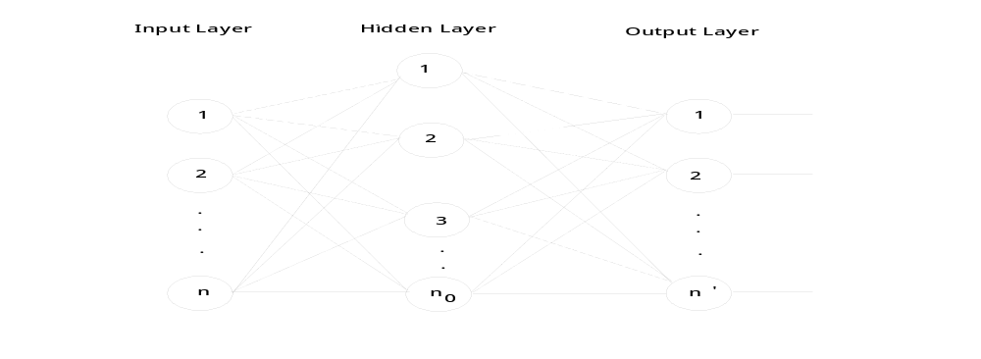
Figure 2.2. A typical neural network.

TABLE 9.12. Comparison Of Various Data Structures.
Operation | Sequential List | Linked List | AVL-Tree
Search | O(log n) | O(n) | O(log n)
Delete | O(n) | O(1) | O(log n)
Insert | O(n) | O(1) | O(log n)

9. Footnotes, Specially Designated Expressions and Paragraphs
a. Footnotes (Footnotes should be used only if absolutely necessary): Footnote references shall be indicated in the text by an Arabic number placed superior to the of the text and immediately following the word phrase or sentence which the footnote concerns.
Footnotes shall be sequential for each page and for the entire report.
Footnotes shall be placed at the bottom of the page on which they are indicated. They shall be indented from the margin line of the text by eight spaces and placed under a broken line made of 15 dashes.
Footnotes shall be single spaced typing.
b. Specially Designated Expressions: Specially designated expressions usually mean equations, formulas, etc.
Specially designated expressions shall be centered on the page according to instruction number 6 and shall be set below the preceding text and before the succeeding text by three line spaces.
The expressions shall be identified by an Arabic number in parenthesis placed opposite the expression and in line with the right margin of the text. They should be numbered in each chapter in the order of their appearance together with the chapter number, e.g. (6.14). The expression in the body of the report can be referred to (6.14).
Avoid to start a sentence in the text with the expression number. This can be avoided by using changing the voice.
10. Pagination and Paragraphs: Each page in the report or dissertation is expected to bear a number. Only one side of the paper may be used. The following plan should be used exclusively:
a. The preliminary section, including the title page; copyright page, if any; foreword, preface, or acknowledgements; table of contents; etc., should be numbered, using lower case Roman Numerals, e.g., i, ii, iii, etc. The title page counts as Page i, but the number does not appear. The sequence of the preliminary section is as follows:
Title Page ........................................................ Page i - number does not appear
Abstract ........................................................... Page ii
Table of Contents ........................................... Page iii
For the remainder of the report, Arabic numbers are used. Each page must be numbered. Page numbers are to be placed 2 centimeters from the top and right hand margins on the pages. All pages for illustrations, tables, appendices, bibliography, etc are included. Use of suffixes, such as 25a, 25b ... are not allowed. The numbering in the main body should begin with Page 1 and run consecutively to the last page. No punctuation, such as dash or a period, should accompany the page number.
b. Paragraphs: Paragraph indentations must be uniformly eight letter spaces long. Series of paragraph items which are to be listed without headings under any of the regular headings may, for clarity be designated as follows: (A), (B), (C), No period is necessary between the parenthesis and the first sentence. Series of items listed in the interior of a paragraph may be designated as follows: (a), (b), (c). A period must not follow the parenthesis. Each item must begin with a lower case letter and must end with a semi-colon, unless it is a complete sentence. A new paragraph must not begin at the bottom of a page if there is not sufficient space for at least two lines.
11. Size of Interim Report: There is no limit on the number of pages to be used in the report. But it should be complete in all respect. However it is expected that the number of pages in the report will not exceed 40 pages of typed matter reckoned from the First page of Chapter 1 to the last page of the Appendix.
12. Spiral Specifications: Beside the personal copies, one copy of the Interim report for evaluation should be in light Blue color .

The following Titles & Sub-titles in the table of contents (attached along) can be omitted
- Certificate
- Acknowledgement
- 2.1.3 ; 2.14; 2.24
- 3.4.2; 3.5.3; 3.5.4
- 3.7.2; 3.7.3; 3.7.4
- 4
- 5

