TrustFund
Design Document
C-DAC, Bangalore
Version 1.0
July 1, 2026
Prepared By
TrustFund Project Team
Project: Secure milestone-based crowdfunding platform
Stack: React, Spring Boot, PostgreSQL, JWT, Bootstrap

Document Status: Draft for design review

Document Control
Field | Value
Project | TrustFund
Document | Software Design Document
Version | 1.0
Date | July 1, 2026
Prepared for | C-DAC, Bangalore
Prepared by | TrustFund Project Team

Revision History
Version | Date | Description
1.0 | July 1, 2026 | Initial design document prepared from project implementation and template.

Contents
1. Introduction
2. Acronyms, Terms and Definitions
3. Assumptions and Constraints
4. Basic Design Approach
5. Risks
6. System Overview
7. Architecture Design
8. Data Design
9. Component Design
10. Interface Design
11. Specific Design Considerations
12. Design Test
13. Cross Reference with System Requirement Specification
Appendix A. API Catalogue
Appendix B. Deployment and Configuration

1. Introduction
TrustFund is a secure milestone-based crowdfunding platform. The application allows creators to publish campaigns, donors to contribute funds, and administrators to approve campaigns, verify milestone proof, monitor risk, and release funds from escrow. The design emphasizes traceable fund movement, role-based access control, fraud monitoring, and operational dashboards.

1.1 Purpose
The purpose of this document is to provide the software design for TrustFund. It explains the architecture, component responsibilities, database structure, API design, user interface design, deployment view, risks, and design-level testing strategy needed by development and testing teams.

1.2 Scope
This document covers the current TrustFund implementation: React/Vite frontend, Spring Boot REST backend, PostgreSQL database, Flyway migrations, JWT authentication, role-based dashboards, campaign approval, donations, escrow, milestone proof, fund release, complaints, notifications, and fraud alerts. External payment processing is represented by a local mock payment service and can be replaced by a payment gateway integration.

1.3 Intended Audience
- Developers implementing or maintaining frontend and backend modules.
- Testers preparing functional, API, security, and regression test cases.
- Reviewers validating architecture, data flow, security controls, and deployment readiness.
- Project evaluators who need a complete technical view of the system.

1.4 References
- Functional Requirement Specification for TrustFund.
- Project README and TrustFund Project Guide.
- Spring Boot, Spring Security, React, Vite, PostgreSQL, Flyway, and Swagger/OpenAPI documentation.
- Source code under backend/src/main/java/com/trustfund and frontend/src.

2. Acronyms, Terms and Definitions
Term | Definition
FRS | Functional Requirements Specification.
JWT | JSON Web Token used for stateless API authentication.
Escrow | Locked campaign funds that are released only after milestone verification.
Creator | Registered user who creates campaigns and submits milestone proof.
Donor | Registered user who contributes money to approved campaigns.
Admin | User role that approves campaigns, verifies milestones, manages users, resolves complaints, and monitors fraud alerts.
DTO | Data Transfer Object used for API request and response payloads.
Flyway | Database migration tool that creates and evolves PostgreSQL schema.
Swagger UI | Interactive API documentation exposed by the backend.

3. Assumptions and Constraints

3.1 Assumptions
- Users have role-specific accounts: DONOR, CREATOR, or ADMIN.
- Campaigns must be approved before active fundraising.
- Funds are not released directly after donation; release depends on milestone verification.
- Email delivery depends on SMTP configuration and can be disabled for local runs.
- The local mock payment mode auto-succeeds payments for development and demonstration.

3.2 Constraints
- Backend must run on port 8080 for the current frontend configuration.
- Frontend development server runs on port 5173.
- PostgreSQL runs as a locally installed service on localhost:5432 for development.
- JWT secret and SMTP credentials must be supplied through environment configuration and must not be committed.
- The sandbox implementation is suitable for limited concurrent project demonstration loads; production scaling, monitoring, and payment gateway hardening remain future work.

4. Basic Design Approach
TrustFund follows a layered API-based design. The frontend is a React single-page application that communicates with REST endpoints through Axios services. The backend separates HTTP controllers, business services, repositories, DTOs, security filters, and exception handling. Data persistence is handled by PostgreSQL with Flyway migrations.
Layer | Design Responsibility | Representative Files
Presentation | Route users to public pages, dashboards, forms, campaign details, and admin screens. | frontend/src/pages, frontend/src/routes/AppRoutes.jsx
API Client | Centralized Axios base URL, JWT header injection, and API-specific service modules. | frontend/src/services/api.js, *Service.js
REST Controllers | Expose typed endpoints and enforce method-level roles. | backend/src/main/java/com/trustfund/controller
Business Services | Implement campaign, donation, escrow, fraud, complaint, notification, and auth rules. | backend/src/main/java/com/trustfund/service
Persistence | Map entities to PostgreSQL tables and query data through repositories. | backend/src/main/java/com/trustfund/model/entity, repository
Security | Authenticate using JWT, BCrypt, stateless sessions, CORS, and role guards. | SecurityConfig.java, JwtAuthFilter.java, JwtService.java

5. Risks
Risk | Impact | Mitigation
Personal data exposure | User emails, roles, and account status must be protected. | JWT authentication, role checks, password hashing, limited DTO exposure, and no credential documentation.
Unauthorized fund release | Funds could be released without valid proof. | Admin-only milestone verification and release endpoints, audit logging, and escrow balance tracking.
Fraudulent campaigns | Donors may fund suspicious campaigns. | Admin approval queue, risk alerts, complaint workflow, and verification documents.
Token misuse | Stolen or stale tokens may access protected APIs. | Short-lived access tokens, refresh tokens, JWT validation, logout cleanup, and active-user checks.
SMTP or payment dependency failure | Notifications or payment confirmation can fail. | Feature flags/mock payment mode, error handling, and replaceable service boundaries.

6. System Overview
The system contains three primary user journeys. Creators submit campaigns and milestone proof. Donors browse approved campaigns and donate. Admins approve campaigns, handle complaints, monitor fraud, verify milestones, release funds, and manage users. Notifications and audit records support transparency across these journeys.
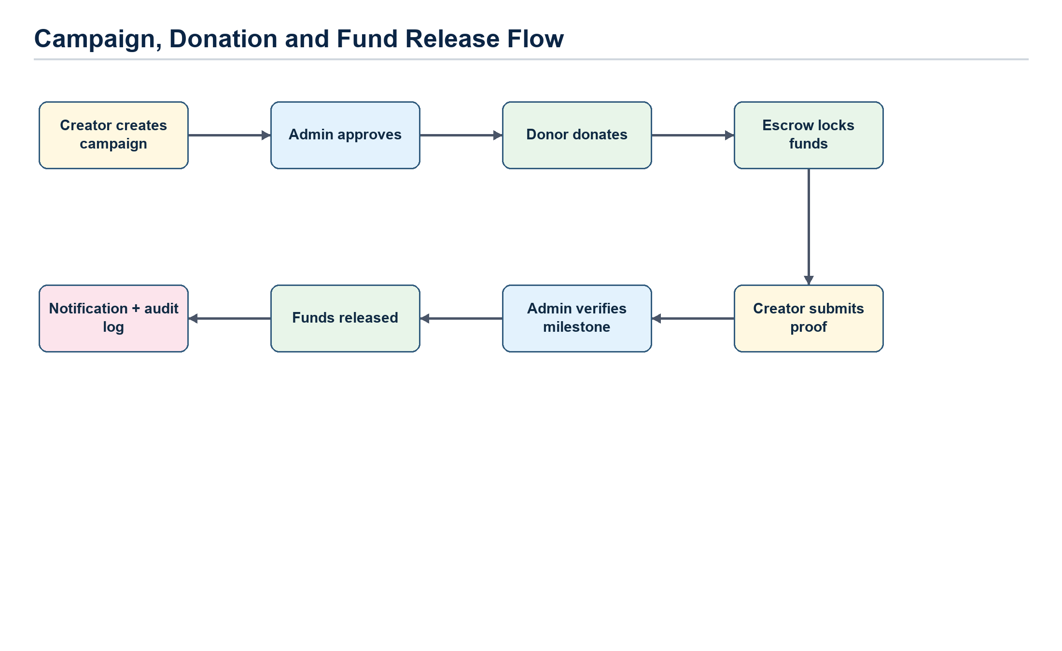
Figure 1: Campaign, donation, escrow and milestone release flow.

6.1 Major Functional Areas
Area | Description
Authentication | Registration, login, refresh token, forgot password, reset password, and route protection.
Campaign Management | Creator campaign creation, public campaign listing, creator campaign ownership, admin approval/rejection/archive/restart/delete.
Donations and Escrow | Donor donation creation, payment status, wallet locking, campaign raised amount updates, and donor history.
Milestones | Creator proof submission, admin verification, and admin fund release.
Complaints and Fraud | User complaints, admin resolution, and fraud alert monitoring.
Notifications | In-app notification list, mark-read actions, and optional email delivery.
Dashboards | Public, donor, creator, admin, and escrow views for operational summaries.

7. Architecture Design
The architecture is a web-based three-tier design with frontend, backend, and database layers. The backend also integrates supporting services for security, notifications, audit, fraud, and escrow.
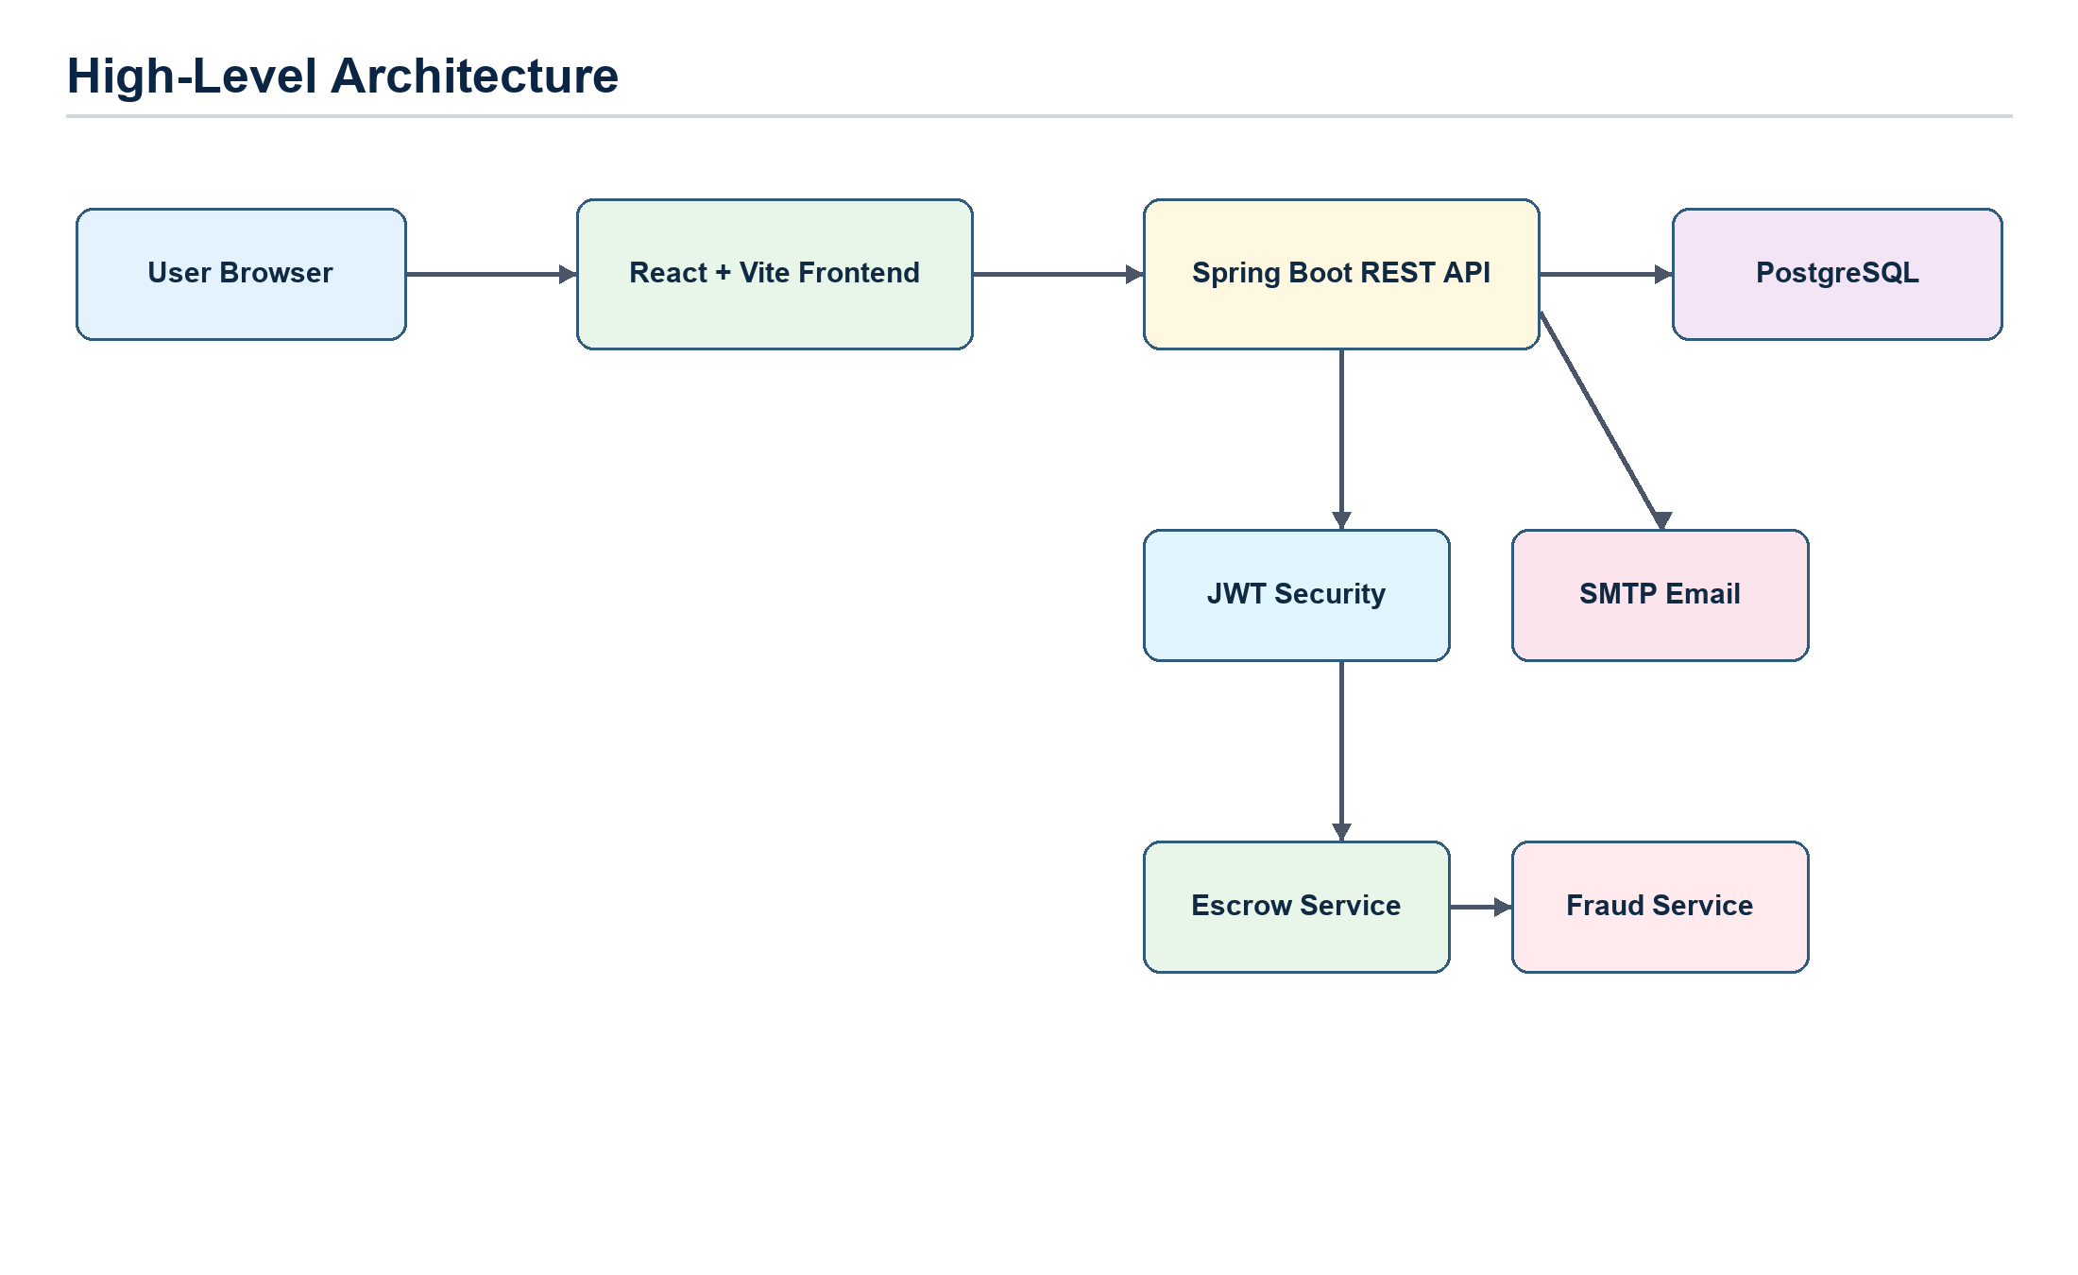
Figure 2: High-level architecture diagram.

7.1 Deployment View
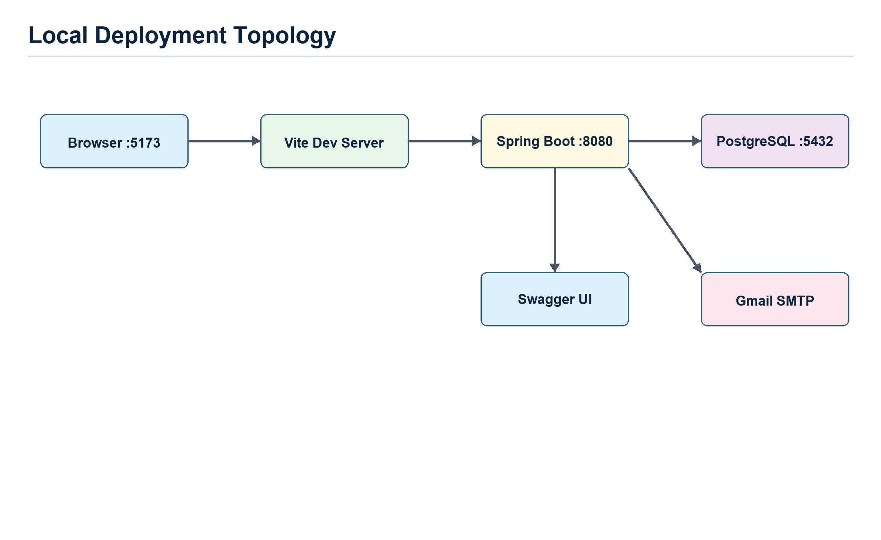
Figure 3: Local deployment topology.

7.2 Security Architecture
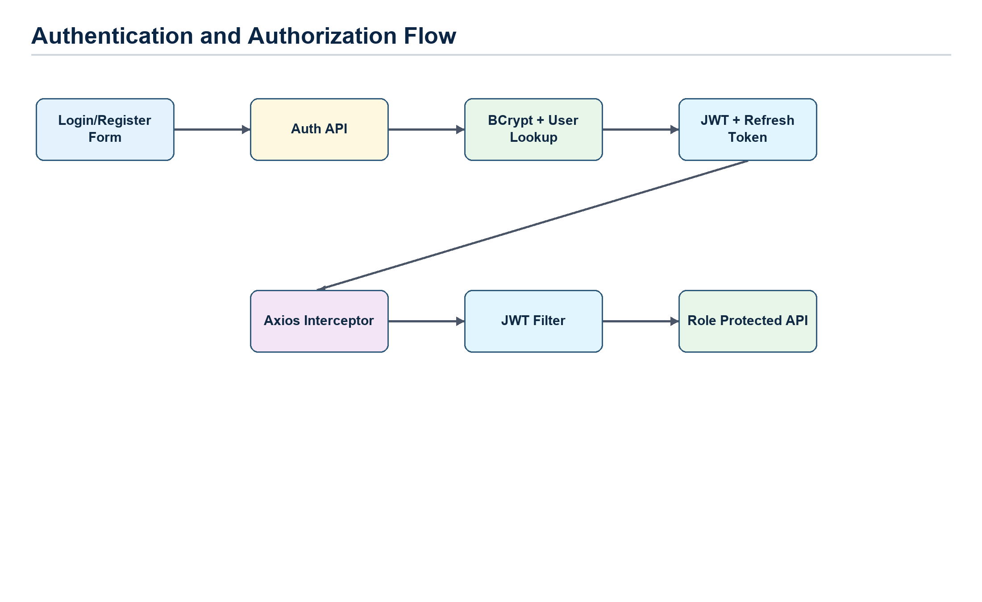
Figure 4: JWT authentication and authorization flow.
- Public endpoints include authentication, campaign browsing, public dashboard data, Swagger UI, and donation webhooks.
- Protected endpoints require a Bearer token supplied by the frontend Axios interceptor.
- Role-based controls use Spring Security method authorization such as hasRole('ADMIN'), hasRole('CREATOR'), and hasRole('DONOR').
- Passwords are hashed using BCrypt with strength 12.

8. Data Design
TrustFund stores data in PostgreSQL. Flyway migrations define schema creation and incremental table changes. UUID primary keys are used across major tables. Monetary values use DECIMAL(14,2). Enum values are stored as strings for readability and compatibility.
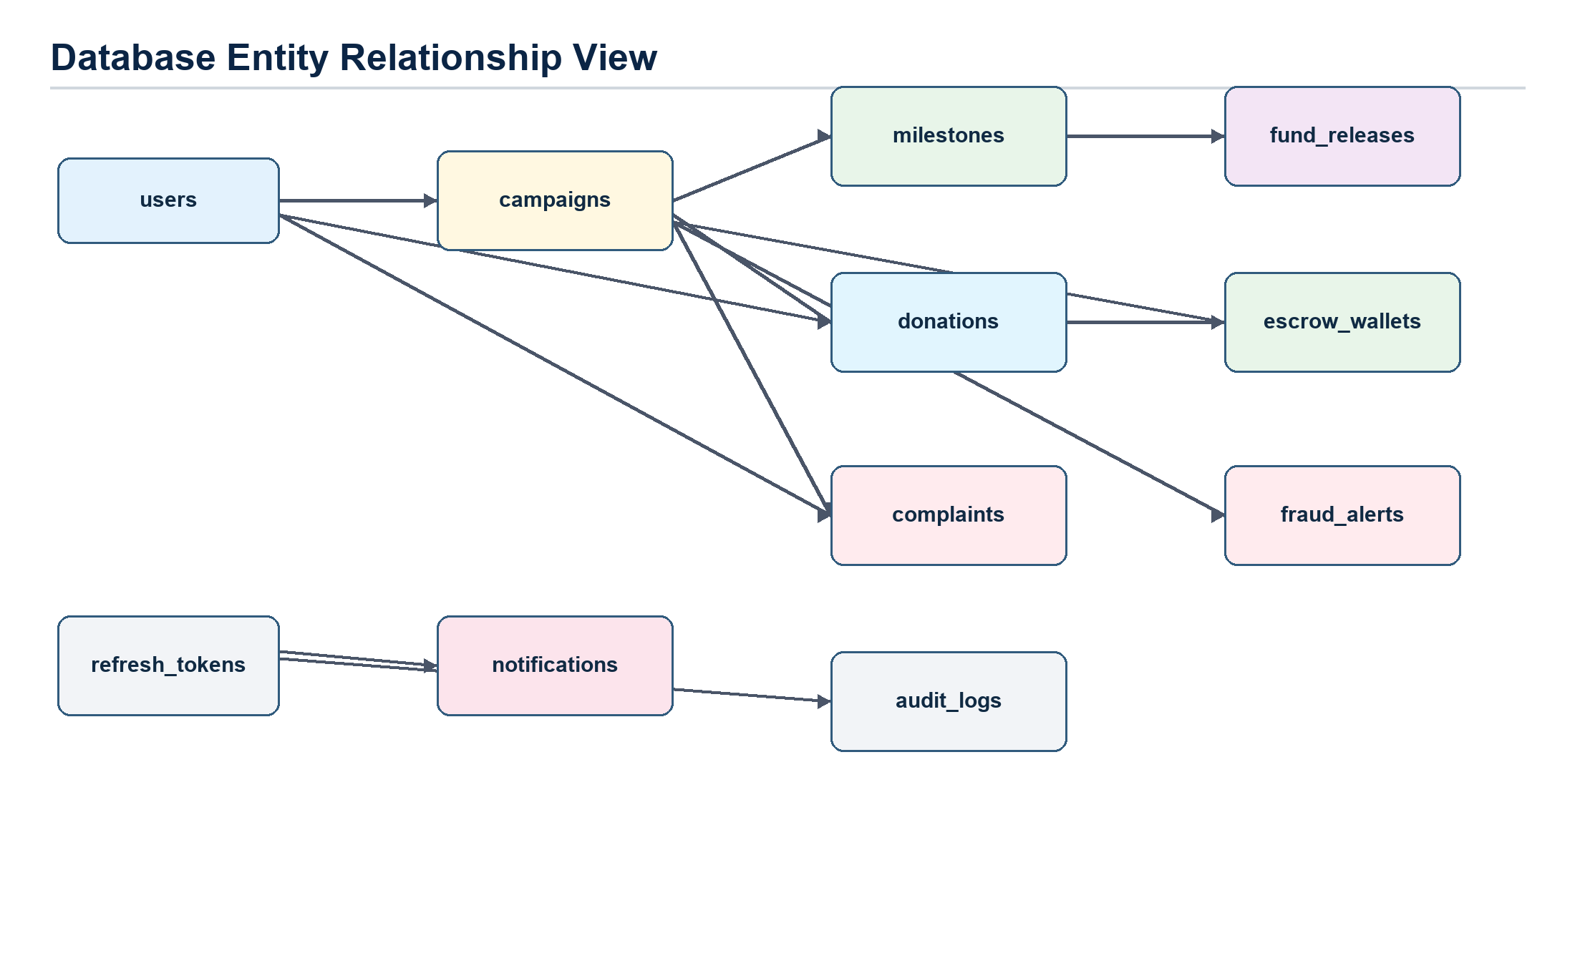
Figure 5: Database ER diagram.

8.1 Database Tables
Table | Purpose | Key Relationships
users | Stores account name, email, hashed password, role, active flag, and created date. | Referenced by campaigns, donations, complaints, notifications, refresh_tokens, and audit_logs.
campaigns | Stores campaign title, description, images, verification documents, target, raised amount, status, and creator. | One creator has many campaigns; campaign has milestones, donations, complaints, escrow wallet, and fraud alerts.
milestones | Stores milestone amount, due date, status, proof URL/notes, and ordering. | Belongs to campaign; linked to fund_releases.
escrow_wallets | Tracks balance, locked amount, released amount, and update timestamp per campaign. | One-to-one with campaign.
donations | Stores donation amount, payment method/status/reference, donor, campaign, and donation time. | Belongs to donor and campaign.
fund_releases | Records milestone-level amount release, release status, release time, and releasing admin. | Belongs to milestone and released_by user.
fraud_alerts | Stores risk score, risk level, reason, and creation time. | Belongs to campaign.
complaints | Stores user complaint text, campaign, status, and created date. | Belongs to campaign and user.
notifications | Stores message and read/unread status per user. | Belongs to user.
audit_logs | Stores action, actor, entity type/id, details, and timestamp. | Performed by user; references logical system entities.
refresh_tokens | Stores hashed refresh tokens and expiry for session renewal. | Belongs to user.

8.2 Entity Status Values
Entity | Statuses
Campaign | PENDING, ACTIVE, DONE, REJECTED, PAUSED
Milestone | PENDING, PROOF_SUBMITTED, VERIFIED, RELEASED
Payment | PENDING, SUCCESS, FAIL
Complaint | OPEN, RESOLVED, DISMISSED
Notification | UNREAD, READ
Fund Release | PENDING, RELEASED
Risk Level | LOW, MEDIUM, HIGH

9. Component Design
Components are grouped by responsibility. Controllers handle HTTP concerns, services enforce business rules, repositories persist data, DTOs define API payloads, and frontend service modules bind screens to backend APIs.
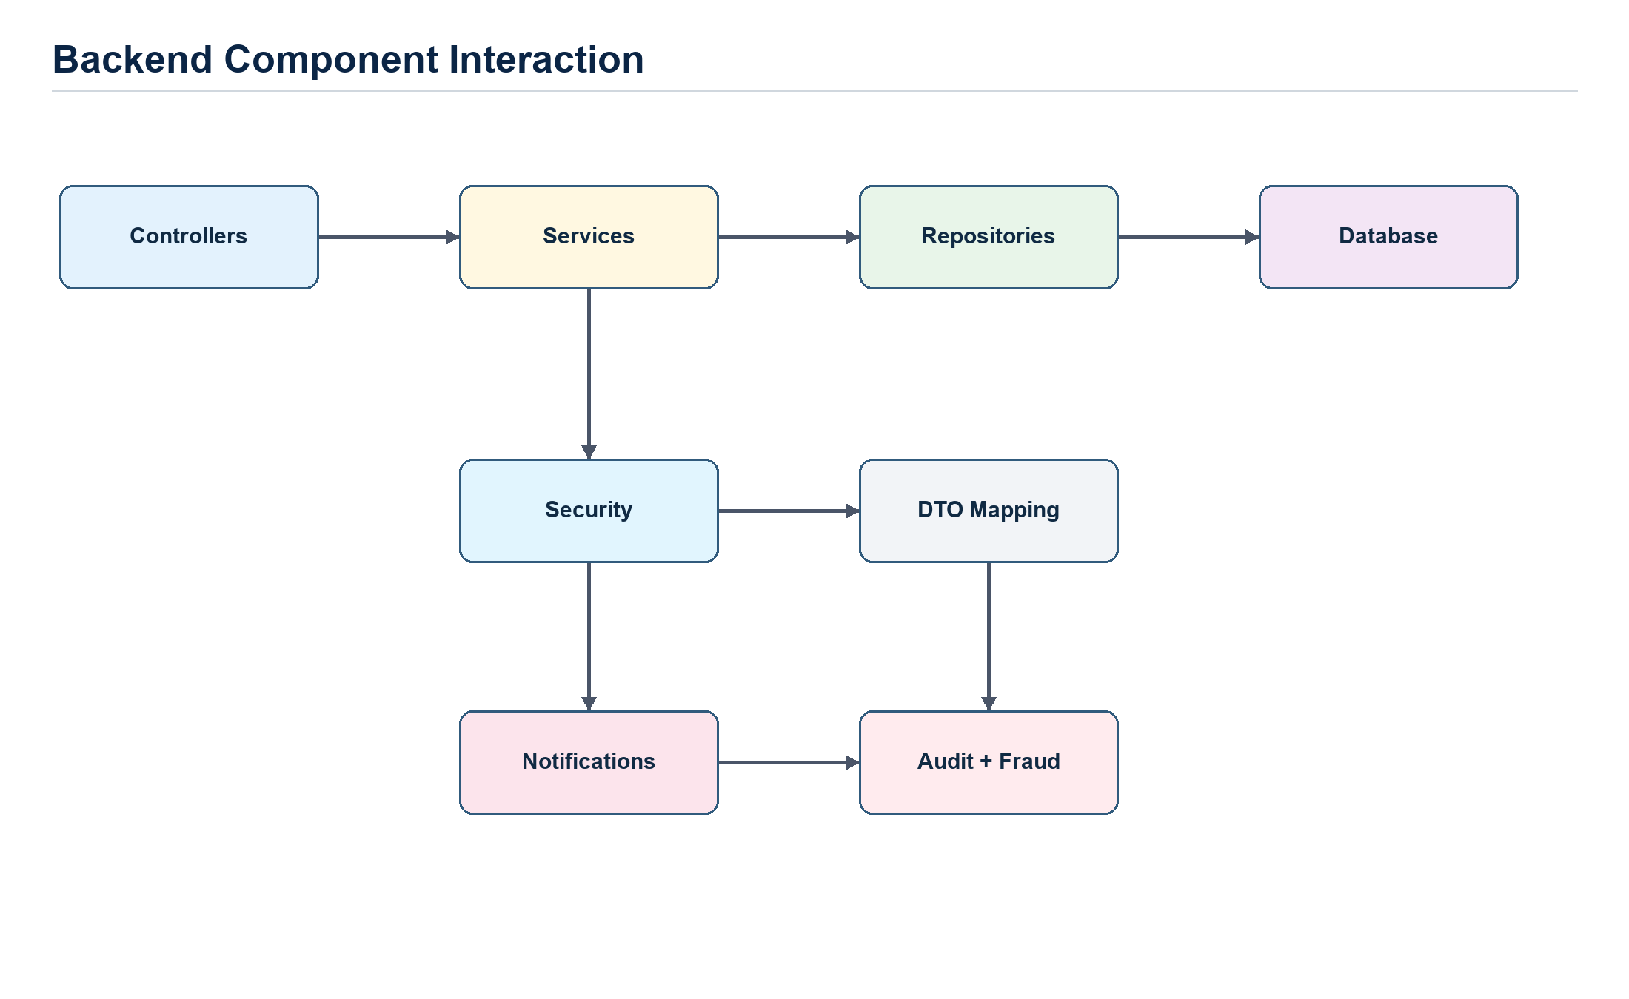
Figure 6: Backend component interaction diagram.

9.1 Backend Components
Component | Responsibilities | Important APIs
Auth | Register, login, refresh, forgot password, reset password, token generation and validation. | POST /api/auth/register, /login, /refresh, /forgot-password, /reset-password
Campaign | Create, list, view, approve, reject, archive, restart, delete campaigns; create escrow wallet and milestones. | POST/GET /api/campaigns, GET /my, PUT /{id}/approve, /reject, /archive, /restart, DELETE /{id}
Donation | Create donor donation, update payment status, update campaign raised amount, lock funds in escrow. | POST /api/donations, GET /my, POST /webhook
Milestone | Submit proof, verify milestone, release funds, map milestone responses. | POST /api/milestones/{id}/proof, PUT /verify, PUT /release
Complaint | Create complaint, list all/my complaints, resolve complaint, notify users. | POST /api/complaints, GET /api/complaints, GET /my, PUT /{id}/resolve
Fraud | Create and list risk alerts using campaign/donation/complaint signals. | GET /api/fraud/alerts
Notification | Persist notifications, expose read/unread operations, send email when enabled. | GET /api/notifications, PUT /{id}/read, PUT /read-all
Admin Users | Create users/admins, activate, deactivate, delete with main-admin restrictions. | POST /api/admin/users, PUT /deactivate, PUT /activate, DELETE /{id}
Dashboard | Aggregate public, donor, admin, and escrow metrics. | GET /api/dashboard/public, /donor, /admin, /escrow

9.2 Frontend Components
UI Module | Design Role
PublicLayout and LandingPage | Public landing experience and entry into login/register/campaign browsing.
DashboardLayout | Authenticated shell for role-based navigation and common dashboard pages.
Auth pages | Login, register, forgot password, and reset password forms.
Campaign pages | Campaign listing, campaign details, creator campaign management.
Dashboard pages | Donor, creator, and admin summary views with charts/cards.
Admin pages | User management, fraud monitoring, complaints, escrow, milestone review.
Common components | Data table, modal, confirmation dialog, stat card, loading states, pagination, toast notifications.
Domain components | Campaign card, donation card, milestone card, fund release card, fraud alert card, notification card.

9.3 Key Activity Flow
- Creator registers and logs in.
- Creator creates a campaign with target amount, description, milestones, image URL, and verification document data.
- Admin reviews and approves or rejects the campaign.
- Donor browses active campaigns and submits donation.
- Payment service marks payment successful in local mock mode.
- Escrow service locks donated funds for the campaign.
- Creator submits proof for a milestone.
- Admin verifies proof and releases funds.
- Notification and audit services record important state changes.

10. Interface Design
The user interface is a responsive React single-page application. Bootstrap supplies base layout and form styles, while custom theme styles provide dashboard cards, glass effects, charts, hover states, sidebar layout, and responsive refinements.

10.1 Route and Screen Map
Route | Access | Screen Purpose
/ | Public | Landing page and project introduction.
/login | Public | User login with email/password.
/register | Public | Create donor or creator account.
/forgot-password, /reset-password | Public | Password reset flow.
/app/donor | DONOR | Donor dashboard and contribution overview.
/app/creator | CREATOR | Creator dashboard.
/app/admin | ADMIN | Admin dashboard.
/app/campaigns, /app/campaigns/:id | Authenticated | Campaign browsing and campaign detail view.
/app/my-campaigns | CREATOR | Creator campaign management.
/app/my-donations | DONOR | Donor donation history.
/app/users | ADMIN | Admin user management.
/app/escrow | Authenticated | Escrow wallet tracking.
/app/milestones | CREATOR, ADMIN | Milestone proof and review workflow.
/app/fraud | ADMIN | Fraud alert monitoring.
/app/notifications | Authenticated | Notification inbox.
/app/complaints | Authenticated | Complaint submission and admin resolution.

10.2 API Interface Summary
Module | Endpoints | Access Control
Auth | POST /api/auth/register, /login, /refresh, /forgot-password, /reset-password | Public
Campaigns | POST/GET /api/campaigns; GET /my; GET /{id}; PUT /approve|reject|archive|restart; DELETE /{id} | Public listing/detail; creator/admin protected mutations
Donations | POST /api/donations; GET /my; POST /webhook | Donor protected except webhook
Milestones | POST /{id}/proof; PUT /verify; PUT /release | Creator proof; admin verify/release
Complaints | POST /api/complaints; GET; GET /my; PUT /{id}/resolve | Authenticated create/my; admin list/resolve
Notifications | GET /api/notifications; PUT /{id}/read; PUT /read-all | Authenticated
Dashboards | GET /public, /donor, /admin, /escrow | Public, donor, admin, authenticated/operational
Fraud | GET /api/fraud/alerts | Admin
Admin Users | POST, PUT deactivate/activate, DELETE | Admin with main-admin restrictions for admin management

11. Any Specific Design Considerations
- The API is stateless and uses JWT tokens rather than server sessions.
- Frontend route guards redirect users away from screens outside their roles.
- CORS allows configured origins and exposes the Authorization header.
- Database migrations make schema setup repeatable.
- The payment component is intentionally isolated so a real gateway can replace local mock payment behavior.
- Sensitive configuration such as JWT secret and SMTP credentials must be environment-based.
- Main admin account rules prevent accidental deletion or deactivation of the primary administrator.
- Users with business history such as campaigns, donations, or complaints are deactivated instead of deleted when appropriate.
Production Readiness Note
Before production use, the project should add a real payment gateway, stronger operational monitoring, rate limiting, secret management, backup/restore procedures, HTTPS enforcement, email deliverability checks, and load testing.

12. Design Test
The design test strategy validates module-level behavior, API contracts, role security, data persistence, and key workflow integration. Existing backend smoke tests provide a baseline; additional tests should be added around business rules and negative cases.
Test Area | Design Verification
Authentication | Register/login/refresh/reset flows, BCrypt password validation, invalid token behavior, deactivated-user rejection.
Authorization | Role checks for donor, creator, admin, main-admin-only actions, and route-guard behavior.
Campaign workflow | Create campaign, approval/rejection, archive/restart/delete, creator ownership rules, public listing filters.
Donation and escrow | Successful donation updates donation, campaign raised amount, and escrow locked balance consistently.
Milestone release | Proof submission, admin verification, fund release, fund release record, escrow released amount, notifications.
Complaints and fraud | Complaint creation/resolution, admin visibility, risk alert creation/listing.
Database | Flyway migration success, table constraints, enum values, indexes, cascade behavior for campaign milestones.
Frontend | Role dashboards, form validation, API errors, loading states, pagination, responsive layouts.

13. Cross Reference with System Requirement Specification
SRS Feature | APIs / Components Developed | Adherence / Limitations
User registration and login | AuthController, AuthService, Login/Register pages | Meets requirement with JWT and refresh tokens.
Role-based dashboards | DashboardController, DonorDashboard, CreatorDashboard, AdminDashboard | Meets requirement for role-specific views.
Campaign creation and approval | CampaignController, CampaignService, MyCampaignsPage, AdminDashboard | Meets requirement; admin review required before active campaign.
Donation processing | DonationController, DonationService, PaymentService | Meets local/demo requirement with mock payment; external gateway integration pending.
Escrow fund holding | EscrowService, EscrowWallet entity, EscrowWalletPage | Meets requirement for locked and released amount tracking.
Milestone proof and release | MilestoneController, MilestoneService, FundRelease entity | Meets requirement with creator proof and admin release.
Fraud monitoring | FraudController, FraudService, FraudAlert entity, FraudMonitoringPage | Meets baseline requirement; advanced risk scoring can be extended.
Complaint management | ComplaintController, ComplaintService, ComplaintsPage | Meets requirement for submission, listing, and resolution.
Notifications | NotificationController, NotificationService, EmailService | Meets in-app notifications; email depends on SMTP settings.
Admin user management | AdminUserController, AdminUsersPage | Meets requirement with main-admin safeguards.

Appendix A. API Catalogue
Controller | Base Route | Primary Operations
AuthController | /api/auth | register, login, refresh, forgot-password, reset-password
CampaignController | /api/campaigns | create, list, my, detail, approve, reject, archive, restart, delete
DonationController | /api/donations | create, my donations, webhook
MilestoneController | /api/milestones | proof, verify, release
ComplaintController | /api/complaints | create, list, my, resolve
NotificationController | /api/notifications | list, mark read, mark all read
DashboardController | /api/dashboard | public, donor, admin, escrow
FraudController | /api/fraud | alerts
AdminUserController | /api/admin/users | create, deactivate, activate, delete

Appendix B. Deployment and Configuration
Item | Local Value / Design Note
Frontend | Vite development server at http://localhost:5173
Backend | Spring Boot server at http://localhost:8080
Swagger UI | http://localhost:8080/swagger-ui.html
Database | Local PostgreSQL service at localhost:5432, database trustfund
Default Admin | trustfund.notification@gmail.com / Admin@123456
JWT Secret | Configured through JWT_SECRET or trustfund.jwt.secret; not hard-coded for production.
SMTP | Configured through SMTP_HOST, SMTP_PORT, SMTP_USERNAME, SMTP_PASSWORD, MAIL_SENDER_NAME, MAIL_ENABLED.
Payment | trustfund.payment.mock-enabled=true for local development; disable when real gateway is integrated.

