📊 Aadhaar Data Analysis Report

Unlocking Societal Trends in Aadhaar Enrolment and Updates

1. Introduction
Aadhaar is India’s foundational digital identity system, supporting access to government services and digital inclusion. While Aadhaar enrolment has achieved near-universal coverage, the system continues to experience significant operational demand through biometric and demographic updates.
This study aims to identify meaningful patterns, trends, and relationships in Aadhaar enrolment and update data using anonymised datasets provided by UIDAI. The insights derived from this analysis are intended to support informed administrative decision-making, operational optimisation, and targeted interventions.

2. Datasets Used
The analysis uses three anonymised, aggregated datasets provided by UIDAI:

2.1 Aadhaar Enrolment Dataset
Columns used:
- date
- state
- district
- pincode
- age_0_5
- age_5_17
- age_18_greater
Purpose:
To study enrolment patterns, age-wise distribution, and identify low-enrolment (underserved) regions.

2.2 Aadhaar Biometric Update Dataset
Columns used:
- date
- state
- district
- pincode
- bio_age_5_17
- bio_age_17_
Purpose:
To analyse biometric revalidation demand and age-driven update patterns.

2.3 Aadhaar Demographic Update Dataset
Columns used:
- date
- state
- district
- pincode
- demo_age_5_17
- demo_age_17_
Purpose:
To understand demographic update behaviour driven by migration, correction, and mobility.

3. Methodology
3.1 Data Preprocessing
- All datasets were loaded using Python (pandas).
- The date column was converted to datetime format.
- Aggregations were performed at district and state levels.
- No personally identifiable information was used.
3.2 Analytical Approach
- Descriptive analysis for understanding overall data composition.
- Trend analysis to capture temporal behaviour.
- Comparative analysis across age groups, districts, and states.
- Bivariate analysis to identify relationships between enrolment and updates.
- Index-based analysis to measure operational pressure.

4. Descriptive Overview of Aadhaar Activity
4.1 Overall Aadhaar Activity Composition
The pie chart titled “Overall Aadhaar Activity Composition” shows the percentage contribution of enrolment, biometric updates, and demographic updates.
Key Findings:
- Biometric Updates: ~56%
- Demographic Updates: ~39.6%
- Enrolment: ~4.4%
Insight:
More than 95% of Aadhaar activity is update-driven, indicating that the Aadhaar ecosystem has transitioned from an enrolment-centric phase to a maintenance-centric system.
This highlights the need to prioritise update infrastructure and operational capacity over enrolment expansion.
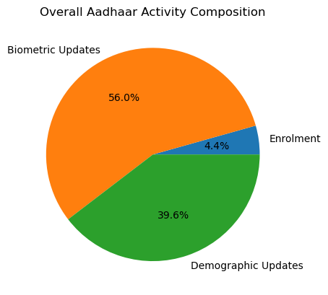

5. Temporal Trend Analysis
5.1 Biometric Updates Over Time (Age-wise)
- Adult population (17+) consistently dominates biometric updates.
- Sharp peaks followed by steep declines indicate batch-driven revalidation cycles.
- Child biometric updates remain comparatively low.
Insight:
Biometric maintenance demand is highly time-dependent and adult-driven.
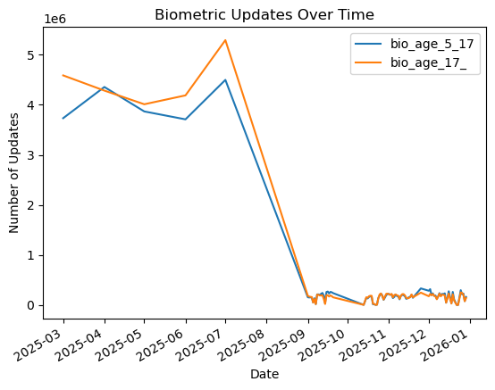

5.2 Demographic Updates Over Time (Age-wise)
- Large initial spikes followed by stabilisation.
- Adult demographic updates far exceed child updates.
- Reflects migration, address changes, and mobile number corrections.
Insight:
Demographic update behaviour is influenced by socio-economic mobility rather than continuous demand.
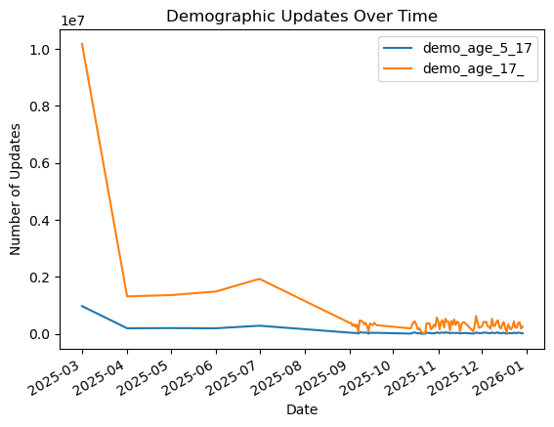

5.3 Aadhaar Enrolment Over Time (Age-wise)
- Enrolment activity is dominated by children (0–5 and 5–17).
- Adult enrolment is minimal.
- Confirms adult enrolment saturation.
Insight:
Aadhaar enrolment is now primarily driven by early-life registration rather than adult onboarding.
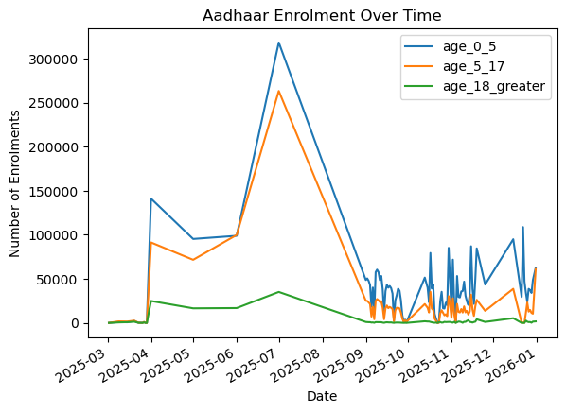

6. District-Level Analysis
6.1 Top Districts by Biometric Updates (Age-wise)
- Urban and semi-urban districts dominate biometric updates.
- Adult updates form the majority of the load.
Insight:
High biometric activity is concentrated in population-dense and service-accessible districts.
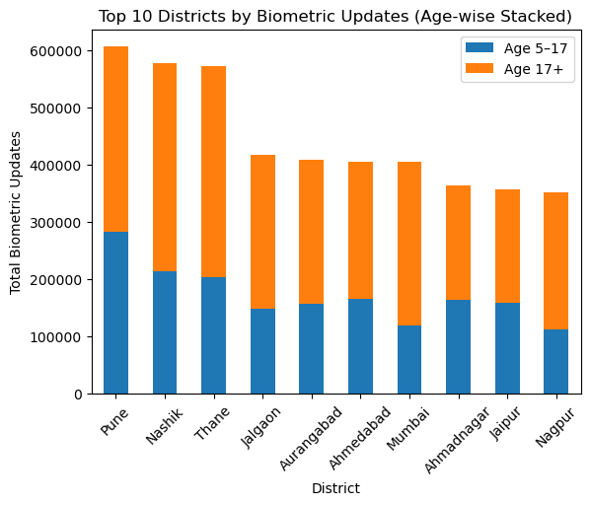

6.2 Top Districts by Demographic Updates (Age-wise)
- Demographic updates are heavily adult-driven.
- Concentrated in migration-prone districts.
Insight:
Demographic update hotspots indicate regions with high population mobility.
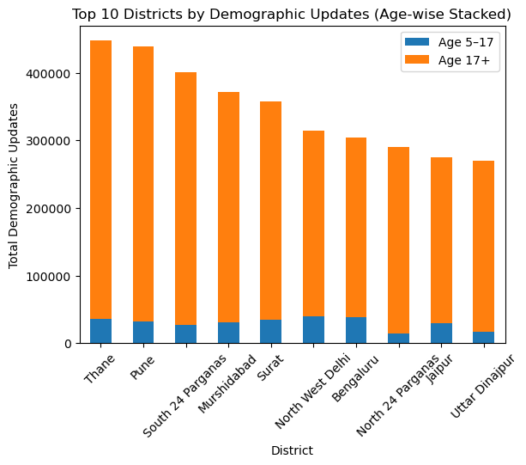

6.3 Low-Enrolment Districts (Age-wise)
- Several districts show low enrolment across all age groups.
- Indicates underserved or hard-to-reach regions.
Insight:
These districts require targeted enrolment drives and mobile enrolment units.
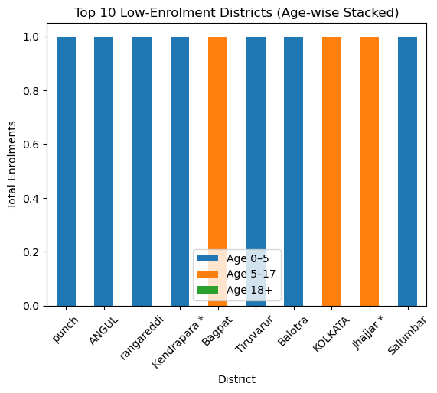

7. State-Level Relationship Analysis
7.1 Enrolment vs Biometric Updates
- Strong positive correlation.
- Higher enrolment states experience higher biometric maintenance.
Insight:
Operational demand continues even after enrolment saturation.
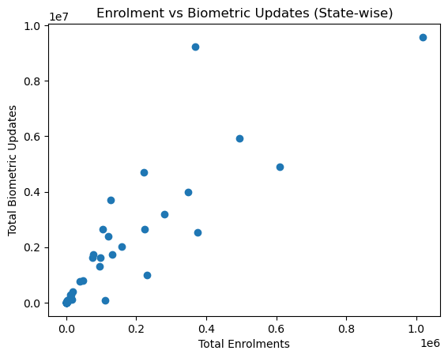

7.2 Enrolment vs Demographic Updates
- Higher enrolment correlates with higher demographic churn.
- Greater variability compared to biometric updates.
Insight:
Demographic updates reflect mobility patterns rather than system-driven cycles.
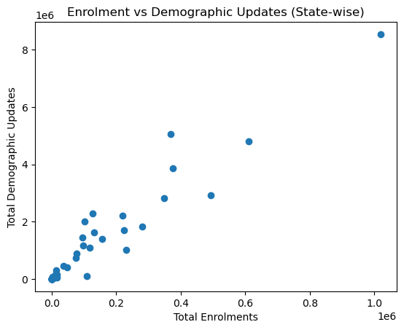

7.3 Biometric vs Demographic Updates
- Strong linear relationship.
- States with high biometric updates also show high demographic updates.
Insight:
These states represent Aadhaar service hotspots.
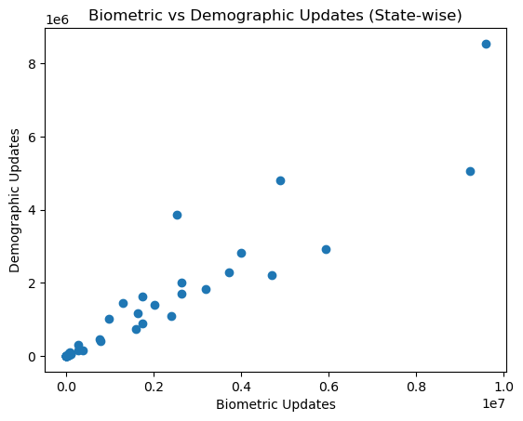

8. Aadhaar Update Intensity Index
Definition:
Update Intensity = (Biometric Updates + Demographic Updates)
Total Enrolments
Findings:
- Smaller states and UTs show disproportionately high update intensity.
- High maintenance load relative to enrolment size.
Insight:
Update intensity is a stronger indicator of operational pressure than population size.
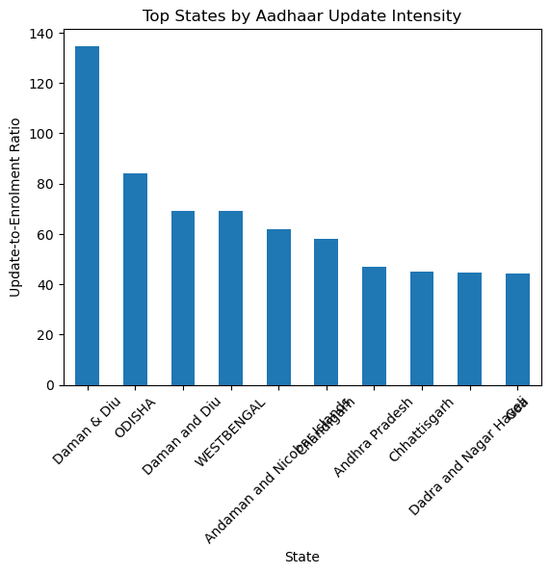

9. Age-wise Percentage Contribution to Biometric Updates
- Adult population dominates biometric updates across all states.
- Child contribution remains consistently low.
Insight:
Biometric maintenance is overwhelmingly adult-centric.
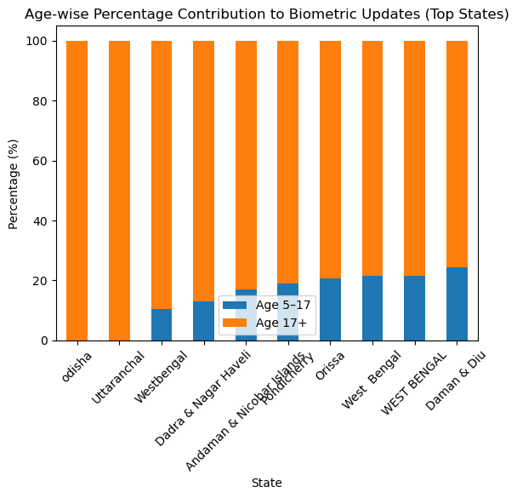

10. Child Enrolment vs Child Biometric Updates
- Positive relationship with significant dispersion.
- Some states show high enrolment but low biometric updates.
Insight:
Indicates delayed or missed biometric refresh cycles among children.
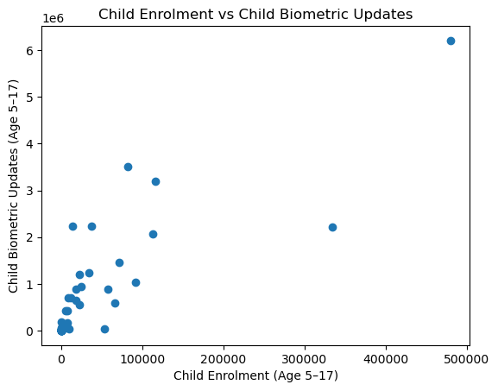

11. Biometric vs Demographic Update Composition
- States differ in update composition:
  - Some are biometric-heavy
  - Others demographic-heavy
Insight:
Different states require customised service strategies, not uniform policies.
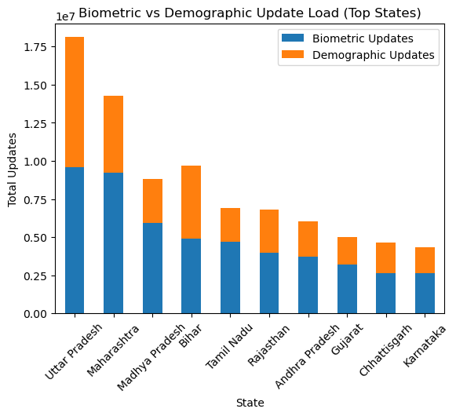

12. Key Insights Summary
- Aadhaar has matured into a maintenance-driven ecosystem.
- Adults dominate biometric and demographic updates.
- Child enrolment is strong, but child biometric refresh lags in some regions.
- Operational pressure varies significantly across states and districts.
- Update Intensity Index effectively identifies maintenance-heavy regions.

13. Impact and Applicability
Administrative Impact
- Supports data-driven resource allocation
- Enables capacity planning for update services
- Helps prioritise underserved districts
Societal Impact
- Improved service delivery
- Reduced wait times
- Better inclusion for children and mobile populations

14. Conclusion
This analysis demonstrates that Aadhaar has transitioned from expansion to maintenance. While enrolment has largely saturated, biometric and demographic updates continue to generate substantial operational demand. Data-driven insights from enrolment and update patterns can directly support UIDAI in optimising service delivery, improving inclusion, and planning future interventions.

15. Future Scope
- Predictive modelling of update demand
- District-level saturation forecasting
- GIS-based spatial visualisation
- Seasonal trend analysis

