

**School of Computing and Information Technology**

|  |  |  |  |  |  |  |  |  |
| --- | --- | --- | --- | --- | --- | --- | --- | --- |
| **Course Code:** BTEC---- | | | **Min-Project work Synopsis** | | | **Year: 2022-2023** | | |
| **Sem: 6th & 7th  (ie.) Phase-I & II** | | |
| **Project Group Members Details** | | | | | | | | |
| **Group No:** | | **Group Name :** | | | | | | |
| **Sl. No** | **SRN** | **Full Name** | | **Sec** | **Mobile No.** | **Email_ID** | | **Sign** |
| **1** | R20EQ018 | Nishant Rawat | | A | 6360932997 | r20201463.Nishant@cit.reva.edu.in | |  |
| **2** | R20EQ008 | Dhruthi HS | | A | 9740145322 | 20010315465.DHRUTHIH@cit.reva.edu.in | |  |
| **3** | R20EQ007 | Sindhuja Chowdary | | A | 8792670349 | 20010315490.DASARISINDHUJA@cit.reva.edu.in | |  |
| **4** | R20EQ039 | Vishal Yogesh Rao | | A | 9901307415 | 20010317588.VISHALYOGISH@cit.reva.edu.in | |  |
| **Project Details** | | | | | | | | |
| **Project Title:** | | **Online proctoring system** | | | | | | |
| **Guide Details:** | | **Name:Dr. Sandhya G**  **Designation: Professor** | | | | | **Mobile No:9448954475** | |
| **Place of Project Work:** | | **REVA University** | | | | | | |
| **External Guide :** | | **Name:**  **Designation:** | | | | | **Mobile No:** | |
| **Remarks by Guide:** | | | | | | | **Guide Signature**  **Date:** | |

**Abstract**

* An online proctoring system ensures the integrity and security of online exams.
* It uses a combination of software and hardware to monitor the behavior of students during the exam.
* The system captures and records the student's exam-taking environment, including their desktop activities, webcam feed, and audio feed.
* The system employs different monitoring modes, including live proctoring, automated proctoring, or a hybrid of both, to monitor and assess the student's behavior in real-time.
* Live proctoring involves a human proctor monitoring the student's activities throughout the exam.
* Automated proctoring uses artificial intelligence algorithms to detect and flag any suspicious behavior, such as plagiarism or cheating.
* Online proctoring systems come with a range of features, including facial recognition, keystroke analysis, browser lockdown, and lockdown browser, among others.
* These features help to prevent cheating and ensure that the exam is conducted in a fair and secure manner.
* Online proctoring systems are essential tools for conducting online exams, especially in the era of remote learning, where online exams are becoming increasingly popular.

**Introduction**

- Online proctoring is a technology-driven solution designed to ensure the integrity and security of online exams.

- With the growing popularity of online learning and remote education, the need for secure online testing has become increasingly important.

- Online proctoring systems use a combination of software and hardware to monitor and record the behavior of students during an online exam.

- The system captures and records various aspects of the student's exam-taking environment, including their desktop activities, webcam feed, and audio feed.

- Online proctoring systems offer different modes of monitoring, such as live proctoring, automated proctoring, or a hybrid of both.

- Live proctoring involves a human proctor who monitors the student's activities in real-time, while automated proctoring uses AI algorithms to detect and flag suspicious behavior.

- Online proctoring systems typically offer features such as facial recognition, keystroke analysis, browser lockdown, and lockdown browser to ensure a secure and fair testing environment.

- Online proctoring is an essential tool for conducting secure and reliable online exams and helps to prevent cheating and ensure the validity of the exam results.

**Literature Survey**

PAPER 1

Title: online exam proctoring system

Authors: Yelkar Anjali & pawar reena vishwas

Year: 2022

Description: They explored several recent works and articles and a comparison between generic application development and immersive technology-based application is included. They discussed about more practical approaches that can be taken to enhance the effectiveness of the application.

PAPER 2

Title: a systematic review on AI based proctoring system past,present and future

Authors: Aditya Nigam & Rithwik Pasrichsa

Year: 2021

Description: There have been giant leaps in the feld of education in the past 1–2 years.. Schools

and colleges are transitioning online to provide more resources to their students. The

COVID-19 pandemic has provided students more opportunities to learn and improve

themselves at their own pace. Online proctoring services (part of assessment) are

also on the rise, and AI-based proctoring systems (henceforth called as AIPS) have

taken the market by storm

PAPER 3

Title: AI based proctoring system for online tests

Authors: Vandana & Hema GA

Year: 2022

Description: In this project we are going to perform the following in online examination:

1. Candidate verification and attendance management.

2. Detection of mobile phones nearby to the student and take necessary actions.

3. Perform voice recognition during the online exam to detect malpractice.

4. In online exam, the system will provide a single portal for logging in, accessing

question paper, chat window to communicate with examiner and to upload answer

sheet using the scanner which is embedded in the portal.

5. Avoiding candidate from opening/accessing any other application during the online

exam in the desktop or mobile.

PAPER 4

Title: On the efficacy of online proctoring system

Authors: Laura & Arend

Year: 2021

Description: Besides the analysis results provided by Proctorio, we

collected several other types of data.

First of all, the 30 gradebooks were reviewed by

six reviewers (each gradebook by a single reviewer),

all of whom were staff members. The reviewers did

not know which students had been assigned which

role. They noted which fraudulent actions they perceived, and compared their findings against the students’ own reports. In reviewing the gradebooks, the

reviewers were guided by what the system had indicated as periods of abnormal activities — so their

findings were not completely independent of the automatic detection system.

**Problem Definition**

One major consideration to be made when designing any software is of the issues which may occur at any stage of execution. For any proctoring software, we must primarily consider two factors where a user may face problems: technological and human response. A major Security factor which can be misused easily is user privacy . Since, user authentication is necessary before allowing the student to attempt the exam; they are required to verify their personal details to the proctor. This can be done by scanning their User Identity Cards like College ID, Aadhar Card etc.

Such documents are often linked to sensitive user details and can be misused easily. The mobile numbers linked can also lead to phishing calls and serious offences like catfishing, harassment and so on. A proctor may end up indulging in immoral activities with the information at hand . Hence, a lot of emphasis must be given to ensuring that any Proctoring Software is robust, secure and ensures privacy of the test-taker. Impersonation by candidates is another security few which needs to be avoided. Since Proctoring Software give us the liberty to attempt any exam at home, this facility can be misused by users as they may make any other person attempt the test using their credentials. User Authentication, therefore, becomes a necessity before permitting anyone to begin with the exam. For ensuring fair assessments, various security measures are applied by Proctoring software.

Some applications involve gaining control of the candidate’s device. This includes webcam, microphone and even gaining screenshare access of the Desktop/Laptop/Mobile Phone.

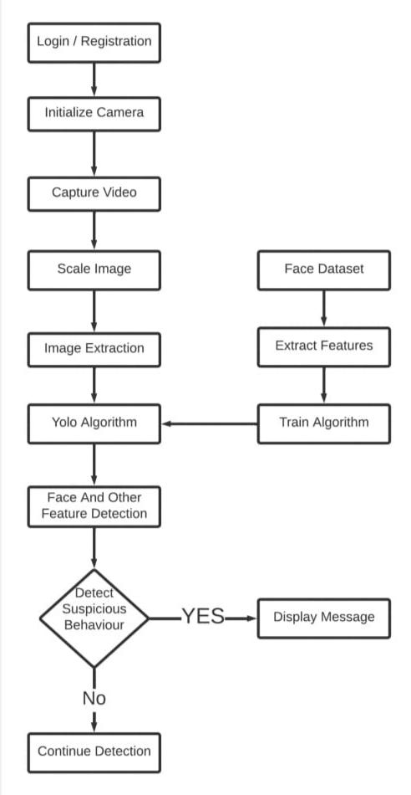

**Methodology:**

* **Registration:**Students who register in a portal for the first time submit their personal data, their ID card and their photo, which is stored in the database and verified using their photo before the exam.
* **Face recognition:**A webcam is installed in the a student’s computer or front camera, when the student takes a test on a face recognition recognizes the student  and if the face matches the stored facial image, the student is verified and allowed to take the exam. During the exam, the student’s image is continuously captured and if the face does not match the stored image, their record is saved in the database. Multiple face detection: If there is more than one person  in the picture, this is also recorded in the database.
* **Head Position Detection:**For MCQ-based exams that do not require pencil and paper, students’ head position is analyzed and if it appears that a student is looking at the other side of the screen, your dataset is also analyzed be saved.
* **Cell Phone Detection –** If a student is found with a cell phone, this will also be recorded as bad practice in the database. Misconduct and will be logged.

**Conclusion:**

Due to the COVID-19 Pandemic, it has become the need of the hour to leverage remote proctoring platforms to conduct seamless tests while also ensuring that the candidates do not indulge in malpractices during these online exams. There are numerous benefits to any organization when they conduct any assessment via remote proctoring instead of the traditional pen-and-paper based method. Scheduling exams becomes easier as there is no need to set up specific testing centers to conduct examinations. Communication between the examiner and the examinee is more streamlined, hassle-free and faster. Results of the examination can be generated faster and, in some cases, almost instantly. Online examinations also give the organization the liberty to conduct the exam on a massive scale without worrying about maxing out the capacity of the examination center. However, a sincere effort needs to be made for developing proctoring technologies to ensure that the level of online examinations is at par with offline examinations in all aspects; be it integrity of marks scored, ensuring candidates do not get involved in wrongdoings etc. Social perception of the masses towards online exams also needs to be changed and they must be made aware of the benefits for the same.

**Applications:**

**A)Convenience**: Online proctored exams can be taken from anywhere at any time, as long as you have a reliable internet connection. This makes it much more convenient for students. Especially those who may have other commitments or live far from the exam center.

**B)Security**: Online proctored tests are typically more secure than pen-and-paper exams. Proctoring software can use features like facial recognition and keystroke analysis to verify the student’s identity and prevent cheating. Online proctored exam cheating incidents are scarce in comparison to conventional testing ones.

**C)Cost-Effective**: Exams with remote proctoring can be more cost-effective than pen-and-paper exams because there is no need to print exam papers, hire invigilators, or rent physical exam centers.

**D)Timely Feedback**: With online proctored exams, students can receive their results immediately after finishing the exam. This allows them to identify areas they need to improve and work on them immediately.

**E)Flexibility**: Online proctored exams can be more flexible regarding the types of questions and their format. For example, they can include multimedia elements like videos, images, and audio recordings. These can help assess a wider range of skills and knowledge.

**References**

Example for reference is given below. Kindly follow the same format for writing reference

1)Abdel Karim N., Shukur Z. Proposed features of an online examination interface design and its optimal values. Computers in Human Behavior. 2016;64:414–422. doi: 10.1016/j.chb.2016.07.013. [CrossRef] [Google Scholar]

2)AbuMansour H. 2017 IEEE/ACS 14th international conference on computer systems and applications (AICCSA) 2017. Proposed bio-authentication system for question bank in learning management systems; pp. 489–494. [CrossRef] [Google Scholar]

3) Aisyah S., Bandung Y., Subekti L.B. 2018 international conference on information technology systems and innovation (ICITSI) 2018. Development of continuous authentication system on android-based online exam application; pp. 171–176. [CrossRef] [Google Scholar]

4) Al-Hakeem M.S., Abdulrahman M.S. Developing a new e-exam platform to enhance the university academic examinations: The case of Lebanese French University. International Journal of Modern Education and Computer Science. 2017;9(5):9. doi: 10.5815/ijmecs.2017.05.02. [CrossRef] [Google Scholar]

5) Alzu'bi M. Proceedings of conference of the international journal of arts & sciences. 2015. The effect of using electronic exams on students' achievement and test takers' motivation in an English 101 course; pp. 207–215. [Google Scholar]

6)Amigud A., Dawson P. The law and the outlaw: is legal prohibition a viable solution to the contract cheating problem? Assessment & Evaluation in Higher Education. 2020;45(1):98–108. doi: 10.10