**VISVESVARAYA TECHNOLOGICAL UNIVERSITY**

Jnanasangama, Macche, Santibastwada Road, Belagavi-590018, Karnataka



**A**

**MINI PROJECT REPORT**

on

**CONVOLUTION ENCODING AND TRELLIS DECODING**

*Submitted in partial fulfillment of the requirement for the degree of*

**Bachelor of Engineering**

**in**

**Electronics & Communications Engineering**

*by*

**NISHANT SAHAY 1DS15EC075**

**RAJAT SUGANDHI 1DS15EC097**

**VI semester**

Under the

guidance

of

**Prof. A. Rajagopal**

Assistant Professor, ECE Dept., DSCE, Bengaluru



**Department of Electronics & Communication Engineering**

**Dayananda Sagar College of Engineering**

(An Autonomous College affiliated to VTU Belgaum & accredited by NBA/NAAC)

Shavige Malleshwara Hills, Kumaraswamy Layout,

Banashankari, Bengaluru-560078, Karnataka

April 2018

**Mini project Report Declaration**

Certified that the UG Mini project entitled, “……..…………………………

……………………………………………………....................................................

.................................…………………………………………………….……………………………………………………....…....” has been submitted as AAT for the subject Digital System design using Verilog with Subject code-EC661 is a bonafide work that is carried out by myself in partial fulfillment for the award of degree of Bachelor of Engineering in Electronics & Communication Engineering of the Visvesvaraya Technological University, Belagavi, Karnataka during the academic year 2017-18.I am solely responsible for all the contents that has have been presented in it.

Student sign

Date : / / Place : Bengaluru -560078

**_______________________________________**

Mini project Guide

Name & Signature

Prof A.Rajagopal

Contents

1. Abstract

2. Introduction to the topic

3. Literature survey related to the topic

4. Scope & Objectives of the work

5. Motivation / Problem statement definition in the work

6. Block diagram

7. Outcome / Results & Applications of work

8. Conclusions

9. References

**ABSTRACT**

The convolutional coding technique is used to encode and decode a continuous stream of bits. The basic concept behind the convolution is the overlapping of two signals to form the other one. Because of the nature of convolution coding technique the binary bit stream source is convolved by applying some binary operations on them. It is a memory based system, which means the output bit is dependent of the current bit being encoded as well as the previous bit stream stored in the memory. The main applications of convolution coding is in the deep space applications and in wireless communication systems.

The TCB code (TCBC) construction is based on an algebraic structure inherent to many LBCs, which allows one to partition an LBC into sub-sets with a constant distance between every pair of code words in the subset. The proposed uniform sub-set partitioning is used to increase the minimum distance of the code, as in trellis coded modulation (TCM). However, unlike conventional An advantage of this construction is that it can be applied to both discrete as well as continuous channels, while conventional TCM is typically designed for continuous channels.

**INTRODUCTION**

In [telecommunication](https://en.wikipedia.org/wiki/Telecommunication), a convolutional code is a type of [error-correcting code](https://en.wikipedia.org/wiki/Forward_error_correction) that generates parity symbols via the sliding application of a [boolean polynomial](https://en.wikipedia.org/wiki/Algebraic_normal_form" \o "Algebraic normal form) function to a data stream. The sliding application represents the 'convolution' of the encoder over the data, which gives rise to the term 'convolutional coding.' The sliding nature of the convolutional codes facilitates [trellis](https://en.wikipedia.org/wiki/Trellis_(graph)) decoding using a time-invariant trellis. Time invariant trellis decoding allows convolutional codes to be maximum-likelihood soft-decision decoded with reasonable complexity.

Convolutional codes are often described as continuous. However, it may also be said that convolutional codes have arbitrary block length, rather than being continuous, since most real-world convolutional encoding is performed on blocks of data. Convolutionally encoded block codes typically employ termination. The arbitrary block length of convolutional codes can also be contrasted to classic [block codes](https://en.wikipedia.org/wiki/Block_code), which generally have fixed block lengths that are determined by algebraic properties.

To convolutionally encode data, start with *k* [memory registers](https://en.wikipedia.org/wiki/Memory_register), each holding 1 input bit. Unless otherwise specified, all memory registers start with a value of 0. The encoder has *n* modulo-2 [adders](https://en.wikipedia.org/wiki/Adder_(electronics)) (a modulo 2 adder can be implemented with a single [Boolean](https://en.wikipedia.org/wiki/Boolean_logic) [XOR gate](https://en.wikipedia.org/wiki/XOR_gate), where the logic is: 0+0 = 0, 0+1 = 1, 1+0 = 1, 1+1 = 0), and *n* [generator polynomials](https://en.wikipedia.org/wiki/Generator_polynomial) — one for each adder (see figure below). An input bit *m*1 is fed into the leftmost register. Using the generator polynomials and the existing values in the remaining registers, the encoder outputs *n* symbols. These symbols may be transmitted or punctured depending on the desired code rate. Now [bit shift](https://en.wikipedia.org/wiki/Bit_shift) all register values to the right (*m*1moves to *m*0, *m*0 moves to *m*−1) and wait for the next input bit. If there are no remaining input bits, the encoder continues shifting until all registers have returned to the zero state (flush bit termination).

Error correcting codes are used in communication systems to provide coding gain, which in turn reduces the energy per bit required for reliable communication. Besides providing a large coding gain, the key features of a good error correcting code include low encoding and decoding complexity, low latency (delay), etc. Although modern codes such as low density parity check (LDPC) codes and turbo codes come within a few tenths of a dB from the Shannon’s limit, these codes use very long code lengths. Hence, the complexity and latency of the decoder is large, which limits their usage in latency-constrained systems. For example, the LDPC decoder in the IEEE 802.11n receivers cannot use a large number of iterations since the receiver (Rx) must send an acknowledgement to the transmitter (Tx) within the short inter-frame spacing (SIFS) time interval. Thus, it is a challenge to design codes with a desired coding gain and at the same time meet the latency and decoding complexity constraints.

**LITERATURE SURVEY**

Coding theory is the study of the properties of [codes](https://en.wikipedia.org/wiki/Code) and their respective fitness for specific applications. Codes are used for [data compression](https://en.wikipedia.org/wiki/Data_compression), [cryptography](https://en.wikipedia.org/wiki/Cryptography), [error-correction](https://en.wikipedia.org/wiki/Error-correction), and [data transmission](https://en.wikipedia.org/wiki/Data_transmission) and [storage](https://en.wikipedia.org/wiki/Data_storage). Codes are studied by various scientific disciplines—such as [information theory](https://en.wikipedia.org/wiki/Information_theory), [electrical engineering](https://en.wikipedia.org/wiki/Electrical_engineering), [mathematics](https://en.wikipedia.org/wiki/Mathematics), [linguistics](https://en.wikipedia.org/wiki/Linguistics), and [computer science](https://en.wikipedia.org/wiki/Computer_science)—for the purpose of designing efficient and reliable data transmission methods. This typically involves the removal of redundancy and the correction or detection of errors in the transmitted data.[3]

Convolutional codes were introduced in 1955 by [Peter Elias](https://en.wikipedia.org/wiki/Peter_Elias). It was thought that convolutional codes could be decoded with arbitrary quality at the expense of computation and delay. In 1967 [Andrew Viterbi](https://en.wikipedia.org/wiki/Andrew_Viterbi) determined that convolutional codes could be maximum-likelihood decoded with reasonable complexity using time invariant trellis based decoders — the [Viterbi algorithm](https://en.wikipedia.org/wiki/Viterbi_algorithm). Other trellis-based decoder algorithms were later developed, including the [BCJR](https://en.wikipedia.org/wiki/BCJR) decoding algorithm.

Recursive systematic convolutional codes were invented by [Claude Berrou](https://en.wikipedia.org/wiki/Claude_Berrou) around 1991. These codes proved especially useful for iterative processing including the processing of concatenated codes such as [turbo codes](https://en.wikipedia.org/wiki/Turbo_codes).

Using the "convolutional" terminology, a classic convolutional code might be considered a [Finite impulse response](https://en.wikipedia.org/wiki/Finite_impulse_response) (FIR) filter, while a recursive convolutional code might be considered an [Infinite impulse response](https://en.wikipedia.org/wiki/Infinite_impulse_response) (IIR) filter.[1]

In [telecommunication](https://en.wikipedia.org/wiki/Telecommunication), trellis modulation (also known as trellis coded modulation, or simply TCM) is a modulation scheme that transmits information with high efficiency over band-limited channels such as [telephone lines](https://en.wikipedia.org/wiki/Telephone_line). [Gottfried Ungerboeck](https://en.wikipedia.org/wiki/Gottfried_Ungerboeck) invented trellis modulation while working for IBM in the 1970s, and first described it in a conference paper in 1976. It went largely unnoticed, however, until he published a new, detailed exposition in 1982 that achieved sudden and widespread recognition[2].

**Motivation / SCOPE OF WORK :**

Convolution Code:

Error control coding applications have grown rapidly in the past several years in various field of communication and information storage mechanism. There are number of techniques of error correction based on applied mathematics which correct various types of errors. These codes have some limitations in mathematical or practical considerations or in other ways.

It is impossible to correct all the errors but these errors can be minimized. Still no error correcting code is available which can correct all the random errors and burst errors. When number of errors was increased designed codes turn out to be inefficient. Small error correction codes with desired correction capabilities can be easily developed but with large error correction capability; developing a code is real practical problem. Now future work can be done on such error correcting code which would be capable to correct the errors with high probability.

Study of this thesis provides many recommended processes that can be added in future work as a next step of system development which are briefed as follows:

Considerations other performance evaluation parameters which are given in chapter 4 in continuation work.

Increasing the constraint length and developing a new low code rate convolutional code which leads to less Generalization of Convolutional and Block codes in other important fields.

Exploring the possibility of combining two block codes and their further studies.

Searching for more perfect and large Hamming distance code.

Study for higher generation cellular services for improving quality by low code rate containing high data rates.Searching for more quality real time data in space communication.

Trellis Code:

In [telecommunication](https://en.wikipedia.org/wiki/Telecommunication), trellis modulation (also known as trellis coded modulation, or simply TCM) is a modulation scheme that transmits information with high efficiency over band-limited channels such as [telephone lines](https://en.wikipedia.org/wiki/Telephone_line). The proposed TCBC is useful in a variety of applications including forward error correction, low rate quasi-orthogonal sequence generation, lattice code construction, etc.

For Digital microwave radio systems a modified symbol rate increased TCM can be used.  The symbol-rate-increased TCM accomplishes coding redundancy through bandwidth expansion instead of through signal point expansion, in order to obtain a greater coding gain than the Ungerboeck-type TCM. However, this scheme requires the bandwidth to be expanded by a fixed factor m/(m-1) for a 2/sup m/QAM (quadrature amplitude modulation) system. The proposed scheme allows the bandwidth expansion ratio to be varied to an arbitrary value smaller than m/(m-1). Simulation results have clarified that the proposed scheme achieves a significant improvement over an uncoded scheme.

**PROBLEM STATEMENT**

To design a convolution encode and a trellis coding technique and verify the same.

**Convolution Code & Trellis Code:**

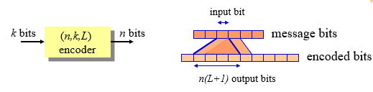

Convolutional codes are applied in applications that require good performance with low implementation complexity. They operate on code streams (not in blocks)

Convolution codes have memory that utilizes previous bits to encode or decode following bits (block codes are memoryless)

Convolutional codes are denoted by (*n,k,L*), where *L* is code (or encoder) Memory depth (number of register stages)

Constraint length *C=n(L+1)* is defined as the number of encoded bits a message bit can influence to

Convolutional codes achieve good performance by expanding their memory depth.

**BLOCK DIAGRAM**

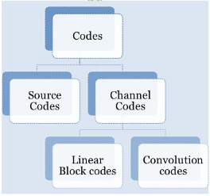

Source Code:

The aim of the source code is to take the source data and make it smaller.

Channel Code:

The aim of the channel coding theory is to find codes which transmit quickly, contain many valid code words and can correct or at least detect many errors.

Channel codes are used add redundancy to the code.

Redundancy adds extra information about the data into the signal.

Convolution Code:

Convolutional code is a type of error-correcting code in which m-bit information symbol to be encoded is transformed into n-bit symbol. Convolutional codes are used extensively in numerous applications in order to achieve reliable data transfer, including digital video, radio, mobile communication, and satellite communication. These codes are often implemented in concatenation with a hard-decision code, particularly Reed Solomon.

Convolutional codes are used extensively to achieve reliable data transfer in numerous applications, such as [digital video](https://en.wikipedia.org/wiki/Digital_video), radio, [mobile communications](https://en.wikipedia.org/wiki/Mobile_communications) and [satellite communications](https://en.wikipedia.org/wiki/Satellite_communications). These codes are often implemented in [concatenation](https://en.wikipedia.org/wiki/Concatenated_code) with a hard-decision code, particularly [Reed–Solomon](https://en.wikipedia.org/wiki/Reed%E2%80%93Solomon_error_correction). Prior to [turbo codes](https://en.wikipedia.org/wiki/Turbo_codes) such constructions were the most efficient, coming closest to the [Shannon limit](https://en.wikipedia.org/wiki/Shannon-Hartley_theorem).

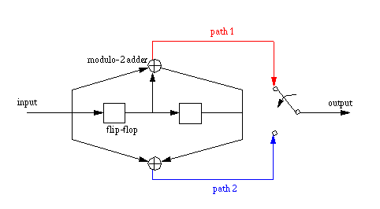

**Fig: Block diagram of Convolution Encoder with k=1,n=2,r=1/2**

If the encoder generates a group of ‘n’ encoded bits per group of ‘k’ information bits, the code rate R is commonly defined as R = k/n. In Fig, k = 1 and n = 2. The number, K of elements in the shift register which decides for how many codewords one information bit will affect the encoder output, is known as the constraint length of the code. For the present example, K = 3.

The operation of a convolutional encoder can be explained in several but equivalent ways such as, by a) state diagram representation, b) tree diagram representation and c) trellis diagram representation.

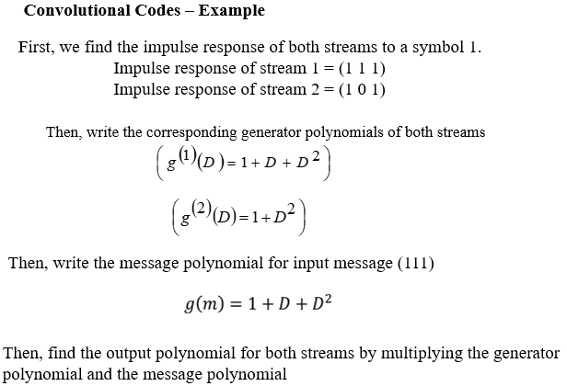

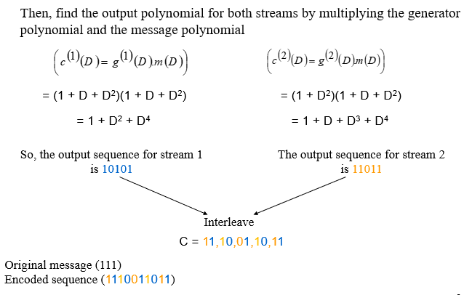

State Diagram Representation:

A convolutional encoder may be defined as a finite state machine. Contents of the rightmost (K-1) shift register stages define the states of the encoder. So, the encoder in Fig. 1.1 has four states. The transition of an encoder from one state to another, as caused by input bits, is depicted in the state diagram. Fig. 1.2 shows the state diagram of the encoder in Fig. 1.1. A new input bit causes a transition from one state to another. The path information between the states, denoted as b/c1c2, represents input information bit ‘b’ and the corresponding output bits (c1c2). Again, it is not difficult to verify from the state diagram that an input information sequence b = (1011) generates an encoded sequence c = (11, 10, 00, 01).

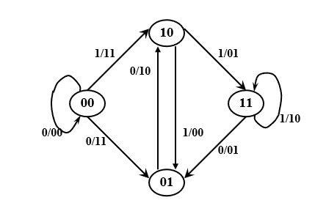

**Fig1.2: State diagram for encoder with k=1,n=2,r=1/2**

b) Tree Diagram Representation:

The tree diagram representation shows all possible information and encoded sequences for the convolutional encoder. Fig. 1.3 shows the tree diagram for the encoder in Fig. 1.1. The encoded bits are labeled on the branches of the tree. Given an input sequence, the encoded sequence can be directly read from the tree. As an example, an input sequence (1011) results in the encoded sequence (11, 10, 00, 01).

c) Trace Back Unit

Once the minimum path metrics of all the nodes at each stage is calculated, the minimum path metric at the last stage is found. The node having the minimum path metrics at the last stage is given as input to Trace Back Unit and then it starts trace backing the survival paths from that node and outputs the corresponding bit which has caused the transition of that path. In this paper decoding depth of 64 is set in the decoder. [7]

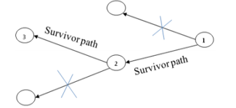

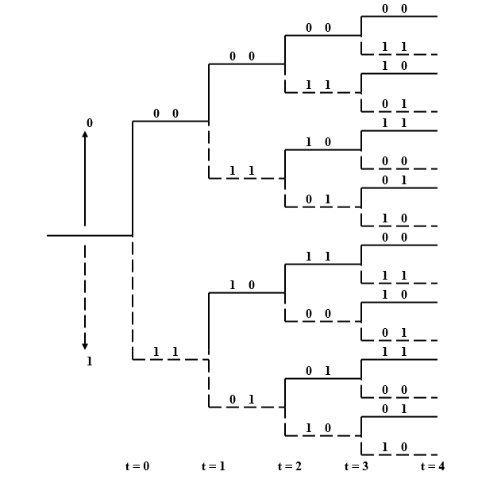

**Fig1.3:Tree Diagram for the encoder in Fig 1.1**

Trellis Diagram Representation:

The trellis diagram of a convolutional code is obtained from its state diagram. All state transitions at each time step are explicitly shown in the diagram to retain the time dimension, as is present in the corresponding tree diagram. Usually, supporting descriptions on state transitions, corresponding input and output bits etc. are labeled in the trellis diagram. It is interesting to note that the trellis diagram, which describes the operation of the encoder, is very convenient for describing the behavior of the corresponding decoder, especially when the famous ‘Viterbi Algorithm (VA)’ is followed. Figure 1.4 shows the trellis diagram for the encoder in Figure 1.1. [5]

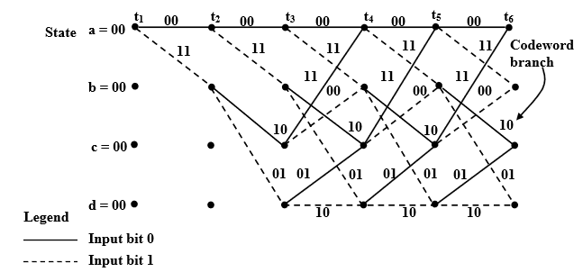

**Fig 1.4: Trellis Diagram Representation for fig 1.1**

**VERILOG CODE**

(a) CONVOLUTIONAL ENCODER

module conv(x,y);

input [6:0]x; //for a 3 bit input pad 00 and 00 in start and last

output [9:0]y;

reg [9:0]y;

always@(*)

begin

y[9]=x[2]^x[0];

y[8]=x[0]^x[1]^x[2];

y[7]=x[3]^x[1];

y[6]=x[1]^x[2]^x[3];

y[5]=x[4]^x[2];

y[4]=x[2]^x[3]^x[4];

y[3]=x[5]^x[3];

y[2]=x[3]^x[4]^x[5];

y[1]=x[4]^x[6];

y[0]=x[4]^x[5]^x[6];

end

endmodule

(b) Trellis Decoder

module trellis_decoder(sequence,path);

input [5:0]sequence;

output [2:0]path;

reg [5:0]a0a1a2a3=6'b000000,a0a1a2b3=6'b000011,a0a1b2c3=6'b001110,a0a1b2d3=6'b001101,a0b1c2a3=6'b111011,a0b1c2b3=6'b111000,a0b1d2c3=6'b110101,a0b1d2d3=6'b110110;

reg [5:0]x1,x2,x3,x4,x5,x6,x7,x8;

reg [2:0]d1,d2,d3,d4,d5,d6,d7,d8;

reg [2:0]path;

reg [2:0]x;

reg [2:0]min=3'b111;

always@(*)

begin

x1=sequence^a0a1a2a3;

x2=sequence^a0a1a2b3;

x3=sequence^a0a1b2c3;

x4=sequence^a0a1b2d3;

x5=sequence^a0b1c2a3;

x6=sequence^a0b1c2b3;

x7=sequence^a0b1d2c3;

x8=sequence^a0b1d2d3;

d1=x1[5]+x1[4]+x1[3]+x1[2]+x1[1]+x1[0]; //Calculating the Hamming distance

d2=x2[5]+x2[4]+x2[3]+x2[2]+x2[1]+x2[0];

d3=x3[5]+x3[4]+x3[3]+x3[2]+x3[1]+x3[0];

d4=x4[5]+x4[4]+x4[3]+x4[2]+x4[1]+x4[0];

d5=x5[5]+x5[4]+x5[3]+x5[2]+x5[1]+x5[0];

d6=x6[5]+x6[4]+x6[3]+x6[2]+x6[1]+x6[0];

d7=x7[5]+x7[4]+x7[3]+x7[2]+x7[1]+x7[0];

d8=x8[5]+x8[4]+x8[3]+x8[2]+x8[1]+x8[0];

//Finding the minimum of the Hamming Distance

if(d1<min) min=d1;

else min=min;

if(d2<min) min=d2;

else min=min;

if(d3<min) min=d3;

else min=min;

if(d4<min) min=d4;

else min=min;

if(d5<min) min=d5;

else min=min;

if(d6<min) min=d6;

else min=min;

if(d7<min) min=d7;

else min=min;

if(d8<min) min=d8;

else min=min;

if(d1==min) path=3'b000;

else if(d2==min) path=3'b001;

else if(d3==min) path=3'b010;

else if(d4==min) path=3'b011;

else if(d5==min) path=3'b100;

else if(d6==min) path=3'b101;

else if(d7==min) path=3'b110;

else if(d8==min) path=3'b111;

end

endmodule

**OUTPUT/RESULTS**

The encoded output for a input bit stream is achieved with the convolution encoder. Trellis Code is generated for the same and the input bit stream is decoded using the tree drawn based on the hamming distances achieved.

Convolution Encoder:

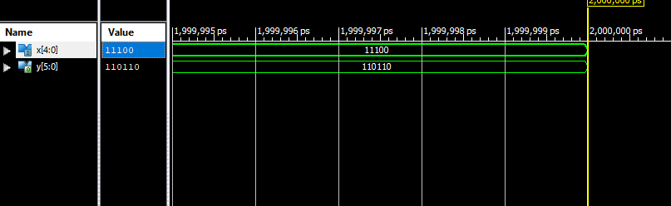

Fig: Encoded Output for 3 bit input

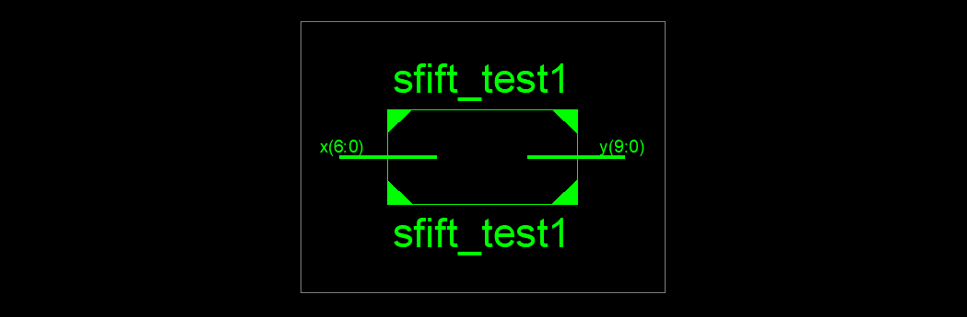

Fig: RTL of Convolution Encoder



Fig: Internal RTL of Convolution Encoder

Design utilisation of Convolution Encoder:

|  |  |  |  |
| --- | --- | --- | --- |
| Logic utilization | Used | Available | utilization |
| Number of slices | 0 | 4800 | 0% |
| Number of LUTs | 3 | 2400 | 1% |
| Number of bonded IOBs | 11 | 102 | 10% |

Power Analysis: 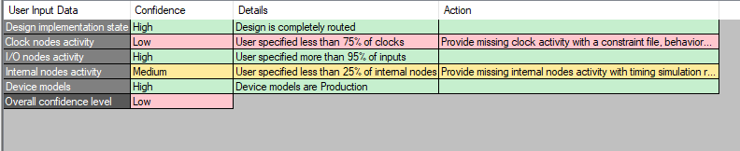

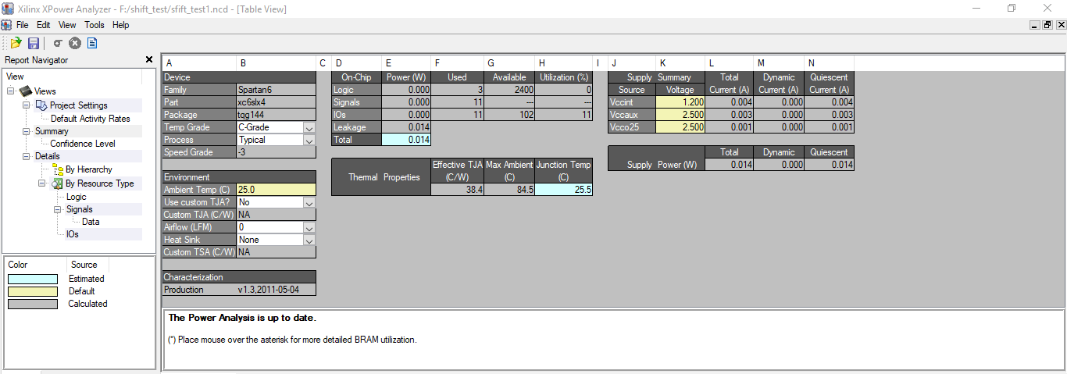

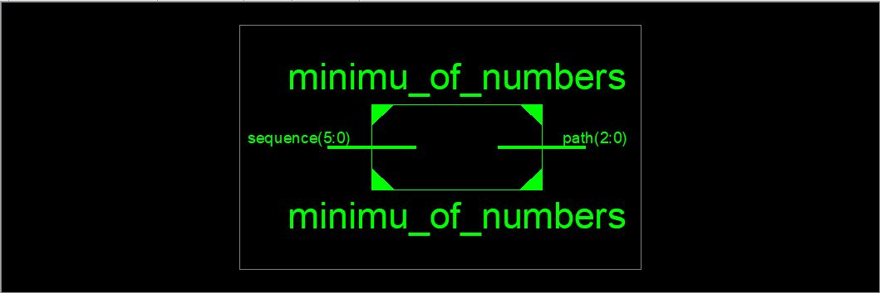Trellis Coding:

Fig: RTL of Trellis Coding

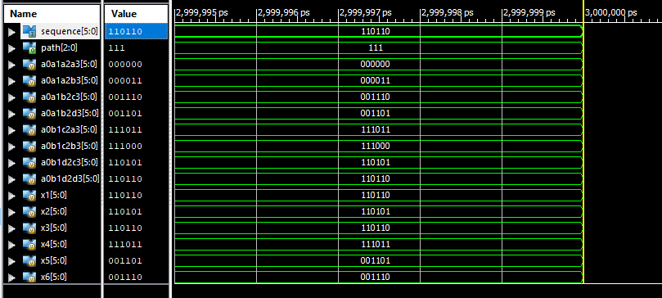

Fig: Decoded Output for 6 bit encoded input

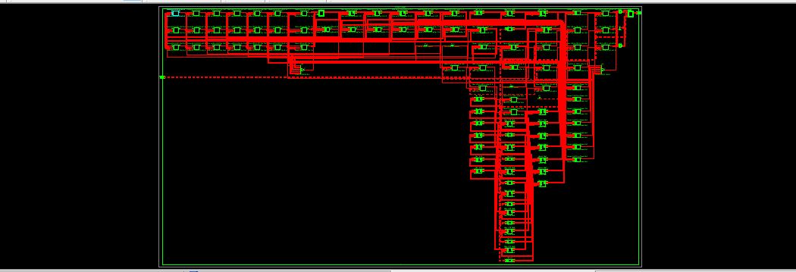

Fig: Internal RTL of Trellis Coding

Design utilization of Trellis Coding:

|  |  |  |  |
| --- | --- | --- | --- |
| Logic utilization | Used | Available | utilization |
| Number of slices | 3 | 4800 | 1% |
| Number of LUTs | 104 | 2400 | 4% |
| Number of bonded IOBs | 9 | 102 | 8% |

Power Analysis:

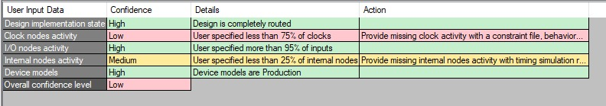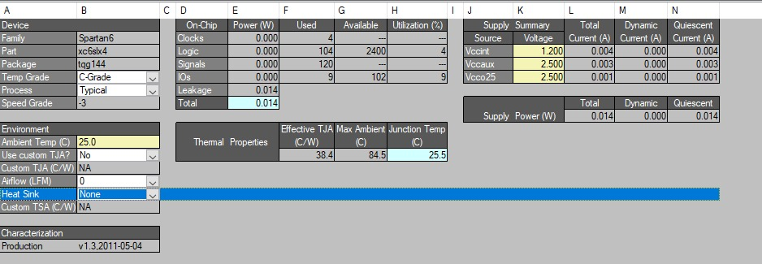

**Fig: Power Analysis for Trellis Coding**

**APPLICATION**

Convolutional codes are used for reliable data transfer in numerous applications, such as [digital video](https://en.wikipedia.org/wiki/Digital_video), radio, [mobile communications](https://en.wikipedia.org/wiki/Mobile_communications) and [satellite communications](https://en.wikipedia.org/wiki/Satellite_communications).

Trellis code is used in Digital Microwave Systems

Problems faced:

Problem 1. To provide input bit stream(serially) in convolution encoder over clock:

Solution: To overcome this issue we used the Output EXOR at each bit locations.

Problem 2. To Trace back the path in Trellis Code Tree: Seeing up Hamming distances from the back of the tree and calculating the path for the same was tough.

Solution: In order to overcome this issue, we noted down the all the possible paths with their hamming distances, then we found out the minimum of that path and for whatever path was the minimum hamming distance was declared as the decoded input bit stream.

**CONCLUSION**

Convolution encoder of constraint length 3 bit and rate ½ is implemented using Verilog and Trellis decoder of 6-bit input is implemented using Verilog hdl and and synthesis is done using Xilinx ISE Design Suit 14.3 tool

The working of the design is cross verified for many trials with introducing errors.

**REFERENCES**

For websites:

1. <https://en.wikipedia.org/wiki/Convolutional_code>
2. https://en.wikipedia.org/wiki/Trellis_modulation
3. <https://en.wikipedia.org/wiki/Coding_theory>
4. [www.eecs.umich.edu/courses/eecs555/lect08.pdf](http://www.eecs.umich.edu/courses/eecs555/lect08.pdf)
5. [www.complextoreal.com/wp-content/uploads/2013/01/tcm.pdf](http://www.complextoreal.com/wp-content/uploads/2013/01/tcm.pdf)

For Conference Papers:

1. Forney, G. David; et al. (September 1984). "Efficient modulation for band-limited channels". IEEE Journal on Selected Areas in Communications. 2: 632–647. [doi](https://en.wikipedia.org/wiki/Digital_object_identifier):[10.1109/jsac.1984.1146101](https://doi.org/10.1109%2Fjsac.1984.1146101).<http://ieeexplore.ieee.org/document/397242/>
2. ["Genius - The Mountain Goats, "We Do It Different on the West Coast," accessed 6/2017"](https://genius.com/amp/The-mountain-goats-we-do-it-different-on-the-west-coast-lyrics).
3. Sherif Welsen Shaker, Salwa Hussein Elramly, Khaled Ali Shehata "FPGA Implementation of a Reconfigurable Viterbi Decoder for Wimax Receiver", International Conference on Microelectronics, 2009.

From books:

1. "Information Theory and Coding", by Prof. K. Giridhar, pooja publications.