Aim: Installation of Anaconda Jupiter along with Python 3.

S/W: Python

Theory

Installing Anaconda on Linux

The installation of the Anaconda distribution of Python on Linux, specifically Ubuntu 18.04, but the instructions should work for other Debian-based Linux distributions as well.

Ubuntu 18.04 comes pre-installed with Python (Version 3.6) and legacy Python (Version 2.7). You can confirm the legacy version of Python is installed by opening a terminal.

In the terminal type:

$ python

You will most likely see Python Version 2.7 is installed. If you enter:

$ python3

You will most likely see Python Version 3.6 is also installed. You can use the 3.6 Version of Python, but each time a new package needs to be downloaded, the $ pip3 install command must be used.

Install the Anaconda distribution of Python to follow the examples in the book without the need to install additional third-party packages.

#### Steps:

1. Visit [Anaconda.com/downloads](https://www.anaconda.com/download/)
2. Select Linux
3. Copy the bash (.sh file) installer link
4. Use wget to download the bash installer
5. Run the bash script to install **Anaconda3**
6. source the .bash-rc file to add Anaconda to your PATH
7. Start the Python REPL

### **1. Visit the Anaconda downloads page**

Go to the following link: [Anaconda.com/downloads](https://www.anaconda.com/download/)

### **2. Select Linux**

On the downloads page, select the Linux operating system

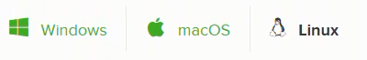

### **3. Copy the bash (.sh file) installer link**

In the **Python 3.6 Version\***box, right-click on the [64-Bit(x86) Installer] link. Select [copy link address].

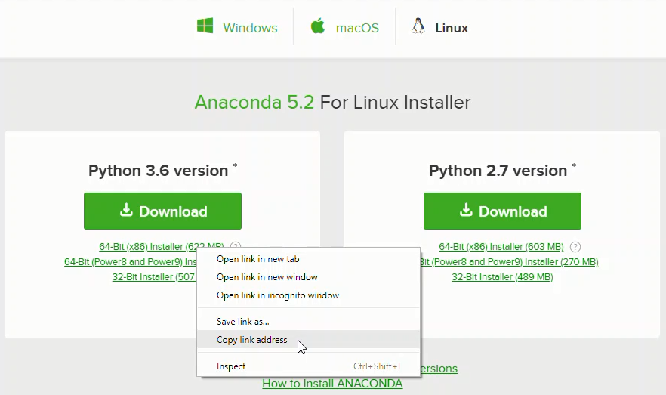

### **4. Use wget to download the bash installer**

Now that the bash installer (.sh file) link is stored on the clipboard, use wget to download the installer script. In a terminal, cd into the home directory and make a new directory called tmp. cd into tmp and use wget to download the installer. Although the installer is a bash script, it is still quite large and the download will not be immediate (Note the link below includes <release>. the specific release depends on when you download the installer).

$ cd ~

$ mkdir tmp

$ cd tmp

$ https://repo.continuum.io/archive/Anaconda3<release>.sh

### **5. Run the bash script to install Anaconda3**

With the bash installer script downloaded, run the **.sh** script to install **Anaconda3**. Ensure you are in the directory where the installer script downloaded:

$ ls

Anaconda3-5.2.0-Linux-x86_64.sh

Run the installer script with bash.

$ bash Anaconda3-5.2.0-Linux-x86_64.sh

Accept the Licence Agreement and allow Anaconda to be added to your PATH. By adding Anaconda to your PATH, the Anaconda distribution of Python will be called when you type $ python in a terminal.

#### 6. source the .bash-rc file to add Anaconda to your PATH

Now that **Anaconda3** is installed and **Anaconda3** is added to our PATH, source the .bashrc file to load the new PATH environment variable into the current terminal session. Note the .bashrc file is in the home directory. You can see it with $ ls -a.

$ cd ~

$ source .bashrc

#### 7. Start the Python REPL

To verify the installation is complete, open Python from the command line:

$ python

Python 3.6.5 |Anaconda, Inc.| (default, Mar 29 2018, 18:21:58)

[GCC 7.2.0] on linux

Type "help", "copyright", "credits" or "license" for more information.

>>>

If you see Python 3.6 from Anaconda listed, your installation is complete. To exit the Python REPL, type:

>>> exit()

## Installing Juypter

The simplest way to install **Jupyter notebooks** is to download and install the Anaconda distribution of Python. The Anaconda distribution of Python comes with Jupyter notebook included and no further installation steps are necessary.

Below are additional methods to install Jupyter notebooks if you are not using the Anaconda distribution of Python.

### **Installing Jupyter on Linux**

To install Jupyter on Linux, open a terminal and type:

$ conda install jupyter

Type y for yes when prompted.

Alternatively, if the Anaconda distribution of Python is not installed, one can use **pip**.

$ pip3 install jupyter

Python Programming Language

Python is a high-level, general-purpose and a very popular programming language. Python programming language (latest Python 3) is being used in web development, Machine Learning applications, along with all cutting-edge technology in Software Industry. Python Programming Language is very well suited for Beginners, also for experienced programmers with other programming languages like C++ and Java.

Below are some facts about Python Programming Language:

Python is currently the most widely used multi-purpose, high-level programming language.

Python allows programming in Object-Oriented and Procedural paradigms.

Python programs generally are smaller than other programming languages like Java. Programmers have to type relatively less and indentation requirement of the language, makes them readable all the time.

Python language is being used by almost all tech-giant companies like – Google, Amazon, Facebook, Instagram, Dropbox, Uber… etc.

The biggest strength of Python is huge collection of standard library which can be used for the following:

Machine Learning

GUI Applications (like Kivy, Tkinter, PyQt etc. )

Web frameworks like Django (used by YouTube, Instagram, Dropbox)

Image processing (like OpenCV, Pillow)

Web scraping (like Scrapy, Beautiful Soup, Selenium)

Test frameworks

Multimedia

Scientific computing

Text processing and many more

Beginning with Python programming:

1) Finding an Interpreter:

Before we start Python programming, we need to have an interpreter to interpret and run our programs. There are certain online interpreters like https://ide.geeksforgeeks.org/, http://ideone.com/ or http://codepad.org/ that can be used to run Python programs without installing an interpreter.

Windows: There are many interpreters available freely to run Python scripts like IDLE (Integrated Development Environment) that comes bundled with the Python software downloaded from http://python.org/.

Linux: Python comes preinstalled with popular Linux distros such as Ubuntu and Fedora. To check which version of Python you’re running, type “python” in the terminal emulator. The interpreter should start and print the version number.

macOS: Generally, Python 2.7 comes bundled with macOS. You’ll have to manually install Python 3 from <http://python.org/>.

**How to install Python on Linux?**

Before we start with how to install Python3 on Linux, let’s first go through the basic introduction to Python. Python is a widely used general-purpose, high-level programming language. Python is a programming language that lets you work quickly and integrate systems more efficiently. There are two major Python versions- Python 2 and Python 3. Both are quite different.

**Getting started with Python**

Python is a lot easier to code and learn. Python programs can be written on any plain text editor like notepad, notepad++, or anything of that sort. One can also use an online IDE for writing Python codes or can even install one on their system to make it more feasible to write these codes because IDEs provide a lot of features like intuitive code editor, debugger, compiler, etc.

To begin with, writing Python Codes and performing various intriguing and useful operations, one must have Python installed on their System. This can be done by following the step-by-step instructions provided below:

**What if Python already exists? Let’s check**

Most of the Linux OS has Python pre-installed. To check if your device is pre-installed with Python or not, just go to terminal using Ctrl+Alt+T

Now run the following command:

For Python2

python --version

For Python3.x

python3.x --version

If Python is already installed, it will generate a message with the Python version available.

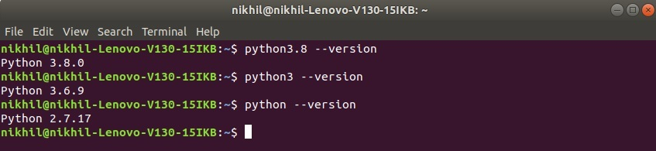

**Beginning the installation.**

For almost every Linux system, the following command could be used to install Python directly:

$ sudo apt-get install python3.8

**Getting Started:**

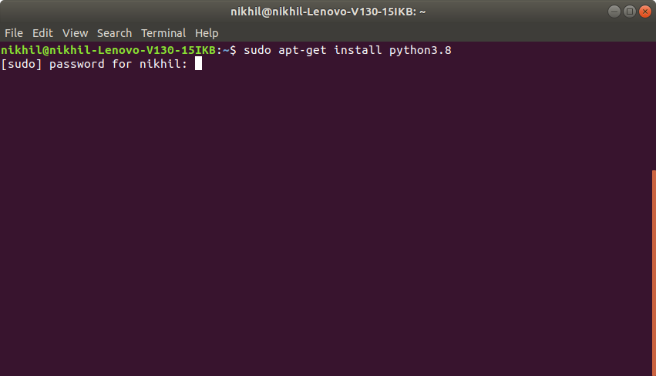

**Assigning Diskspace:**

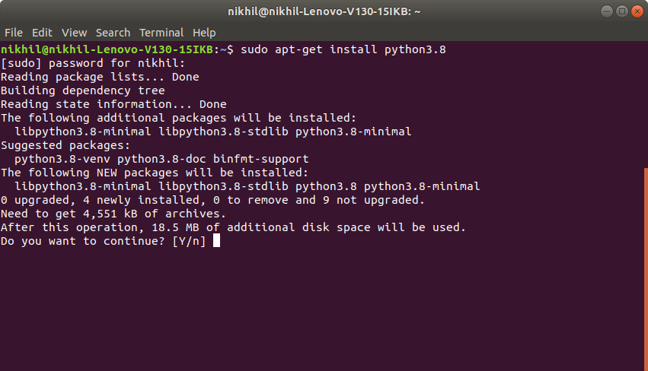

**Fetching and Installing Packages:**

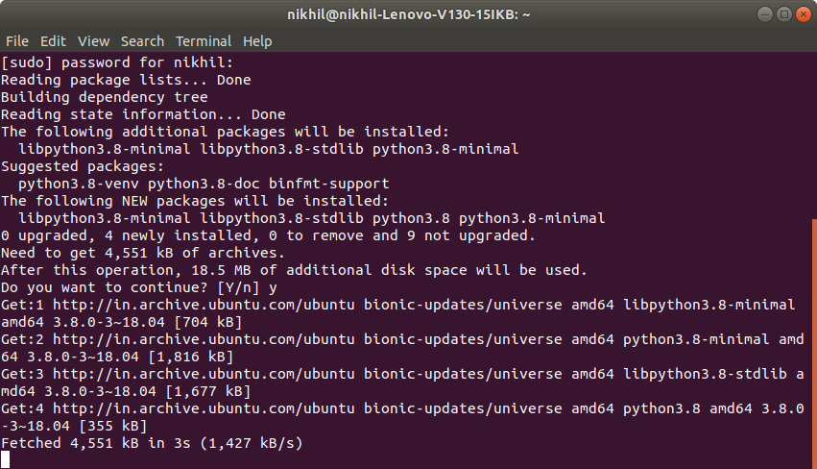

**Getting through the installation process:**

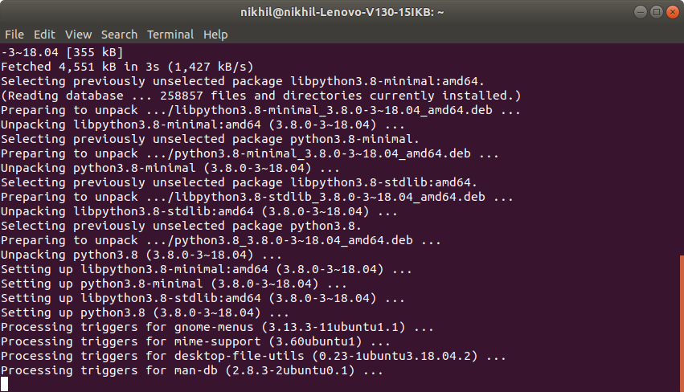

**Finished Installation:**

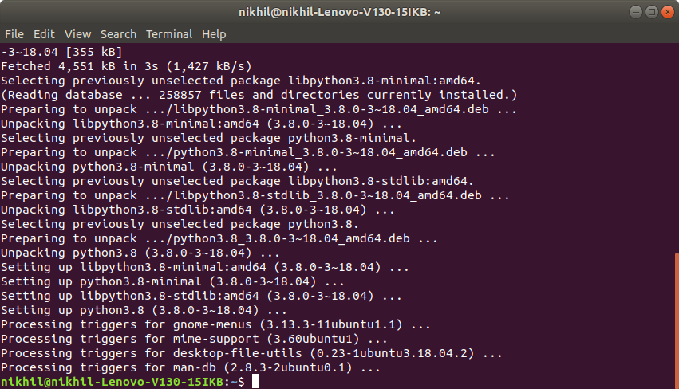

To verify the installation enter the following commands in your Terminal.

python3.8

Let’s consider a simple Hello World Program.

|  |
| --- |
| # Python program to print  # Hello World    print("Hello World") |

**Output:**

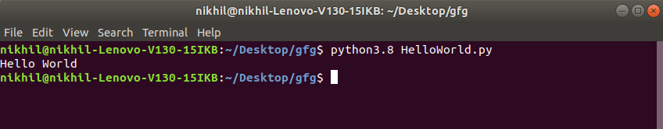

Result: Thus, we have successfully installed Python anaconda on Linux.