FLOOD DAMAGE CLAIM
ASSESSMENT SYSTEM
Phase 1 Project Report
Course/Project: CAP455 / CPP CA1
Student Name: _NISHANT THAKUR
Student ID: 12627950
Submission Date: 26 October 2026

1. Introduction
Floods can damage houses, crops, and other property. After a flood, claim details need to be recorded and checked in an organised way. The Flood Damage Claim Assessment System is a beginner-level C++ console application that records basic claim information, validates the entered details, and displays claims and the total number of accepted claims.

2. Problem Statement
Manual recording of flood damage claims can lead to duplicate claim IDs, incomplete information, and errors in claim counts. A simple computer-based system can help organise basic claim records and reject invalid entries.

3. Objectives
- Allow a user to create a flood damage claim.
- Record claim ID, claimant name, damage type, and damage amount.
- Accept only House or Crop as the damage type.
- Reject duplicate claim IDs and invalid or negative values.
- Display all claims and the total number of successfully created claims.

4. Scope and Limitations
Phase 1 supports basic claim entry, validation, duplicate-ID checking, listing claims, and counting claims. Claims are stored in an array in the program's memory and are lost when the application closes. This phase does not include a database, file-based persistence, user login, automated damage verification, or a graphical interface.

5. Development Approach
The project is being developed incrementally. Phase 1 establishes the basic C++ program structure and claim-management features. Further phases should be aligned with the exact requirements provided in the course assignment.

6. System Flowchart
The flowchart summarises the program's menu, claim-validation process, output options, and exit path.
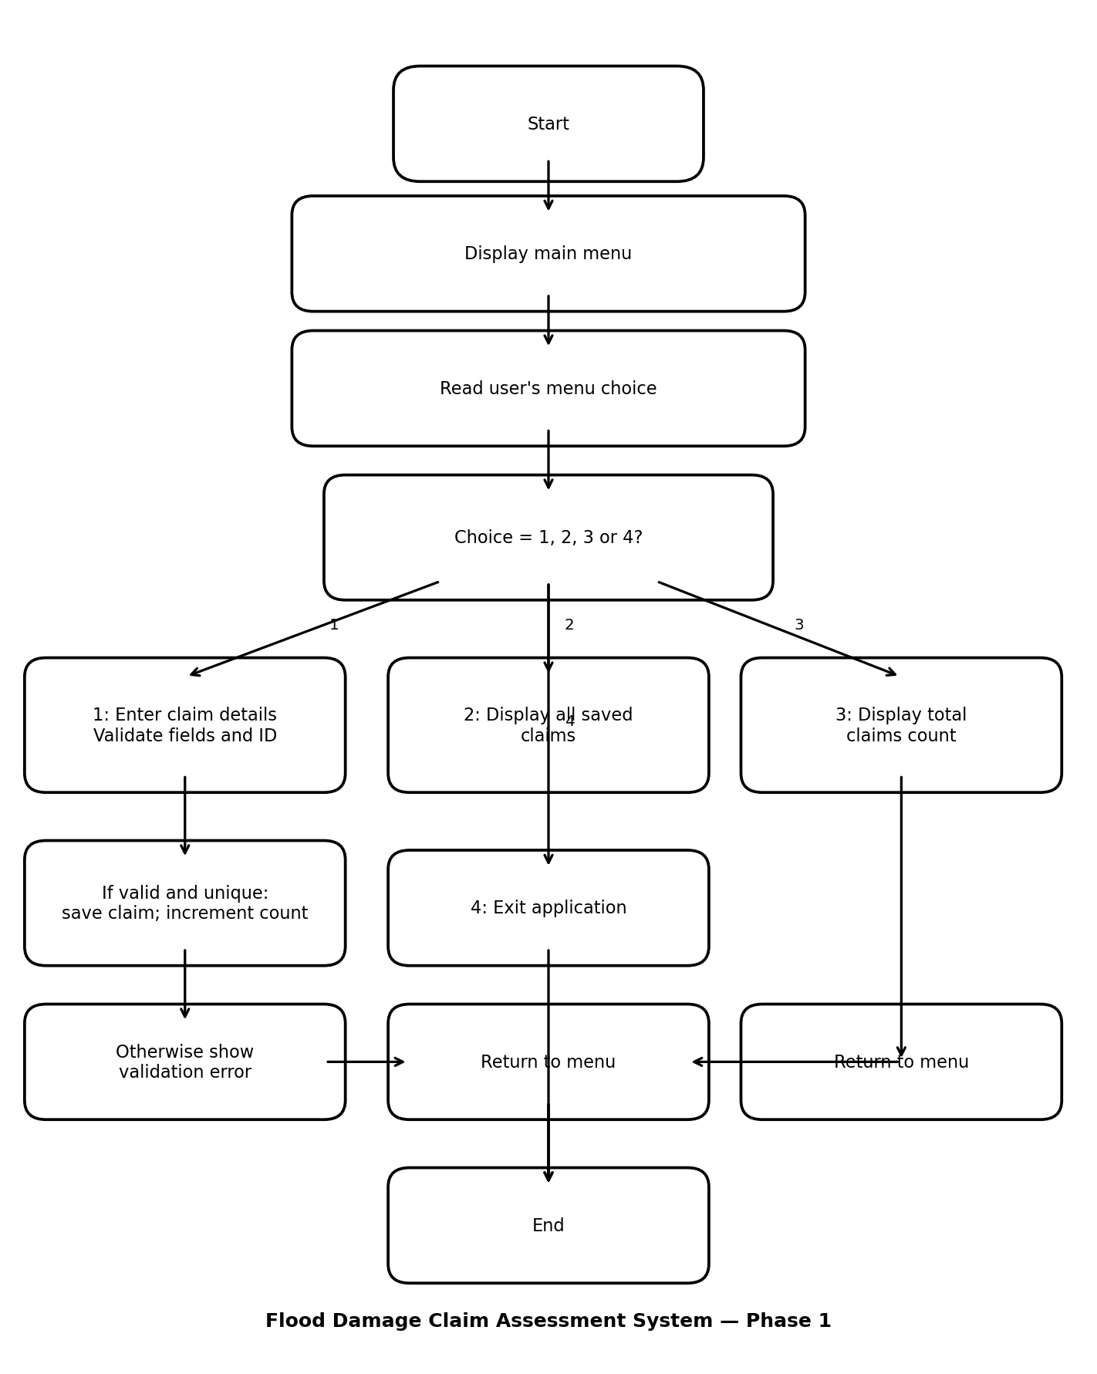

7. Data Flow Diagram (DFD) — Level 0
The diagram shows the user interacting with the system and the main inputs and outputs.
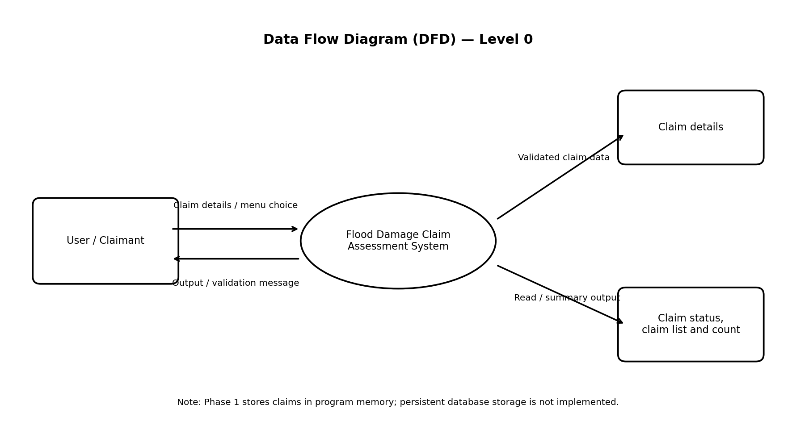

8. Testing Report
The following tests were run manually in the console. The recorded outcomes were reported as successful by the user.
Test Case | Input / Condition | Expected Result | Actual Result | Status
1. Valid claim | ID 101; Rahul Sharma; House; 15000 | Claim is created | Claim created successfully | PASS
2. Duplicate ID | Enter ID 101 again in same run | Duplicate is rejected | Duplicate ID message displayed | PASS
3. Invalid type | Damage type: Water; unique ID | Invalid details message | Invalid details displayed | PASS
4. Negative amount | Amount: -5000; unique ID | Invalid details message | Invalid details displayed | PASS
5. Total count | Select menu option 3 after Test 1 | Total is 1 | Total claims created: 1 | PASS

9. Screenshot Evidence
Insert the screenshots captured during testing in this section, using the suggested filenames below. Only include screenshots that were actually captured.

- Test1_Valid_Claim.png — Successful claim creation and claim summary
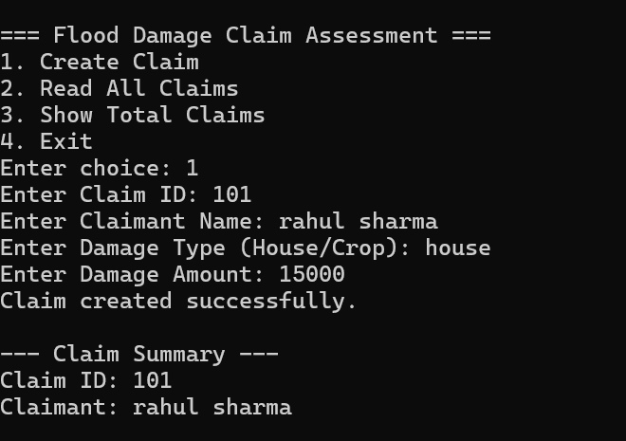
- Test2_Duplicate_ID.png — Duplicate claim ID rejection
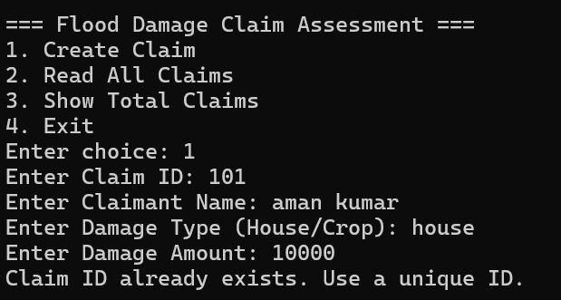
- Test3_Invalid_Damage_Type.png — Invalid damage type rejection
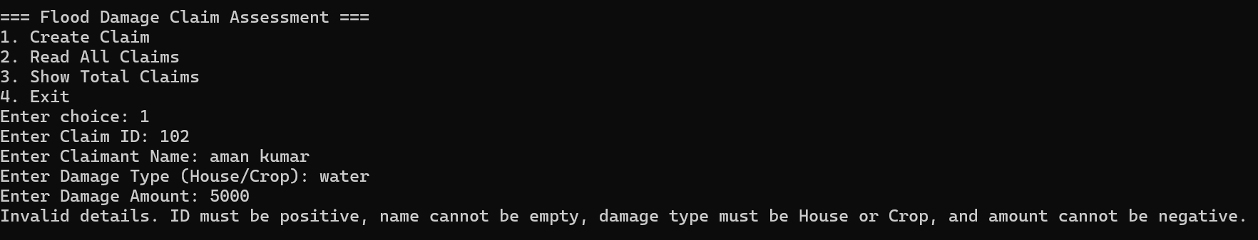
- Test4_Negative_Amount.png — Negative amount rejection
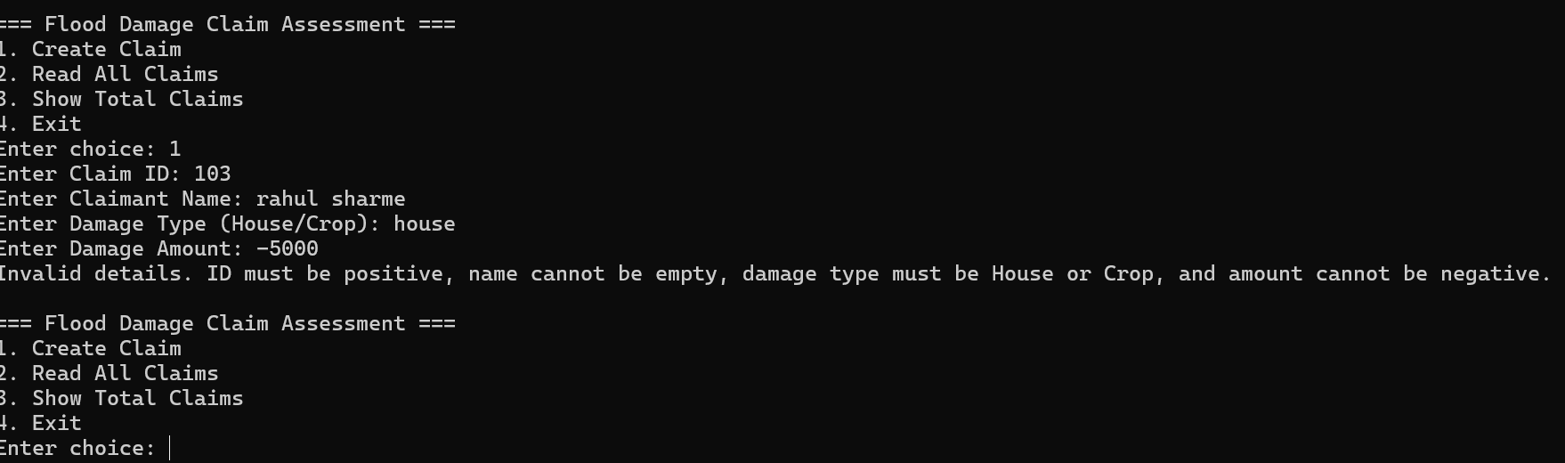
- Test5_Total_Claims.png — Total claims count output
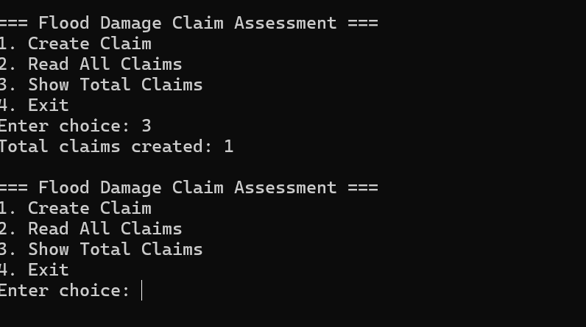
- GitHub_Main_CPP.png — GitHub repository showing main.cpp

10. Tools and Technologies
- C++
- Code::Blocks IDE
- Git and GitHub
- Microsoft Word for documentation

11. Conclusion
Phase 1 provides a working foundation for the Flood Damage Claim Assessment System. The five manual test cases described in this report passed: valid claim creation, duplicate ID rejection, invalid damage type rejection, negative amount rejection, and total-count display. The next development steps should follow the exact assignment brief and may extend the system with the features required for later phases.

12. Git Tracking Commands
After saving this report inside the project folder, run the following commands from that folder:
git status
git add Flood_Damage_Claim_Assessment_Phase1_Report.docx phase1_flowchart.png phase1_dfd.png
git commit -m "Phase 1: Add report, flowchart, and DFD"
git push
If Git says a file path is not found, check that the report and diagram image files are saved in the repository folder. If there are no changes to commit, do not create an unnecessary commit.

