Exercise 1: TicketProgram: There is a base rate of ticket i.e. $15 and use that to calculate the total cost of the tickets that the user want to buy.
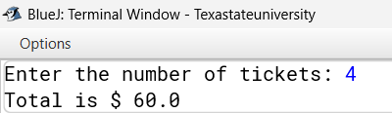
Output:

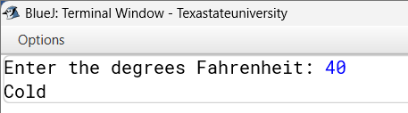
Exercise 2: TemperatureProgram: It take the reading in Fahrenheit and determine if it is classifies as four categories (warn, cold, freezing or hot). I uses if else statement to check if it fall into that categories.
Output:

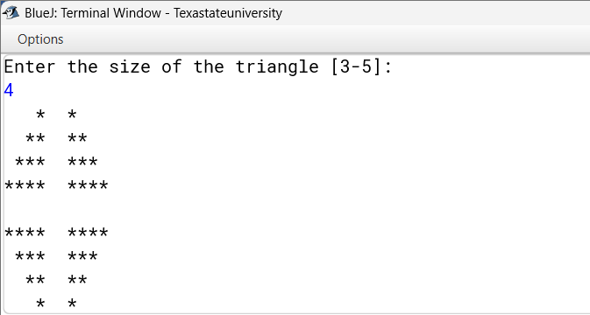
Exercise 3: TrianglesProgram: I used nested loop to make the triangles from asterisk and also to make a gap for it to be formatted clearly.
Output:

Git Command used:
- git init
- git status
- git add TicketProgram.java
- git commit -m “Add Exercise 1: Ticket Program”
- git add TemperatureProgram.java
- git commit -m “Add Exercise 2: Temperature Program”
- git add TrianglesProgram.java
- git commit -m “Add Exercise 3: Triangles Program”
Challenges and resolution:
The main challenges is to do the exercise 3. It was hard to figure out the pattern and to combines all the loops. At first I tested by inputting 2 and then checking the output line by line and used git status before each commit to keep the files out of the repository.

