**INDEX**

1. Introduction 2

2. System Requirement 3

3. Software Activation 3

4. Installation 3

Step I : Install Mysql 4

Step II : Install PES-VB 4

5. Launching of Application 6

6. Create New User 7

7. Login to the system 8

Local Login 9

Remote Login 9

8. Competition 10

1. New Competition 10

2. Edit Competition 12

3. Delete Competition 14

9. Team 15

1. New team 15

2. Edit Team 18

3. Delete Team 20

10. Player 22

1. New Player 22

2. Edit Player 25

3. Delete Player 28

11. Match 30

1. New Match 30

2. Edit Match 33

3. Delete Match 36

12. Keyboard Shortcuts 38

13. Evaluation 39

Steps to evaluate match 39

14. Evaluating a Match 43

Rotation Order 57

Substitute player 59

Timeout 61

Replace Libero 63

Evaluating both team in network 64

15. Reports 69

Consolidated Match Report 70

Rotation Performance 72

Best Player performance 73

Team report 75

DataSheet 78

# Introduction

PES-VB is the performance evaluation software for the volleyball design for the coaches and trainer to evaluate the team performance match. PES-VB provides the two kinds of evaluation Brief evaluation and Detail evaluation. Various kinds of reports provided in the PES-VB to analyse the team performance. LIVE match evaluation provides the Consolidated report of the match with Best Rotation and Best Performance of the Player in every skill. In detail evaluation of the match provides the report with detail analysis of the Skill and zone wise performance of the team.

# System Requirement

Minimum system requirement for PES-VB :

**Screen Resolution :** Minimum 1280 X 768

**Windows OS :** Windows 7, Windows 8, Windows 10

**RAM :** 2 GB or More

**Processor :** Intel I3 or above

# Software Activation

PES-VB requires 16 digit product key (looks like “XXXX-XXXX-XXXX-XXXX”) to activate the application. The application comes with Trial Period of 7 Days and all the functionalities are available in the trial period. The user can enter product key before or after the installation of the application. After the expiration of the trial period user need to purchase the product key. If the product key is purchased before the installation of application user can enter the product key at the time of installation. If the product key purchased later the installation, the system will ask for the product key every time before login to the system. Once the key is entered and it is validated system will not prompt for activation of the application.

# Installation

PES-VB comes in a CD with other required software. To run the PES-VB it requires MySql installed on the system. Both PES-VB and MySql software are available in CD. Installing PES-VB allows user

Step by Step installation is provided below :

## Step I : Install Mysql

**Note:** If my SQL is already installed on System then Skip this MySql Installation step

## Step II : Install PES-VB

1. Open CD or Pendrive.
2. Click on “PES-VB.exe”.
3. The following setup window will open.

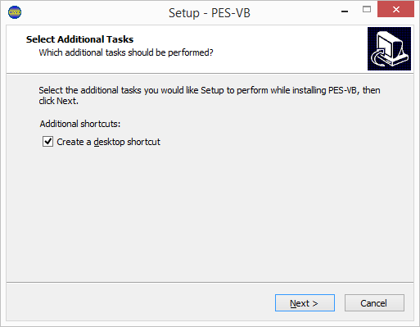

If you want a shortcut to be created on the desktop, Select Create a desktop shortcut checkbox or else unselect it.

1. Click on “Next”.

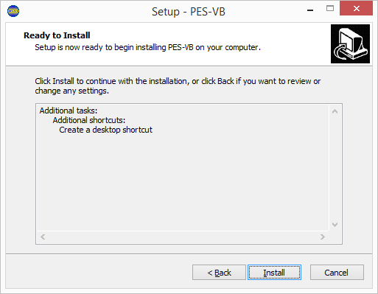

1. Click on “Install”.
2. It will start installing application on your system.

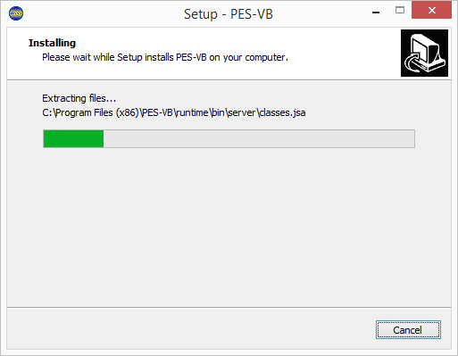

1. After successful installation it shows following window.

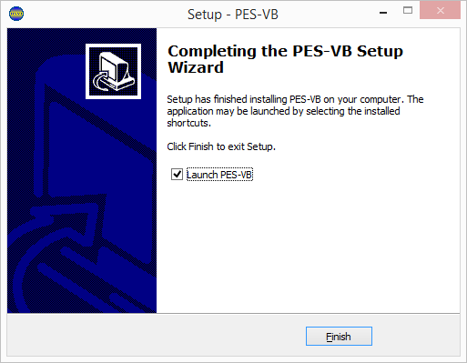

If you want to launch the application, Select Launch PES-VB checkbox or else unselect it.

1. Click on “Finish”.

**PES-VB Application is Successfully Installed on your system**

# Launching of Application

* If desktop shortcut is created then go to desktop and click on “PES-VB”
* If there is no shortcut on the desktop then go to start menu and search for “PES-VB” and Click on PES-VB.
* The following window will open after launching of the application.

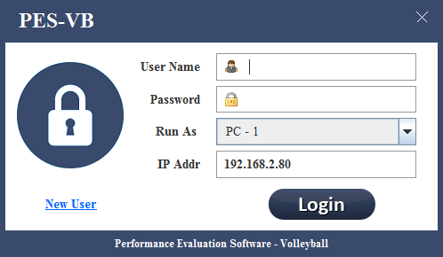

# Create New User

To run the PES-VB it requires User Id and Password. If user doesn’t have user ID and password then follow the following steps to create a new user

1. click on “New User”.



1. PES-VB allows only one user per system. If user is already created in the system then it will give the error as “User had already register for this PC”.

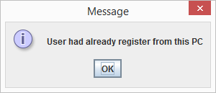

1. If user is not created before it will go to the next step
2. PES-VB requires product key for [Software Activation](#_Software Activation).

* If you have product key then enter key in textbox and click “Continue”.
* If you don’t have product key then left textbox blank and click “Continue”.

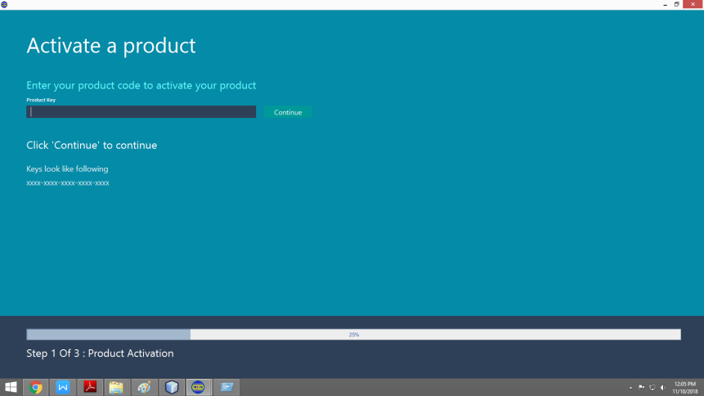

1. Enter all details in user details window.

* Create a credential for PES-VB application.
* Click on “Submit”

**Note :** User name is the name which you will use to login in the PES-VB Application.

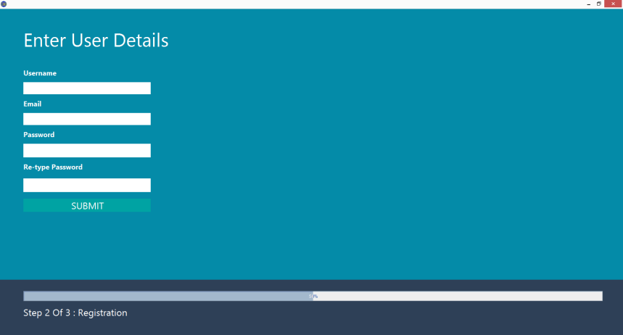

1. Application will start setting up the user.

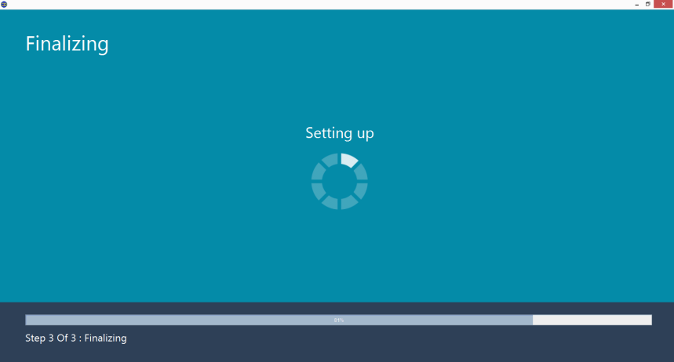

1. After completion of setting the user click on “Finish”

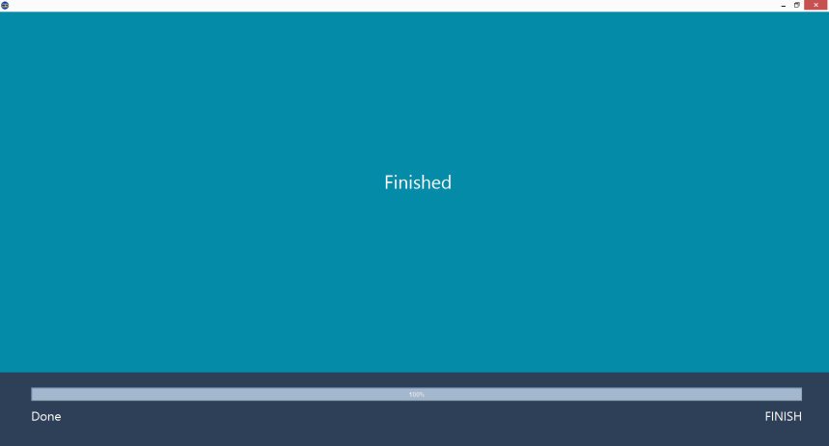

1. Now Login to system to evaluate the volley ball

# Login to the system

Two kinds of the login provided in the PES-VB

**Local Login :**

User is logged into his/her own PES-VB application which is install on the user’s system

**Remote Login :**

User is logged into remote PES-VB application which is install on some other system not on users system.

## Local Login

1. User will enter his/her own user id and password
2. In Run as field default selected Run as PC1 (Don’t change it.)
3. In IP Address field keep IP address default selected.(Don’t Change it)
4. Click on “Login”.

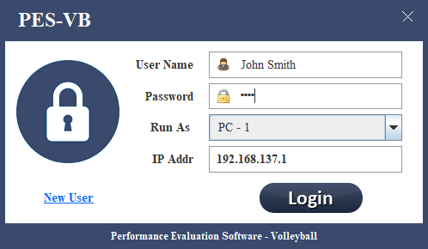

Keep Default. Don’t Change

## Remote Login

Remote login is used to connect two PC’s in LAN. For parallel evaluation of the two teams.

1. User will enter PC1 users User ID and password.
2. In run as field, select “PC2”.
3. In IP Addr field, Enter the IP Address of PC1(visible at PC1’s IP address Field).
4. Click on “Login”.

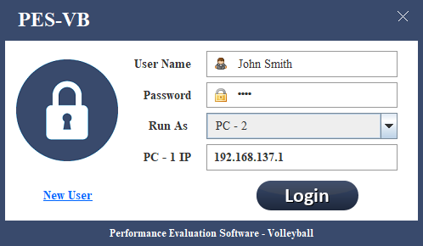

Enter PC-1’s IP Address

Select “PC-2”.

User ID and Password of PC1’s User

# Competition

User can create new competition in the application. Competition consist of matches and team. Each competition have teams and matches respectively.

## New Competition

1. Login to the Application
2. After successful login, Following window will open

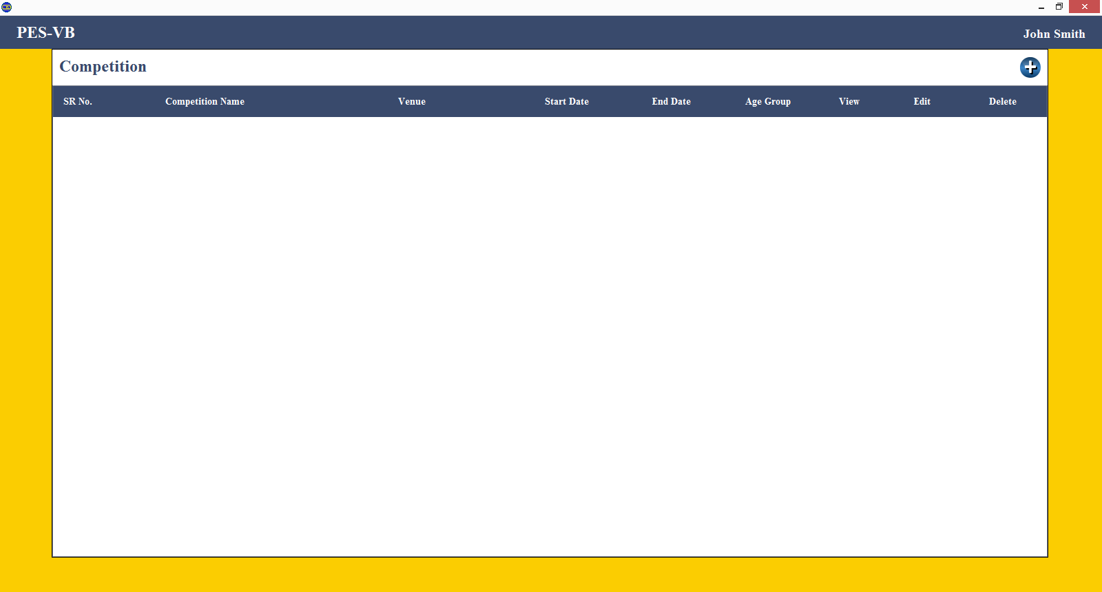

1. Click on C:\Users\#my\AppData\Local\Microsoft\Windows\INetCache\Content.Word\button (1).png icon



Click Here

1. New Competition window will open.

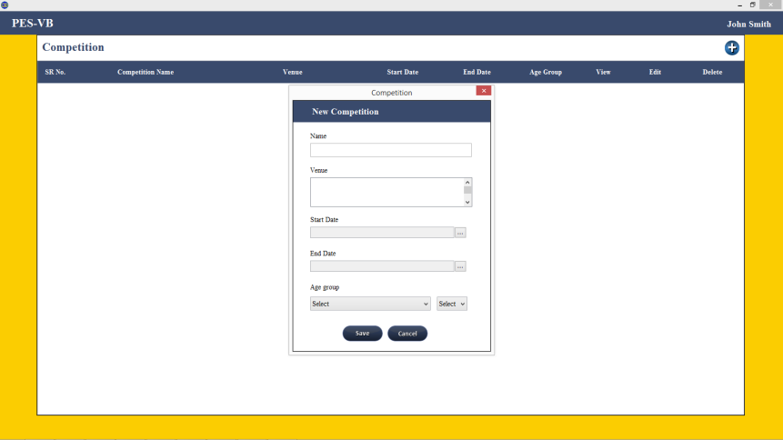

1. Following are the Fields on New Competition window
2. Name : Name of the Competition.(Mandatory)
3. Venue : Where the competition is held.(Mandatory)
4. Start Date : Start Date of competition.(Mandatory)
5. End Date : End Date of competition. (Mandatory)
6. Age Group : Two Types of Group. (Mandatory)
7. Open
8. Under : Subcategories are as follows
9. 14
10. 16
11. 18
12. 21

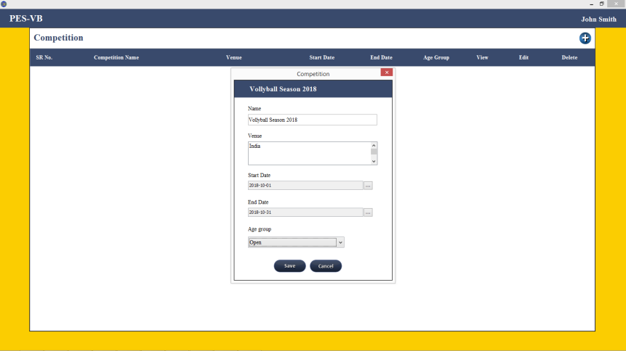

1. Click on “Save” button
2. On Successful creation of the competition, It will give “Competition <name> Created Successfully” message.

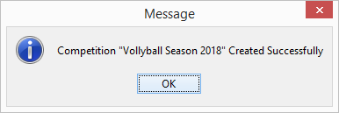

1. Click on “OK” Button
2. Newly Created competition is now added on competition home screen.

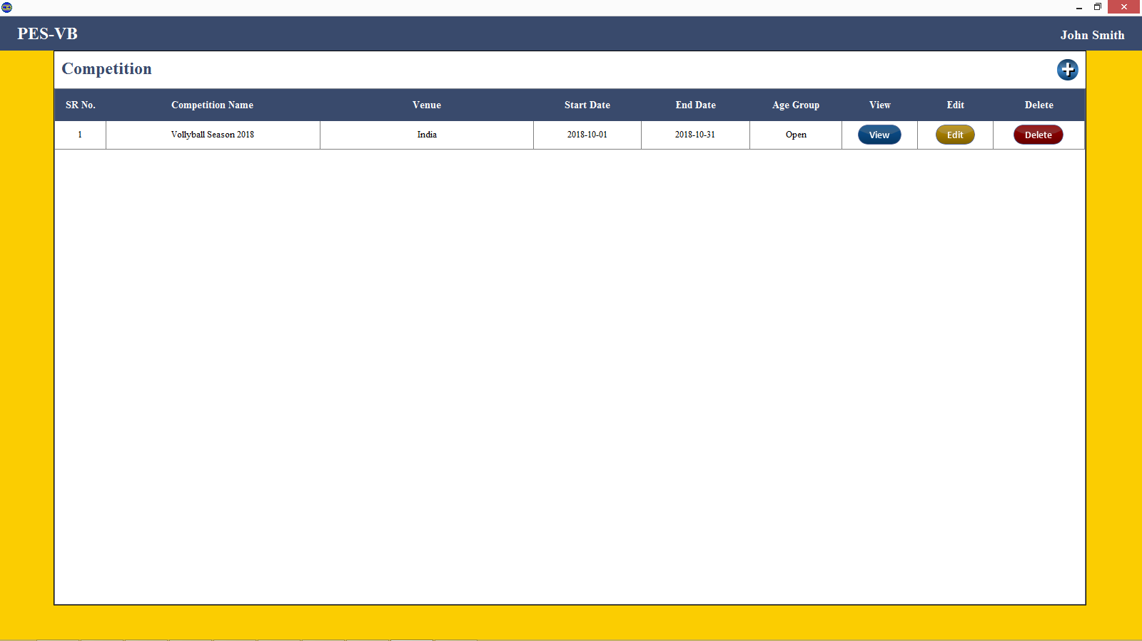

## Edit Competition

In edit competition, user can edit the existing competition. User can able to change the name, venue, start date, end date and age group. All the Fields are editable.

Steps to Edit competition

1. Click on “Edit” button of respective competition .



Click Here

1. Edit Competition window will open.

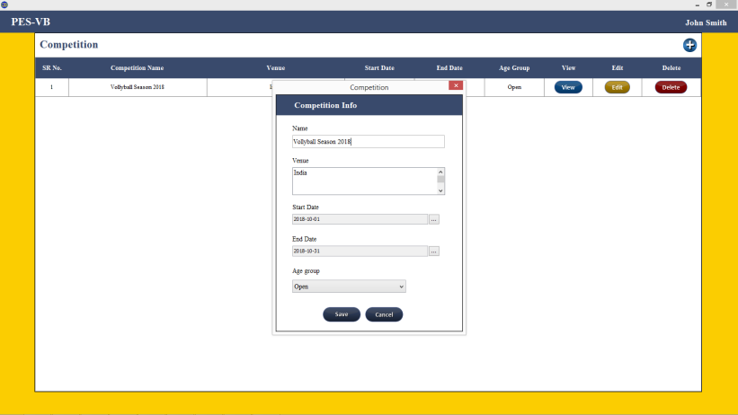

1. Edit the required fields

* Name : Name of the Competition.(Mandatory)
* Venue : Where the competition is held.(Mandatory)
* Start Date : Start Date of competition.(Mandatory)
* End Date : End Date of competition. (Mandatory)
* Age Group : Two Types of Group. (Mandatory)

1. Open
2. Under : Subcategories are as follows
3. 14
4. 16
5. 18
6. 21

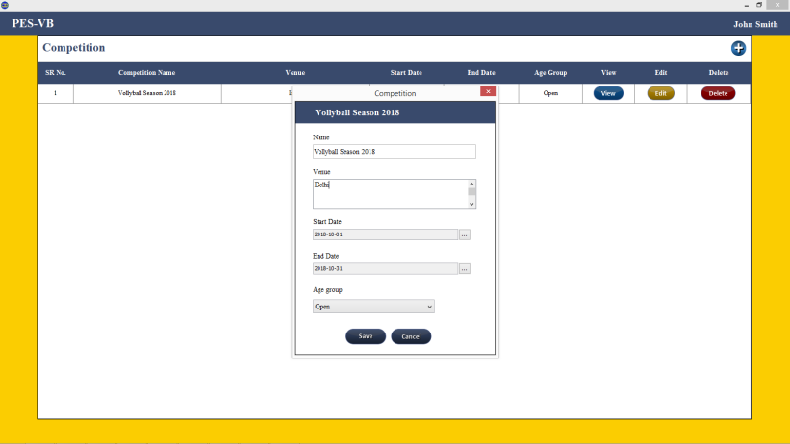

Changed to **Delhi** from **India**

1. Click on “Save”.
2. On successful editing of competition, it will shows message as “Updated Competition <Competition name> “

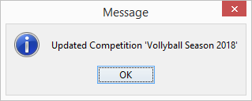

1. Changes Will reflected in the list of competition.

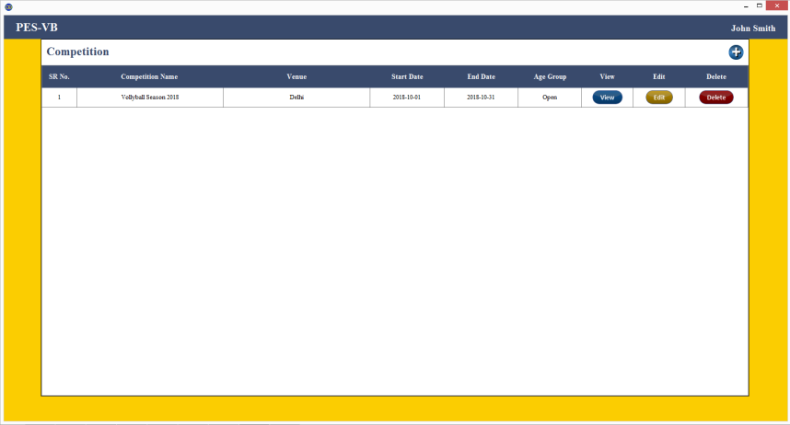

## Delete Competition

User can delete the competition from the application. On click of delete it will ask one time for user confirmation. On deletion of the Competition, all the matches, teams and players of that competition is also deleted. Once competition is deleted it can not be restored by user, Contact support team for restoration of competition.

Steps to delete competition

1. Click on “Delete” button of respective competition .



Click Here

1. It will ask for user confirmation only once as “Are you sure want to delete <Competition name>”

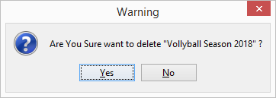

1. Click on “Yes” to confirm else “No”
2. On successful delete, success message is shown “Competition deleted Successfully”.

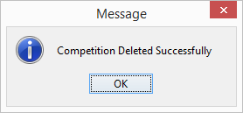

1. On successful delete, the competition is not visible in competition list.

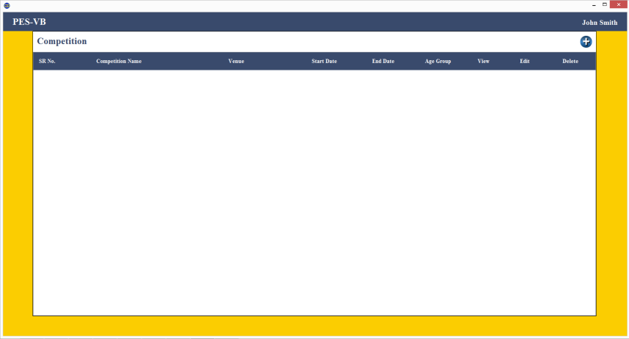

Competition Deleted successfully

# Team

Each Competition has their own teams. Team consist of players (minimum 7 and maximum 14), coach, assistant coach, trainer, medical officer and analyzer. Team name in competition must be unique.

## New team

New Team window consist of two tabs Team Tab and Player Tab. In Team tab add details of team name and names of coach, assistant coach, trainer, medical officer and analyzer. In player tab add player name , position of the player and is captain.

**Steps to Create Team**

1. Click on “View” button of corresponding “Competition”

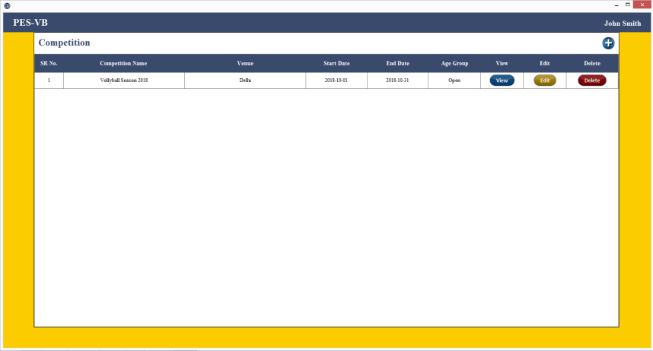

Click Here

1. Click on “Teams” tab

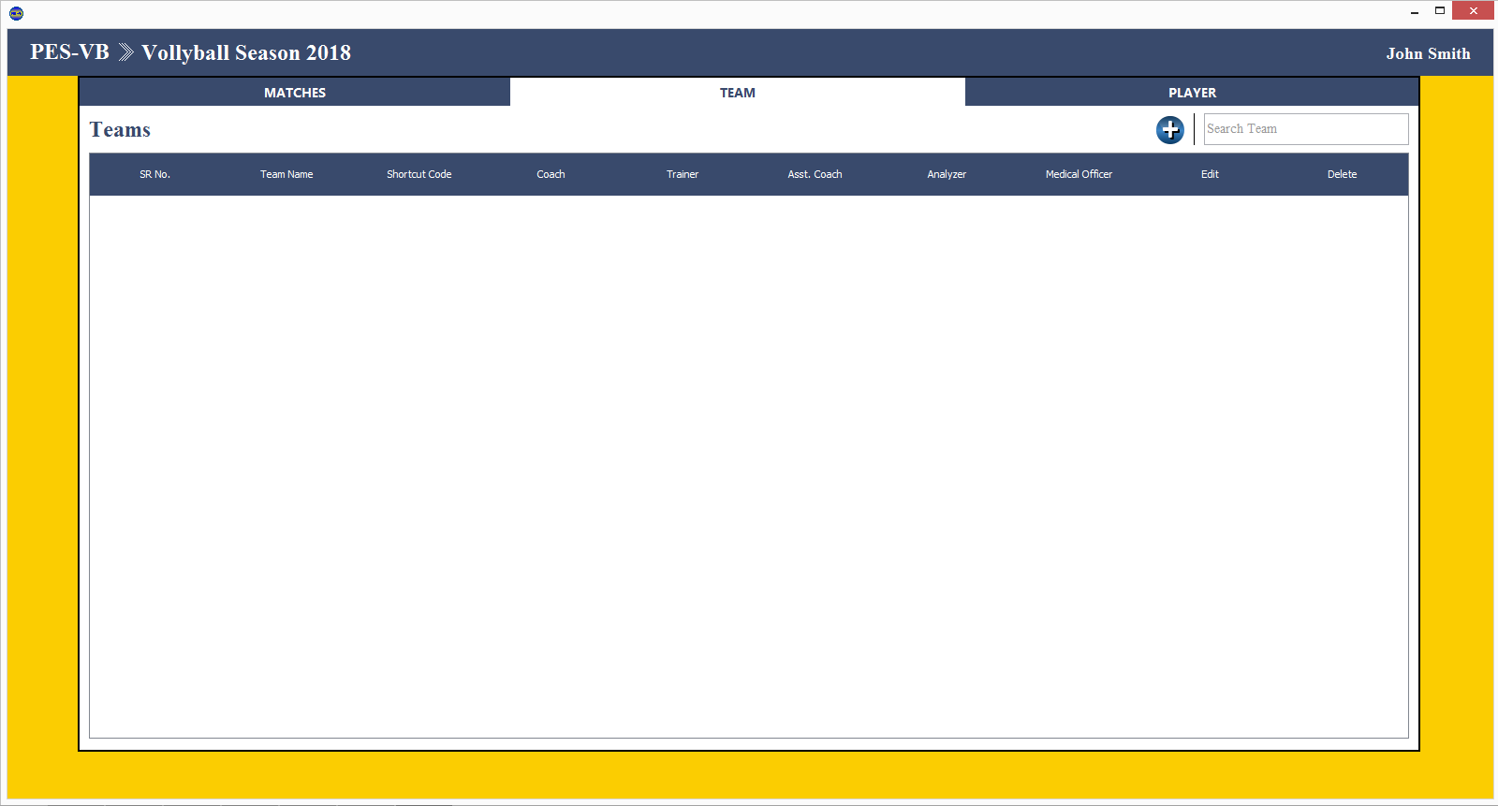

Click Here

1. Click on C:\Users\#my\AppData\Local\Microsoft\Windows\INetCache\Content.Word\button (1).png button icon



Click Here

1. Following New Team window will open

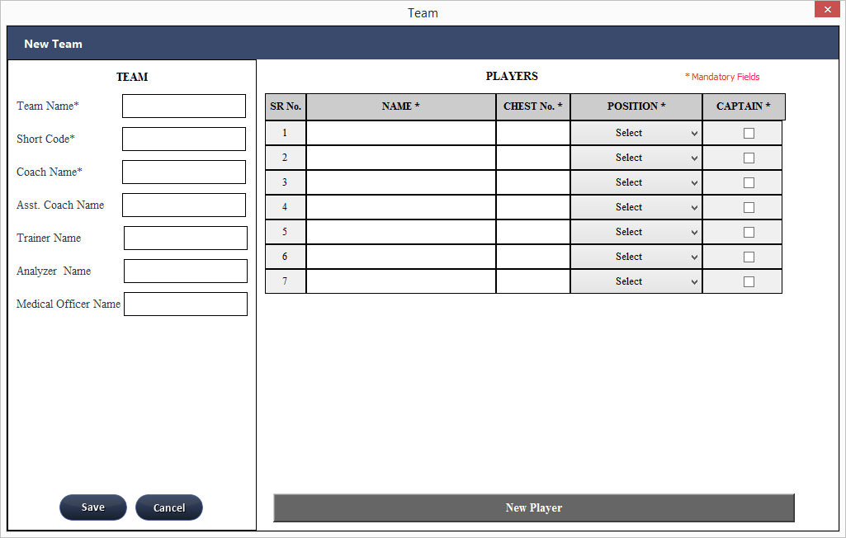

1. Fields on Team Tab
2. Team Name : Name of the team. (Mandatory)
3. Short Code : Short form of the team name. (Mandatory)
4. Coach Name : Coach Name of the team. (Mandatory)
5. Asst. Coach Name : Asst. Coach Name of the team.
6. Trainer Name : Trainer name of the team.
7. Analyzer Name : Analyzer name of the team.
8. Medical Officer : Name of Medical Officer of the team
9. Fields on Player Tab

In team there are 7 minimum player and maximum 14 players are allowed. And there is only one captain allowed in team.

* + 1. Name : Name of the player. (Mandatory)
    2. Chest No : Jersey Number of the player. (Mandatory and Unique)
    3. Position : Position of the player in the team. (Mandatory)
    4. Captain : Select if player is the captain.
* Only 7 players are by default viewed if user wants to add more players then click on “New Player”

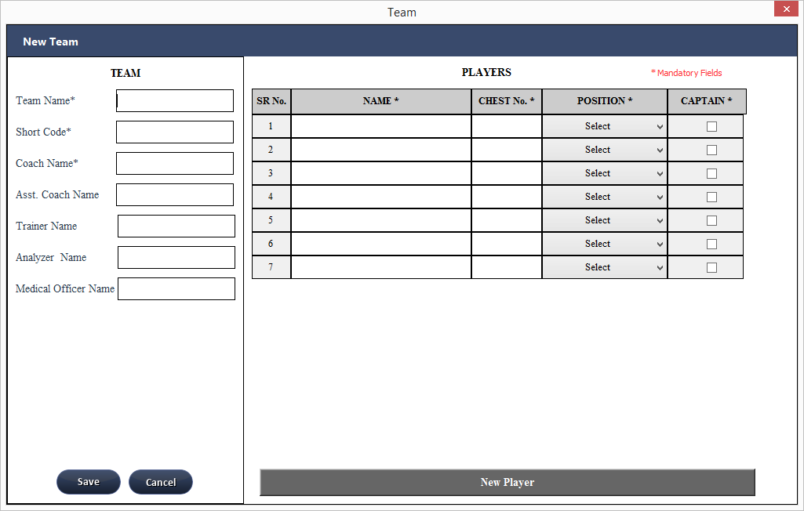

Click Here

* It will add one row for player

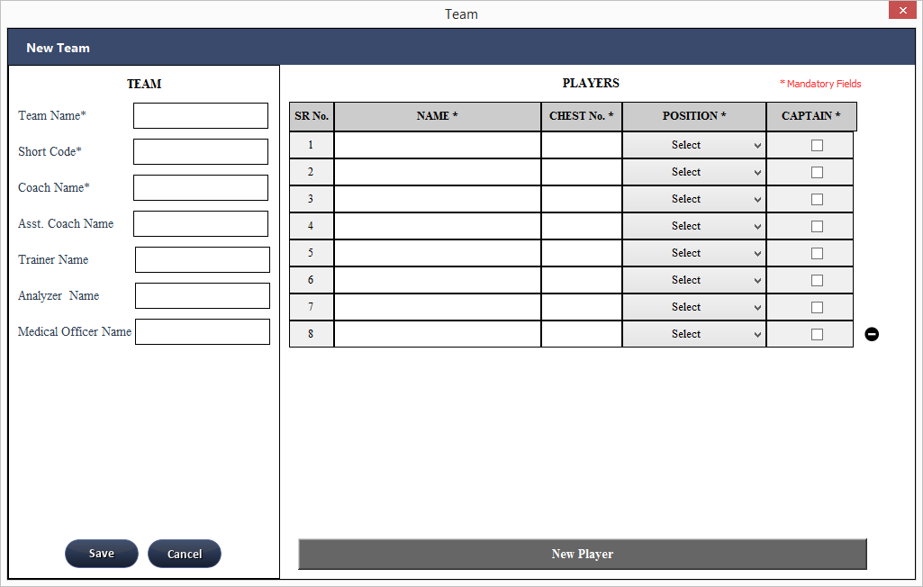

Added One row for player

* If user wants to delete the last row then click on “-”



Click here to delete last player

1. Enter All the mandatory fields and click on “Save”

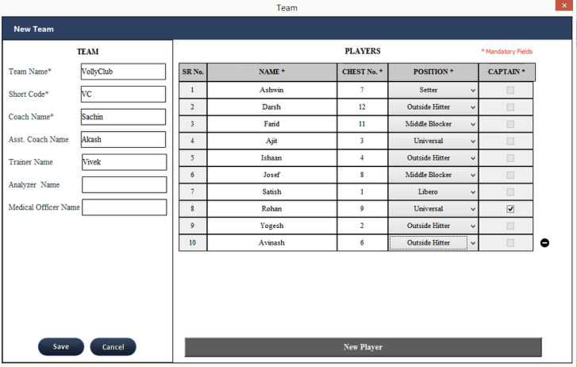.

Click Here

1. On Successful creation of team it shows message as “Team <team Name> Created Successfully”.

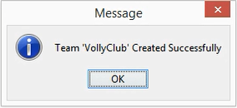

1. Newly created team is visible in Team’s tab team list window

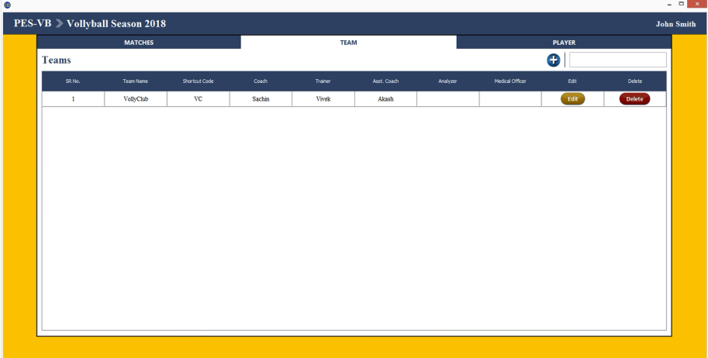

Newly Created Team

## Edit Team

In edit team user can edit the basic team information. Fields editable on forms are : team name , shortcut code and names of coach, assistant coach, trainer, medical officer and analyzer. After successful edit of the team the changes will reflect in team list.

**Steps to edit team**

1. Click on “Edit” button of respective team from team list

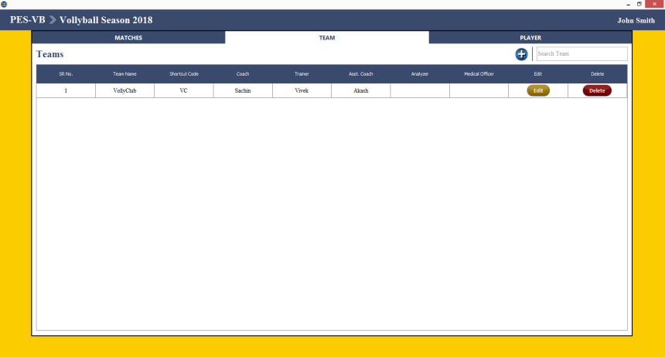

1. Following Team Info window will open.

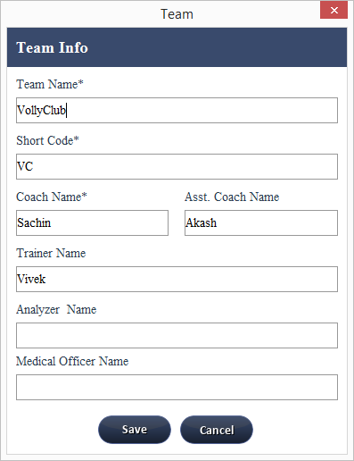

1. Edit required fields
2. Team Name : Name of the team. (Mandatory)
3. Short Code : Short form of the team name. (Mandatory)
4. Coach Name : Coach Name of the team. (Mandatory)
5. Asst. Coach Name : Asst. Coach Name of the team.
6. Trainer Name : Trainer name of the team.
7. Analyzer Name : Analyzer name of the team.
8. Medical Officer : Name of Medical Officer of the team

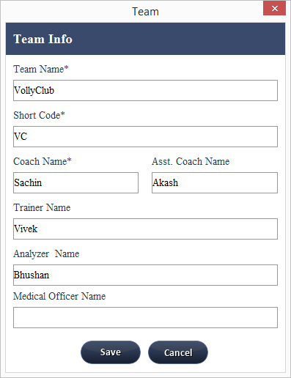

1. Click on “Save”
2. On successful editing of team, it will shows message as “Team Updated Successfully“.

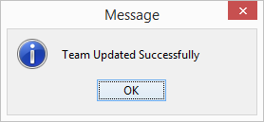

1. Changes Will reflected in the list of teams.

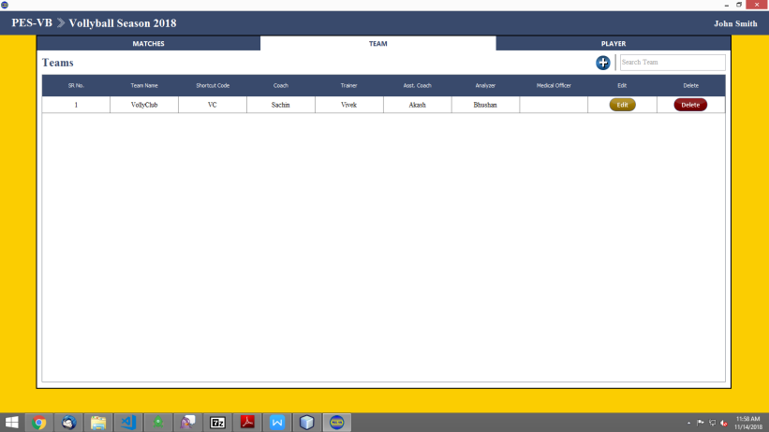

## Delete Team

User can delete the team from the competition. On click of delete it will ask for user confirmation only once. On deletion of the team, team and players of respective team will also be deleted. Once team is deleted it can not be restored by user, Contact support team for restoration of team.

Note : We recommend not to delete team if there is a match scheduled for that team.

**Steps to delete team**

1. Click on “Delete” button of respective team

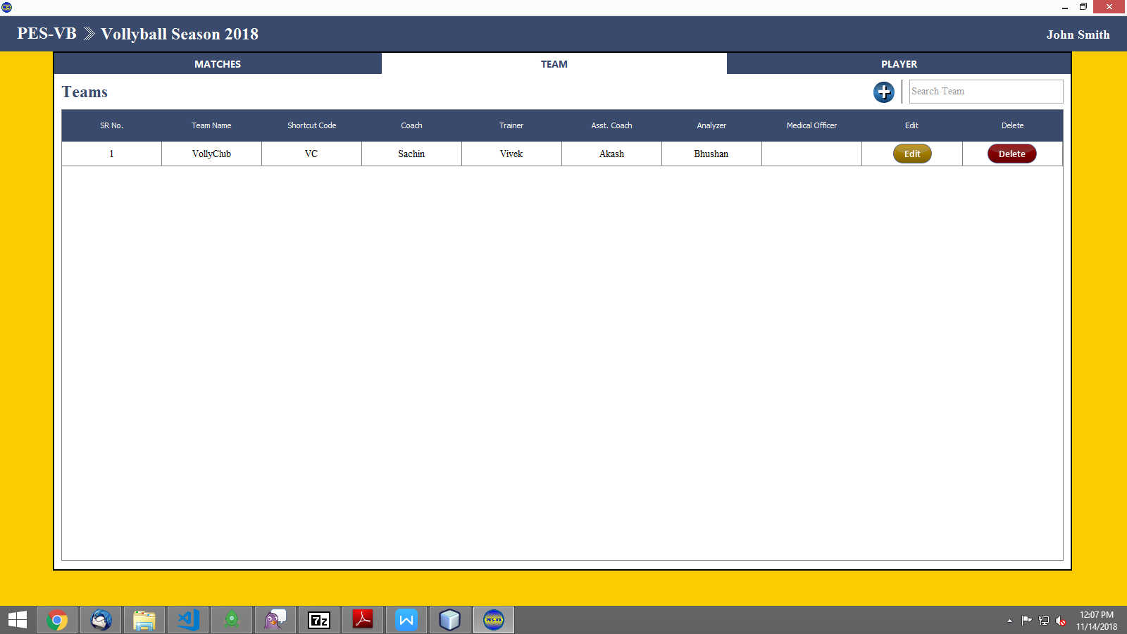

1. It will ask for user confirmation only once as “Are you sure want to delete <team name>”

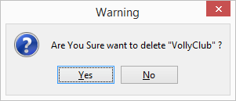

1. Click on “Yes” to confirm else “No”
2. On successful delete, success message is shown as “Team deleted Successfully”.

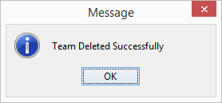

1. On successful delete, the team is not visible in team list.

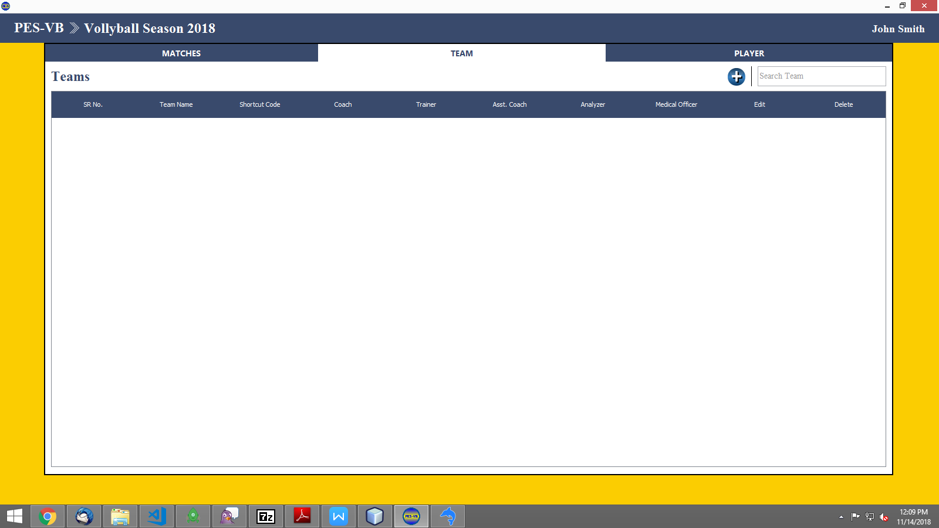

# Player

Each Competition has their own teams and respective players. User can add player from player tab but before adding player, respective team of the player should be created. User can view the player info, edit the player and can delete the player from the player tab. Once the player is deleted it can not be restored.

## New Player

User can add new player but before adding the player, team of the player should be already created.

Steps to create player

1. Click on C:\Users\#my\AppData\Local\Microsoft\Windows\INetCache\Content.Word\button (1).png button icon

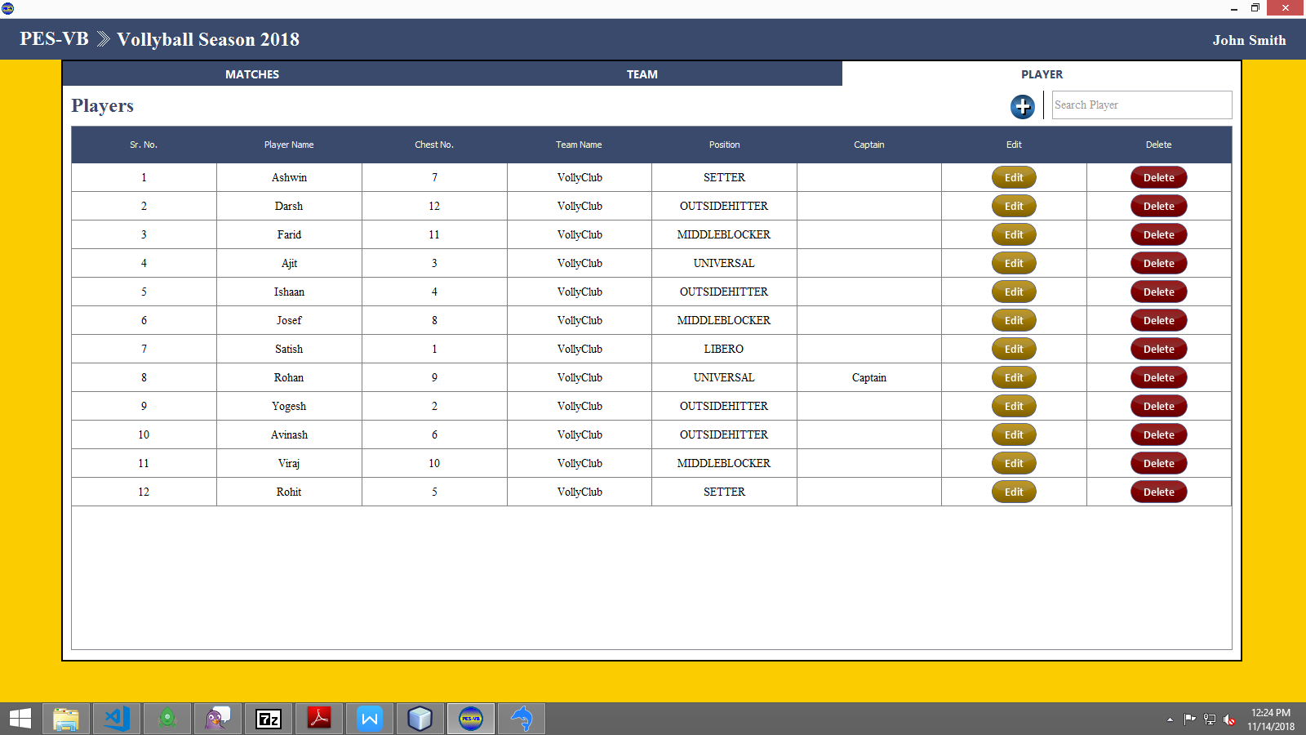

1. Following New Player window will open

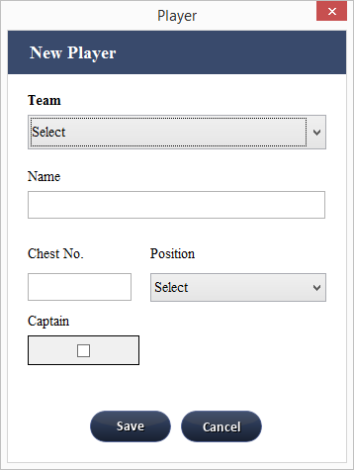

Fields on New Player tab

Team : Name of the team in which player need to added. (Mandatory)

Name : Name of the Player. (Mandatory)

Chest No: Jersey number of the player. (Mandatory and unique)

Position : Position of the player in the team. (Mandatory)

Captain : If there already captain present it in team then it will not allow user to select the captain player as captain. If user wants to make new player as captain then edit old captain player remove his/her captainship and new player as captain

1. Enter All the mandatory fields and click on “Save”

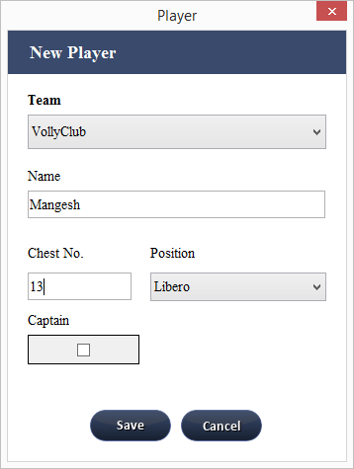

On Successful creation of player it shows message as “Player <Player Name> Added Successfully”.

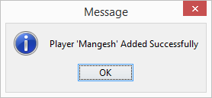

1. Newly created player is visible in player list

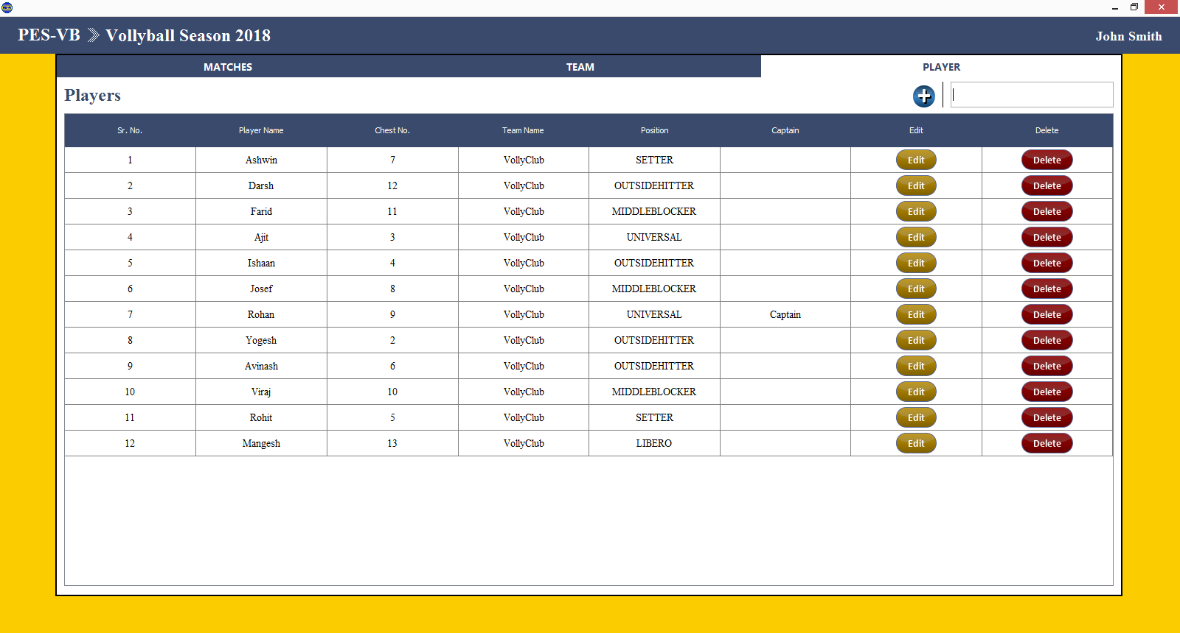

## Edit Player

Steps to edit player

1. Click on “Edit” button of respective player from player list



1. Following Player Info window will open.

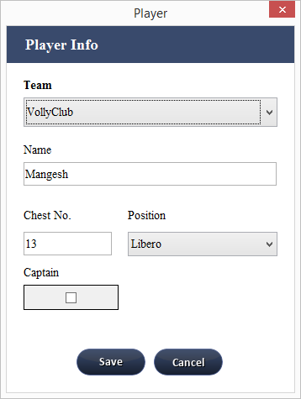

1. Edit required fields

Fields on Player info tab

Team : Name of the team in which player need to added. (Mandatory)

Name : Name of the Player. (Mandatory)

Chest No: Jersey number of the player. (Mandatory and unique)

Position : Position of the player in the team. (Mandatory)

Captain : If there already captain present it in team then it will not allow user to select the captain player as captain. If user wants to make new player as captain then edit old captain player, remove his/her captainship and new player as captain

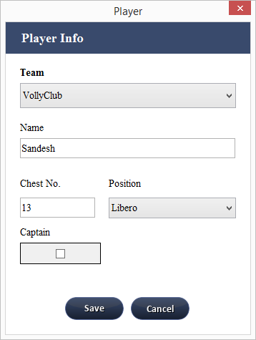

1. Click on “Save”
2. On successful editing of player, it will shows message as “Player <Player name > Updated Successfully“.

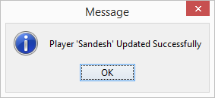

1. Changes Will reflected in the list of players.

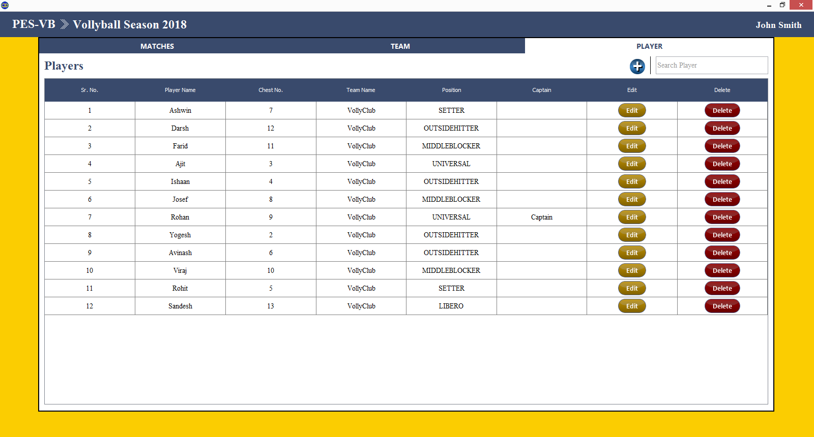

## Delete Player

Steps to delete player

1. Click on “Delete” button of respective player

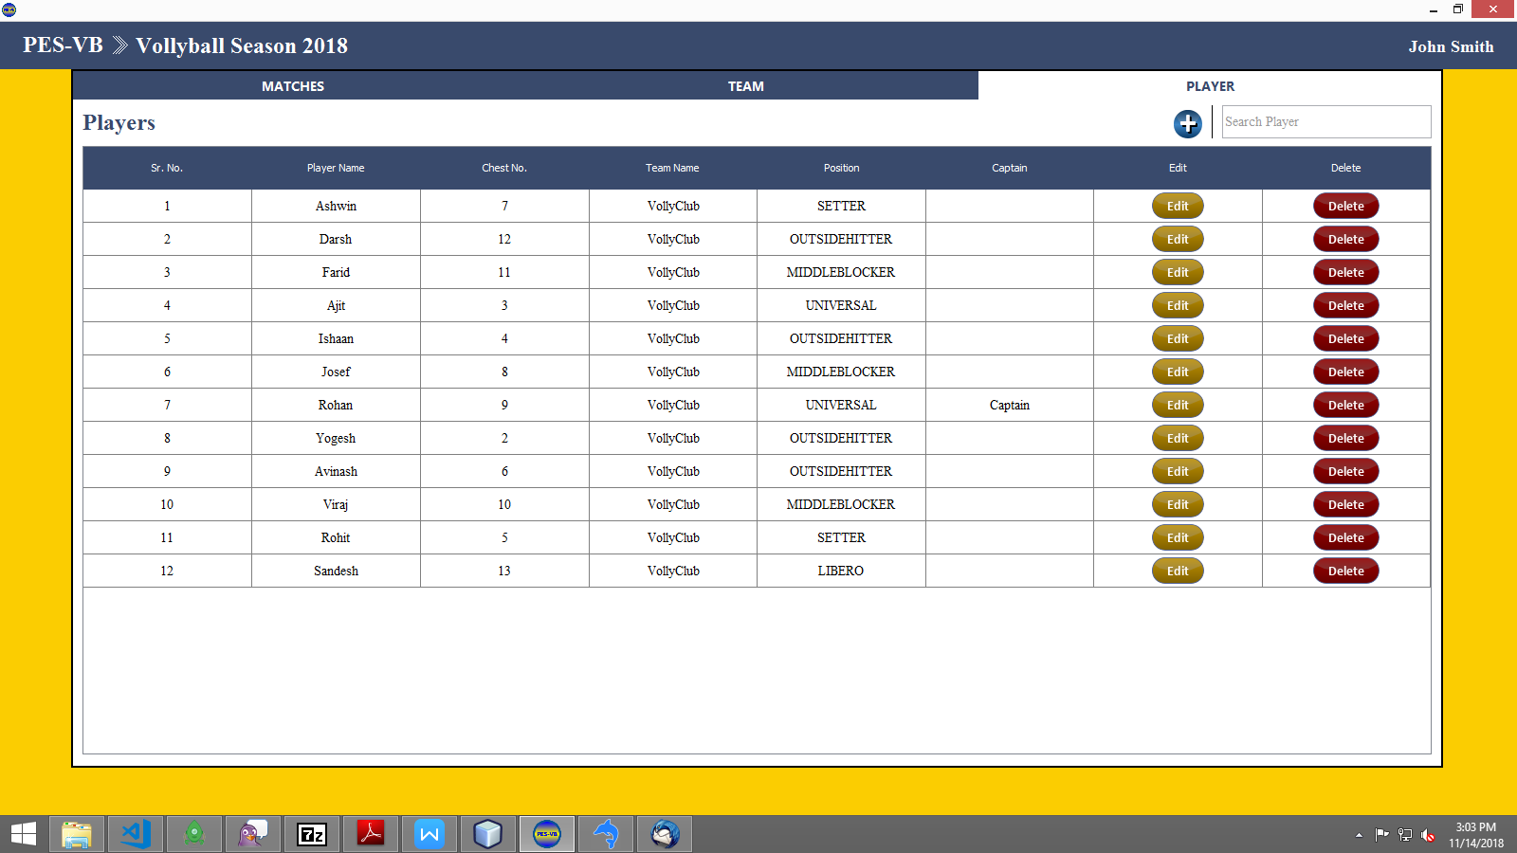

1. It will ask for user confirmation only once as “Are you sure want to delete <player name>?”

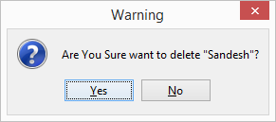

1. Click on “Yes” to confirm else “No”
2. On successful delete, success message is shown as “Player deleted Successfully”.

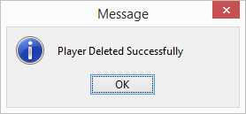

1. On successful delete, the player is not visible in player list.

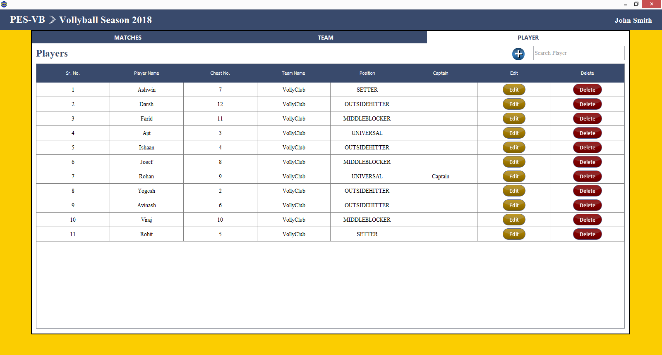

# Match

## New Match

Steps to create Match

1. Click on C:\Users\#my\AppData\Local\Microsoft\Windows\INetCache\Content.Word\button (1).png button icon

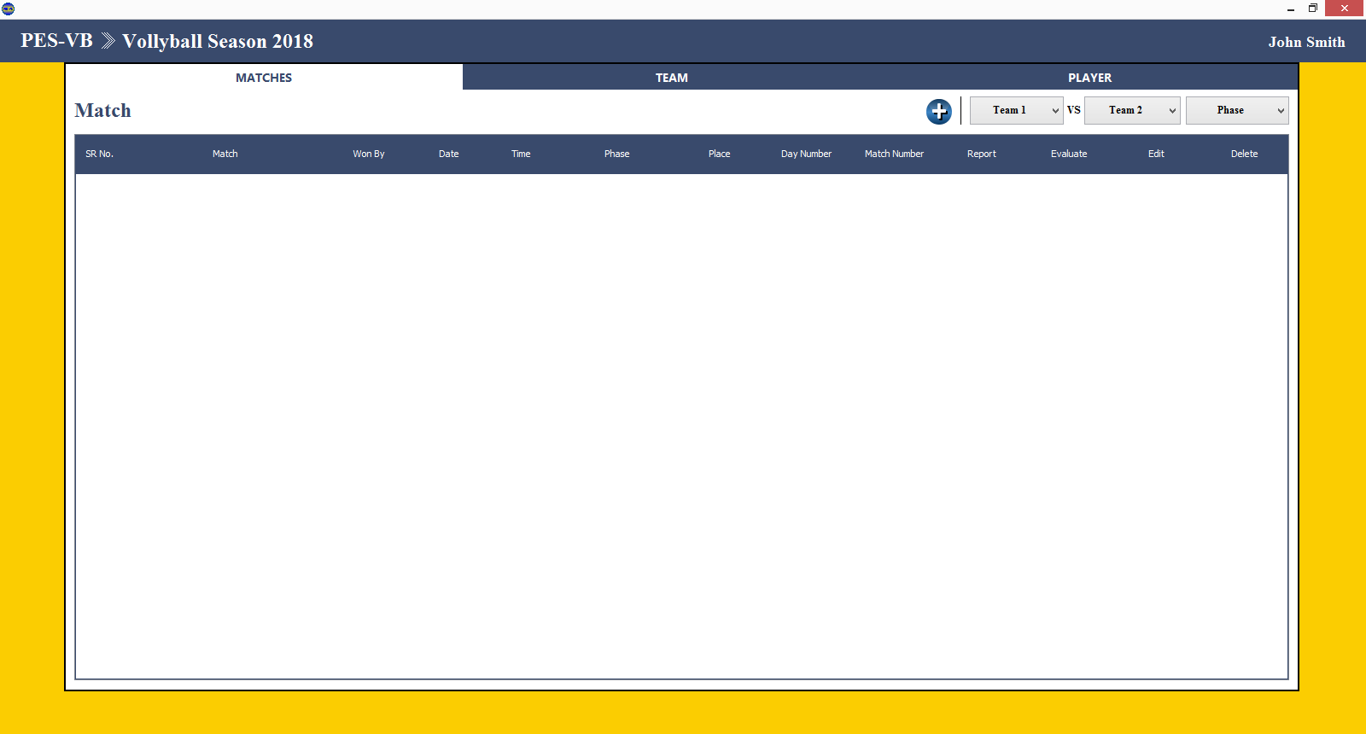

Following window will open

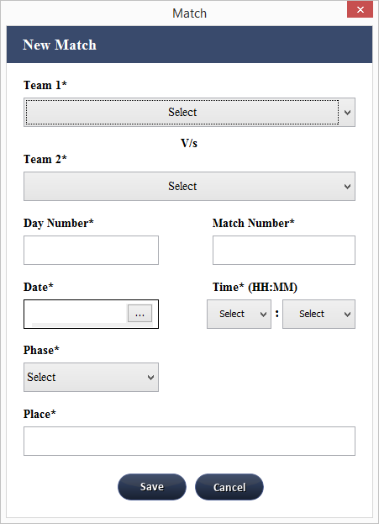

Fields on New Match window

Team 1: Name of First Team. (Mandatory)

Team 2: Name of Second Team. (Mandatory)

Day Number : Day Number of when match is scheduled in competition. (Mandatory)

Match Number : Match number when match is scheduled in a day. (Mandatory)

Date : Date when match is scheduled. (Mandatory)

Time : Time of the match in a day. (Mandatory)

Phase : Phase of the match . (Mandatory)

Final

Semi Final

Third Place

Quarter Final

Pre Quarter Final

Pool

Place : Place where the match is being held.

1. Enter All the mandatory fields and click on “Save”

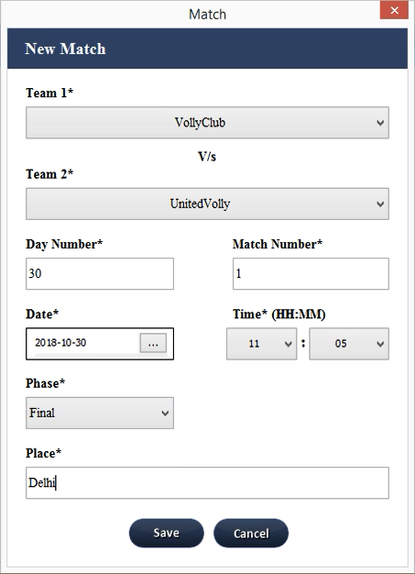

1. On Successful creation of match it shows message as “Added New Match <Team1> vs <Team2>”.

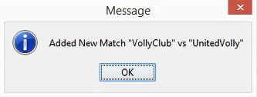

1. Newly created match is visible in match list

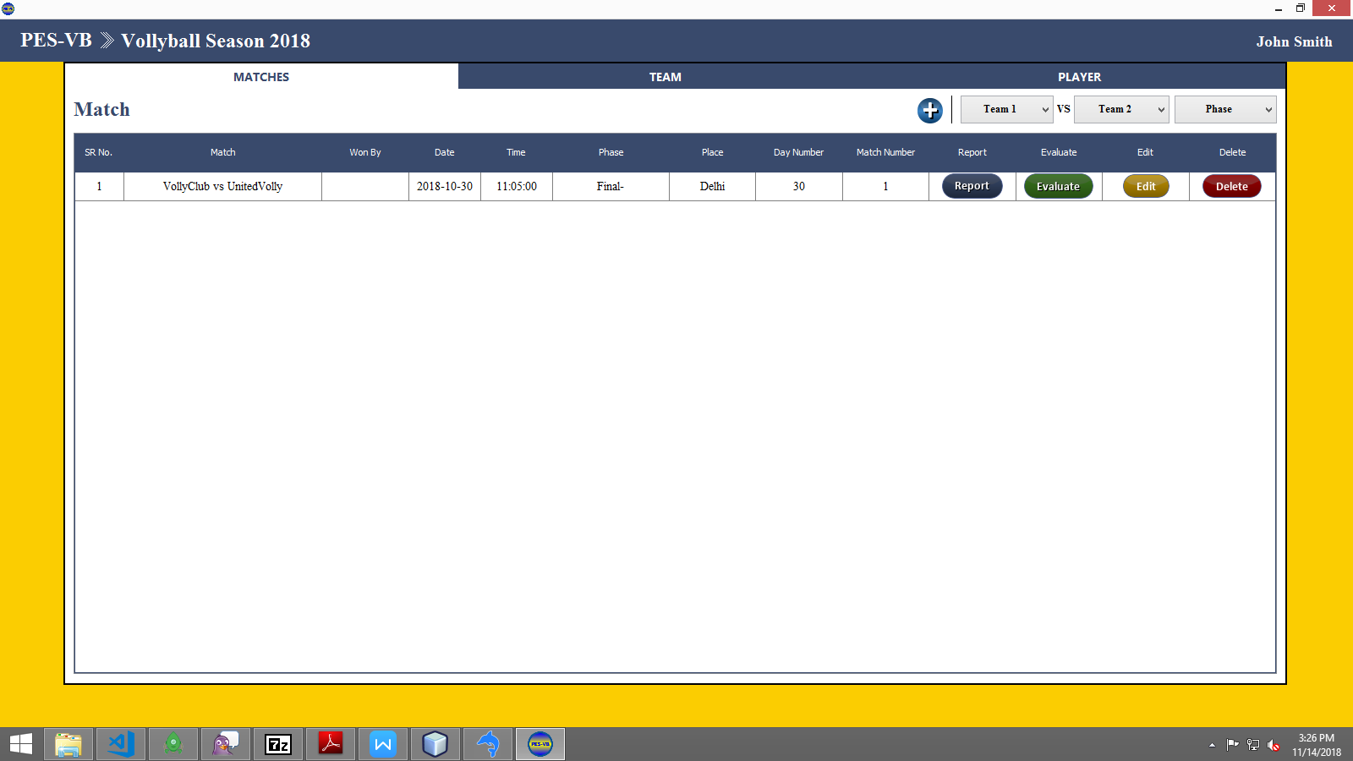

## Edit Match

Steps to edit match

1. Click on “Edit” button of respective match from match list

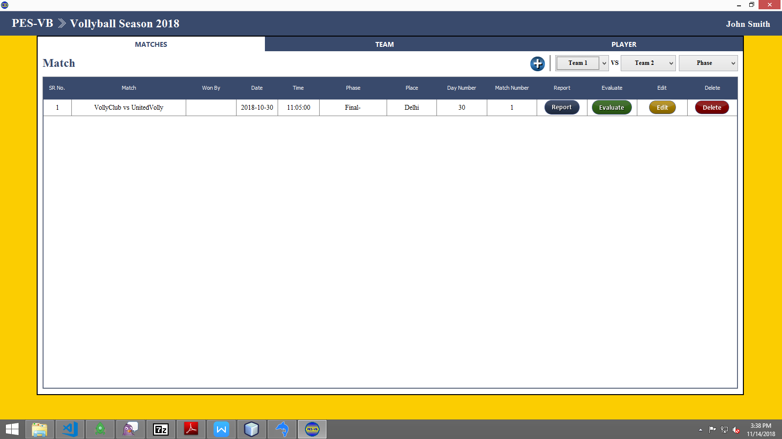

1. Following match Info window will open.

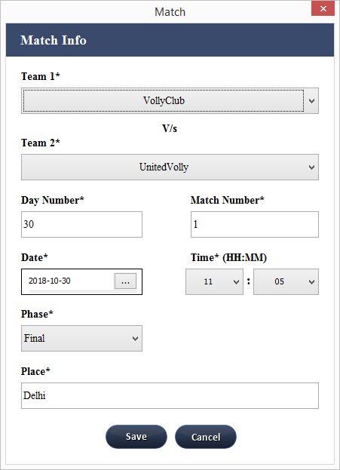

1. Edit required fields

Fields on Match Info window

Team 1: Name of First Team. (Mandatory)

Team 2: Name of Second Team. (Mandatory)

Day Number : Day Number of when match is scheduled in competition. (Mandatory)

Match Number : Match number when match is scheduled in a day. (Mandatory)

Date : Date when match is scheduled. (Mandatory)

Time : Time of the match in a day. (Mandatory)

Phase : Phase of the match . (Mandatory)

Final

Semi Final

Third Place

Quarter Final

Pre Quarter Final

Pool

Place : Place where the match is being held.

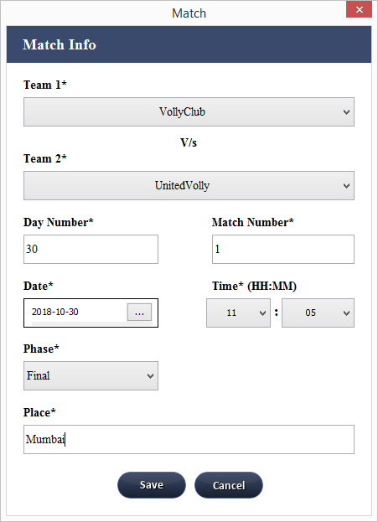

1. Click on “Save”
2. On successful editing of player, it will shows message as “Updated Match <Team 1 > vs <Team2>“.

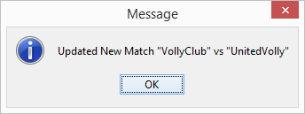

1. Changes Will reflected in the list of players.

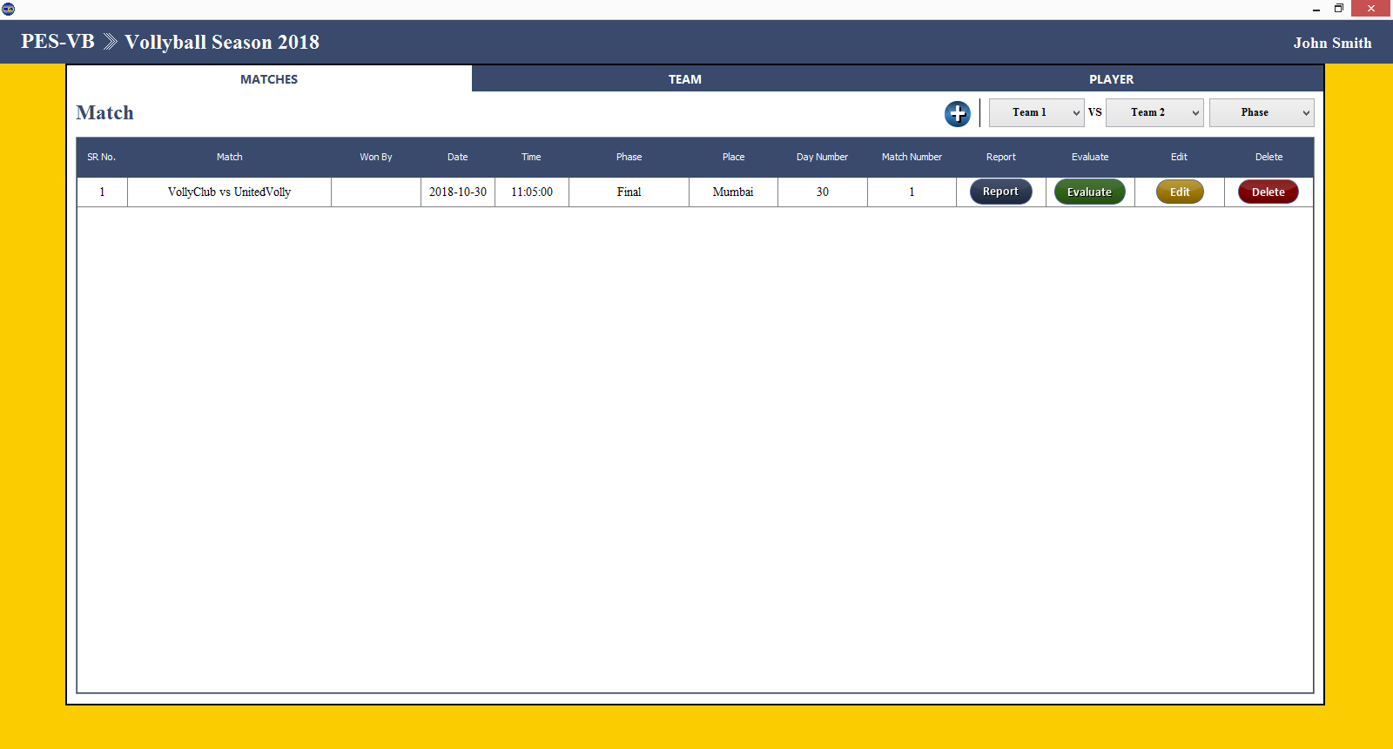

## Delete Match

Steps to delete match

1. Click on “Delete” button of respective match



1. It will ask for user confirmation only once as “Are you sure want to delete <team 1> vs <team 2>?”

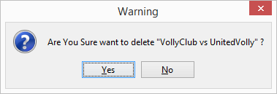

1. Click on “Yes” to confirm else “No”
2. On successful delete, success message is shown as “Match deleted Successfully”.

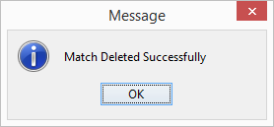

1. On successful delete, the match is not visible in match list.



# Keyboard Shortcuts

PES-VB allows user to personalise the keyboard shortcut keys to insert certain information command, to help and speed up the evaluation process. For example, by using a **shortcut key** inside the evaluation window, the program will automatically insert the associated code.

To open the keyboard shortcut

Click on User name

Click on Settings

The shortcuts are preset by the program, but user can define own shortcut codes before starting of the evaluation,user need to define the corresponding commands for detail evaluation.

PES-VB provides some non editable shortcut keys for Skill and Score. Which can not be changed by user or it can not be used for other shortcuts.

Following are the default non editable Shortcut keys

For Skill

|  |  |
| --- | --- |
| Skill | Key |
| Service | Q |
| Reception | W |
| Attack | E |
| Set | R |
| Block | T |
| Defence | Y |
| OP+ | U |
| TF- | I |

For Score

|  |  |
| --- | --- |
| Score | Key |
| 1 | Z |
| 2 | X |
| 3 | C |
| 7 | V |
| 5 | B |

User can edit shortcut keys by clicking editing value of the respective command.

The following window will appear. User have to fill the appropriate field with the new shortcut for the selected command.

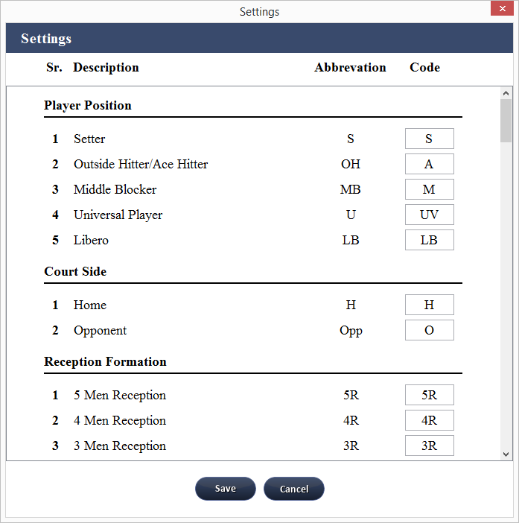

# Evaluation

## Steps to evaluate match

1. Click on “Evaluation” button of respective match

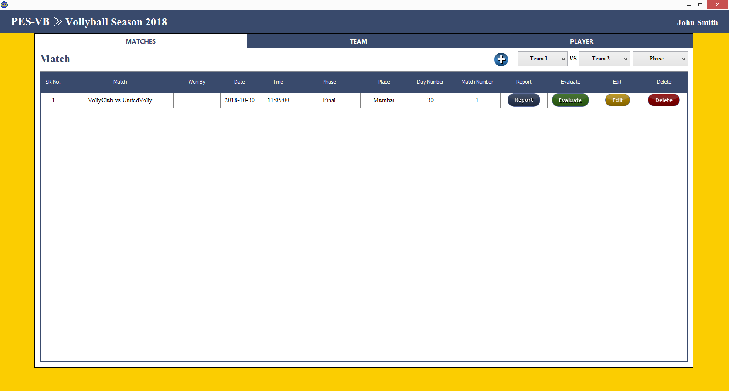

1. Select Team which you want to evaluate

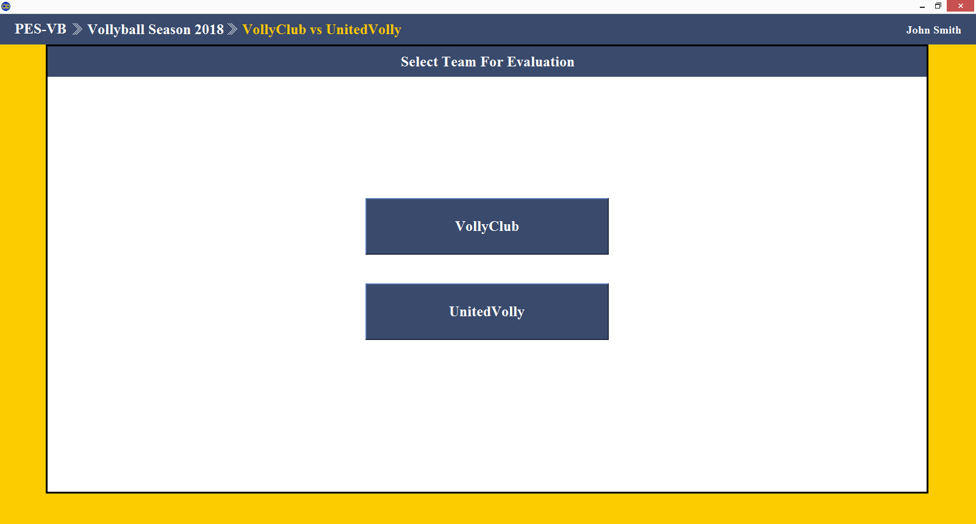

1. Select Set

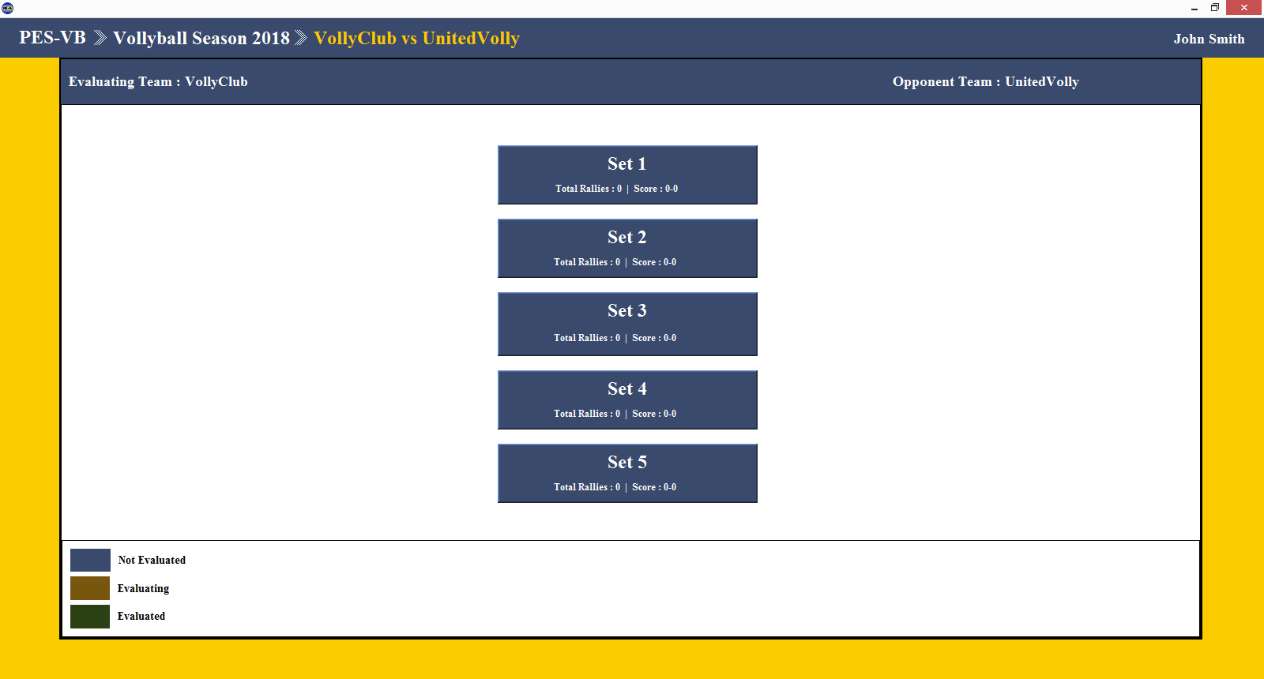

1. Select Initial Rotation Order and enter evaluator name

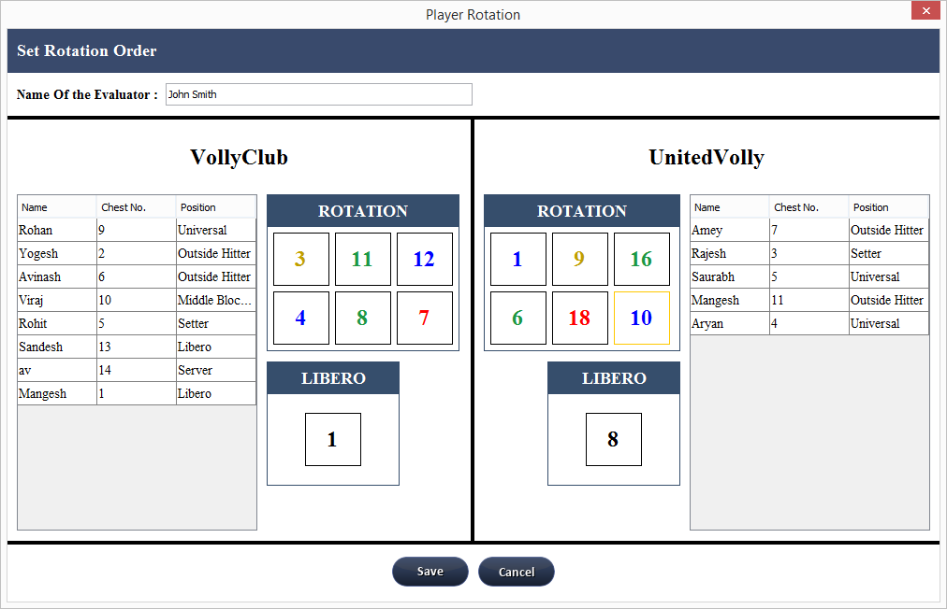

1. Following evaluation window will open

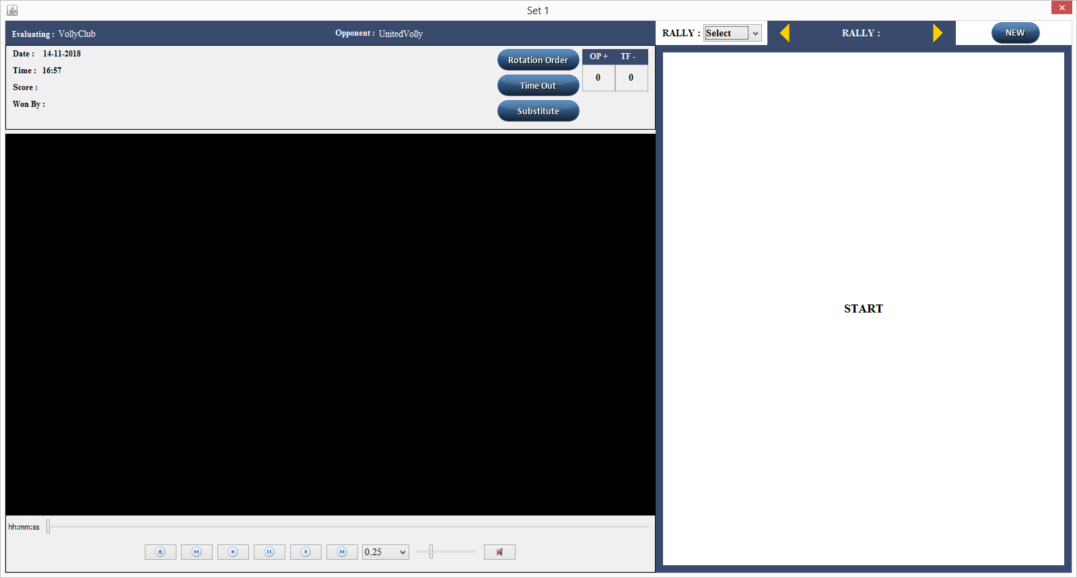

Evaluation Window

Evaluation window is divide into two parts

1. Main Window
2. Rally Window

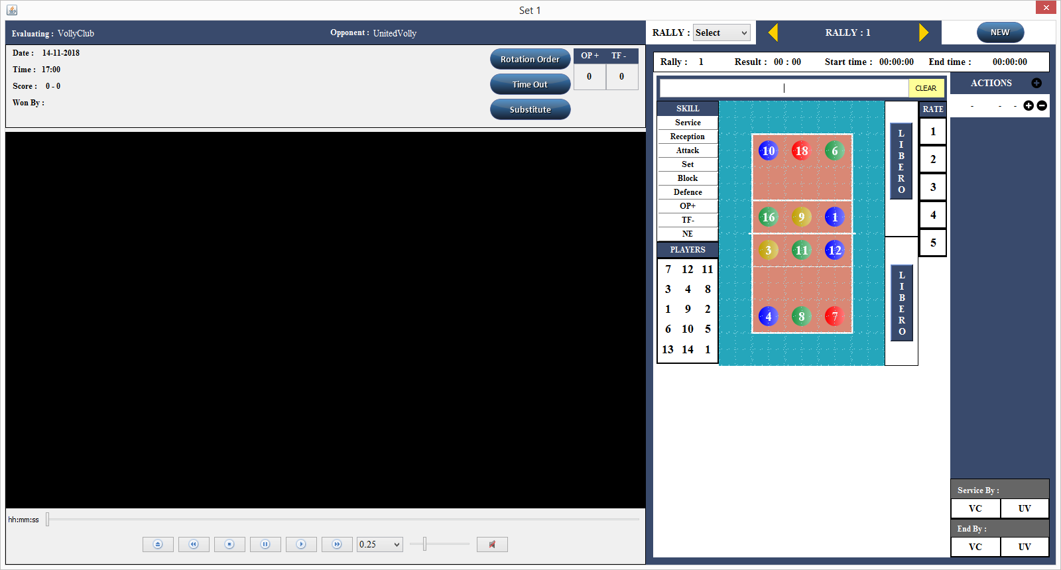

1. Rally Window
2. Main Window

Main window consist of video player and the overall score and date time of the match

Rally window consist of details of the individual rally.

# Evaluating a Match

The evaluation allows evaluator to quickly transform the action performed by the team players in a *standard code* analyzed by the evaluator. The evaluation can be made for one or both teams.

User type the code inside the evaluation Window through the keyboard. User have to type a multiple number of codes for each skill, depending on the accuracy of the analysis required. The type of evaluation to be made is depends on the evaluator choice:

Brief Evaluation : 3 required keys

1. Skill
2. Chest No.
3. Rate

Detail Evaluation : Minimum 3 Keys are required as brief evaluation with additional keys for start zone and landing zone and the detail values keys depends upon the skill.

Before starting to evaluating the match it is important to know the evaluation type and code used by PES-VB for each evaluation.

Brief Evaluation

In brief evaluation, Evaluator enter only minimum three keys for skill, chest no and for rate of the action performed by the player. Brief evaluation is most likely used for LIVE match evaluation. It is faster than the Detail evaluation.

The pattern for evaluating the match is Skill-chestno-rate. Evaluator enters the keys in the evalution bar present on the rally window.



After each key, evaluator will press the enter button present on the keyboard eg. Sequence would be (skill key [Enter] chest no [Enter] rate [Enter]). While evaluating PES-VB will convert enter symbol in eiphen “-” symbol eg. If evaluator enter the sequence of key code as [q][Enter][7][Enter][x][Enter] the code in evaulation bar will look like q-7-x.

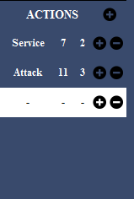

The Enter button pressed after the rate, PES-VB will end that action and new action window will open in the rally window. The current action is listed in the action list bar. In action bar PES-VB will convert the key into its respective skill or rate.

After the scoring rate (1 or 5) enter by the evaluator, PES-VB automatically end current rally and new rally window will open. Evaluator no need to explicitly save the current rally. The score of the team will be updated based on the rally win.

If in any case while continuing the action evaluator makes a mistake, the evaluator can press the clear button present on the evaluation bar and will again enter that action sequence.

If evaluator enters all the detail of the action and that action is saved in action bar but later evaluator comes to know that there is some mistake in action then evaluator will select that action. And click on Edit button on the evaluation bar.



On click of the edit, evaluator can change the chest no or rate of the action but Skill is not editable in PES-VB. If there mistake in skill then evaluator need to delete that action and need to add new action for the skill.

Action can be deleted by pressing [-] button present in front of the action in action bar.



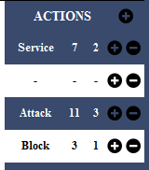To add new action evalutor need to click on [+] button of the upper rally where new action need to be added. Eg suppose there are two actions in the rally but evaluator miss the one action between the rally. Evaluator wants to add action after the 1st action then evalutor will click on [+] button of the first action and new action will be added after 1st action. Now evaluator can enter the new action details

Updation of the rally is not implicitly provided in the PES-VB, After editing the rally evalutor needs to click on the update button present on the action bar.



PES-VB provides one more feature “Missed Rally”

while evaluting the match if match is going faster than evaluation and evaluator missed the whole rally then evaluator only needs to enter the detail as which team serviced the rally and which teams ends that rally.

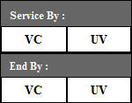

If evaluator, selects the home team as service by then that action is known as Service action and if evaluator, selects the opponent team as service by then that action is known as reception. Rate of the this start action is “0” and chest number will empty. Later evaluator can edit that action and enters the chest no and rate.

If evaluator, selects any of the team as end by of the rally then that action will be stored as NE as skill i.e. Not Evaluated but the score will be added as per the team selected. If home team as winning team of that action then rate will 5 else 1. Later to update this missed rally, evaluator need to delete the last NE action and need to add new action because skill is not editable in the PES-VB.

If evaluator, enters the starting actions of the rally but missed the other actions then evaluator needs to enter only the end by team of the rally explicitly. Later to update this missed rally, evaluator need to delete the last NE action and need to add new action because skill is not editable in the PES-VB.

Once the score of any team is greater than 25 and there is score difference between two team is greater than 2 then PES-VB implicitly ends that set and shows the result that score is homeScore : OppenentScore and won by winning team name.

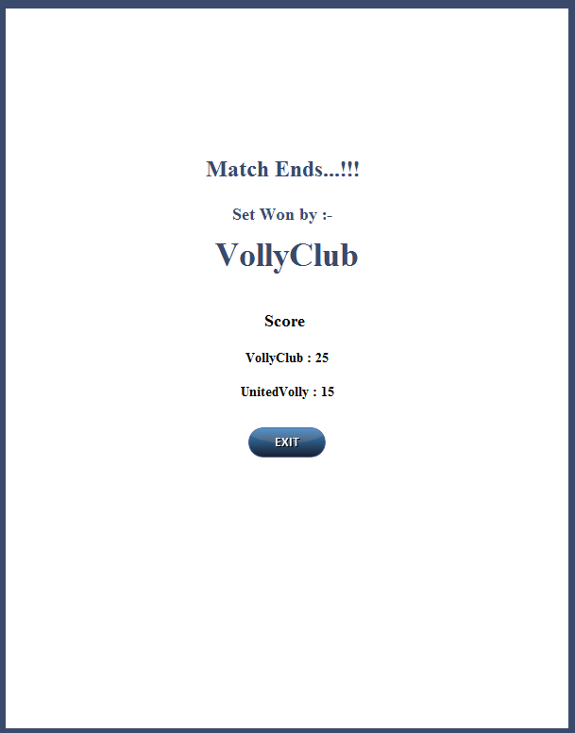

Evaluator can exit the set and start with new set or can view all the rallies one by one, by clicking the navigation arrows present on the navigation bar



Evaluator can extent the brief evaluation into the Detail evaluation in PES-VB. Once the match is over and evaluator needs more accurate result then evaluator can edit all the rally and its action and insert the detailed values in the system.

Detail Evaluation

Detail evaluation is the extension to the brief evaluation. In detail evaluation three main key(skill,ChestNo and rate) are mandotatory addition to that there number of keys for each skill. The process of entering the evaluation value is same as the brief evaluation but while evaluating evaluator will the enter the ball starting zone to ball ending zone addition to that detailed values for each skill.

Detail evaluation consist of ball Start zone, landed zone and reflected zones. The court is divided into two parts Opponent and Home separated by the net. Both of this court is then divided into 9 major parts, each part have one unique key. Each major part is subdivided into the 4 sub-parts A,B,C,D.

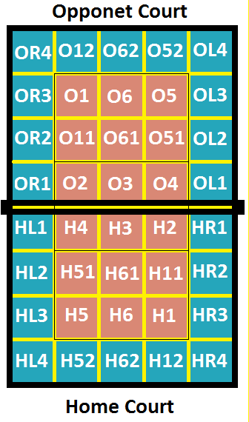The Main two parts of the court is

Home Court : H

Opponent Court : O

The home and Opponent court is divided into 20 parts from 1 to 6 zones and Left and Right outer zones.

Each division is then subdivided into 4 equal parts

|  |  |
| --- | --- |
| A | B |
| D | C |

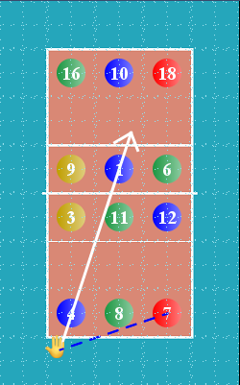

For example, if player chest no 7 serviced from back of zone 5 to opponent zone 6 near attack line then code will be Q-7-H52B-O61C.

Here in this diagram white arrow shows that ball is passed from H52A zone and landed on O61C zone i.e. near attack line.

The blue line in this diagram represents that the player has moved from his/her original position to the ball started zone.

Another detail evaluation consist of skill wise keys. Each skill have their respective description criteria. Some of the criteria are auto filled by the entering the diagram shortcut keys e.g if ball start from H5A and landed to O6B then in Ball sent from zone value will be 5 and to zone value will 6.

Following are the skill wise description criteria with their shortcut keys

Service

In service Evaluator need to only enter values for type and technique of service and reception formation of opponent except this other values will populate automatically once the start and landing zone of the ball is entered by evaluator.

|  |  |  |  |
| --- | --- | --- | --- |
| id | type | Code | Shortcut Key |
| 1 | Type & Techniques of Service | JF | S1 |
| JP | S3 |
| SF | S4 |
| SS | S5 |
| JS | S2 |
| 2 | Serve Tactics | DC | - |
| 3 | Direction of Service | C | - |
| L | - |
| 4 | Serve From Zone | 1 | - |
| 5 | - |
| 6 | - |
| 5 | Serve To Zone | 1 | - |
| 2 | - |
| 3 | - |
| 4 | - |
| 5 | - |
| 6 | - |
| 6 | Reception formation | 5 | 5R |
| 4 | 4R |
| 3 | 3R |
| 2 | 2R |
| 7 | Receiver Position | OH | - |
| MB | - |
| L | - |
| U | - |
| 8 | Score at the time of ace serve | 0 | - |
| 9 | Serve in situation | RC | - |
| SC | - |
| 10 | Opponent Setter Position | FR | - |
| FM | - |
| FL | - |
| RR | - |
| RM | - |
| RL | - |
| 11 | Diagram Points |  | - |

Attack

|  |  |  |  |
| --- | --- | --- | --- |
| 11 | Type & Techniques of attack | IN | A1 |
| OT | A2 |
| BT | A3 |
| OL | A4 |
| D | A5 |
| BC | A6 |
| R | A7 |
| BTL | A8 |
| 12 | Attack Combination | 4C | 44 |
| 3C | 33 |
| 2C | 22 |
| 5C | 55 |
| 1C | 1C |
| NC | NN |
| 13 | Attacking Tactics | DC | - |
| PP | - |
| SP | - |
| MB | - |
| BP | - |
| NSE | - |
| NEL | - |
| BT | - |
| 14 | Attack on Tempo | LOW | T1 |
| MEDIUM | T2 |
| HIGH | T3 |
| ODB | T4 |
| 15 | Attacking From Zone | 1 | - |
| 2 | - |
| 3 | - |
| 4 | - |
| 5 | - |
| 6 | - |
| 16 | Attacking To Zone | 1 | - |
| 2 | - |
| 3 | - |
| 4 | - |
| 5 | - |
| 6 | - |
| 17 | Attack in phase | K1 | Q1 |
| K2 | Q2 |
| TPS | Q3 |
| 18 | Attackers position | OH | AA |
| MB | MM |
| U | UU |
| S | SS |
| 19 | No. of Blockers | SGL | E1 |
| DBL | E2 |
| TPL | E3 |
| NB | E4 |
| 20 | Opponent Defence Formation | 37623 | D1 |
| 37259 | D11 |
| 37288 | D2 |
| 2-0-4 | D22 |
| 37316 | D3 |
| 3-0-3 | D33 |
| 36952 | D333 |
| 37653 | D23 |
| Non Organised | DN |
| 21 | Attack Defended Zone | 1 | - |
| 2 | - |
| 3 | - |
| 4 | - |
| 5 | - |
| 6 | - |
| 22 | Defender Role | S | S |
| OH | A |
| MB | M |
| L | - |
| U | U |
| 23 | Score at time of attack | 0 | - |
| 24 | Setter position | FR | - |
| FM | - |
| FL | - |
| RR | B2 |
| RM | - |
| RL | - |
| 25 | Direction of Attack | C | - |
| L | - |
| 26 | Type of Block | Commit | B1 |
| Read and react | B2 |
| Stack or zone | B3 |
| None | - |
| 83 | Diagram Points |  | - |
| 91 | Ball Reflected Zone | 1 | - |
| 2 | - |
| 3 | - |
| 4 | - |
| 5 | - |
| 6 | - |
| LOC | - |
| ROC | - |
| BOC | - |
| 92 | Attack Approach Run from | 1 | - |
| 2 | - |

Block

|  |  |  |  |
| --- | --- | --- | --- |
| 27 | Type of Block | Commit | B1 |
| Read and react | B2 |
| Stack or zone | B3 |
| None | - |
| 28 | Technique of Block | Kill | K |
| Soft | D |
| LC | LK |
| LO | LO |
| LI | LI |
| CB | CB |
| R | A7 |
| 29 | Block on Type of Attack | C | - |
| L | - |
| IN | A1 |
| OT | A2 |
| BT | A3 |
| OL | A4 |
| D | A5 |
| BC | A6 |
| R | A7 |
| BTL | A8 |
| 30 | Block on Combination of attack | 4C | 44 |
| 3C | 33 |
| 2C | 22 |
| 5C | 55 |
| 1C | 1C |
| NC | NN |
| 31 | Block on Attacking Tempo | LOW | T1 |
| MEDIUM | T2 |
| HIGH | T3 |
| ODB | T4 |
| 32 | Opponent Attacking Zone | 1 | - |
| 2 | - |
| 3 | - |
| 4 | - |
| 5 | - |
| 6 | - |
| 33 | Blocking Zone | 2 | - |
| 3 | - |
| 4 | - |
| 34 | Block Deflected ball at Zone | 1 | - |
| 2 | - |
| 3 | - |
| 4 | - |
| 5 | - |
| 6 | - |
| LOC | - |
| ROC | - |
| BOC | - |
| 35 | Blocking in phase | K1 | Q1 |
| K2 | Q2 |
| TP | Q3 |
| 36 | Blockers Position | OH | - |
| MB | - |
| U | - |
| S | - |
| 37 | No. of Blockers | SGL | E1 |
| DBL | E2 |
| TPL | E3 |
| NB | E4 |
| 38 | Defence Formation | 1/2/2003 | D1 |
| 1/3/2002 | D11 |
| 2/1/2002 | D2 |
| 2-0-4 | D22 |
| 3/1/2002 | D3 |
| 3-0-3 | D33 |
| 3/2/2001 | D333 |
| 2/1/2003 | D23 |
| Non Organised | DN |
| 39 | Block Defended court | H | - |
| OPP | - |
| 40 | Score at time of Block | 0:00 | - |
| 41 | Opponent Setter Position | FR | - |
| FM | - |
| FL | - |
| RR | B2 |
| RM | - |
| RL | - |
| 84 | Diagram Points |  | - |
| 88 | Direction Of Block | C | - |
| L | - |

Set

|  |  |  |  |
| --- | --- | --- | --- |
| 42 | Type of Set | JS | W1 |
| RB | W2 |
| FP | W3 |
| HP | W4 |
| BC | W5 |
| R | A7 |
| 43 | Set Tempo | HIGH | T3 |
| MEDIUM | T2 |
| LOW | T1 |
| ODB | T4 |
| 44 | Reception at | ON | N1 |
| CN | N2 |
| AN | N3 |
| LT | N4 |
| ANF | N5 |
| 45 | Reception Formation | 5 | 5R |
| 4 | 4R |
| 3 | 3R |
| 2 | 2R |
| 46 | Parabolla of received ball | Favourable | F |
| Semi Favourable | F1 |
| Non Favourable | F0 |
| 47 | Set delivery from Zone | 1 | - |
| 2 | - |
| 3 | - |
| 4 | - |
| 5 | - |
| 6 | - |
| 48 | Set delivery to Zone | 1 | - |
| 2 | - |
| 3 | - |
| 4 | - |
| 5 | - |
| 6 | - |
| 49 | Combination of attack | 4C | 44 |
| 3C | 33 |
| 2C | 22 |
| 5C | 55 |
| 1C | 1C |
| nC | NN |
| 50 | No. of Blockers | SGL | E1 |
| DBL | E2 |
| TPL | E3 |
| NB | E4 |
| 51 | Game of phase | K1 | Q1 |
| K2 | Q2 |
| TP | Q3 |
| 52 | Attackers position | OH | - |
| MB | - |
| U | - |
| S | - |
| 53 | Score at the time of set | 0:00 | - |
| 85 | Diagram Points |  | - |
| 89 | Attack Cover | 1/2/2003 | D1 |
| 1/3/2002 | D11 |
| 2/1/2002 | D2 |
| 2-0-4 | D22 |
| 3/1/2002 | D3 |
| 3-0-3 | D33 |
| 3/2/2001 | D333 |
| 2/1/2003 | D23 |
| Non Organised | DN |

Reception

|  |  |  |  |
| --- | --- | --- | --- |
| 54 | Type of Serve | JF | S1 |
| JS | S2 |
| JP | S3 |
| SF | S4 |
| SS | S5 |
| 55 | Reception Formation | 2 | 2R |
| 3 | 3R |
| 4 | 4R |
| 5 | 5R |
| 56 | Reception From Zone | 1 | - |
| 2 | - |
| 3 | - |
| 4 | - |
| 5 | - |
| 6 | - |
| 57 | Reception To Zone | 1 | - |
| 2 | - |
| 3 | - |
| 4 | - |
| 5 | - |
| 6 | - |
| 58 | Receiver Position | OH | A |
| MB | M |
| U | U |
| S | S |
| L | LB |
| 59 | Parabola of Received ball for setter | Favourable | F |
| Semi Favourable | F1 |
| Non Favourable | F0 |
| 60 | Reception at | ON | N1 |
| CN | N2 |
| AN | N3 |
| LT | N4 |
| ANF | N5 |
| 63 | Score at the time of Reception | 0:00 | - |
| 64 | Setter Position | FR | - |
| FM | - |
| FL | - |
| RR | B2 |
| RM | - |
| RL | - |
| 86 | Diagram Points |  | - |

Defence

|  |  |  |  |
| --- | --- | --- | --- |
| 65 | Type of Attack by opponent | IN | A1 |
| OT | A2 |
| BT | A3 |
| OL | A4 |
| D | A5 |
| BC | A6 |
| R | A7 |
| BTL | A8 |
| 66 | Attack on Tempo | HIGH | T3 |
| MEDIUM | T2 |
| LOW | T1 |
| ODB | T4 |
| 67 | Combination of Attack | 5C | 55 |
| 4C | 44 |
| 3C | 33 |
| 2C | 22 |
| 1C | 1C |
| NC | NN |
| 68 | Blocking at Zone | 4 | - |
| 3 | - |
| 2 | - |
| 69 | No. of Blockers | SGL | E1 |
| DBL | E2 |
| TPL | E3 |
| NB | E4 |
| 70 | Block Cover | LO | LO |
| LC | LK |
| C | CB |
| S | ST |
| 71 | Defence System | 1/2/2003 | D1 |
| 1/3/2002 | D11 |
| 2/1/2002 | D2 |
| 2-0-4 | D22 |
| 3/1/2002 | D3 |
| 3-0-3 | D33 |
| 3/2/2001 | D333 |
| 2/1/2003 | D23 |
| Non Organised | DN |
| 72 | Defence Sent From Zone | 1 | - |
| 2 | - |
| 3 | - |
| 4 | - |
| 5 | - |
| 6 | - |
| 73 | Defence Sent To Zone | 1 | - |
| 2 | - |
| 3 | - |
| 4 | - |
| 5 | - |
| 6 | - |
| 74 | Defenders Role | OH | A |
| MB | M |
| U | U |
| S | S |
| L | LB |
| 75 | Defence Ball At | ON | N1 |
| CN | N2 |
| AN | N3 |
| LT | N4 |
| 76 | Parabola of Defended Ball for Setter | Favourable | F |
| Semi Favourable | F1 |
| Non Favourable | F0 |
| 77 | Defence in phase | K1 | Q1 |
| K2 | Q2 |
| TP | Q3 |
| 78 | Setter position | FR | - |
| FM | - |
| FL | - |
| RR | B2 |
| RM | - |
| RL | - |
| 80 | Score at time of Defence | 0:00 | - |
| 81 | Direction of Attack | C | - |
| L | - |
| 87 | Diagram Points |  | - |
| 90 | Type of Defended Ball | HA | HA |
| HB | HB |
| HD | HD |
| OA | OA |
| OB | OB |
| 95 | Attack Cover | 1/2/2003 | D1 |
| 1/3/2002 | D11 |
| 2/1/2002 | D2 |
| 2-0-4 | D22 |
| 3/1/2002 | D3 |
| 3-0-3 | D33 |
| 3/2/2001 | D333 |
| 2/1/2003 | D23 |
| Non Organised | DN |

In detail evaluation, Evaluator can play the match videos in the media player. PES-VB provides the media player to run the post match videos. This videos can be used for brief evaluation also. Video format supported by the player are : 3GP, AVI, MP4, FLV and MKV.

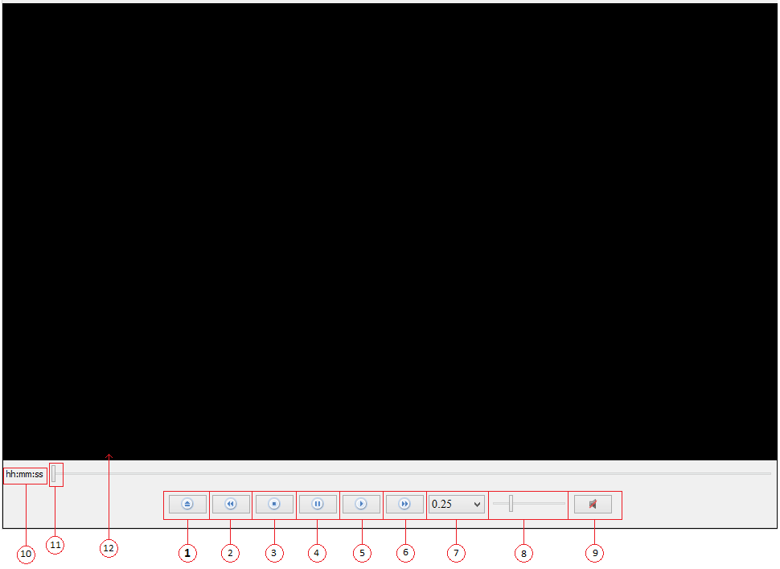

1. Open : This button is used to open the match videos from the local drive
   * 1. On click of this button it will ask for the video path

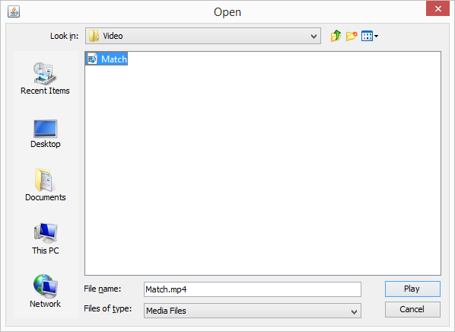

On Selection of video It will start playing the video in video player

1. Skip Back : Video will skip back by 10 sec.
2. Stop : To stop the playing video
3. Pause : To pause the video
4. Play : Play the video if it is stopped or paused
5. Skip Forward : Video will skip forward by 10 Sec.
6. Playback speed : Evaluator can control the video playback speed by 0.25x , 0.5x , 1x(Normal), 1.25x, 1.5x and 2x.
7. Volume : Control the volume of speakers.
8. Mute : To mute or unmute the audio of the video.
9. Times : Shows the current playback time.
10. Slider : To move the video at particular time.
11. Screen : Video will play in this area.

## Rotation Order

The player standing position is entered in the rotation order. Initial rotation order for both team is entered while starting of the SET. On evaluation window, evaluator can edit the rotation order. We recommend to edit rotation order before starting of the first rally.

Rotation order is automatically shifts in PES-VB. Evaluator needs to provide the initial rotation order. Once the rally started, the rotation order of home and opponent will be automatically shifs based on the condition.

Player of the team shifts in anticlock wise direction if the team is servicing the ball. Each rotation is visible in the rally’s court diagram.

Rotation order window description

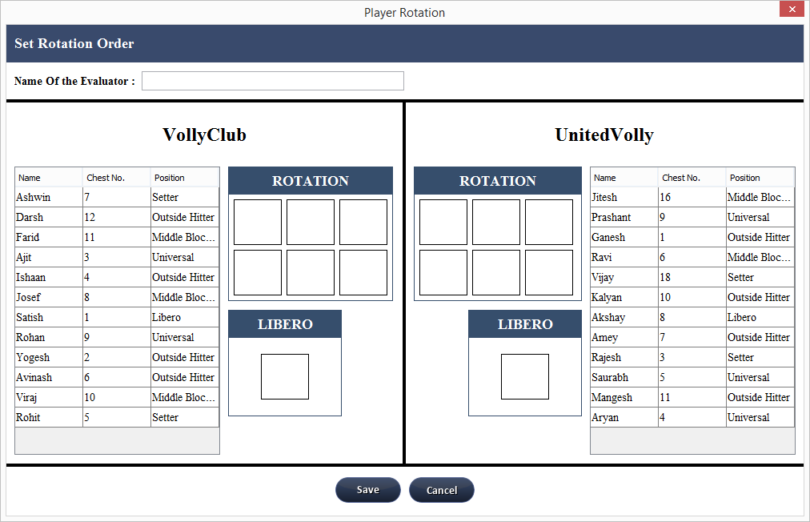

Roation order window is divided into two parts. Home team rotation on Left side and Opponent team rotation on right side. Evaluator can entered his/her name in the name field.

Insert rotation

Double Click on the Player name from the player list.

Player will set in rotation order in the sequenced and lastly libero will set.

If the player is entered in the rotation order then that player will be removed from the player list.

If evaluator wants to change or removed the player from rotation order then double click on the chest number of the player in rotation that will player again added to the player list and will be removed from rotation.

There is the color notation for the player in rotation, based on the players position in the team

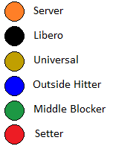

## Substitute player

A player in the starting line-up may leave the set and re-enter, but only in his/her previous position in the line-up. The player which is replaced for in player, that player is only replaced again for that player eg. If player chest no 8 is playing in the match and after end of the 4th rally out player chest no 10 is substitute the player 8 then no player 10 will in the place of player 8. For second time substitution of the player 10 only out player 8 will substitute that player.

PES-VB allows to substitute home as well as opponent player. To open the substitute window in PES-VB click on substitute button on evaluation window.



On click of substitute button it will open following window

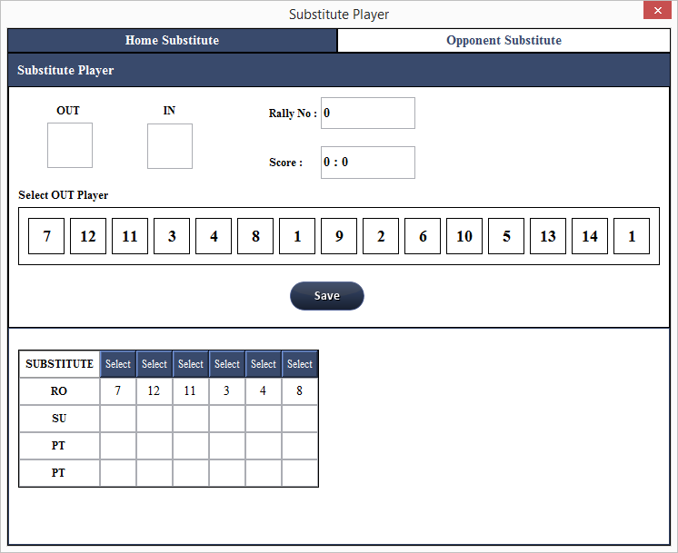

There is two substitution tab on substitution window. Home substitution window and opponent window.



In home substitution evaluator will substitute the home line-up players and in opponent substitution evaluator will substitute the opponent line-up players.

Substitution window is divided into 4 parts.

1. Select Player : Select player chest no for OUT and IN player.
2. Rally score : Rally at which substitution is done.
3. Player list : List of all players from current team.
4. Substitute detail : Details of current set substitution.
5. Select Player :

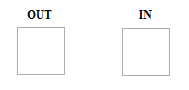There are two fields in the select player

1. OUT
2. IN

OUT : In this field, the player who is not in line-up will be selected from the list of player

To select the player click on OUT textbox the textbox will glow in red color then select the chest number from the player list listed below the fields

Once the player is selected OUT textfield will be color back to black and IN Player textfield will glow in red color

IN : In this field, the plyer who is going to replace by out player is selected.

To select IN player click on IN textbox the textbox will glow in red color then select the chest number from the player list listed below the fields

Rally Score

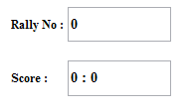

IN rally score there is option for rally num and the score. PES-VB records the rally num while substituting player to know at which rally player is substituted in the match. By default last rally number and score of that rally is selected. If evaluator wants to change the rally num then evaluator will enter the rally num in the Rally No field and click on TAB button from the keyboard the score of that rally is automatically entered in the score field.

Once the OUT and IN player is selected and rally num is selected click on SAVE button to save the substitution

Once the substition is saved, The Detail of the substituion is visible in the Substitute table in the details window.

Substitute detail :

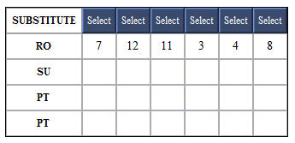

Consist of the substitute table where substitution detail is stored. RO is the line up player chest num. SU is substituted player chest number. First PT consist of the score at which line-up player is exited. Second PT is the score at which line-up player is re-enter at his/her initial position.

The table consist of the Select Button on each column.

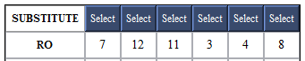

This Select button is used to edit the substitution.

In case by mistakenly evaluator entered the wrong sustitution detail then evaluator will select that substituion detail. Edit form will open right side of the window

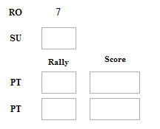Edit form consist of 3 editable field. RO is the line-up player chest number. SU is editable where evaluator can enter new player chest number. First PT is editable where line-up player exited rally number and score can be entered. Second PT is editable where line-up player reentered rally number and score can be entered. To get the score of the rally, Click TAB button from the keyboard score will be automatically updated in score field.

## Timeout

PES-VB allows to record the timeout detail in the application. Evaluator can record the detail of time out that which team ask for timeout and what was the score of both team at that time out.

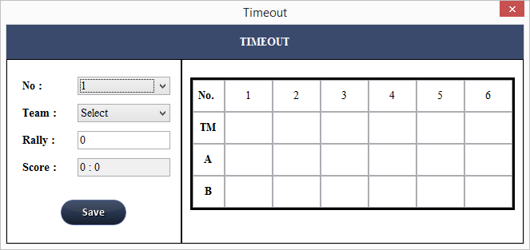

Timeout window consist of the Time out form and details of current match timeouts.

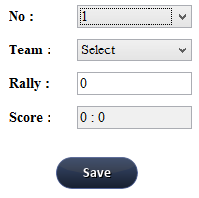Timeout form

1. No : It is the number of timeout I.e 1st timeout or 2nd or so on.
2. Team : Team name which ask for timeout
3. Rally : Rally at which timeout is asked. By default last rally and its correspoing score is selected. Evaluator can change the rally number, enter the previous rally number and press TAB key from keyboard the score of that rally is automatically updated
4. Click on “Save”

Once the timeout is saved the window will closed. To check the timeouts click on TIMEOUT button again. The details of the timeout will visible in timeout detail table

To edit the timeout, again click on the timeout BUtton. Same timeout windo will open. Now if evaluator wants to edit the 1st time out then select NO as 1 and enter the new info. Team can be changed, rally at which timeout is taken also be changed.

Timeout detail window

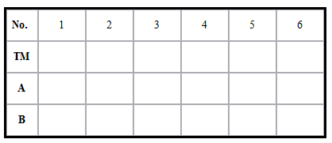

Details of the current set timeout is visible in this table.

Table Consist of

No. : The number of the timeout

TM : Name of the team which takes the timeout

A : Home team score at the timeout

B : Opponent team score at the timeout

## Replace Libero

PES-VB allows to replace the libero in the match. Both team libero can be replaced in the match. Select the libero and player to which libero wants to be replaced. Libero can be replaced in Position 1,6 and 5. In PES-VB, at the time of the rotaion if libero will never shift from position 5 to position 4. i.e libero will automatically exited if libero is crossing attack line in rotation.

Replace libero option is provided only at the start of the Rally. Once the rally started libero will never replaced in that rally.

To replace the libero of any team select click on LIBERO button on rally details window



Following window will open

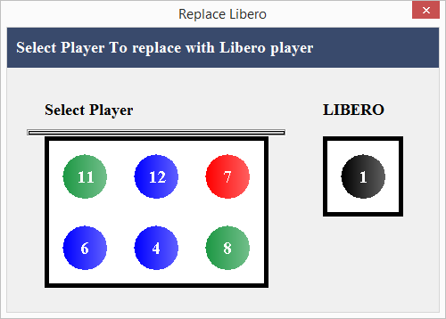

Line up players are shown in the window with libero. Click on the player chest number which needs to be replaced by libero. Once the player is selected window will closed and update line-up is visible in the court of the rally.

Before replacement After Replacement

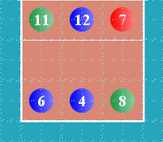 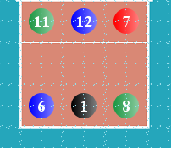

Rally navigation Bar



PES-VB provide navigation through the rally of the set. User can view old rally details by selecting the rally number from rally list

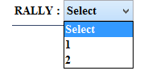

If user wants to navigate through one by one rally then user can click on next or back button

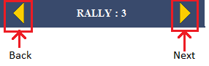

While navigating if user wants to start with new rally then click on “New” button. New button will start from the rally count plus one. I.e if there are total 10 rallies and user click on NEW button then new rally will start from 11.

## Evaluating both team in network

PES-VB provides parallel evaluation of the both teams. In this parallel evaluation two PC’s are connected via RJ45 LAN Cable. The data of both team evaluation is collected in PC1 and another PC2 system will be used only for other team evaluation.

Steps to Connect two PC’s

Connect Two PCS by using RJ45 cable



****1.  Insert IP address in both computer .****

* Open ****control panel****window****.****
* Choose ****Network and Sharing Center**** button.

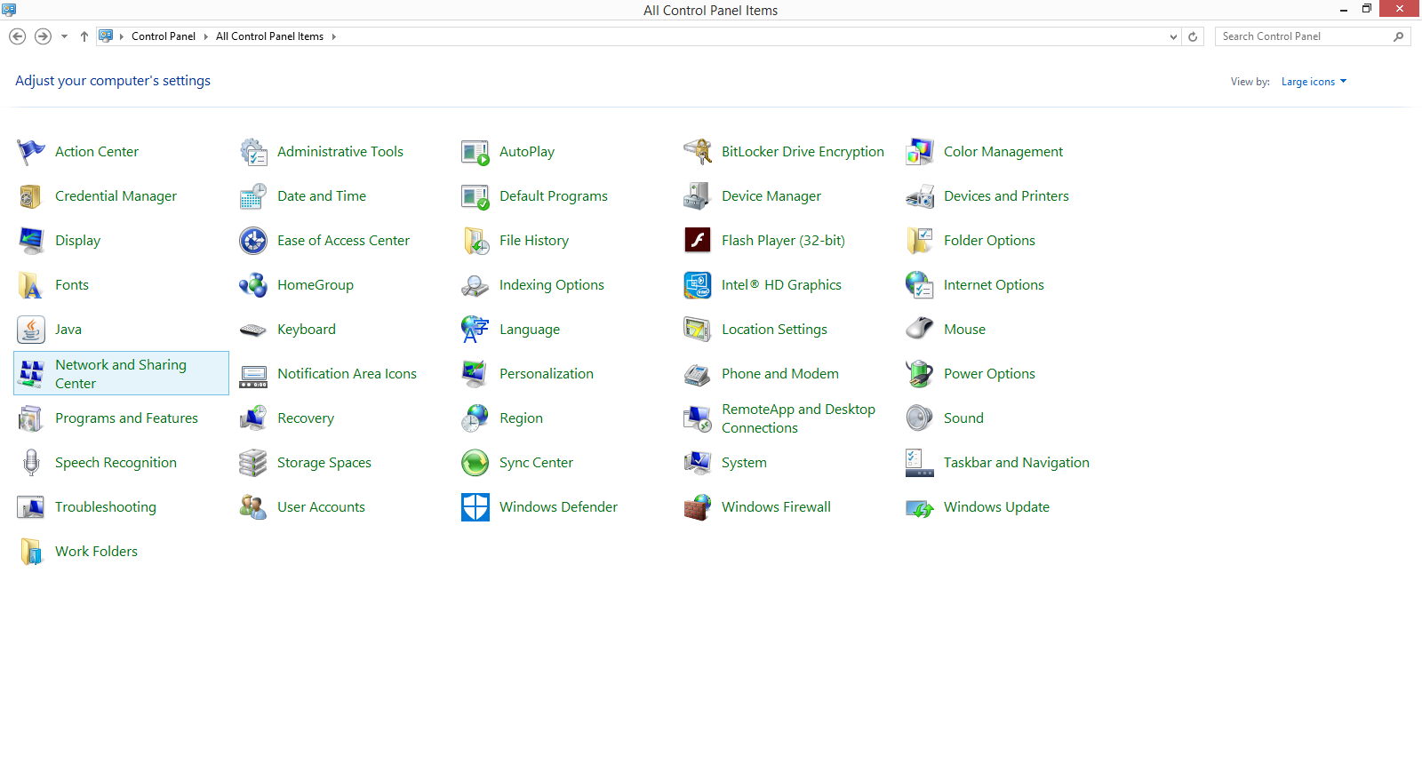

, click on ****Change adapter setting.****

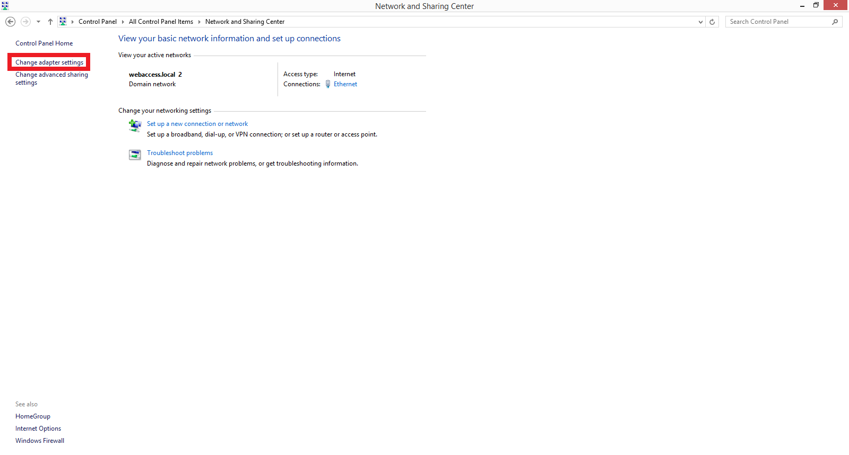

* In Network Connections Pop –up Window, right click on correctly installed LAN Card hardware adapter in your computer and select its ****properties.****

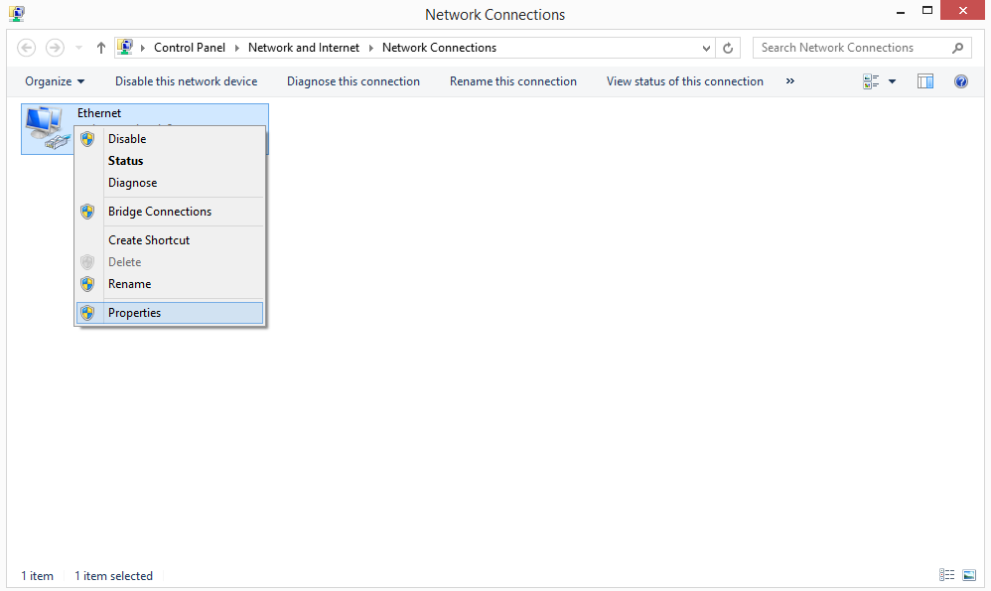

* Then Local Area Connection (LAN) properties window is appearing. Choose ****Internet protocol Version 4 (TCP/IPv4)**** button and click on ****properties**** option.

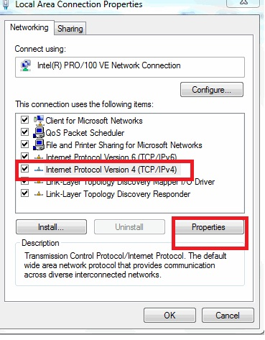

* Now enter IP (Internet protocol) address in both computers manually according to below and select ****OK**** Option.

**For PC-1**

Enter IP Address: – 192.168.0.1

Enter Subnet mask: – 255.255.255.0

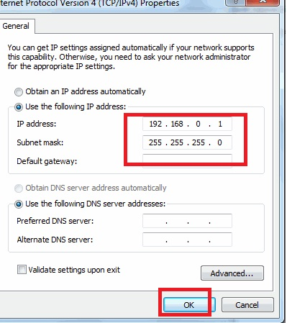

****For PC-2****

Enter IP Address: – 192.168.0.2

Enter Subnet mask: – 255.255.255.0

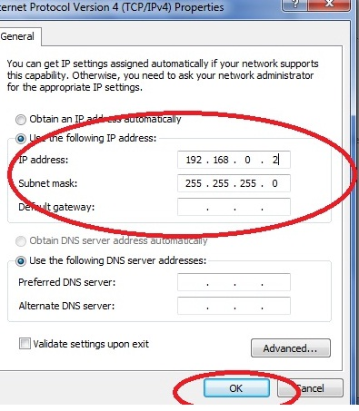

After inserting IP address in both computer properly,

# Reports

Once the evaluation of the match is over Evaluator can look at the reports of the match. Reports shows the overall match statistics, best rotation of the match per set, best players in each skill, best zones of each skill. PES-VB also provides the Team performance in each skill.

To get the reports click on “Report” button of respective match



## Consolidated Match Report

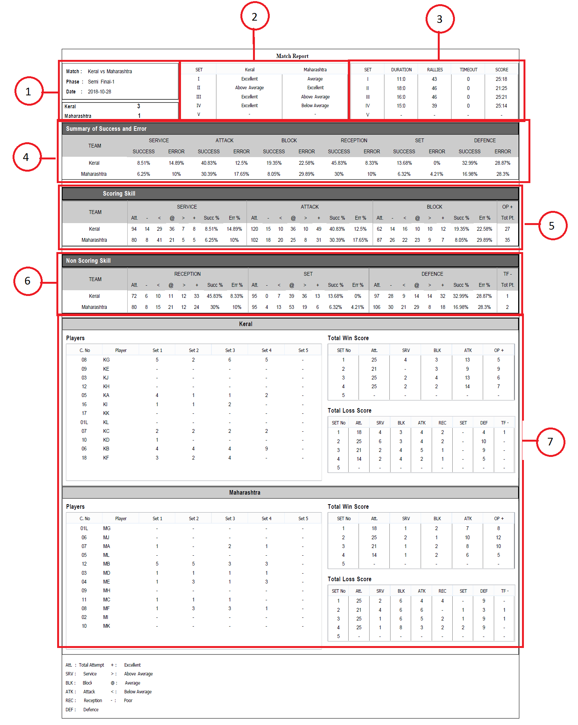

1. The detail of the match is provided in this section, it consist of Match name, Phase of the match, date of the match, And how much set won by each team
2. Performance:

It shows the performance of both team in each set. Performance decide on basis of score percentage and it is measure on basis of following formula

Score percentage = (Score / total rallies) * 100

If score percentage is greater than 50 then “Excellent”, If greater than 44 then above average, if greater than 38 then average, if greater than 32 then Below average and if less than 32 then Poor

1. Set Description:

Set description dscibes the short details of each set

Fields

Set : Set Number

Duration : Time Duration of the set in MM:ss format I.e minute and seconds

Rallies : total rallies in the set

Timeout : Total number of timeout taken in set

Score : Score of the set

1. Summary of success and error

This section described the success and error rate of both team in each skill.

Success rate of each skill is measured by

= (Total number of Excellent score of skill/ total number of all scores of the skill)*100

Failure rate of each skill is measured by

= (Total number of Poor score of skill/ total number of all scores of the skill)*100

1. Scoring skills

This section describes the in detail description of scoring skills ie. Reception, Set, Defence and TF-

In each skill there is Following fields

Att: Total Number of attempt of the skill

- : Total number of poor score of the skill

< : Total number of Below average score of the skill

@ : Total number of Average score of the skill

> : Total number of Above average score of the skill

+ : Total number of Excellent score of the skill.

Succ % : Success rate of each skill

Err % : Failure rate of each skill

1. Non Scoring skills

This section describes the in detail description of scoring skills ie. Service, Attack , Block and OP+

In each skill there is Following fields

Att: Total Number of attempt of the skill

- : Total number of poor score of the skill

< : Total number of Below average score of the skill

@ : Total number of Average score of the skill

> : Total number of Above average score of the skill

+ : Total number of Excellent score of the skill.

Succ % : Success rate of each skill

Err % : Failure rate of each skill

1. This section consist of player’s score detail of both team along with Winning and Losing score details:

In Players Table, It gives the view of each player’s that how much points have been earned by player in each set.

Total win score table shows bifurcation of score in each scoring skill

Total Loss score table shows bifurcation of loss score in each skill

## Rotation Performance

It explains the rotation performance of both team.

In overall section it shows which was the strongest rotation in the match. It also shows the weakest, favourable and non favourable rotations.

Below the overall section it gives shows that in each set both teams rotation performance

There are total 6 rotation and in each of this rotation there are following fields

Rotation number

Reapeated : How many time this rotation played in the set

Win : Success rate of the rotation

Loss : Failure rate of the rotation

## Best Player performance

This report shows the top 6 player of each skill. Each skill consist of two sections

1. Skill Details
2. Player Performance table

Skill Details :

Total Attempt : total attempt of the by all players

Success Rate : Success rate is defined by following formula

(Total of success points / total attempt) * 100

Failure Rate : Failure rate Is defined by following formula

(Total of failure points / total attempt) *100

Player performance table :

Player performance table consist players success rate and failure rate. Ordered by players success rate.

Table consist of player name, total attempt by the player, count of success point, success rate, count of failure points , failure rate of the player

Zone wise skill performance

In zone wise skill performance shows that in each skill which zone performs well and which performs worst.

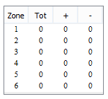Table shows the zone number with total attempt in that zone, successful attempt and failure attempt of the respective zone

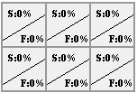

This table shows the success and error rate of the zone. If the success rate is high in all zone then that will mark in green and if failure rate is high among all zone then that zone is mark as red.

In second part of each skill it shows some detail of each skill.

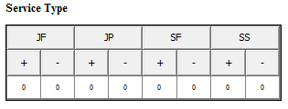Service

In Service, it briefs the success and failure attempt the type of service. Ie. How much successful or failure attempt by Jump float service or other types

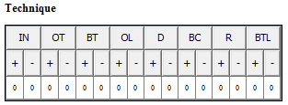Attack

In attack, it briefs the success and failure attempt in technique, I.e. how much successful or failure attempt by inward attack or outward attack and with other attacking techniques.

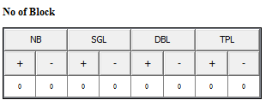Block

In block, it briefs the success and failure attempt in block, I.e. how much successful or failure attempt by no block or single block and with other blocks.

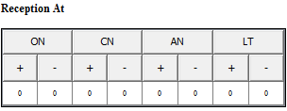Reception

In block, it briefs the success and failure attempt in reception, I.e. how much successful or failure attempt on over the net or close to net and with other receptions

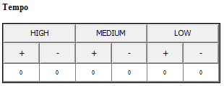Set

In set, it briefs the success and failure attempt in types of tempo, I.e. how much successful or failure attempt by high tempo or medium or low tempo.

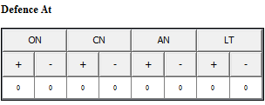Defence

In defence, it briefs the success and failure attempt in defence, I.e. how much successful or failure attempt on over the net or close to net and with other defence

## Team report

It consist of the details of each skill of team. To get the report select team from side bar



Skills

### Service

Service overview

In service overview, it shows the statistics of reception formation(2M,3M,4M & 5M) against the type of service, zone and the opponent receiver position.

Evaluator can analzed the team’s service skill by type of the service I.e when team is servicing the ball by Jump Float and opponents reception formation was 2M or 3M or other then what was teams performance, how much percentage of the success they got or how much percentage of the failure they got.

So evaluator can analyzed the team by various parmater against the opponents reception formation. The comparison parameter’s are type of service, the zone from which home team is serving the ball and opponet receiver posision

Service success:

In Service success, evaluator can analyze in which formation Most of the type team got success for type particular type of service. Which zone is best for type of service and receiver position.

Service sucess gives detail view of what is the percetange of success favpurable and failure of formation, zone and reciver against each the type of service.

Digramatic Representation

Digramatic Representation shows comparison between the type of service. It shows diagramatially that if from which is best service zone and land zone to representation of

### Attack

Attack Overview

Evaluator can analyze the success and failure rate in complex with tempo, block, type of attack and zone.

Successful combination of attack

In succeful combination of attack evalutor can get the reports for individual no of block against the tempo. In which tempo of no of block which was the best technique, zone, complex, attack combination and overall in successful, favoucble and failure

Digramatic represention

Digramatic representation shows successful and failure direction of attack in each no of block I.e in triple block, double block, single block and no block situtation .

### Block

In Block overview, it shows the statistics of defence system (No block, singel double and triple block ) against the type of attack , tempo, blocking tactics, blocking zone, blocker, complex and attack combination

Block success:

In Block success, evaluator can analyze in which type of block, which is best, facourblae and failure Attack type, tempo, block zone,complex attack combination and block tactics

### Reception

In Reception overview, it shows the statistics of reception formation(2M,3M,4M & 5M) against the opponet type of service, zone, reception at, parabola, and receiver position

Reception success:

In Reception success, evaluator can analyze in which reception formation , which is successful, favourblae and failure type of service, reception at , zone of reception, parabola and receiver position

Digramatic representation

Digramatic representation shows successful and failure direction of reception in each reception formation I.e in 2M, 3M,4M and 5M

Set overview

Evaluator can analyze the success and failure rate in complex against tempo, block, type of set,zone and parabola

Successful combination of set

In Reception success, evaluator can analyze in which type of set , which is successful, favourblae and failure tempo,block , zone of reception, parabola and complex and attack combination

Digramatic representation

Digramatic representation shows successful and failure direction of set in each type of set.

### Defence

Evaluator can analyze the success and failure rate in defence system against type of block, zone, defence at, parabola, defender role, complex.

Defence Succes

In Defence success, evaluator can analyze at which defence happen , which is successful, favourblae and failure complex, type of block, defence ball at zone, ball parabola, defender role, defence system.

Digramatic representation

Digramatic representation shows successful and failure direction of defence in each defence at.

## DataSheet

Datasheet provides the rally detail sheet which gives the consolidated view of the data which is filled by the evaluator.

To get the data select the team name and the set and click on report



It shows following info

It contains initial team rotation, substitute of the players and time out taken by the teams

In rally section it consist of rally time, rally score and each rally action details with score.