**LAB-1 GETTING STARTED WITH ASANA**

**THEORY**Asana is similar to other task and project management software which allow teams to organize, collaborate, plan, and execute tasks. It acts as a perfect companion to overcome chaos and meet deadlines. It is a web-based task management and collaboration tool which eliminates the email mess and brings all tasks together. Teams can use Asana to keep track of all tasks, collaborate with other team members, exchange related files, and more.

It's a comprehensive work management tool that allows you to track project and task progress, share files, comments, and notes, and keep track of deadlines. It is a modern method of working together in collaboration. Asana, as already mentioned above, is a task management software that has certain features like projects, workspaces, tasks, and sections to manage projects and tasks related to several clients and teams.

**OUTPUT**

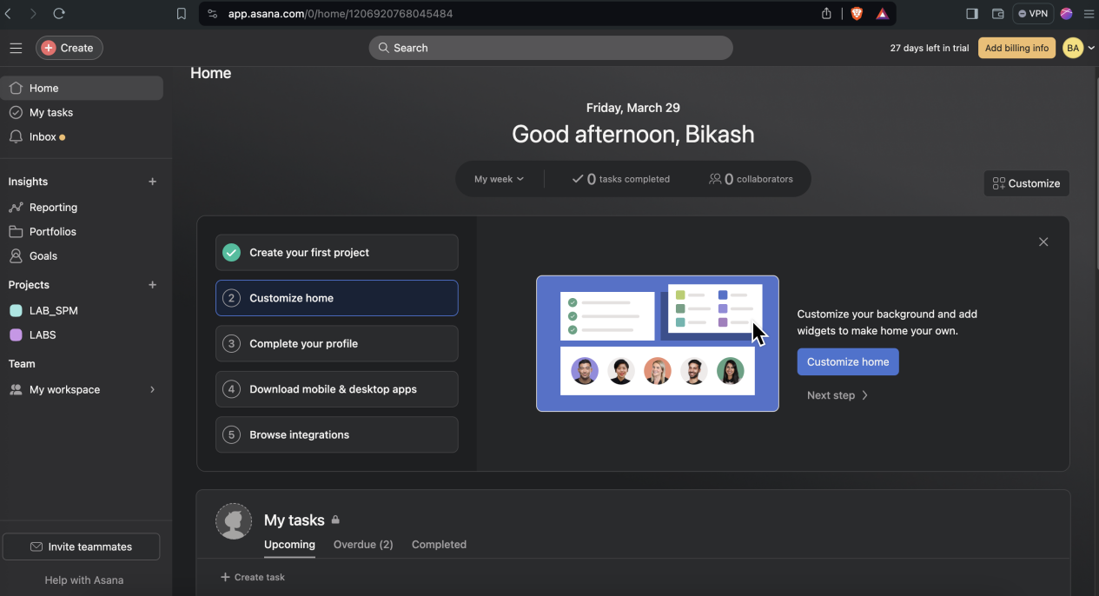

**CONCLUSION**

Hence, we were familiarized with Asana tool and created a project successfully.

**LAB-2 CREATING PROJECT PLANNING USING ASANA.**

**THEORY**

Project planning in SPM involves meticulously defining scope, objectives, tasks, resources, schedules, and milestones for software development. It entails breaking down tasks, allocating resources, and scheduling activities while addressing risks and ensuring quality. Communication plans facilitate collaboration among stakeholders and team members. Budgeting ensures efficient resource utilization. Monitoring mechanisms track progress, expenses, and changes, allowing for timely adjustments. Ultimately, comprehensive planning serves as a roadmap, guiding the project from initiation to completion, while minimizing risks and uncertainties, and ensuring that deliverables meet quality standards within the allocated time and budget constraints.

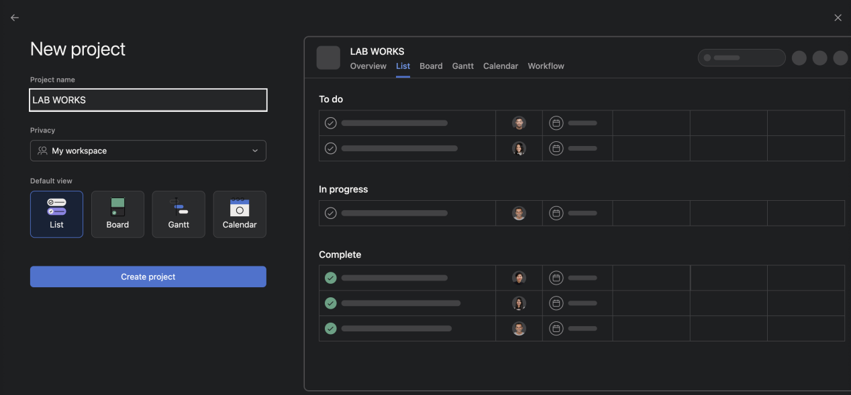**OUTPUT**

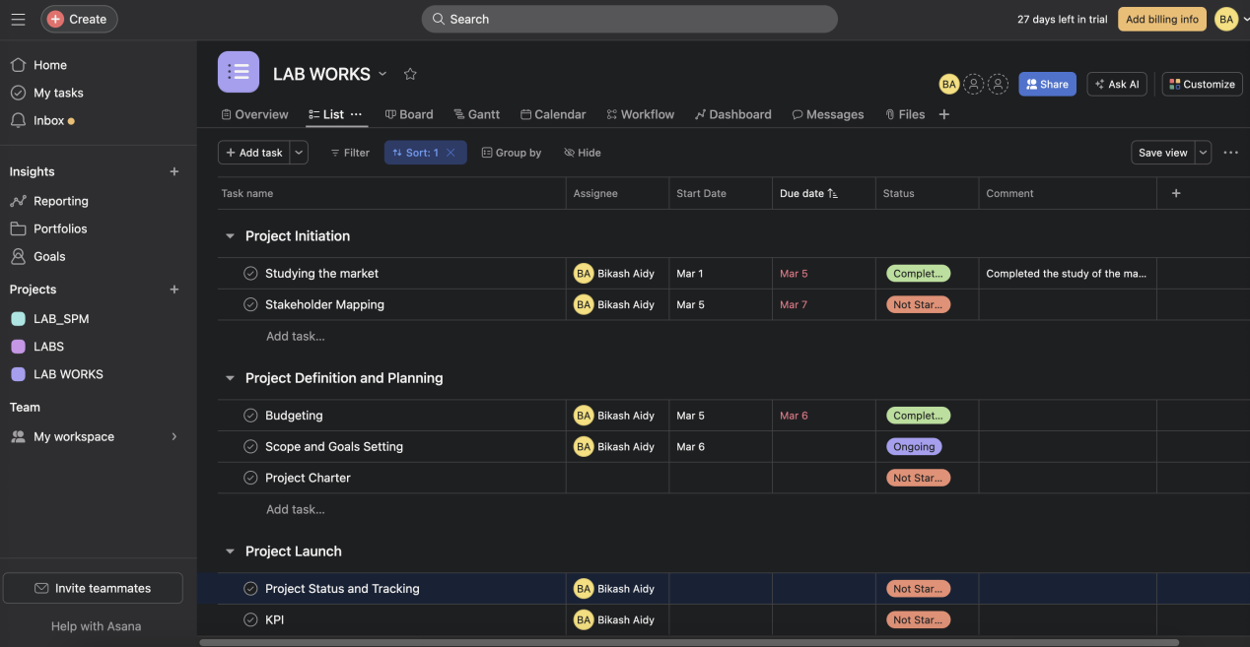

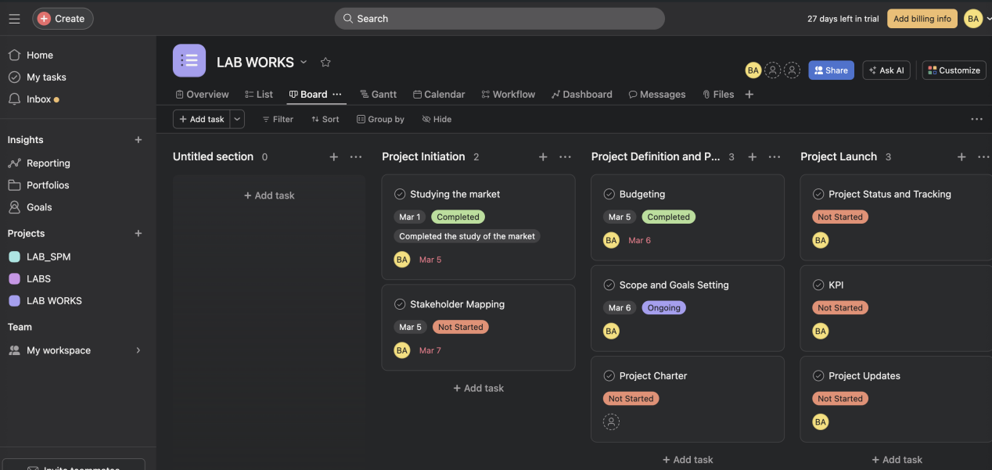

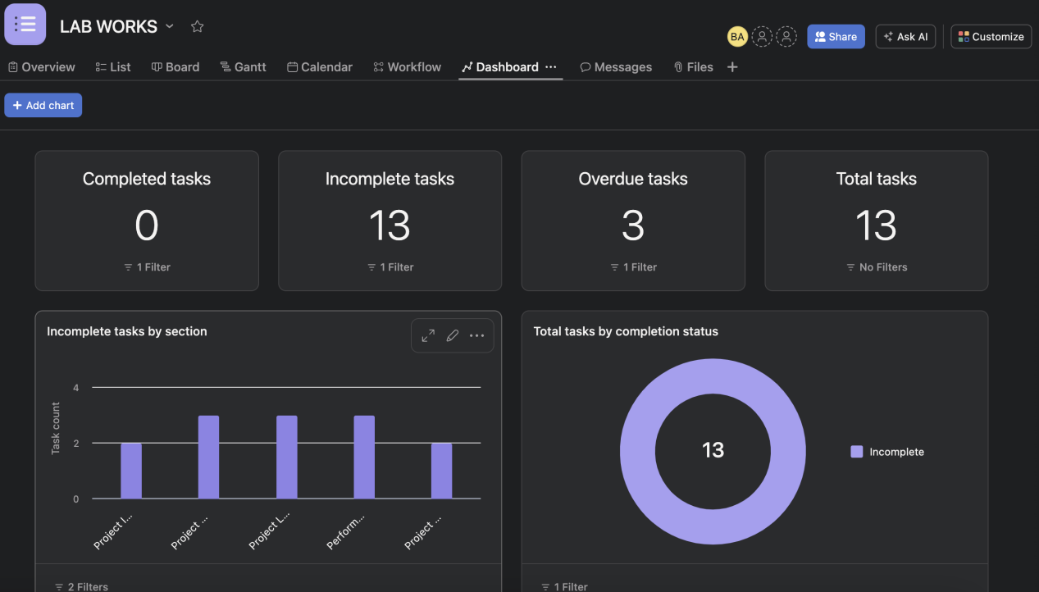

**CONCLUSION**Using list feature of Asana, we were able to define tasks, start date, due date, project status and comment under the task. Additionally,board and dashboard feature were selected to visualize the progress of the project in an interactive way.

**LAB-3 GETTING STARTED WITH PROJECT PORTFOLIO MAKING USING ASANA**

**THEORY**

A project portfolio is a collection of projects or programs managed as a group to achieve strategic objectives. It involves selecting, prioritizing, and managing a set of projects or programs to maximize their collective benefits and align with organizational goals. Project portfolio management (PPM) involves evaluating projects based on criteria such as strategic alignment, resource availability, risk, and return on investment. By managing projects collectively, organizations can optimize resource allocation, minimize risks, and ensure that project investments contribute to overall business success.

**OUTPUT**

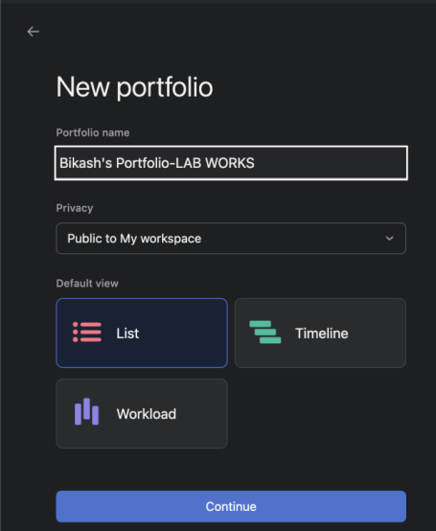

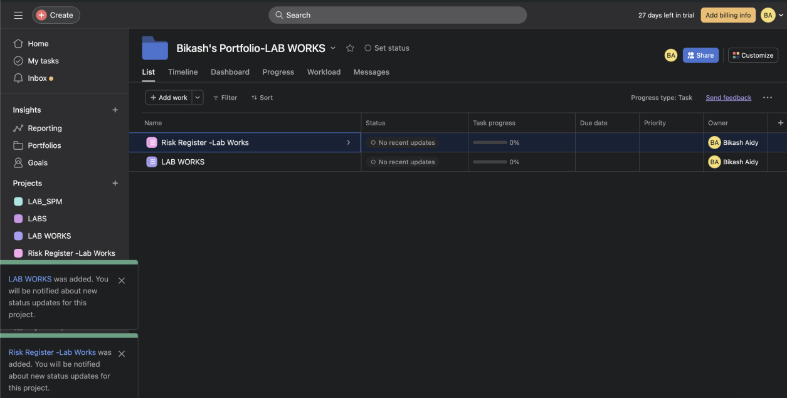

**CONCLUSION**

Hence, a portfolio containing projects was developed successfully.

**LAB-4 CREATE A RISK REGISTER IN ASANA AND SHARING WITH TEAM MEMBERS.**

**THEORY**

A risk register is a document or database used to capture, track, and manage risks throughout the duration of a project. It typically includes details such as the nature of the risk, its potential impact, likelihood of occurrence, mitigation strategies, responsible parties, and current status. The risk register serves as a central repository for all identified risks, helping project managers and stakeholders to proactively assess, prioritize, and address potential threats to project success. Risk analysis, on the other hand, is the process of evaluating risks to understand their potential impact and likelihood of occurrence. It involves identifying and assessing various types of risks that could affect project objectives, such as technical, financial, schedule, or external risks. Risk analysis techniques may include qualitative methods (such as risk probability and impact assessment) and quantitative methods (such as Monte Carlo simulation or sensitivity analysis). The goal of risk analysis is to inform decision-making by providing insights into the level of risk exposure and guiding the selection of appropriate risk response strategies, such as avoidance, mitigation, transfer, or acceptance

**OUTPUT**

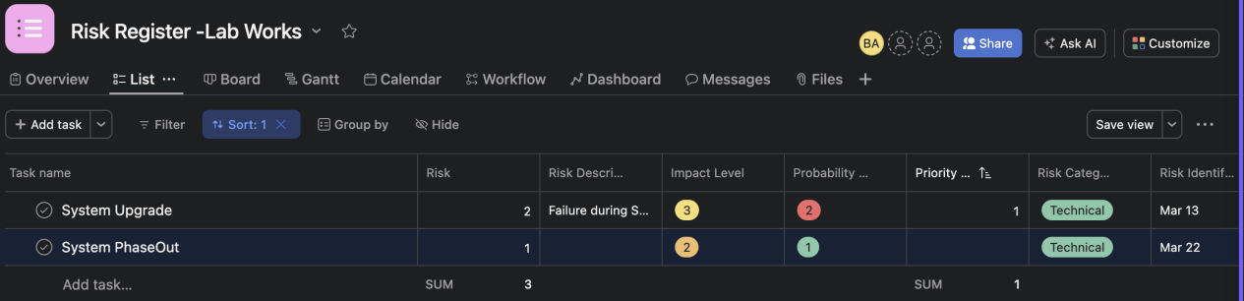

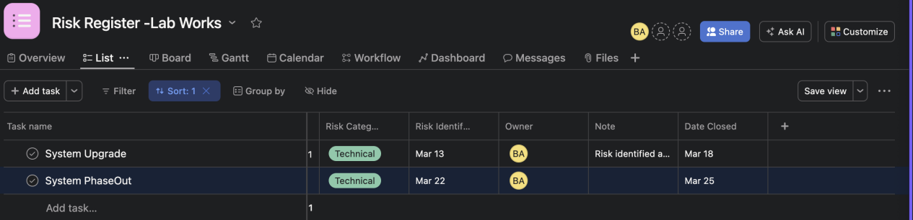

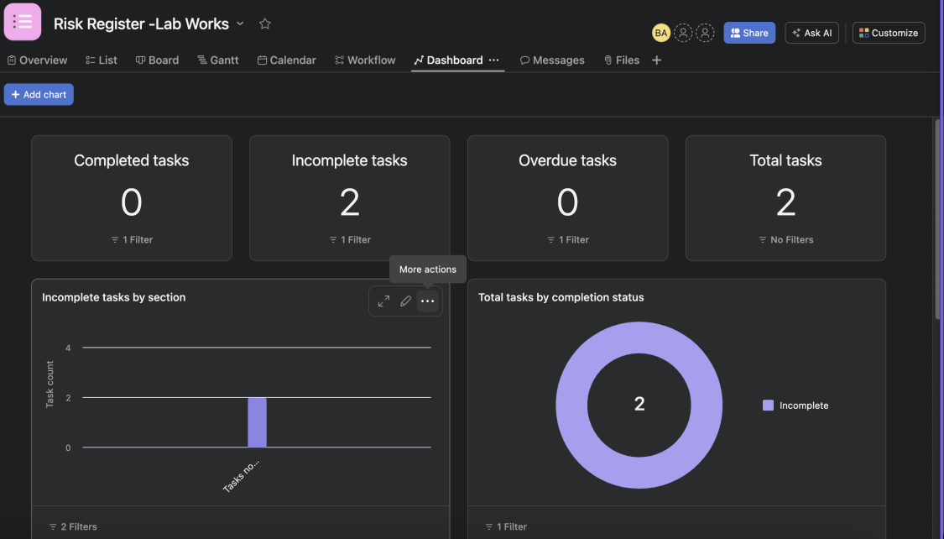

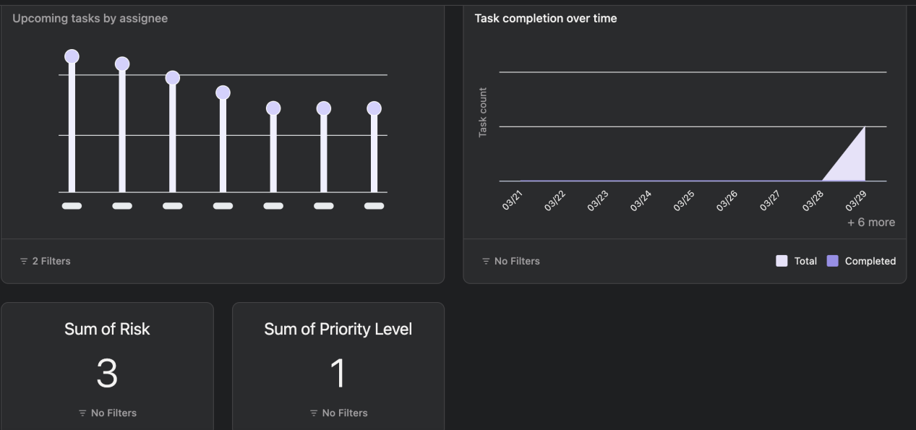

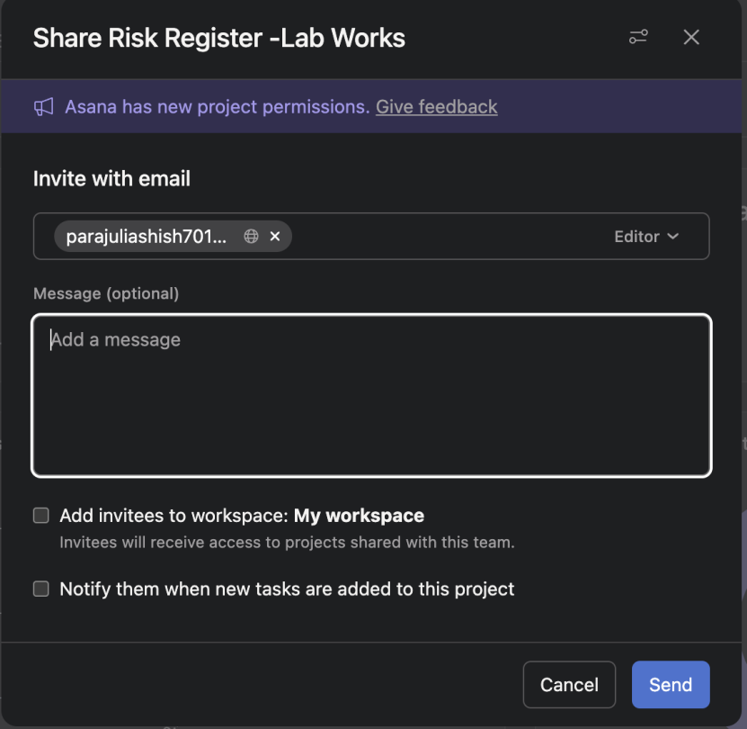

**CONCLUSION**

Hence, risks affecting projects were identified and listed under task along with the fields like risk category, risk identification date, risk description, its impact level, probability level, priority, note and date closed

**LAB-5 CREATING NETWORK DIAGRAM AND PERT CHART USING DRAW.IO**

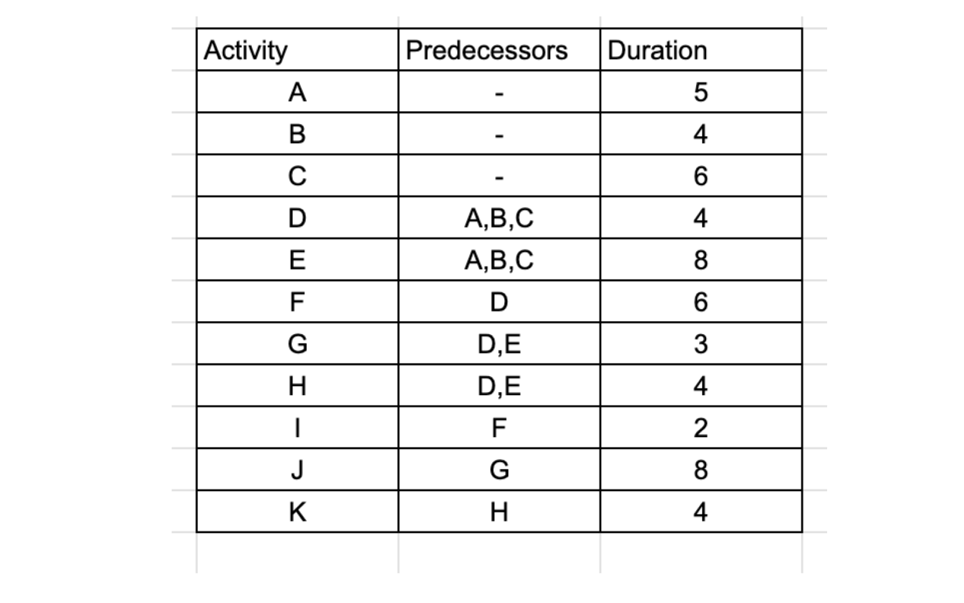

**THEORY**

A network diagram is a visual representation of project tasks and their dependencies, illustrating the sequence of activities required to complete a project. Tasks are represented as nodes or boxes, connected by arrows to show the flow of work from one task to another. Network diagrams help project managers visualize project workflows, identify critical path activities, and understand the relationships between tasks.

PERT (Program Evaluation and Review Technique) chart is a type of network diagram used for scheduling and planning projects. It incorporates three time estimates for each task: optimistic, pessimistic, and most likely. These estimates are used to calculate the expected duration of each task, taking into account uncertainties and variability. PERT charts also show the critical path, which represents the longest sequence of dependent tasks and determines the minimum time required to complete the project. PERT charts are useful for identifying project bottlenecks, managing project schedules, and assessing project risks.

**OUTPUT**

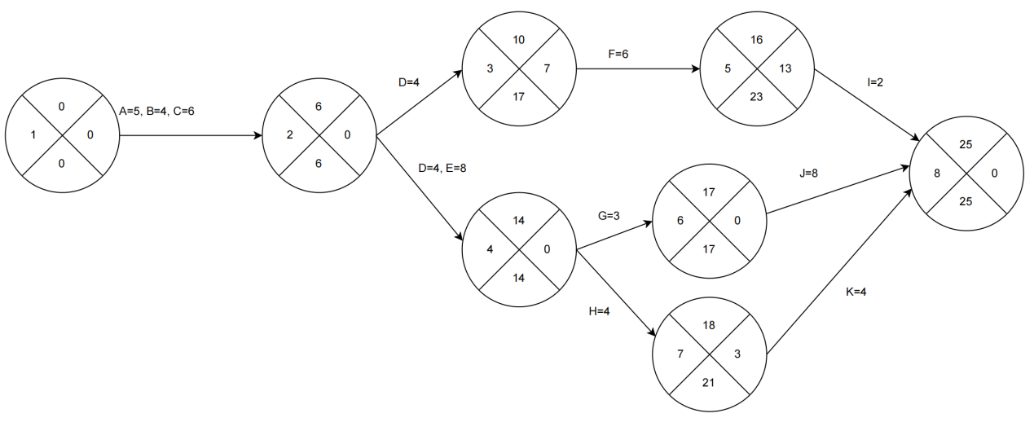

**LAB-6 BUDGET PLANNING FOR PROJECT**

**THEORY**

Budget planning for a project involves estimating, allocating, and managing financial resources to ensure that the project is completed within the approved budget. It typically includes identifying costs, such as labor, materials, and overhead, estimating their amounts, and then allocating funds accordingly. Budget planning also involves considering potential risks and uncertainties that could impact costs and developing strategies to mitigate them. Throughout the project, budget monitoring and control are essential to track expenses, compare them against the budget, and make adjustments as needed to prevent cost overruns and ensure financial viability.

**OUTPUT**

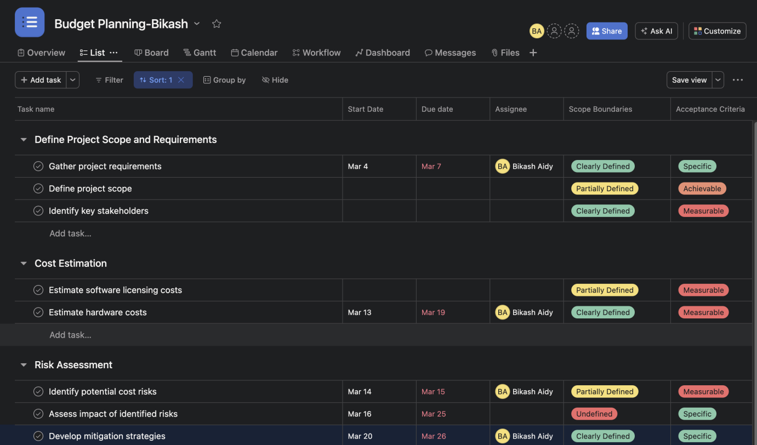

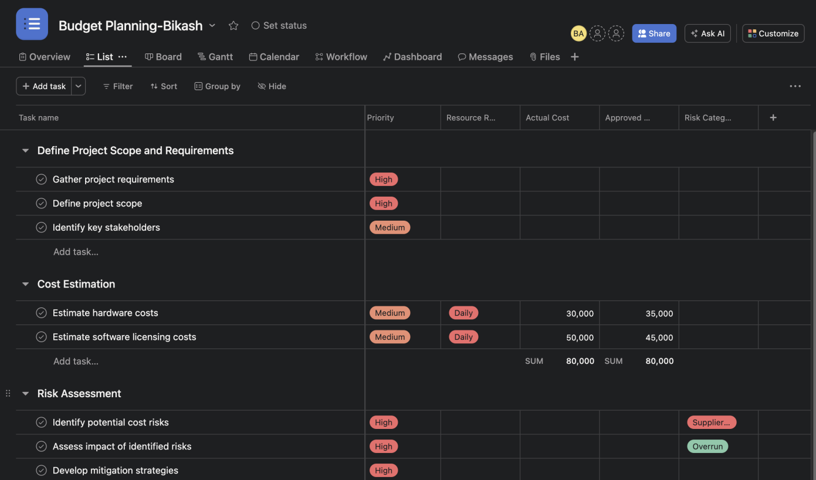

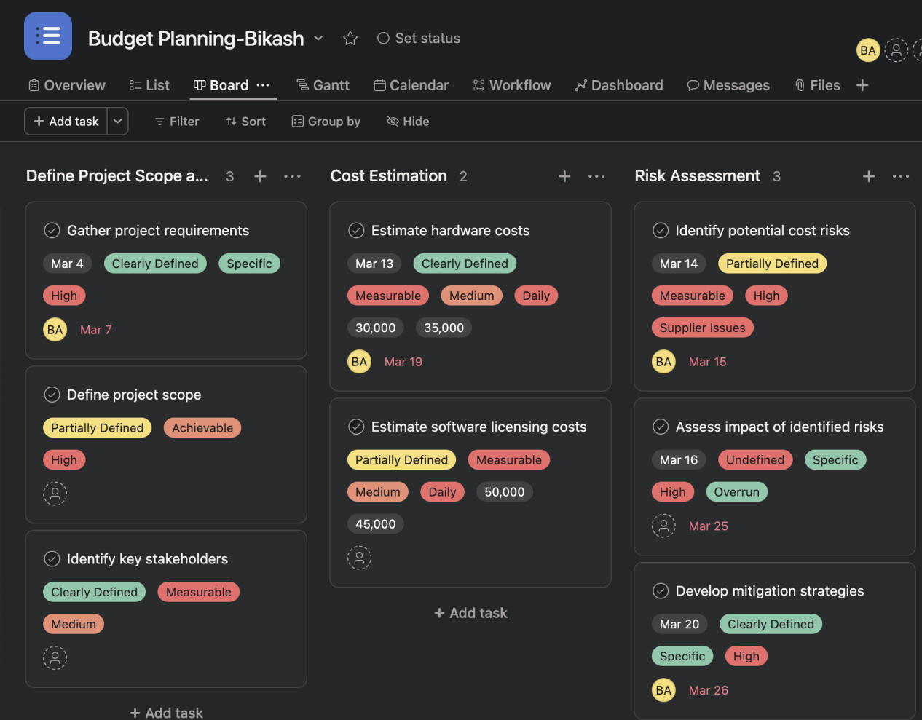

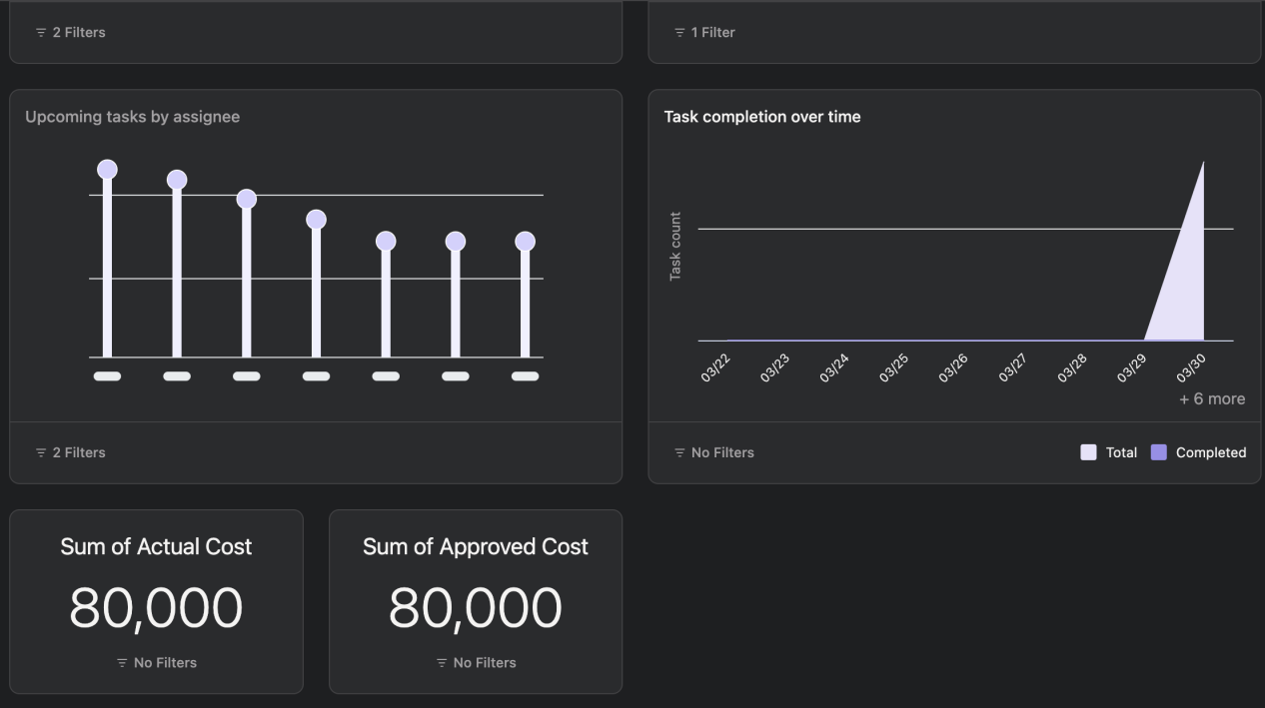

**CONCLUSION**

Hence, a budget plan was developed for the defined project.

**LAB-7 VERSION CONTROL USING Git and Github**

**THEORY**

A Version Control System is a tool we use to track, make, and manage changes to the software code. It's also called source control.

A version control system helps developers store every change they make to a file at different stages so they and their teammates can retrieve those changes at a later time.

Version control in GitHub is the process of managing changes to source code or other project files using Git, a distributed version control system. GitHub provides a platform where developers can host Git repositories, allowing for collaborative development and efficient management of project files. With GitHub, developers can create branches to work on new features or fixes independently, commit changes to their local repository, and later push those changes to the GitHub-hosted repository. Pull requests enable developers to propose changes for review and integration into the main codebase, fostering collaboration and ensuring code quality through peer review. GitHub also offers issue tracking for managing project tasks and integrates with continuous integration/continuous deployment (CI/CD) tools for automated testing and deployment. Overall, version control in GitHub streamlines the software development process, facilitating collaboration, code management, and project organization.

**OUTPUT**

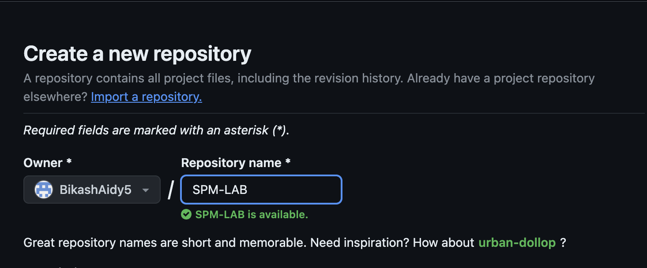

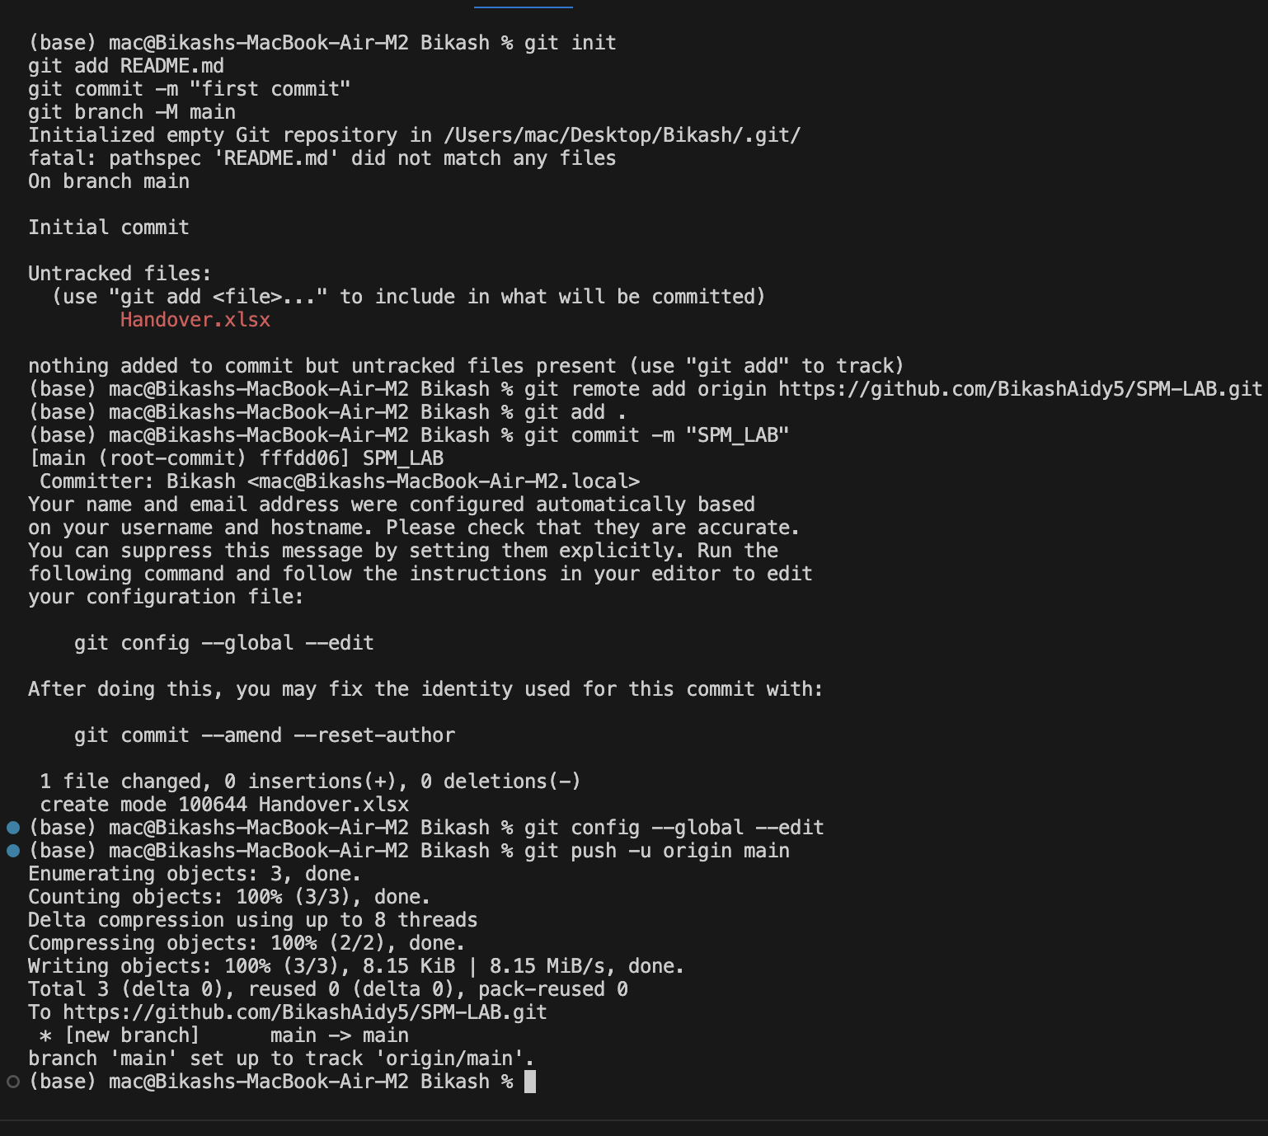

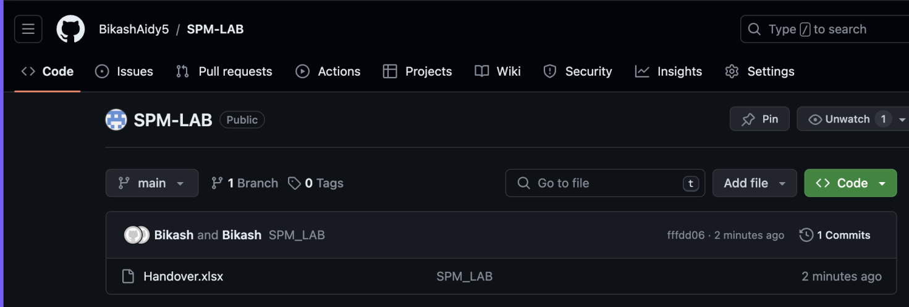

**CONCLUSION**  
Hence, using github a repository was created entitled SPM-LAB and a project was uploaded under the repository using commands of git.