LLM,agent & MCP
LLM(Large language model)-chatgpt,deepseek,GoogleGemini
Agent-Takes instruction from LLM and performs action on External tool(MCP)

MCP-model context program

UserpromptLLMAgentMCP

Playwright MCP-it is a browser Automation mcp and works with playwrights

GitHub Copilot(llm) we will give prompt here to get code
GitHub Copilot
- An AI coding assistant built specifically for software development.
- Integrated into code editors (like VS Code).
- Designed to help you write code, not hold full conversations.
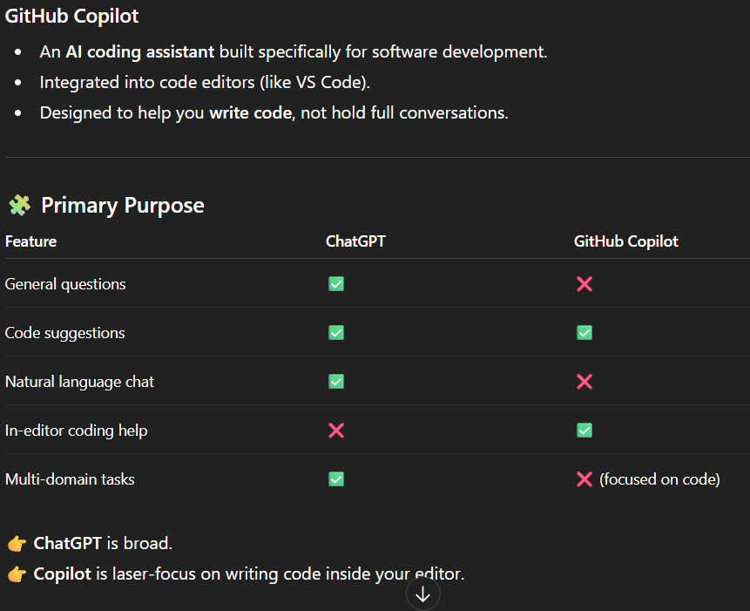

Playwright MCP+Github copilot

Install github copilot

