 | Diagnostic Medicare Center Management  Technical Design Document
 | Prepared By / Last Updated By | Reviewed By | Approved By
Name | Jughisathvi D,  Kohila C,  Ragul S,  Nishanth Kumar B M
Role | Team Member
Signature
Date | 27/09/2019

Table of Contents

1.0 Introduction 3
1.1 Purpose of this document 3
Objectives 3
1.2 Project overview 4
2.0 Solution Summary 4
2.1: Scope 4
3.0 Assumptions 5
3.1 Dependencies 5
3.2 Risks 5
Schematic Diagram 6
4.0 System Design 7
4.1 Data Model 7
4.2 Proposed design 10
4.3 Component inventory 10
4.3.1 Model Components 10
4.3.2 Dao classes 10
4.3.3 UI Components 11
5.0 Database Design 13
5.1 Data Model 13
6.0 Table Structure 14
6.1.1 Patient / User 14
6.1.2 Doctor 14
6.1.3 Admin 15
6.1.4 Medicare Services 15
6.1.5 Medical Test History 15
6.1.6 Appointment 16
7.0 Appendices 17
7.1 Glossary 17
7.2 Terms and Conditions 18
8.0 Change Log 18

Introduction

1.1 Purpose of this document
This document is aimed at:
- Providing the necessary inputs to the detailed requirements gathering phase and further on for the SDLC processes.
- This document also serves to establish the traceability between the Business Objectives and the requirements identified in the proposed solution and how they satisfy the stated objectives.
- Provide expectation traceability in terms of the requirements and the Customer expectation
- Serves as a formal template for documenting the Business Requirements, which also includes statutory and regulatory requirements.
The purpose of this document is to systematically capture requirements for the project and the system to be developed. Functional requirements are captured in this document. It also serves as the input for the project scoping.

Objectives
Following are the objective of above mentioned Project:
- Create and maintain customer and doctor information.

- Search for the Medicare services.

- Customer applies for the Health Checkup.

- Customer can search for agent.

- Customer/Doctor will view the result.

1.2 Project overview
The Diagnostic Medicare Center Management project, helps many people by providing the right need at the right time in a sophisticated and user friendly platform.
This project describes the user interface being implemented and have a better understanding towards the flow of the Diagnostic Medicare Center Management.
This project helps us to understand the problems of a normal person and provide him/her, a better opportunity to receive and provide help to one another in a large scale.
It will provide, us a high secured environment as well as a better opportunity to serve the person in need.

Solution Summary

2.1: Scope
This sub-section shall state the scope of this detailed design document,
- Create and maintain Admin, Doctor and Customer information
- Raise a request for Checkup
- Update test results
- Manage Medicare services

Assumptions
- Once the application is built the DIAGNOSTIC MEDICARE CENTRE MANAGEMENT PORTAL will load the user details into the system.
- There will be no concurrent users for the application. The Patient profile will be maintained by the User.
- Any changes to the design mentioned in the BRD would be taken as a Change Request

Dependencies
- MS SQL Server 2014 is needed for database operations.
- Without IIS server the application will not run.
- Without Visual Studio 2015 software, we will not be able to run the application.

Risks
As we are using HTTP Session objects, the data is transferred using http, which is less secured than https, so there is a possibility of data corruption.

Schematic Diagram
A schematic, or schematic diagram, is a representation of the elements of a system using abstract, graphic symbols rather than realistic pictures. It gives an overview of overall system
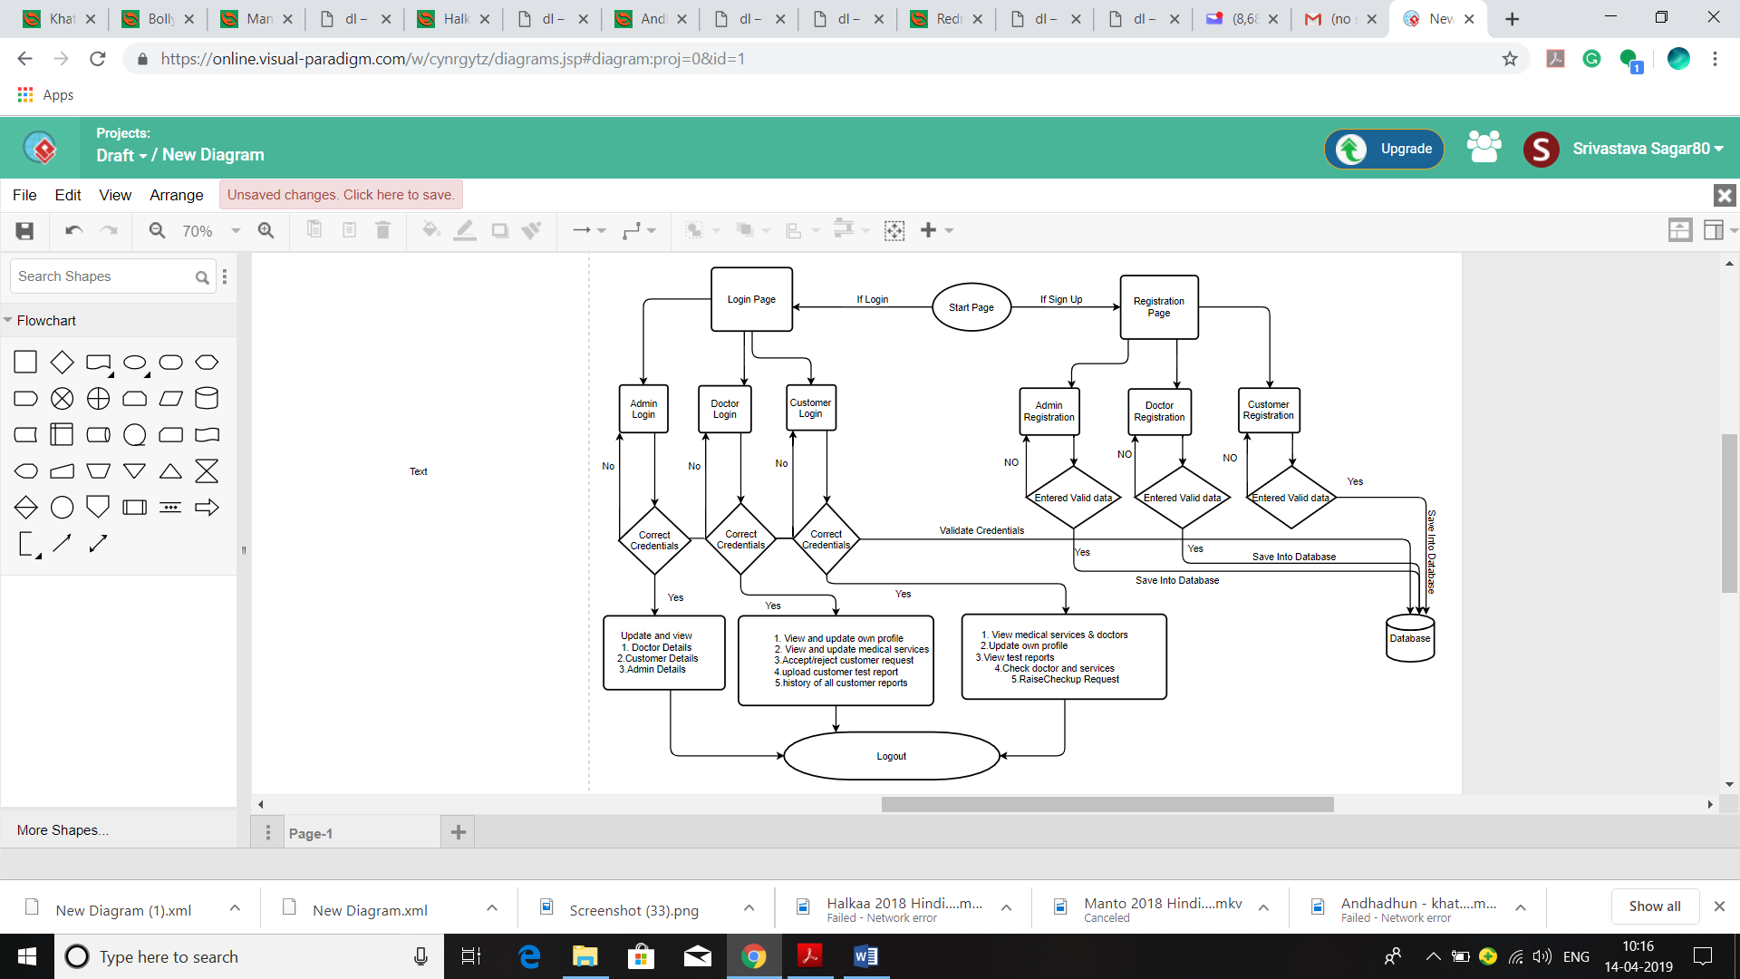
Figure 4.0 schematic Diagram

System Design

Data Model

Admin Process flow
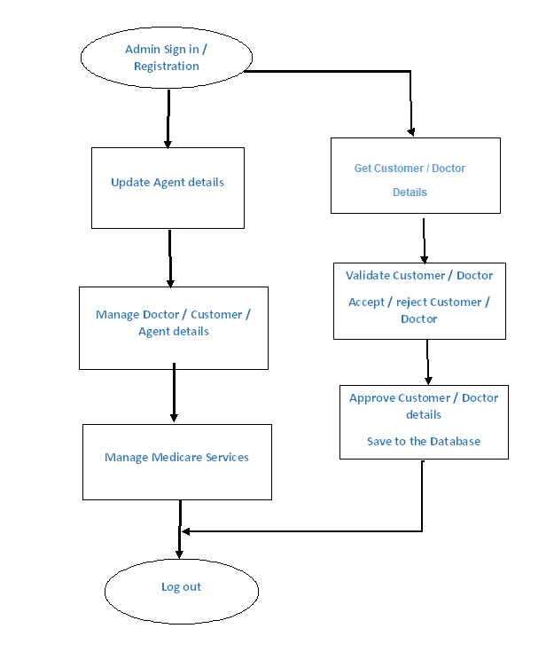

Customer Process Flow
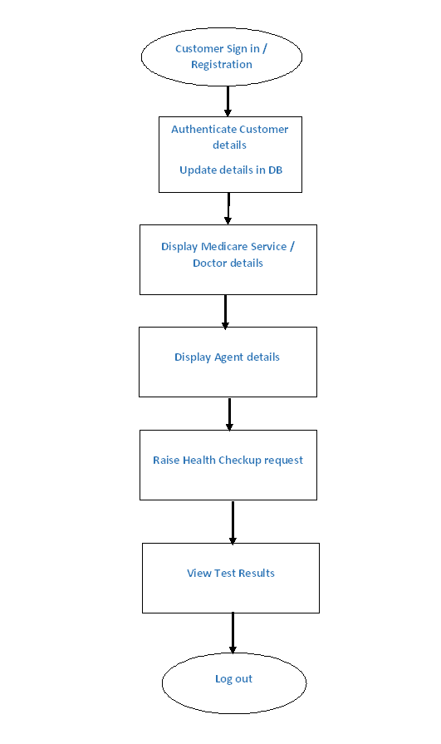
Doctor Process flow
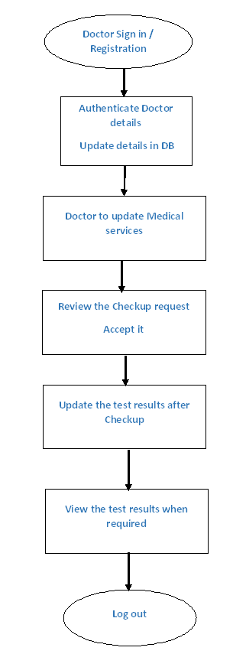

Proposed design
Considering the anomalies in the existing system computerization of the whole activity is being suggested after initial analysis. The “Diagnostic Medicare Center Management” is a Medicare center management system that helps in managing various Medicare management operations effectively. This is a web application allows you to access the whole information about Diagnostic Medicare Center Management, readily scalable and adaptable to Create and maintain Admin, Doctor and Customer information, Raise a request for Checkup, Update test results, Manage Medicare services.

Component inventory

Model Components
- Doctor.cs
- Patient.cs
- Admin.cs
- Appointment.cs
- MedicalTestHistory.cs
- MedicareServices.cs

Dao classes
- ConnectionHandler.cs
- AdminDaoSqlImpl.cs
- AppointmentDaoSqlImpl.cs
- AppointmentEmptyException.cs
- ConstantsImpl.cs
- DoctorDaoSqlImpl.cs
- IAdminDao.cs
- IAppointmentDao.cs
- IDoctorDao.cs
- IMedicalHistoryDao.cs
- IMedicareServiceDao.cs
- IPatientDao.cs
- MedicalHistoryDaoSqlImpl.cs
- MedicareServiceDaoSqlImpl.cs
- PatientDaoSqlImpl.cs
- QueriesImpl.cs

UI Components
- Home.aspx
- AdminDoctorDetails.aspx
- AdminLogin.aspx
- AdminPage.aspx
- AdminPatientDetails.aspx
- AdminRegistration.aspx
- BookAppointment.aspx
- DoctorLogin.aspx
- DoctorPage.aspx
- DoctorRegistration.aspx
- ErrorPage.aspx
- GenerateId.aspx
- GeneratePatientId.aspx
- MedicalTestReport.aspx
- Patient.aspx
- PatientDetails.aspx
- PatientLogin.aspx
- PatientRegistration.aspx
- RegistrationMedicareServices.aspx
- UpdateMedicalReport.aspx
- UpdateMedicareServices.aspx
- ViewMedicalReport.aspx
- ViewMedicalReportPatient.aspx
- ViewMedicareServices.aspx

Database Design

Data Model
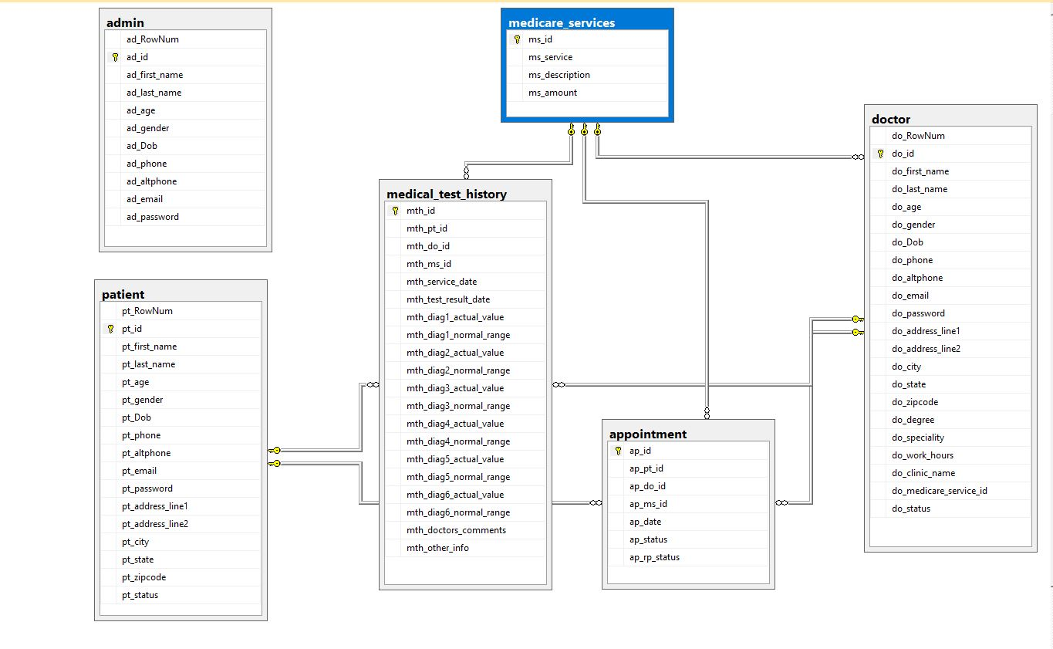

Table Structure

Patient / User
Field Name | Field Type | Data Type | Mandatory | Possible Values
Row Number | Numeric | Numeric | Yes | System Generated
Patient / User ID | Text(10) | Alphabetic | Yes | System Generated
First Name | Text(50) | Alphabetic | Yes
Last Name | Text(50) | Alphabetic | Yes
Age | Numeric(2) | Numeric | Yes
Gender | Drop Down | NA |  | Male, Female
DoB | Text(10) | Alphanumeric | No
Contact Number | Text(10) | Numeric | Yes
Alt Contact Number | Text(10) | Numeric | No
Email ID | Text(50) | Alphanumeric | Yes
Password | Text(15) | Alphanumeric | Yes
Address Line 1 | Text(100) | Alphanumeric | Yes
Address Line 2 | Text(100) | Alphabetic | No
City | Text(50) | Alphabetic | Yes
State | Text(50) | Alphabetic | Yes
Zip Code | Text(10) | Numeric | Yes
Status | Text(10) | Alphabetic | Yes

Doctor
Field Name | Field Type | Data Type | Mandatory | Possible Values
Row Number | Numeric | Numeric | Yes | System Generated
Doctor ID | Text(10) | Alphabetic | Yes | System Generated
First Name | Text(50) | Alphabetic | Yes
Last Name | Text(50) | Alphabetic | Yes
Age | Numeric(2) | Numeric | Yes
Gender | Drop Down | NA |  | Male, Female
DoB | Text(10) | Alphanumeric | No
Contact Number | Text(10) | Numeric | Yes
Alt Contact Number | Text(10) | Numeric | No
Email ID | Text(50) | Alphanumeric | Yes
Password | Text(15) | Alphanumeric | Yes
Address Line 1 | Text(100) | Alphanumeric | Yes
Address Line 2 | Text(100) | Alphabetic | No
City | Text(50) | Alphabetic | Yes
State | Text(50) | Alphabetic | Yes
Zip Code | Text(10) | Numeric | Yes
Degree | Text(50) | Alphabetic | Yes
Specialty | Text(50) | Alphabetic | Yes
Work hours | Drop down | NA | Yes
Hospital/Clinic Name | Text(100) | Alphanumeric | Yes
Medicare Service ID | Numeric(10) | Numeric | Yes | System Generated
Status | Text(10) | Alphabetic | Yes

Admin
Field Name | Field Type | Data Type | Mandatory | Possible Values
Row Number | Numeric | Numeric | Yes | System Generated
Admin ID | Text(10) | Alphabetic | Yes | System Generated
First Name | Text(50) | Alphabetic | Yes
Last Name | Text(50) | Alphabetic | Yes
Age | Numeric(2) | Numeric | Yes
Gender | Drop Down | NA |  | Male, Female
DoB | Text(10) | Alphanumeric | Yes
Contact Number | Text(10) | Numeric | Yes
Alt Contact Number | Text(10) | Numeric | No
Email ID | Text(50) | Alphanumeric | Yes
Password | Text(15) | Alphanumeric | Yes

Medicare Services
Field Name | Field Type | Data Type | Mandatory | Possible Values
Medicare Service ID | Numeric(10) | Numeric | Yes | System Generated
Medicare Service | Text 50 | Alphabetic | Yes
Service Description | Text(200) | Alphabetic | Yes
Amount | Numeric(10) | Numeric | Yes

Medical Test History
Field Name | Field Type | Data Type | Mandatory | Possible Values
Report ID | Numeric(10) | Numeric | Yes | System Generated
Customer ID | Text(10) | Alphabetic | Yes | System Generated
Doctor ID | Text(10) | Alphabetic | Yes | System Generated
Medicare Service ID | Numeric(10) | Numeric | Yes | System Generated
Agent ID | Text(10) | Alphabetic | Yes | System Generated
Service date | Text(10) | Alphanumeric | Yes
Test Result date | Text(10) | Alphanumeric | Yes
Diag 1 – Actual Value | Numeric(10) | Numeric | Yes
Diag 1 – Normal Range | Numeric(10) | Numeric | Yes
Diag 2 – Actual Value | Numeric(10) | Numeric | No
Diag 2 – Normal Range | Numeric(10) | Numeric | No
Diag 3 – Actual Value | Numeric(10) | Numeric | No
Diag 3 – Normal Range | Numeric(10) | Numeric | No
Diag 4 – Actual Value | Numeric(10) | Numeric | No
Diag 4 – Normal Range | Numeric(10) | Numeric | No
Diag 5 – Actual Value | Numeric(10) | Numeric | No
Diag 5 – Normal Range | Numeric(10) | Numeric | No
Diag 6 – Actual Value | Numeric(10) | Numeric | No
Diag 6 – Normal Range | Numeric(10) | Numeric | No
Doctors Comments | Text(300) | Alphabetic | Yes
Other info | Text(300) | Alphabetic | No

Appointment
Field Name | Field Type | Data Type | Mandatory | Possible Values
Appointment ID | Numeric(10) | Numeric | Yes | System Generated
Patient ID | Text(10) | Alphabetic | Yes | System Generated
Doctor ID | Text(10) | Alphabetic | Yes | System Generated
Medicare Service ID | Numeric(10) | Numeric | Yes
Date | Date | Date | Yes
Status | Text(20) | Alphabetic | Yes
Report Status | Text(20) | Alphabetic | Yes

Appendices

Glossary
Acronyms | Definitions
ADO.NET | Persistent Model for Database Work
API | Application Programming Interface
ASPX | UI
DB | Database
IIS | It is the server provided by Microsoft for running .NET Applications.

7.2 Terms and Conditions
GenC shall be solely responsible for all its acts and omissions under this program. GenC will comply at all times with all applicable laws. GenC shall not use Cognizant’s name, logo and trademark in any promotional materials or other communications with third parties without the prior written consent of Cognizant. Any materials used by GenC in relation to program will not infringe the copyrights, trademarks, patents, trade secrets or other intellectual property rights, privacy or similar rights of any person or entity. GenC agrees not to post, draw, make, display any content that is threatening, libelous, obscene, defamatory, abusive, pornographic, or advocates/encourages any conduct that could constitute a criminal offence or give rise to any civil liability. Cognizant its associates’ personal details including but not limited to name, address, contact number shall not be shared or forwarded to any third party, without prior written consent of Cognizant, its associates. All intellectual property provided by Cognizant, as part of program shall be owned exclusively by Cognizant. Intern shall indemnify, defend and indemnify Cognizant its associates, officers, directors from and against any claims, demands, loss, damage, liability, causes of action, judgments, or costs and expenses of every nature (including attorney’s fees and expenses) incurred by Cognizant based on any claim that any breach of terms and conditions of this program

Change Log

Please note that this table needs to be maintained even if a Configuration Management tool is used.
Version Number | Changes made
V<n.n> | <If the change details are not explicitly documented in the table below, reference should be provided here>
V<n.n> | Page no | Changed by | Effective date | Changes effected

