**1. See the below picture and create the exact table with exact formatting.**

**Font – ‘Times New Roman’ Size – 14, Color of first line Orange.**

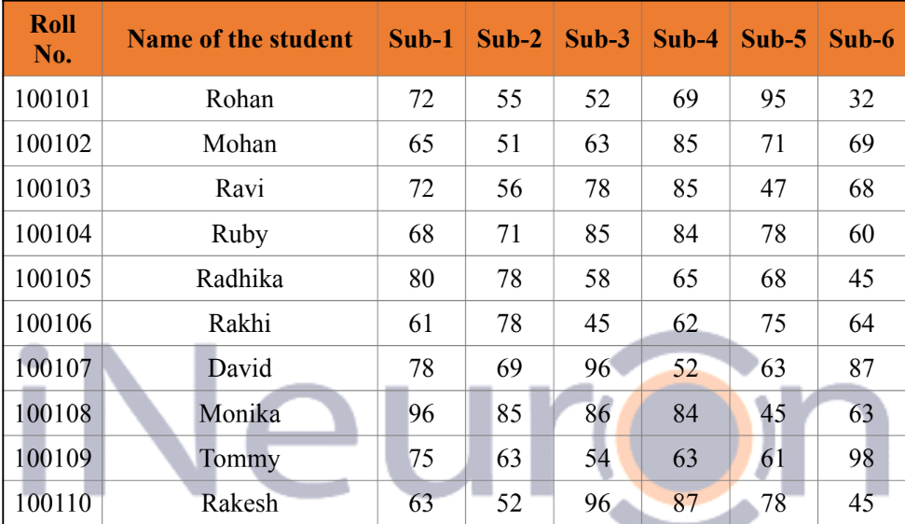

**2.From the above table use Sum Formula and find the total for each**

**student.**

Formula used is **=sum(number1,number2…)**

|  |  |
| --- | --- |
| Name | Sum |
| Mohan | 404 |
| Ravi | 406 |
| Ruby | 446 |
| Radhika | 394 |
| Rakhi | 385 |
| David | 445 |
| Monika | 459 |
| Tommy | 414 |
| Rakesh | 421 |

**3. Calculate Average for each student in the next row. Use Formulas.**

**Formula used is =average(number1,number2…)**

|  |  |
| --- | --- |
| Name | Average |
| Mohan | 67.33333 |
| Ravi | 67.66667 |
| Ruby | 74.33333 |
| Radhika | 65.66667 |
| Rakhi | 64.16667 |
| David | 74.16667 |
| Monika | 76.5 |
| Tommy | 69 |
| Rakesh | 70.16667 |

**4. Calculate Rank for each student. Use Formulas.**

**Formula used is =rank(number,ref,[order]…)**

|  |  |
| --- | --- |
| Name | Rank |
| Mohan | 7 |
| Ravi | 6 |
| Ruby | 2 |
| Radhika | 8 |
| Rakhi | 9 |
| David | 3 |
| Monika | 1 |
| Tommy | 5 |
| Rakesh | 4 |

**5. Calculate Percentage for each student. Use Formulas. Round off the**

**decimals up to 2 points.**

|  |  |
| --- | --- |
| Name | Percentage |
| Mohan | 67.33% |
| Ravi | 67.67% |
| Ruby | 74.33% |
| Radhika | 65.67% |
| Rakhi | 64.17% |
| David | 74.17% |
| Monika | 76.50% |
| Tommy | 69.00% |
| Rakesh | 70.17% |