**1. What are the various elements of the Excel interface? Describe how they're used.**

Quick Access Toolbar, File Tab, Title Bar, Control Buttons, Menu Bar, Ribbon/Toolbar, Dialog Box Launcher, Name Box, Formula Bar, Scroll Bars, Spreadsheet Area, Leaf Bar, Column Bar, Row Bar Cells, Cells, Status Bar, View Buttons, Zoom control.

**2. Write down the various applications of Excel in the industry**.

* Data Entry and Storage.
* Performing Calculations.
* Data Analysis and Interpretation.
* Reporting and Visualizations.
* Accounting and Budgeting.
* Collection and Verification of Business Data.

**3. On the ribbon, make a new tab. Add some different groups, insert commands in the groups and name them according to their commands added. Copy and paste the screenshot of the steps you followed.**

Click file tab, in that click on options, excel options window opens, in left side select customize ribbon, select new tab, a new tab is created you can rename as you like.

After creating new tab, create group and rename its default name as you like and add all frequently used functions as you like. Below are screenshots

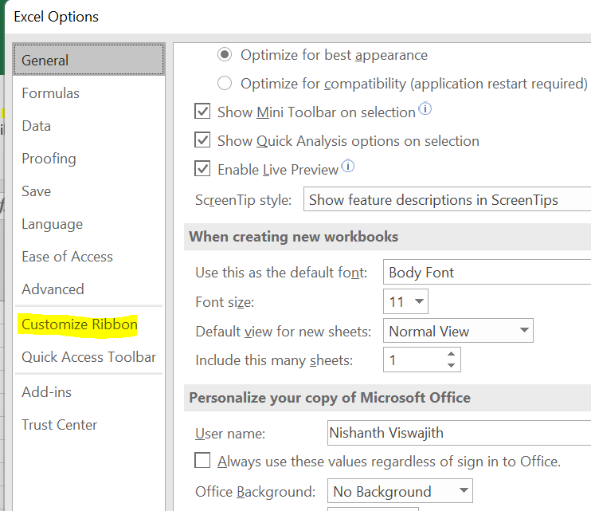 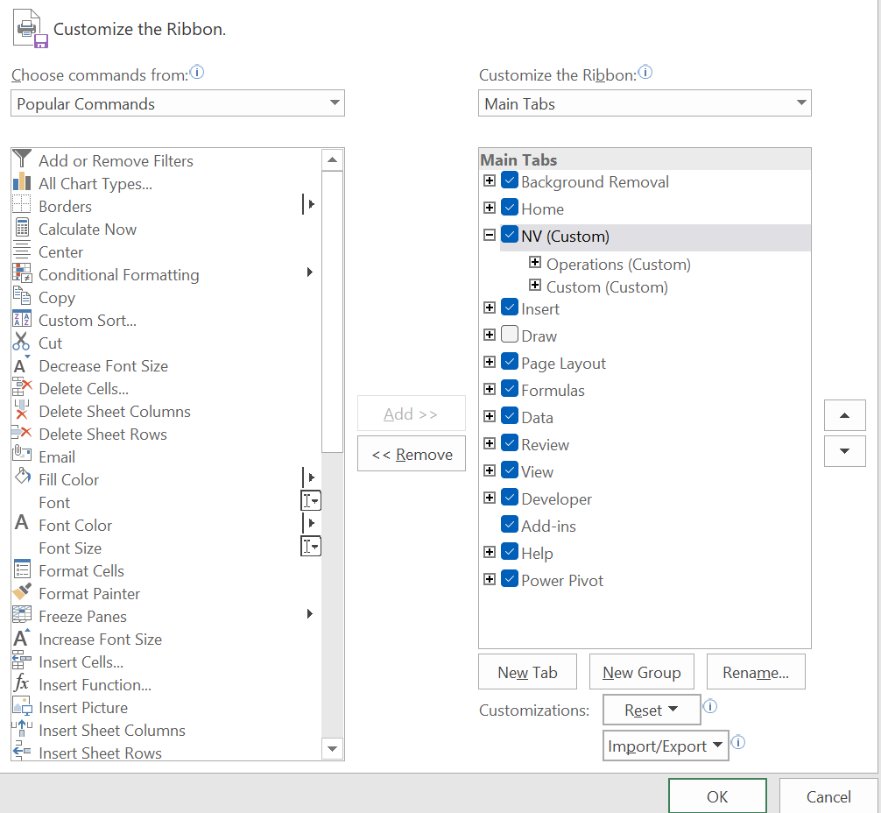

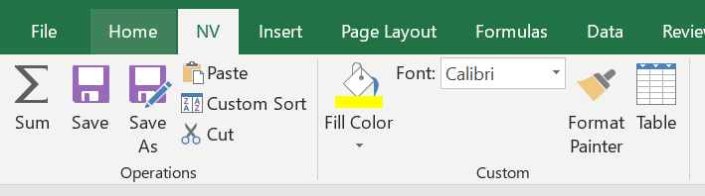

I have created tab name called NV and groups are operations and custom.

**4. Make a list of different shortcut keys that are only connected to formatting with their functions.**

Ctrl + T For table creation

ALT + H + B + A for border creation of cells

Ctrl + B for bold

Ctrl + Shift+ A for capital letters

**5. What distinguishes Excel from other analytical tools?**

* Easy to learn
* Organize raw data into readable format with actionable insights
* Inbulid formulas which makes calculations easier.

**6. Create a table and add a custom header and footer to your table.**

Select the table and in insert tab select header and footer in text section.