**1. What are the different margins options and do we adjust the margins of**

**the excel worksheet?**

Different margins options are Normal, wide, narrow, Yes we have option to adjust margins in custom margins.

2. **Set a background for your table created.**

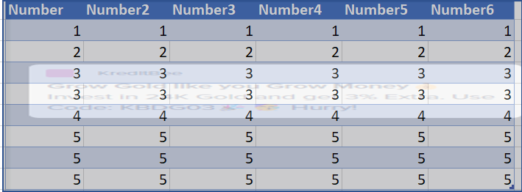

Steps:

Create a table and insert a shape according to the table size and in format shape option click fill and insert a picture and make it transparent so that data is visible.

3. **What is freeze panes and why do we use freeze panes? Give**

**examples.**

Excel keeps specific rows or columns visible when you scroll in the worksheet. For example, if the first row in your spreadsheet contains labels, you might freeze that row to make sure that the column labels remain visible as you scroll down in your spreadsheet.

**4. What are the different features available within the Freeze Panes**

**command?**

* Freeze Panes: It freezes the rows as well as the columns.
* Freeze Top Row: It freezes all the rows above the active cell.
* Freeze First Column: It freezes all the columns to the left of the active cell.

5**. Explain what the different sheet options present in excel are and what**

**they do?**

1.Ribbon Sheet Options

2.Right-click Sheet Options

In Ribbon Sheet Options two options gridlines, headings