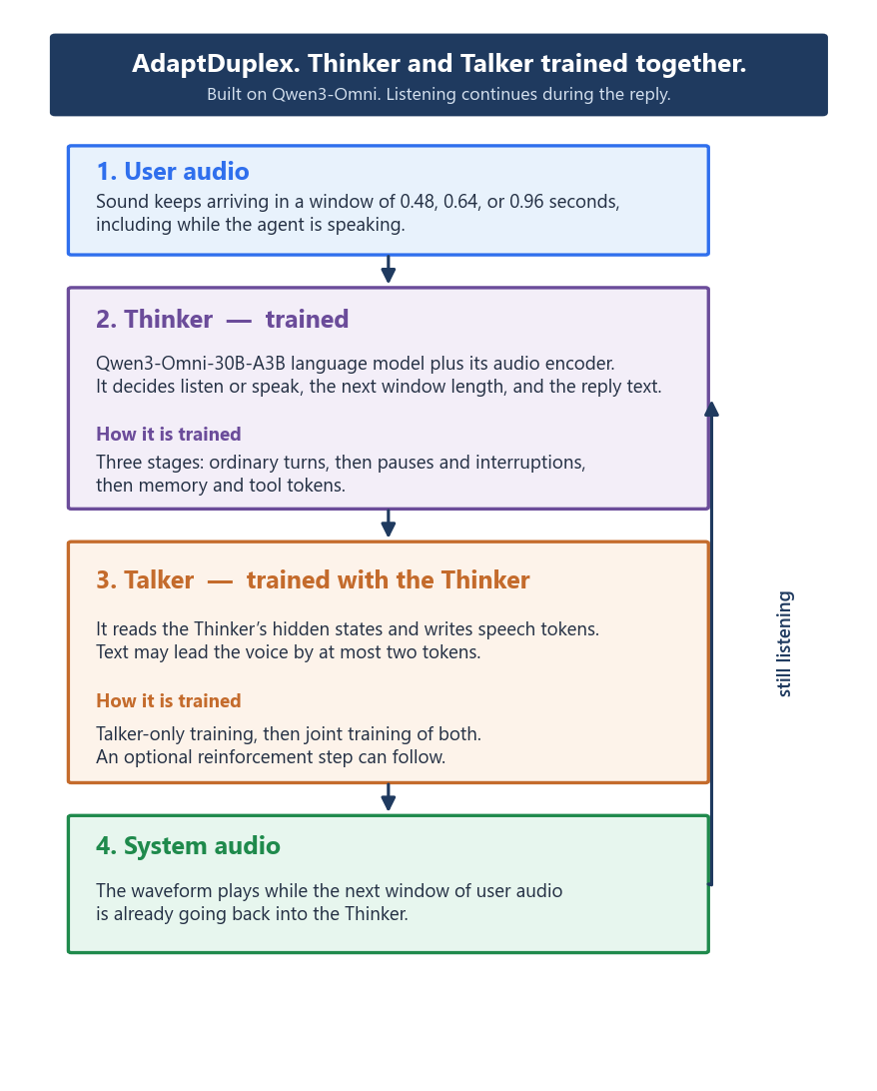Recognition, the language model, and the voice are trained as one system. There is no separate frozen speech recognizer and no separate frozen voice.
765,424 synthetic dialogues, 17,259 hours, then a smaller joint fine-tune, on 8 H100 GPUs.
HumDial-FDBench Final 69.6, the highest among the duplex models that paper compares.

