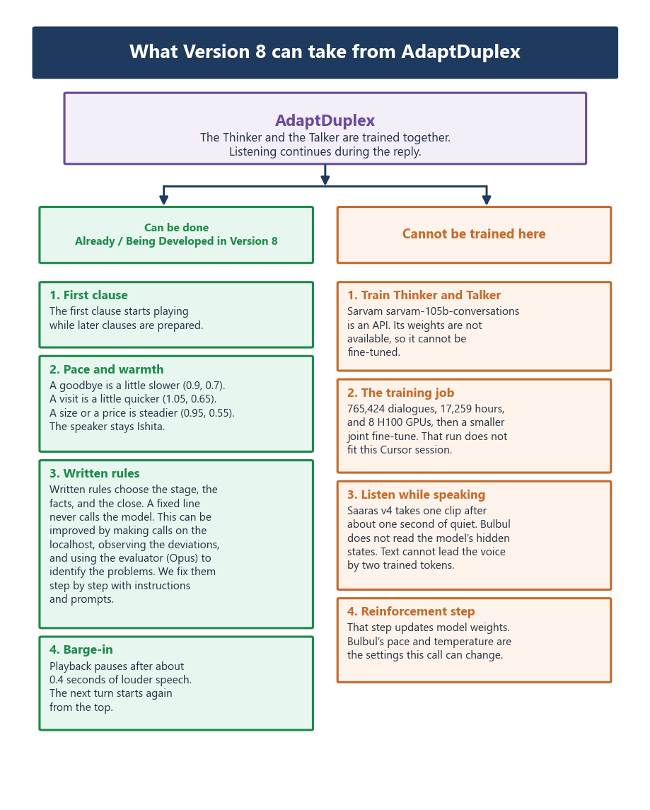
The green items are already in the localhost. The written rules keep improving through localhost calls and the Opus evaluator. The warm items stay in the paper because they require training a model we do not host.

