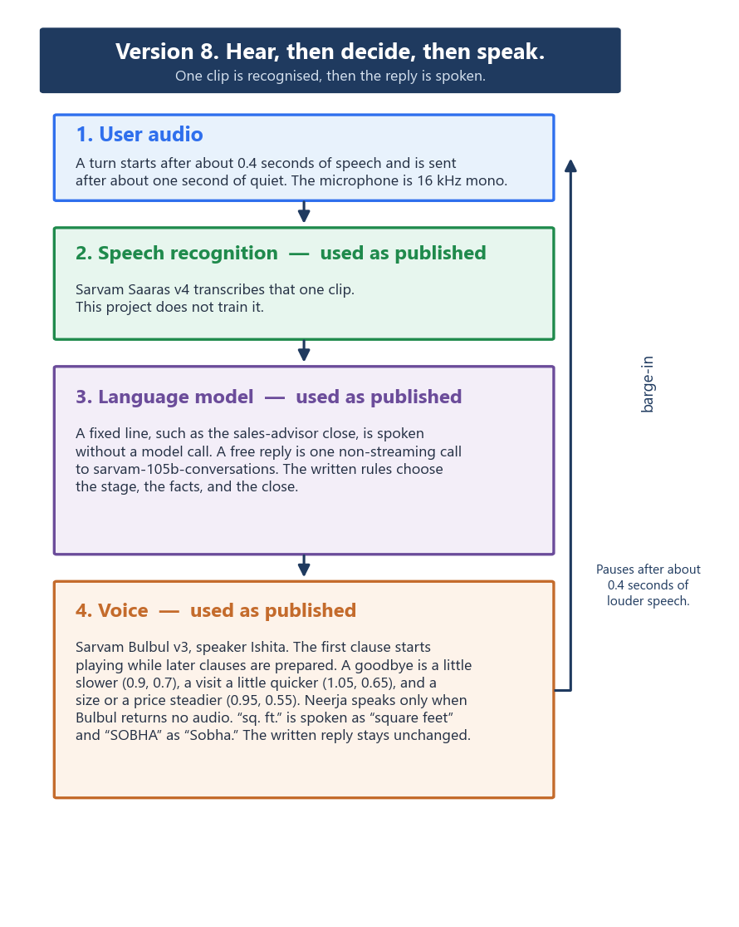
Recognition, the language model, and the voice are three separate published services. This project does not train them.
A fixed line never calls the model. A free reply is one call to sarvam-105b-conversations.
Ishita speaks the first clause while the rest of the reply is prepared.

