Framework to scale the AI automated calls
Version 11 on this computer
29 October 2026
A customer call is the same conversation already running in the browser. The new part is the phone network: something has to ring a real mobile, carry the voice both ways, and keep each customer’s answers separate. The words, the language model, the speech-to-text, and the text-to-speech stay as they are.

1. What one call is
Three jobs happen on every turn.
- Hear -The customer speaks. Sarvam Saaras turns that sound into English text. This is speech-to-text.
- Decide - Version 11 reads that text and chooses the next line. The script owns a recognized answer: area, configuration, a yes, a no, a hold, a callback. The language model is used only when the script has no branch for that sentence.
- Speak-Bulbul, voice Ishita, turns the chosen line into sound, one clause at a time. If Bulbul returns no audio, Neerja speaks that clause(fallback). Hindi, Kannada, Tamil, Telugu, and Malayalam are translated before they are spoken. This is text-to-speech.
On this computer that looks like this.
Figure 1. One call on the computer
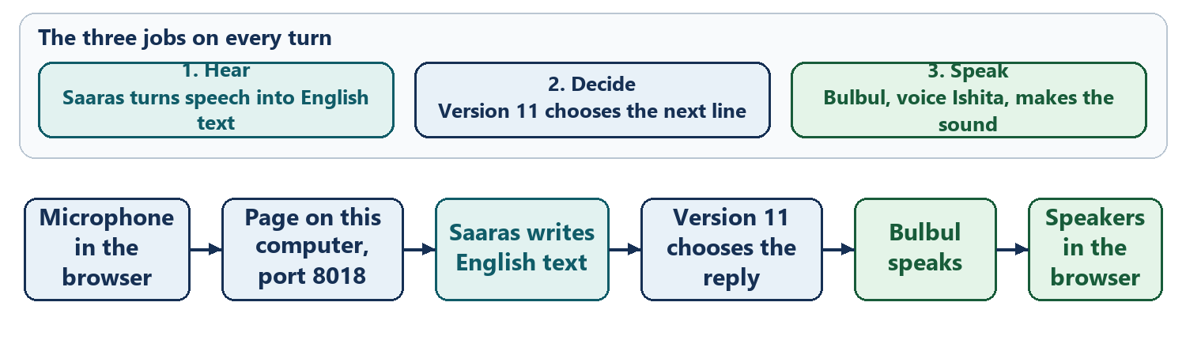
127.0.0.1 means “this computer only.” The browser on this machine can reach the page at port 8018. A customer’s mobile phone cannot. That is why the page can prove the conversation, and a real ring needs a phone company in between (Telephony).

2. What has to stay the same
The words, the model, Saaras, and Bulbul stay the Version 11 ones. Scaling adds a way to reach many numbers. It does not add a second script.
Piece | Stays
Who decides the next line | handle_speech in Version 11
Language model | sarvam-105b-conversations, and only for an unmatched reply
Voice | Ishita, pace 1.0, warmth 0.6, Bulbul v3, Neerja if Bulbul misses
Hearing | Saaras, with the same 0.45 second speech gate
Record | The same scorecard, one file per call

3. Who rings the phone
Three roles sit in front of the conversation.
- The list is a text file of Indian mobile numbers. It lives outside this git repository, so the numbers are never committed.
- Exotel is the Indian phone company. It rings the mobile from a +91-caller ID, and it keeps a pipe open for the whole call so sound can move both ways. That pipe is a WebSocket: a connection that stays open until someone hangs up, instead of a one-shot request.
- Our program still hears, decides, and speaks. Exotel does not choose the reply.
Figure 3. From a private list to the same Version 11 conversation
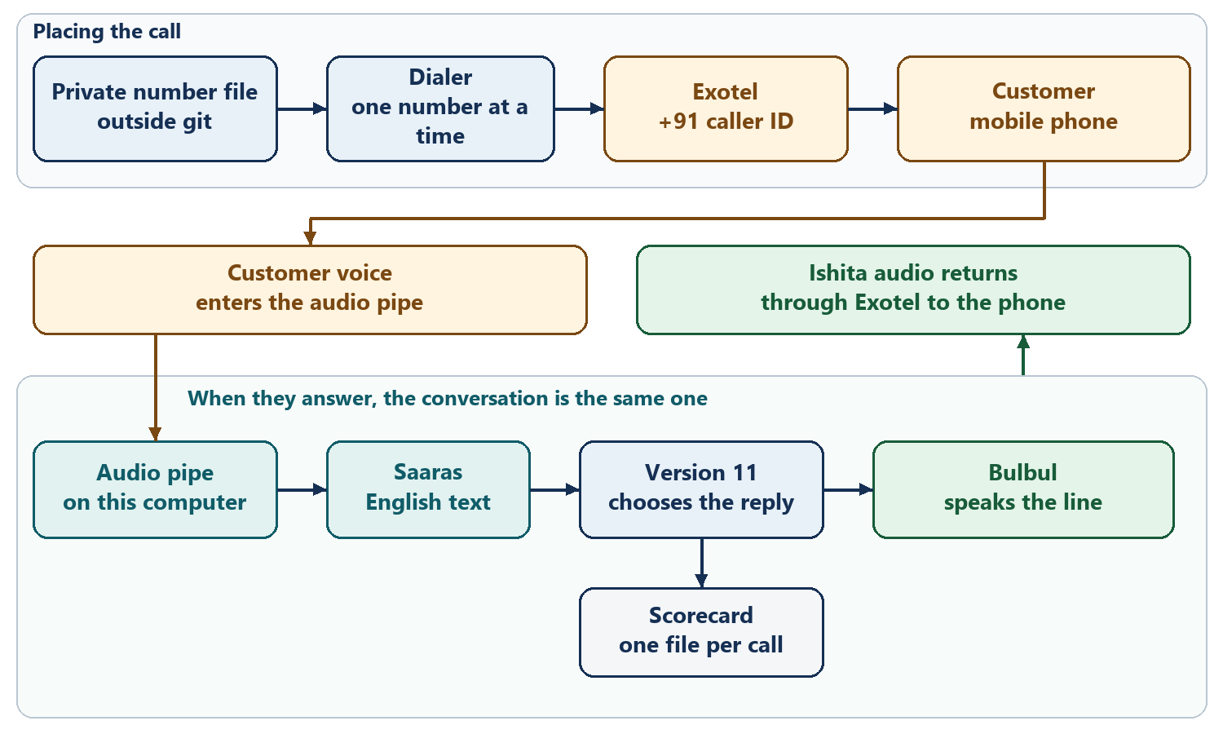
Exotel cannot open that pipe to 127.0.0.1. For a real proof call, this same Version 11 process is given a temporary public address.

4. One answered call, step by step
The pipe carries sound. The script still decides every sentence. Nothing in this path invents a new reply.
Figure 4. One answered call
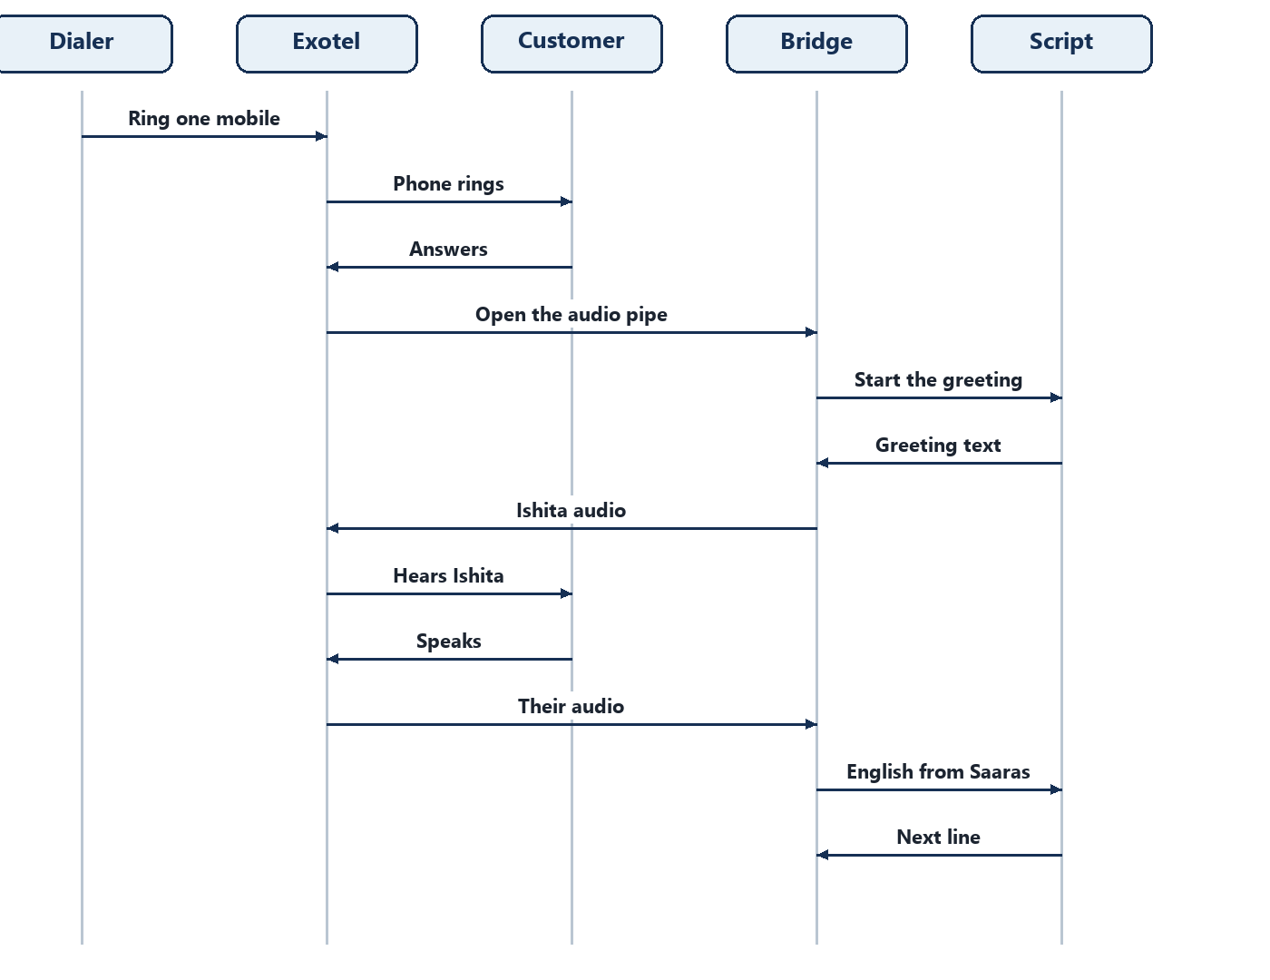
After the greeting, each next turn is the same loop. The customer speaks. Saaras writes English. Version 11 chooses the line. Bulbul speaks it. Exotel plays it on the phone. This continues until the script hangs up.
When the script hangs up, the pipe closes and that number is marked finished. A finished call includes “not interested.” It is not dialed again.
If they ask for a callback and name a time, the call stores that time on the scorecard and ends. This slice records the time. It does not ring them again.

5. How a list of hundreds is walked
One answered call lasts a few minutes, and many people do not pick up. Four or five hundred calls are a day’s campaign, not one burst.
The dialer is a small walker with these rules.
Figure 5. Walking the customer list
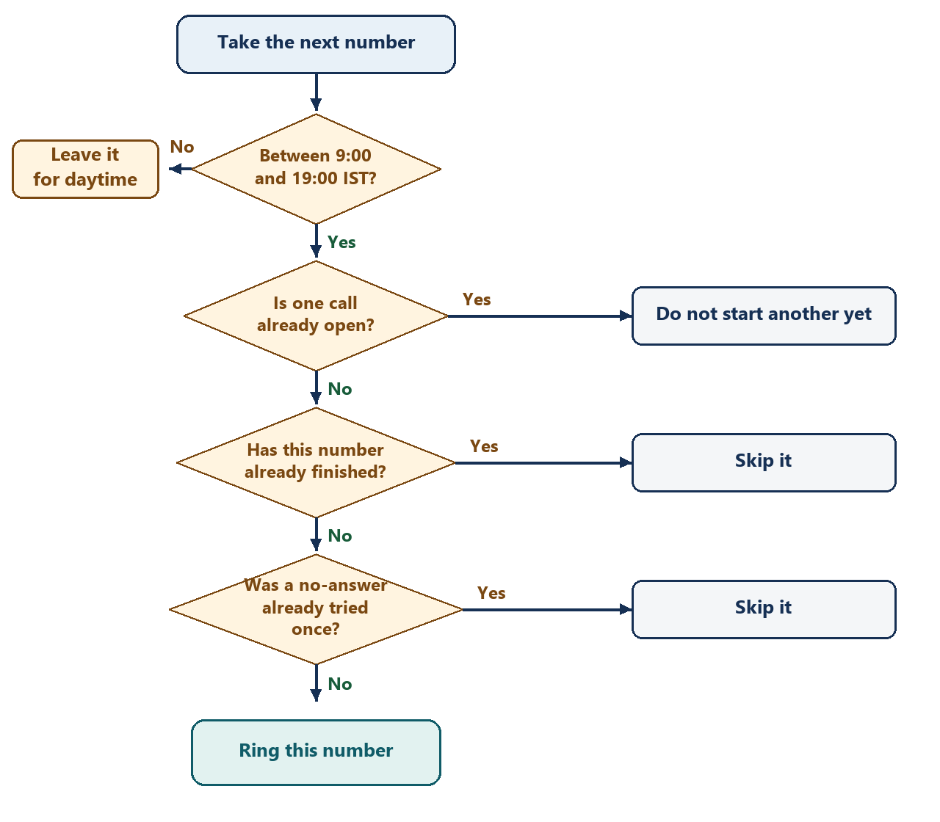
Figure 6. After the phone rings
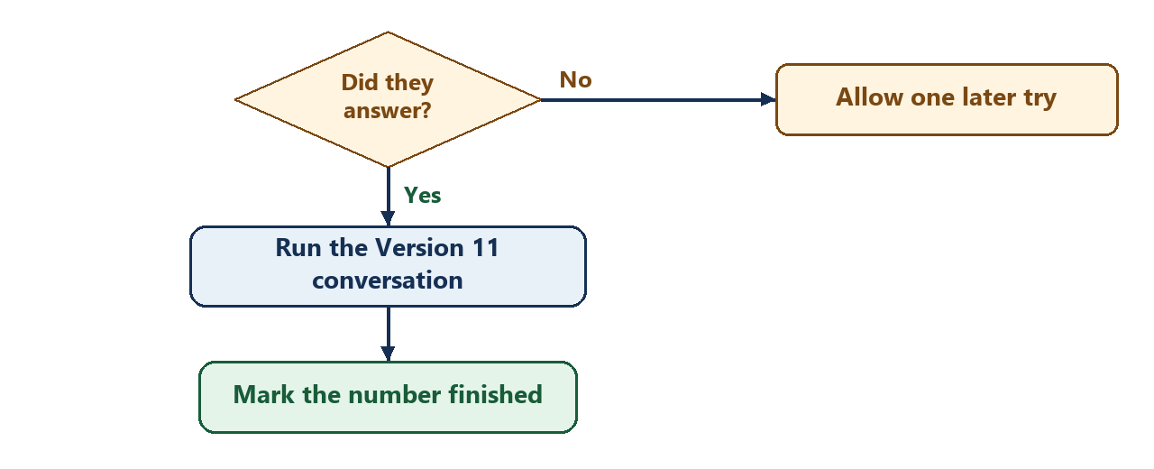

The first cap is one call at a time. After one live call sounds like the browser call, a short list is next. Five at a time is the working target only after the separate notepads stay reliable. The full list is dialed only where the customer has agreed to the call.
The dialer does not talk to Exotel by itself. The actual send is a function passed in, called a poster in the code. Tests pass a fake poster and check the request. With no poster, the walker refuses and no phone rings. A real ring happens only when that function is passed on purpose, on the public address, with Exotel enabled.
Outbound trial calls go to verified numbers, and voice streaming must be turned on. A paid Indian number and company checks come before scaling the calls.

6. What is built first, on local computer
The page on port 8018 remains how the words and the voice are checked. Building the pipe does not replace that page, and it does not need Exotel until the proof call.
Figure 7. Order of the work
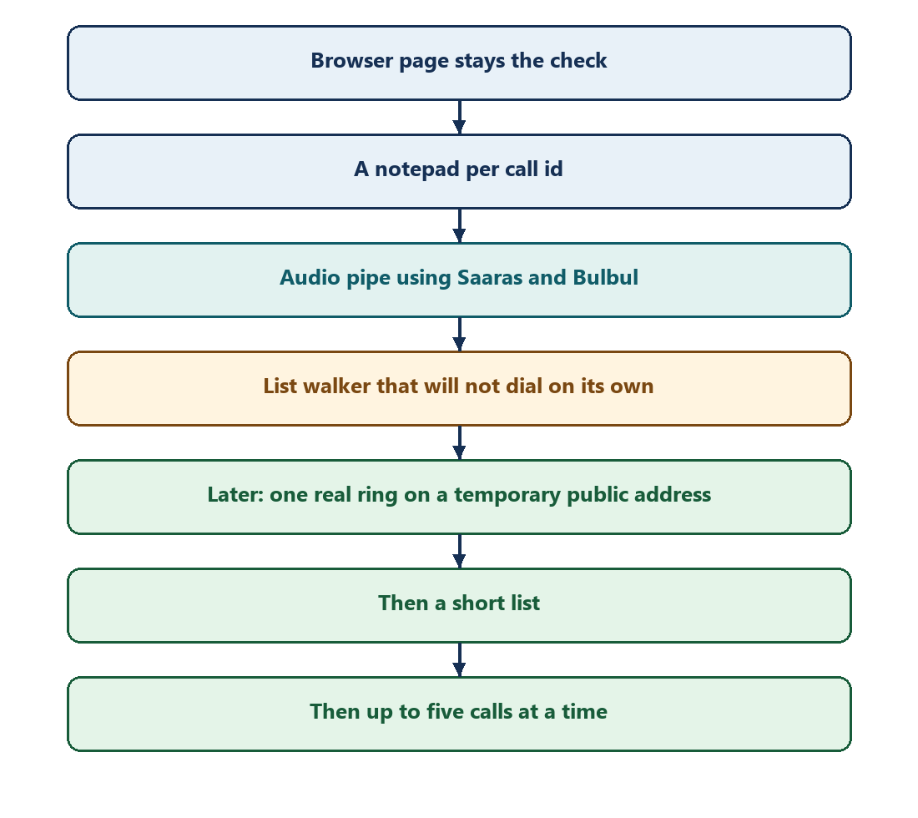
The work on this computer, before any live ring, is:
- Give each call its own notepad and its own scorecard, chosen by call id. The browser keeps the single default notepad.
- Add the audio pipe beside the local page. On answer it runs the same greeting. Customer audio goes through Saaras. The English text goes through handle_speech. Each clause goes through Bulbul, including translation and the Neerja fallback, and returns as sound Exotel can play.
- A hold that asks the agent to wait stays quiet for 45 seconds, then speaks the saved question, unless the customer speaks during the quiet. Talking over Ishita still stops the audio that is playing.
- Add the list walker. It reads numbers only from a file outside the repository. It places at most one call, only between 09:00 and 19:00 IST. With no poster it refuses. A finished call is not retried. A no-answer can be tried once. The scorecard is the one the local page already writes.

A real ring cannot reach 127.0.0.1. The proof call, a short list, and the later cap of five toward 400–500 wait until this process is on a temporary public address and Exotel voice streaming is enabled. The list is dialed only where the customer has agreed to the call, from a +91-caller ID.
7. Why cannot two calls share one notepad
Version 11 keeps the call in one notepad: stage, area, project, language, whether the customer asked to wait, and whether a callback time was taken. The browser uses that one notepad, which is correct for one person at the page.
If two customers were answered in the same program with that one notepad, the second customer’s “South” could overwrite the first customer’s “East.” Each call needs its own notepad, chosen by that call’s id before the turn runs. The browser leaves the choice unset, so the page keeps working exactly as it does now.
Figure 2. Each customer gets a separate notepad
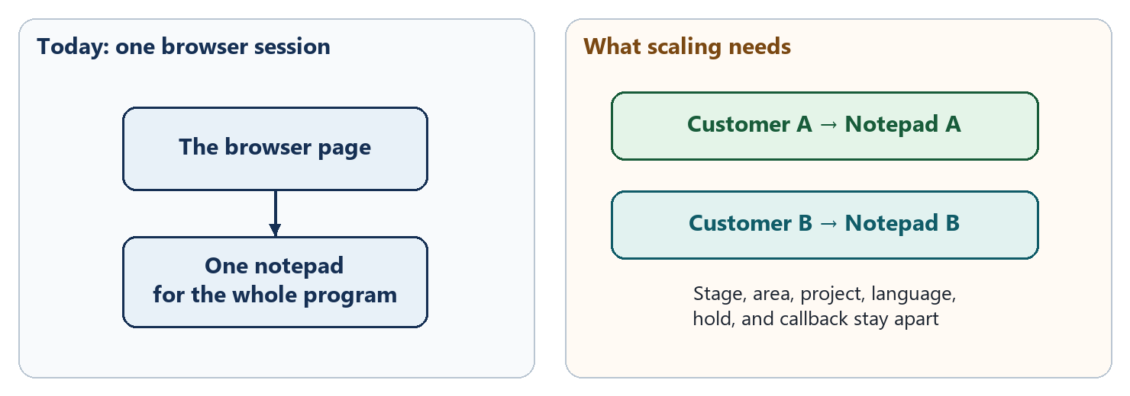
The scorecard is split the same way. Customer A’s transcript is not written into Customer B’s file.

