AI CALLING AGENT
LLM Evaluation & Performance Report
Based on the Master Evaluation Evidence Workbook

Summary:
Evaluation scale - The master evidence contains 15 unique model-evaluation runs, 131 customer turns and 520 actual model-turn evaluations. The current four-model comparison accounts for 480 of those observations; 40 observations belong to historical/out-of-scope model identifiers retained for traceability.
Controlled benchmark - The final controlled benchmark evaluated the four current models over the same conversation sequence: 48 expected and 48 evaluated observations, with no skipped evaluations. All four achieved 100% grounded-response rate and 0% unsupported-claim rate in that benchmark.
Latency - Aggregate LLM response latency across the accumulated evidence ranges from 4.06 to 7.69 seconds on average for the four current models. The final English benchmark itself averaged 8.46–12.80 seconds. These are model response times only; STT, TTS, Twilio, network and infrastructure are excluded.
Interpretation - The evaluation framework is now measuring quality, grounding, conversation behavior, language behavior, latency, tokens and estimated LLM cost across a meaningful accumulated dataset. Production voice performance remains a separate validation step.

1. Evaluation Scale & Evidence Base
Evidence measure | Count
Unique model-evaluation runs | 15
Customer turns | 131
Model-turn evaluations | 520
Labelled evaluations | 412
Unlabelled turns | 108
Models represented in evidence | 6
Languages represented | 4
Framework tests (separate) | 149
Framework tests are intentionally excluded from model-trial counts. A model-turn evaluation means one actual model response evaluated for one customer turn.

2. Evaluation Methodology
The evaluation compares model responses against expected intents/actions and evaluates factuality, grounding, conversation quality, language behavior, latency and token usage. The evidence is primarily offline; Twilio is disabled in the recorded evaluation runs.
- Controlled benchmark: fixed scenarios with defined expectations.
- Exploratory interactive evaluation: manually entered customer sequences evaluated by the same model-comparison framework.
- Framework validation: automated tests of evaluators, adapters, interactive session handling and multilingual infrastructure.
- Run-level deduplication: exported copies of the same RUN_ID are not counted as additional trials.

3. Models Evaluated
Model | Provider | Reporting treatment
Sarvam 105B Conversations | Sarvam | Current comparison
DeepSeek V4.1 Flash | DeepSeek | Current comparison
Claude Sonnet 4.6 | Anthropic | Current comparison
Claude Opus 4.8 | Anthropic | Current comparison
Sarvam Flagship | Sarvam | Historical/out-of-scope evidence
claude-sonnet-4-20250514 | Anthropic | Historical/out-of-scope evidence

4. Final Controlled English Benchmark
RUN_ID 20260923_084857 is the primary controlled English comparison. It contains 48 model-turn observations, 12 for each current model, using the same customer sequence.
Model | N | Intent | Action | Factual | Grounded | Unsupported Claims | Avg Latency
Sarvam | 12 | 100% | 89% | 90% | 100% | 0% | 8.46s
DeepSeek | 12 | 89% | 100% | 80% | 100% | 0% | 8.98s
Claude Sonnet | 12 | 100% | 100% | 90% | 100% | 0% | 12.80s
Claude Opus | 12 | 89% | 89% | 90% | 100% | 0% | 10.73s

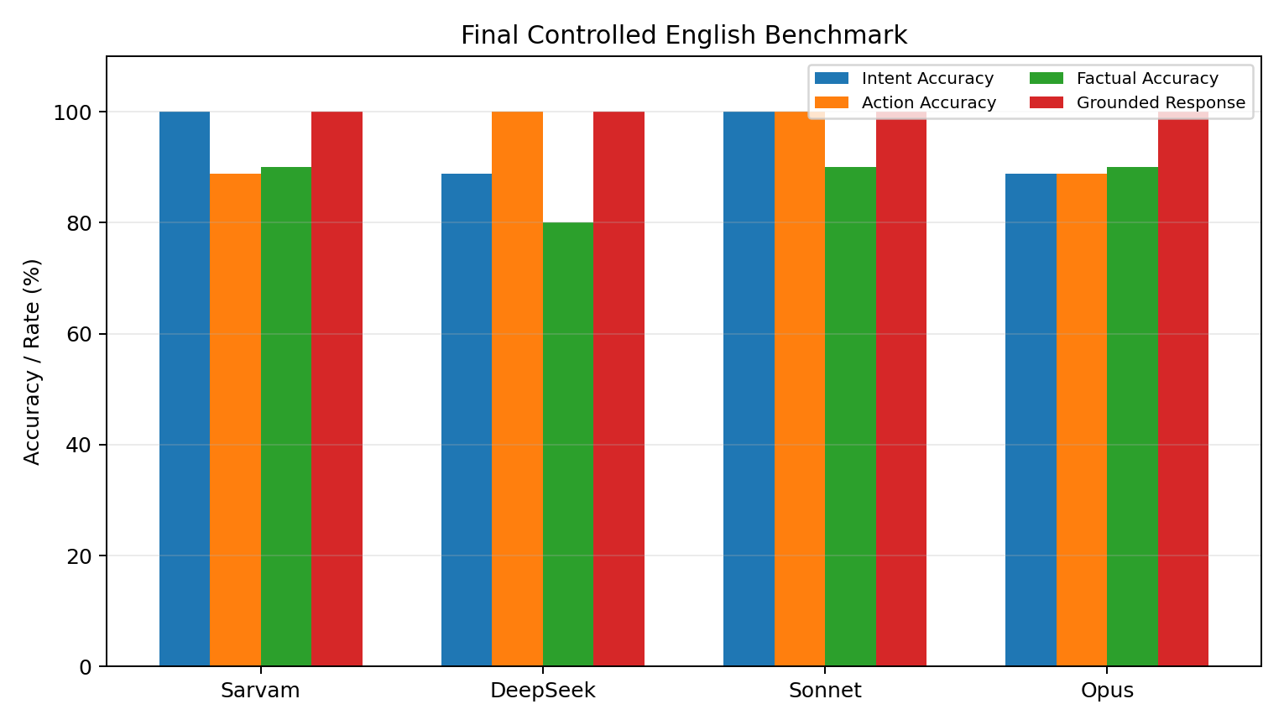

5. Aggregate Model Performance
Aggregate metrics below are calculated from the accumulated master evidence. Sample sizes differ by model, so the N column should always be read alongside the percentages. No overall score or ranking is used.
Model | N | Intent | Action | Factual | Grounded | Context | Stage
Sarvam | 135 | 83.2% | 80.4% | 88.5% | 98.5% | 79.6% | 76.8%
DeepSeek | 95 | 86.6% | 92.5% | 81.8% | 99.0% | 81.0% | 75.8%
Claude Sonnet | 125 | 83.5% | 89.7% | 89.7% | 96.0% | 82.2% | 67.4%
Claude Opus | 125 | 87.0% | 90.9% | 87.9% | 99.1% | 81.4% | 68.4%
The workbook also contains precision, recall, macro-F1, relevance, completeness, clarity, conversational quality and naturalness at model level.

6. Error & Behavior Analysis
The observation-level error table records actual error categories from the evaluation data. The most frequent current-model categories in the workbook include context errors, factual errors, language-understanding errors, premature confirmation and other behaviour-level issues.
Model | Observed error type | Count
Claude Sonnet | Stage Error | 31
Claude Opus | Stage Error | 30
DeepSeek | Stage Error | 23
Sarvam | Stage Error | 22
Sarvam | Context Error | 21
Sarvam | Wrong Action | 21
Claude Opus | Context Error | 18
Claude Sonnet | Context Error | 18
DeepSeek | Context Error | 18
Sarvam | Factual Error | 18
Sarvam | Wrong Intent | 18
Claude Sonnet | Wrong Intent | 16

7. Latency & Token Usage
Model | N | Avg | P50 | P95 | Mean Input | Mean Output | Mean Total
Sarvam | 133 | 4.06s | 3.10s | 7.50s | 954 | 69 | 1023
DeepSeek | 93 | 5.44s | 4.48s | 9.99s | 1166 | 83 | 1249
Claude Sonnet | 123 | 7.69s | 6.56s | 12.84s | 1142 | 97 | 1239
Claude Opus | 123 | 6.32s | 6.04s | 10.66s | 1744 | 110 | 1854

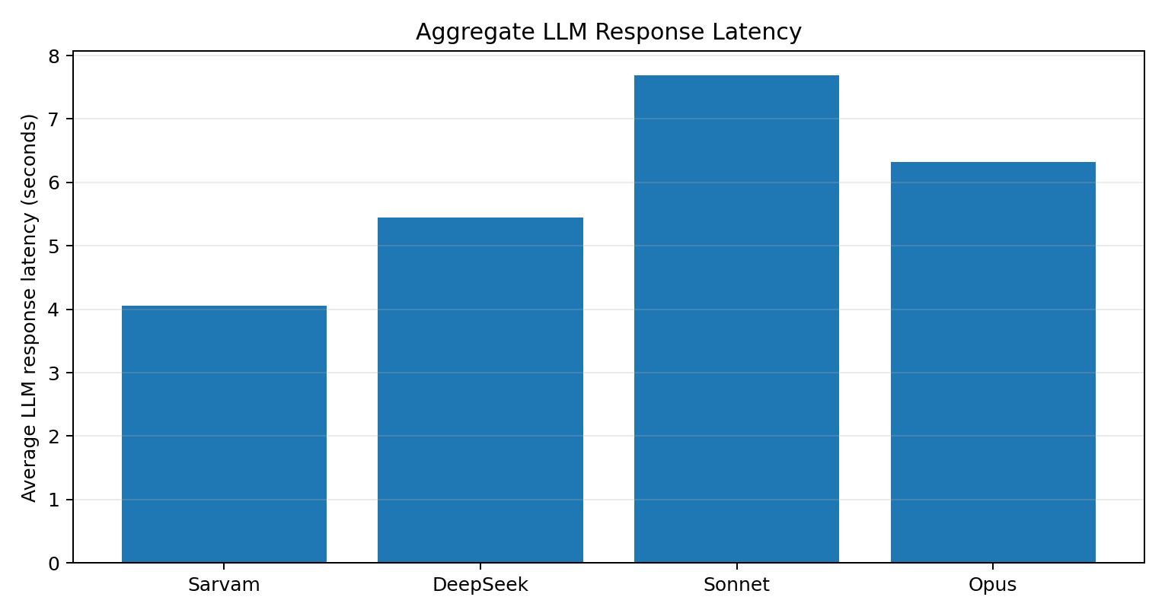
Latency is LLM/model response latency only. It is not total end-to-end voice latency and excludes STT, TTS, Twilio and infrastructure/network overhead.

8. LLM Cost Comparison
Model | Input tokens | Output tokens | LLM cost/call | 1,000 calls | 10,000 calls
Sarvam Conversational | 1,154 | 63 | ₹0.46 | ₹461 | ₹4,609
DeepSeek V4.1 Flash | 1,168 | 69 | ₹0.50 | ₹497 | ₹4,973
Claude Sonnet 4.6 | 1,332 | 84 | ₹6.03 | ₹6,035 | ₹60,349
Claude Opus 4.8 | 1,891 | 99 | ₹13.70 | ₹13,698 | ₹136,975

9. Cost Calculation Method
Cost = (Input ÷ 1,000,000 × Input Price) + (Output ÷ 1,000,000 × Output Price)
For USD-priced models, the USD result is converted to INR using ₹95.71/USD. The reported per-call figures below use the benchmark's separate input/output token measurements.

9. Multilingual Evaluation Evidence
The master workbook contains evidence for English, Hindi, Kannada and mixed-language tracks. It also explicitly distinguishes multilingual capability evidence from production validation.

Language | Model-turns | Avg language understanding* | Avg response-language match* | Interpretation
English | 330 | 100.0% | 100.0% | Capability evidence; not production-validated
Hindi | 72 | 85.9% | 35.9% | Capability evidence; not production-validated
Kannada | 36 | 93.8% | 34.4% | Capability evidence; not production-validated
Mixed | 42 | 97.5% | 100.0% | Capability evidence; not production-validated
These are simple summaries across model rows, not standardized language scores. Hindi includes exploratory interactive evidence; the evidence base should not be presented as production multilingual validation.

10. Evaluation Framework Validation
The master workbook records 149 pytest node-level tests as framework validation. These tests are separate from model performance and are not counted as model-turn evaluations.
Test suite | Count | Passed | Failed | Scope
tests/test_deepseek.py | 13 | 13 | 0 | DeepSeek adapter configuration and token handling
tests/test_eval_framework.py | 12 | 12 | 0 | Deterministic evaluator unit tests (facts, grounding, schema)
tests/test_eval_v11.py | 17 | 17 | 0 | LLM-EVAL.1.1 configuration, availability, Excel summary
tests/test_interactive.py | 19 | 19 | 0 | Interactive session commands, dry-run, isolation
tests/test_master_report.py | 6 | 6 | 0 | Master report aggregation / reconciliation
tests/test_multilingual.py | 28 | 28 | 0 | Multilingual tracks, language match, FakeProvider CLI
tests/test_outbound.py | 12 | 12 | 0 | Outbound opening/stage metrics with FakeProvider
tests/test_outbound_gt_coverage.py | 10 | 10 | 0 | Outbound ground-truth coverage and visit binding
tests/test_session_evaluation.py | 9 | 9 | 0 | Session /evaluate coverage and missing GT handling
tests/test_visit_calibration.py | 23 | 23 | 0 | Visit DATE-before-TIME policy (FakeProvider)
interactive_runs (FakeProvider / DRY_RUN dumps) | 56 | 56 | 0 | Pytest and dry-run session folders
Total collected pytest tests: 149. These MUST NOT be reported as model evaluation trials.

11. Current Limitations
- The evidence is predominantly offline LLM evaluation; Twilio/real voice-call performance is not validated by this workbook.
- LLM latency excludes STT, TTS, telephony and network overhead.
- LLM cost estimates exclude Twilio, STT, TTS and infrastructure and use explicit pricing assumptions.
- Controlled benchmark and exploratory runs are both present; conclusions should preserve their evidence class.
- Multilingual evidence is limited and is not production validation.
- Historical/out-of-scope model identifiers are retained for traceability but should not be mixed into the current four-model decision set.

12. Recommended Next Steps
- Expand standardized English evaluation to increase the number of controlled observations for the four current models.
- Continue standardized Hindi and Kannada benchmark testing using matched scenarios and consistent ground truth.
- Measure end-to-end voice latency once the Twilio + Lightsail path is enabled, including STT, LLM and TTS.
- Recalculate operating cost using confirmed provider pricing and an agreed USD-INR accounting rate.
- Keep the master workbook as a repeatable evidence layer for future evaluation runs.
- Use observation-level error analysis to prioritize intent, stage, language and grounding improvements.

Appendix — Metric Definitions
Metric | Definition
Intent Accuracy | Share of evaluated turns where predicted intent matches expected intent.
Action Accuracy | Share of evaluated turns where predicted action matches expected action.
Factual Accuracy | Share of evaluated turns judged factually correct against available ground truth/evidence.
Grounded Response % | Share of responses supported by configured project knowledge/context.
Unsupported Claim Rate | Share of responses containing unsupported claims.
P50 / P95 Latency | 50th / 95th percentile LLM response latency.
Model-Turn Evaluation | One actual model response evaluated for one customer turn.
Evaluation Run | A unique RUN_ID; exported copies of the same RUN_ID are not additional trials.

Source & Audit Note
Primary source: AI_Calling_Agent_Master_Evaluation_Report.xlsx. The workbook contains the evaluation run inventory, observation-level model results, aggregate metrics, error analysis, latency/token analysis, cost assumptions, multilingual evidence, framework validation and data lineage.

