AI Calling Agent
How each path speaks
The same comparison as the architecture table, drawn as the order of one call
Version4 is the phone path. Version6 is the localhost page, and it stays frozen. Version7 is only the four-hour change: the reply is still written in full, then Ishita starts at the first clause.
1. Phone path, Version4
How the call starts

Figure 1. Twilio dials the customer, and Polly Kajal speaks the greeting.
make_call.py asks Twilio to dial and open /voice. Polly Kajal-Neural speaks the greeting. The customer hears it on the phone.
Each later turn

Figure 2. The customer speaks, Gather returns the text, and Polly speaks the whole reply.
Twilio Gather listens in Indian English and sends the text to /handle-speech. The Townpark stages use a fixed line or Sarvam 105B. Polly then speaks that whole line. A live phone turn was not measured for this note.
2. Localhost baseline, Version6

Figure 3. One localhost turn. Ishita speaks only after the whole clip is ready.
You speak into the Cursor page at 127.0.0.1:8013. The browser uploads one WAV clip. Sarvam Saaras v4 transcribes that whole clip. The stages prepare the full reply, then Bulbul v3 Ishita speaks all of it. “sq. ft.” is spoken as “square feet.” If Bulbul returns nothing, Neerja speaks. The microphone stays open during playback and can stop the current clip. One measured turn took about 3.8 seconds: 1.0 second to recognise, 0.8 second for the model, and 2.3 seconds for the full voice clip.
3. Proposed four-hour change, Version7
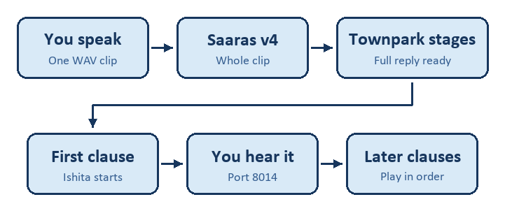
Figure 4. The reply is still written in full. Ishita starts speaking at the first clause.
The page would be 127.0.0.1:8014. The WAV upload, the Saaras request, and the full reply stay as they are on Version6. Speech then starts with the first clause. The later clauses play in order. If you speak over Ishita, the clauses still waiting are dropped. The Townpark stages, the project facts, the Opus 5.5 scorecard, and the Polly phone voice stay as they are. Recognition time and model time remain. A 350 millisecond full turn is not the expected result.

