AI Calling Agent
Three ways the call is spoken
The comparison table first, then the same paths drawn as the order of one call
Version4 is the Twilio phone path. Version6 is the localhost page in Cursor, and it stays frozen. Version7 is the copy where the next change would be made. The table lists the three paths side by side. The diagrams that follow show those same paths as the order of one call. This note does not include a duplex WebSocket, streaming speech recognition, or a 350 millisecond full turn.
1. Architecture comparison
Architecture dimension | Phone path (Version4) | Localhost baseline (Version6) | Proposed in Research Papers (Version7)
Where it runs | Twilio app. The call opens /voice. | Cursor at http://127.0.0.1:8013/ | Cursor at http://127.0.0.1:8014/
How audio moves | Twilio webhooks: /voice and /handle-speech. | HTTP: /local/listen, /local/turn, /local/speak, and /local/end. | The same HTTP calls. The first clause is spoken before the rest of the reply is synthesized.
How the customer is captured | Twilio Gather, Indian English, speech model experimental_utterances. | The browser records one WAV clip and uploads it. | The same WAV upload.
Speech to text | The text Twilio Gather returns. | Sarvam Saaras v4, one request for the whole clip. | The same Saaras request.
How a turn runs | One customer utterance, then one reply. | One customer utterance, then one full reply. | One customer utterance, then the reply is spoken clause by clause.
Interruption | Gather collects the next utterance. | The microphone stays open during playback and can stop the current clip. | The same interrupt, and clauses that have not played are dropped.
Who writes the reply | Sarvam 105B, or a fixed line. | Sarvam 105B, or a fixed line. The full text is ready before speech starts. | The same full text. Speech then starts at the first clause.
Who speaks | Polly Kajal-Neural, the whole line. | Bulbul v3 Ishita, the whole clip. “sq. ft.” is spoken as “square feet.” Neerja speaks only if Bulbul returns nothing. | The same voice and wording, starting with the first clause.
How you hear it | Twilio plays the audio on the phone. | The browser plays one complete audio file. | The browser plays the first clause, then the following clauses.
Timing | A live phone turn was not measured for this table. | One measured localhost turn was about 3.8 seconds for the whole turn: 1.0 second recognition, 0.8 second model, 2.3 seconds for the full voice clip. | The wait before the first words can shrink toward the first clause. Recognition and model time stay.
What the Version7 change would achieve
Ishita can start the answer before the rest of the sentence is synthesized. If the tester speaks over her, the clauses still waiting do not continue. The Townpark stages, the project facts, the Opus 5.5 scorecard, and the Polly phone voice stay as they are.
The caller remains Sarvam 105B. Speech recognition remains one Saaras request for the finished clip. The phone customer still hears Polly Kajal-Neural.
From the table to the diagrams
The rows above compare the three paths on the same questions. The following pages draw those paths as the order of one call. Figures 1 and 2 are the phone path in the first column. Figure 3 is the localhost baseline in the second column. Figure 4 is the Version7 change in the third column: the reply is still written in full, then Ishita starts at the first clause.

2. How each path speaks
Each diagram follows one call from the first words to the reply
Phone path, Version4
How the call starts

Figure 1. Twilio dials the customer, and Polly Kajal speaks the greeting.
make_call.py asks Twilio to dial and open /voice. Polly Kajal-Neural speaks the greeting. The customer hears it on the phone.
Each later turn

Figure 2. The customer speaks, Gather returns the text, and Polly speaks the whole reply.
Twilio Gather listens in Indian English and sends the text to /handle-speech. The Townpark stages use a fixed line or Sarvam 105B. Polly then speaks that whole line. A live phone turn was not measured for this note.
Localhost baseline, Version6

Figure 3. One localhost turn. Ishita speaks only after the whole clip is ready.
You speak into the Cursor page at 127.0.0.1:8013. The browser uploads one WAV clip. Sarvam Saaras v4 transcribes that whole clip. The stages prepare the full reply, then Bulbul v3 Ishita speaks all of it. “sq. ft.” is spoken as “square feet.” If Bulbul returns nothing, Neerja speaks. The microphone stays open during playback and can stop the current clip. One measured turn took about 3.8 seconds: 1.0 second to recognise, 0.8 second for the model, and 2.3 seconds for the full voice clip.
Proposed four-hour change, Version7
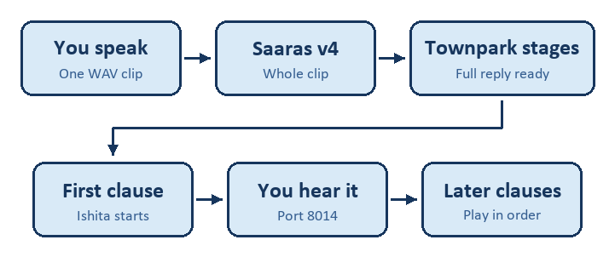
Figure 4. The reply is still written in full. Ishita starts speaking at the first clause.
The page would be 127.0.0.1:8014. The WAV upload, the Saaras request, and the full reply stay as they are on Version6. Speech then starts with the first clause. The later clauses play in order. If you speak over Ishita, the clauses still waiting are dropped. The Townpark stages, the project facts, the Opus 5.5 scorecard, and the Polly phone voice stay as they are. Recognition time and model time remain. A 350 millisecond full turn is not the expected result.

