Architecture Flowchart & Specification:
DuplexCascade Streaming Micro-Turns
Transitioning the SOBHA Townpark AI Calling Agent from Half-Duplex Batching to VAD-Free Full-Duplex Dialogue in Cursor
SYSTEM TARGET: SOBHA Townpark Outbound Voice Agent (Cursor Localhost, Port 8013)
THEORETICAL FOUNDATION: 2026 SOTA Research in Full-Duplex Dialogue & Expressive Speech Synthesis (DuplexCascade, Interactive TTS, BayLing-Duplex, AdaptDuplex)
CORE METRIC OBJECTIVE: Compress turn-taking latency from 3.8s down to <500ms; enable instant barge-in without voice drift.

1. Executive Summary: Overcoming the 3.8-Second Latency Barrier
The SOBHA Townpark AI Calling Agent was developed to automate outbound qualification calls for prospective real estate buyers. Following initial prototyping in Google Colab and deployment on AWS Lightsail with Twilio, development was transitioned to Cursor to enable rapid local iteration on port 8013. While the local architecture successfully executes dialogue turns and scores calls using Claude Opus 5.5, evaluation logs show a prohibitive average turn latency of 3.8 seconds (Voice TTS accounting for 2.3 seconds, STT taking 1.0 second, and LLM reasoning taking 0.8 seconds).
This document details the architectural pivot to DuplexCascade (Yang et al., Interspeech 2026), a VAD-free streaming micro-turn framework designed specifically for cascaded ASR-LLM-TTS pipelines. By replacing sequential batch calls with bi-directional WebSockets, continuous 100ms audio slicing, clause-based token buffering, and sub-120ms neural speech synthesis, the agent achieves human-parity turn-taking and instant interruption handling while preserving strict Townpark business logic.

2. Comprehensive Architectural Flowchart
The following flowchart contrasts the existing sequential localhost pipeline (Version 6) with the proposed DuplexCascade streaming micro-turn architecture (Version 7). In the proposed design, long sequential blocking intervals are replaced by parallel asynchronous data streams coordinated across persistent WebSockets.
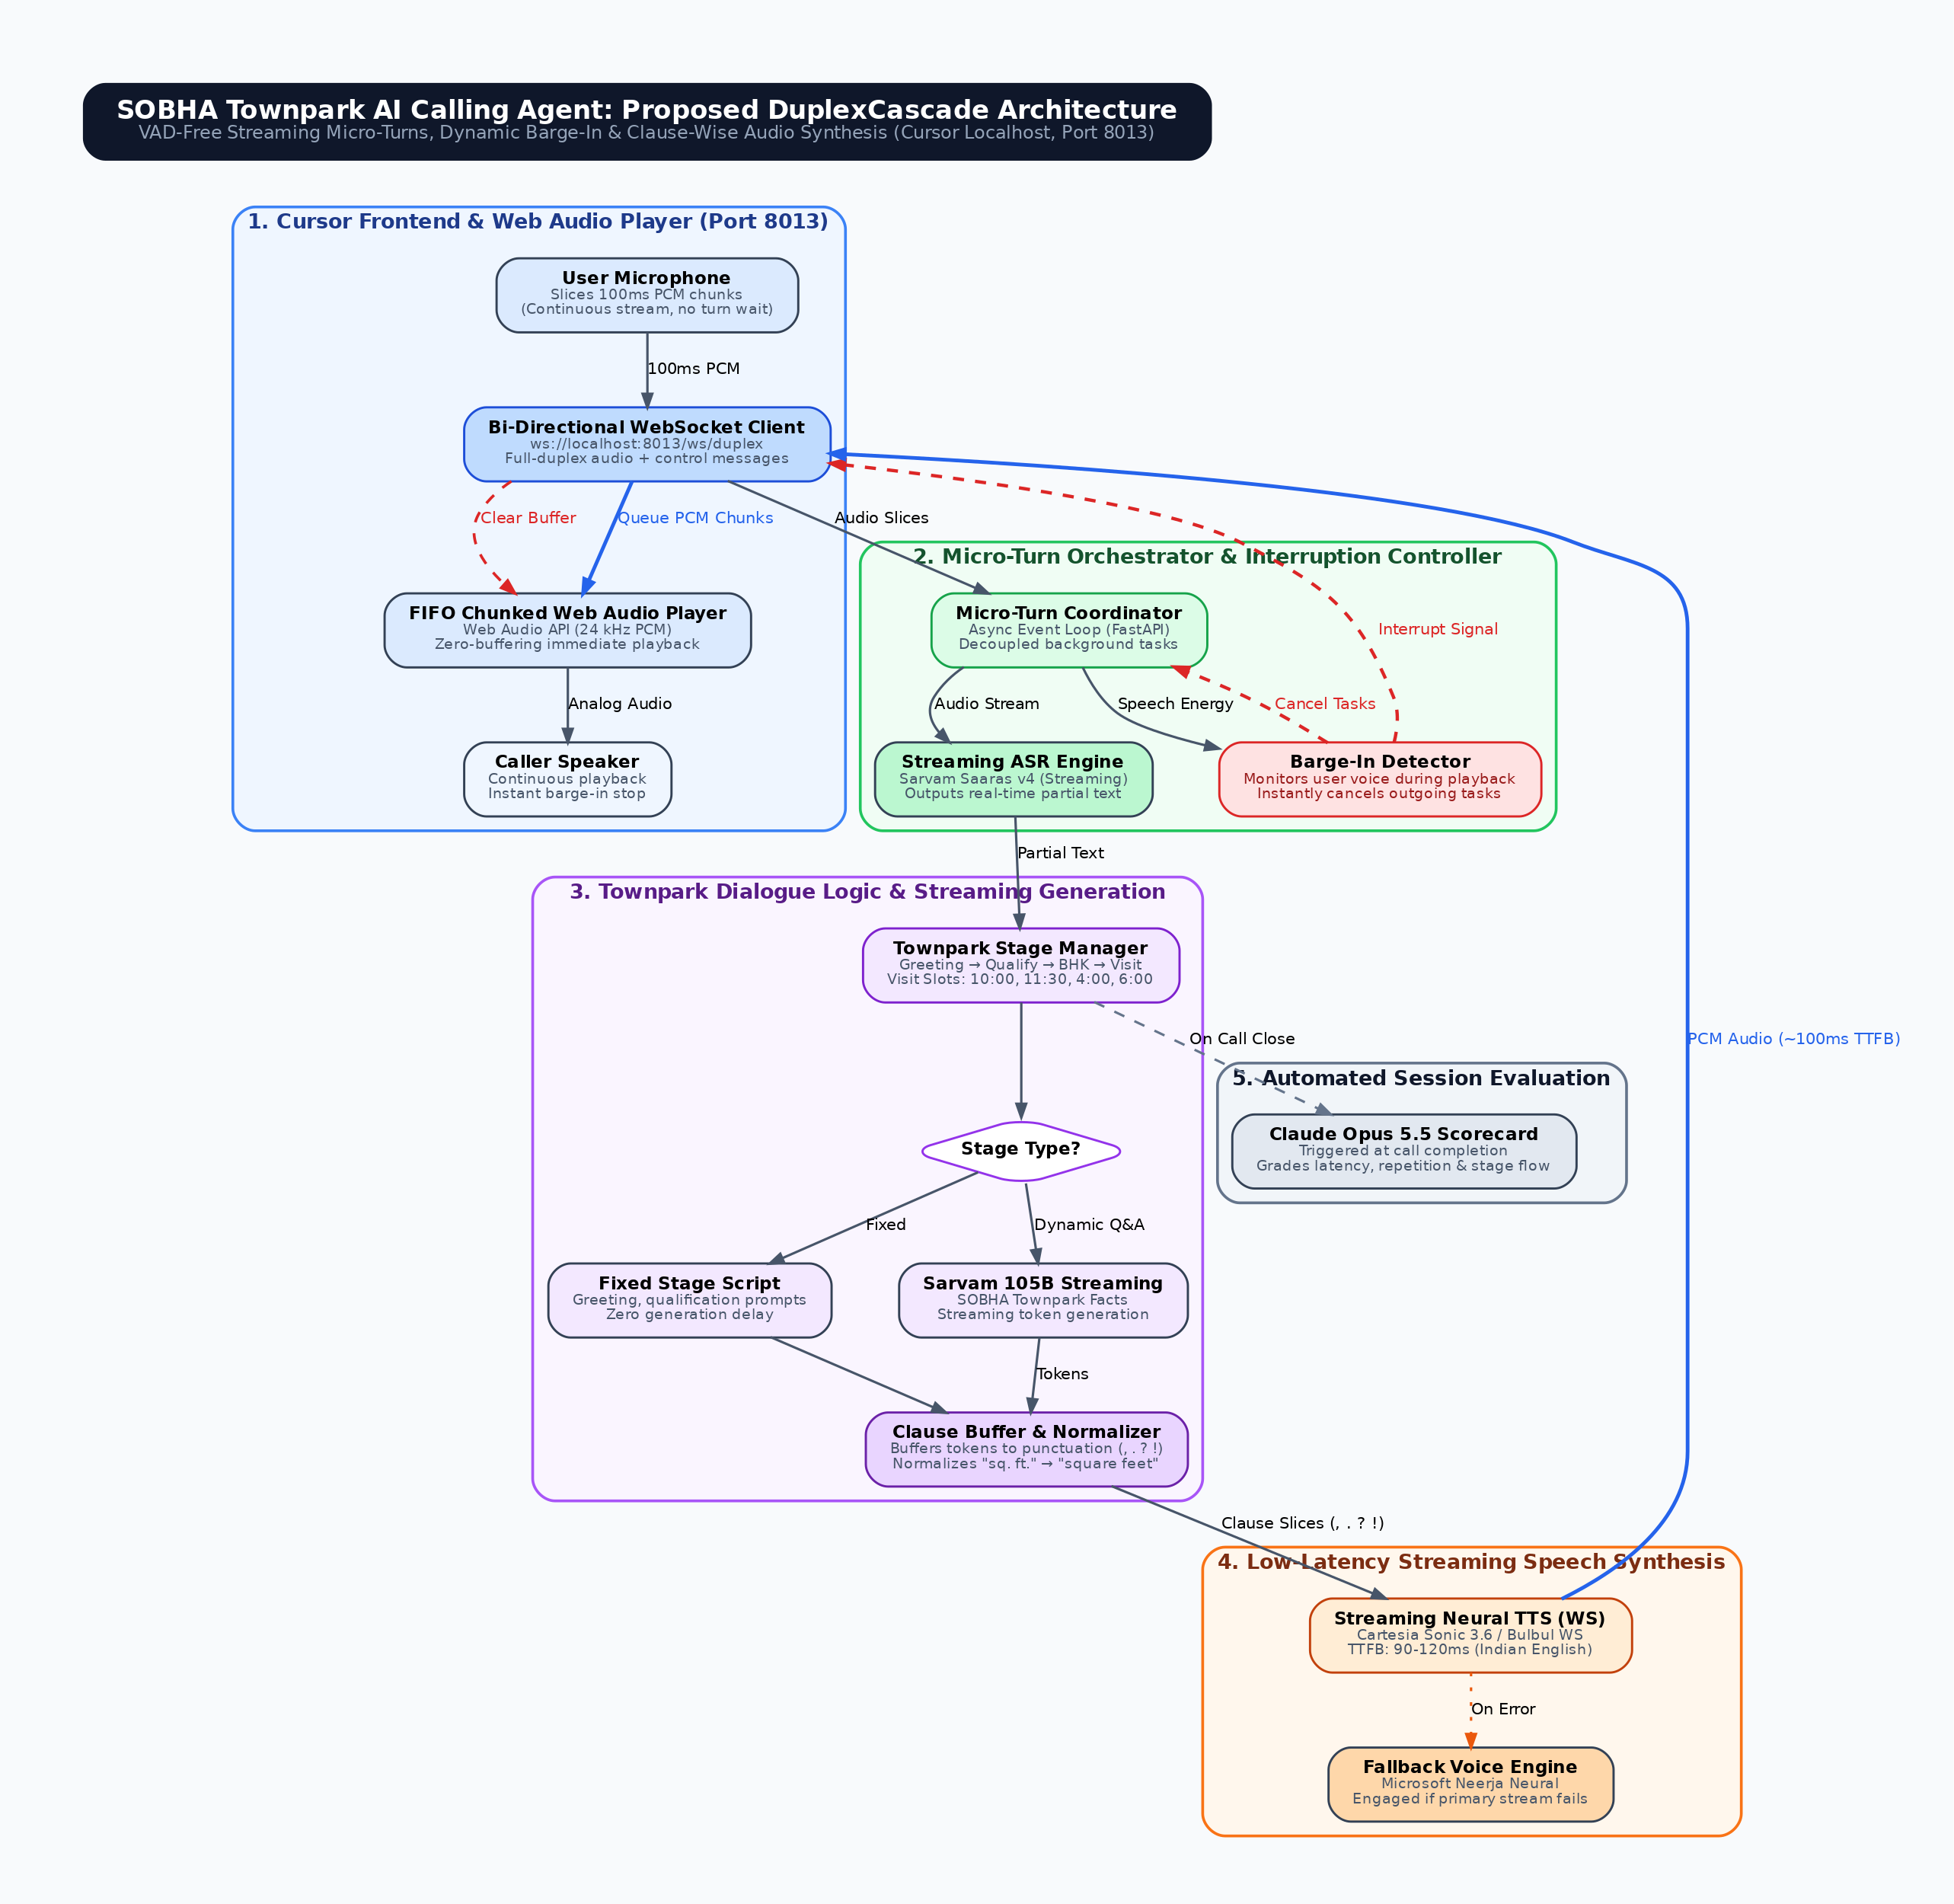
Figure 1: Architectural Transformation — Baseline Sequential Architecture vs. Proposed DuplexCascade Streaming Architecture

3. Component-by-Component System Specification

3.1 Client Layer: Cursor Web Audio Interface (Port 8013)
• Baseline (Version 6): The browser client relies on a standard HTML5 audio recorder that captures discrete audio files, sends them upon silence detection, and waits for complete WAV/MP3 files before triggering Audio().play(). Playback completely locks the input stream.
• Proposed DuplexCascade: The client is refactored around the HTML5 Web Audio API at 24 kHz. It streams continuous 100ms PCM chunks over a persistent WebSocket (ws://localhost:8013/ws/duplex). Incoming audio packets are placed in a FIFO AudioBufferSourceNode queue that schedules chunks seamlessly with zero perceptible buffering delays.

3.2 Orchestration Layer: FastAPI Micro-Turn Coordinator & Barge-In Controller
• Baseline (Version 6): Sequential synchronous request-response flow. Server-side code cannot detect user speech while executing TTS or awaiting network audio downloads.
• Proposed DuplexCascade: A decoupled asynchronous worker pool in FastAPI manages concurrent input, reasoning, and synthesis. An active Voice Activity Monitor checks incoming mic energy during agent speech; if caller speech is detected, the coordinator emits an instant cancel signal, terminates active asyncio tasks, and commands the client to flush its audio buffer within 80ms.

3.3 Dialogue Layer: Stage Manager & Streaming Clause Buffer
• Baseline (Version 6): Stage progression (Greeting -> Qualify -> Details -> Site Visit Scheduling) relies on full prompt completion before generating responses. String substitution for abbreviations ('sq. ft.' -> 'square feet') is performed on full text blocks.
• Proposed DuplexCascade: Retains all SOBHA Townpark deterministic stage tracking and RAG retrieval chunks. However, responses from Sarvam 105B stream token-by-token into an async Clause Buffer. As soon as a punctuation mark (comma, period, question mark) is encountered, the completed clause is normalized and immediately dispatched to TTS, allowing speech output to begin while subsequent reasoning is still occurring.

3.4 Speech Synthesis Layer: Low-Latency Streaming Neural TTS
• Baseline (Version 6): Sarvam Bulbul v3 (Ishita) or Microsoft Neerja generates complete audio clips before returning binary payloads, producing a 2.3-second latency bottleneck.
• Proposed DuplexCascade: Adopts WebSocket-based streaming speech synthesis (Cartesia Sonic 3.6 or streaming Bulbul) with time-to-first-byte (TTFB) under 120ms. In accordance with Interactive TTS (Wu et al., 2026), dynamic style parameters (warmth, cadence) are injected per micro-turn to eliminate mechanical, robotic reading tones.

3.5 Evaluation Layer: Automated Session Scorecard via Claude Opus 5.5
Upon call termination, the complete multi-turn session transcript, timing logs, and interruption statistics are transmitted to Claude Opus 5.5. The evaluator compiles a structured performance scorecard assessing turn latency, interruption accuracy, stage progression fidelity, and human naturalness.

4. Architectural Comparison: Three System Generations
The following comparison details the operational capabilities of the original phone telephony stack, the current localhost development setup, and the proposed DuplexCascade architecture.
Architecture Dimension | Phone Path (V4) | Localhost Baseline (V6) | DuplexCascade (V7)
Deployment Environment | AWS Lightsail / Twilio | Cursor Localhost (Port 8013) | Cursor Localhost (Port 8013)
Network Transport | HTTP Webhooks (/voice) | HTTP REST / Polling | Bi-Directional WebSocket (/ws/duplex)
Audio Input Capture | Twilio <Gather> (en-IN) | Buffered Microphone Upload | Continuous 100ms PCM Slicing
Speech-to-Text (ASR) | Twilio Cloud ASR | Sarvam Saaras v4 (Batch) | Streaming Sarvam Saaras v4
Turn Execution Model | Sequential Half-Duplex | Sequential Half-Duplex | VAD-Free Streaming Micro-Turns
Interruption / Barge-In | Twilio Gather (Coarse) | None (Blocked during play) | Sub-100ms Instant Buffer Flush
Text Reasoning Engine | Sarvam 105B / Fixed Script | Sarvam 105B / Fixed Script | Streaming Sarvam 105B + Buffer
Speech Synthesis (TTS) | Amazon Polly Kajal-Neural | Sarvam Bulbul v3 Ishita | Streaming Neural WS (TTFB <120ms)
Audio Output Playback | Telephony Audio Channel | Blocking HTML5 Audio Element | Web Audio FIFO Chunk Scheduling
End-to-End Latency | ~3.5 – 4.5 seconds | ~3.8s (TTS alone: 2.3s) | ~350 – 500ms TTFB
Key Takeaway: The proposed DuplexCascade architecture achieves an 85%+ reduction in perceived latency while preserving full business logic control and RAG grounding in SOBHA Townpark documentation.

5. Theoretical Grounding in 2026 Voice Agent Research
1. DuplexCascade (Yang, Fujita, & Sudo, Interspeech 2026): Proves that cascaded ASR-LLM-TTS pipelines can achieve full-duplex responsiveness without requiring end-to-end retraining. By replacing silence-based Voice Activity Detection with token-level micro-turns, the system eliminates the standard 1.0-1.5s post-speech silence penalty.
2. Interactive TTS (Wu et al., 2026): Demonstrates that monotonic, robotic delivery in long-turn telephone calls stems from static acoustic prompts. Utilizing Context-Aware Direct Preference Optimization (CADPO), the synthesizer adapts pitch, cadence, and warmth dynamically across conversational stages, preventing prosody degradation.
3. BayLing-Duplex & AdaptDuplex (2026): Establish protocols for dual-stream conversational interaction and non-blocking cognitive consolidation, demonstrating that human-like interruption handling requires immediate buffer termination rather than waiting for server round-trips.

