AI Calling Agent
How the call is spoken
Localhost in Cursor, and the Twilio phone call
The localhost page and the phone call use the same Townpark conversation. A customer is greeted, asked which home they want, answered from the project facts, and offered a site visit. The two paths differ in who hears the customer and who speaks the reply.
1. Localhost in Cursor
This is Version6, the page used to test and improve the agent. It runs only on this computer. Twilio and Polly are not used. The chart below is one spoken turn. After you hear the reply, the page listens again.
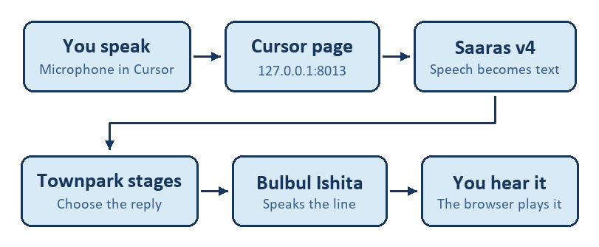
Figure 1. One localhost turn, from the microphone back to the speaker.
You speak into the microphone in the Cursor window. The page records a short clip and sends it to Sarvam Saaras v4, which returns the words as text. Those words enter the Townpark stages. The chosen reply is then spoken by Sarvam Bulbul v3, using the voice Ishita, and the browser plays the whole clip.
A few rules sit around that path:
• A fixed line, such as the greeting or the BHK question, is used as written. Sarvam 105B is not called for that line.
• Any other reply is written first by Sarvam 105B, using the SOBHA Townpark facts.
• Where the reply is written as “sq. ft.”, Ishita is given the words “square feet.” The text on the page still shows the abbreviation.
• If Bulbul returns no audio, Neerja speaks that line instead.
• When the call ends, the page saves the transcript and Claude Opus 5.5 writes a scorecard.
Version5, on port 8012, follows this same path. The one difference is speech: Version5 still lets Ishita read “sq. ft.” as separate letters.
2. The phone call
The phone path is the Version4 Twilio design. A short script places the call. From then on, Twilio carries the customer’s voice and plays each reply. The localhost microphone, Bulbul, Neerja, and the Opus scorecard are not part of this path.
How the call starts
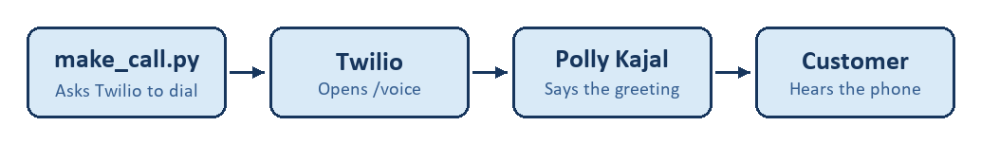
Figure 2. The outbound call, from the dial script to the customer’s phone.
make_call.py asks Twilio to dial the customer and open the public /voice address. The application answers with instructions for Twilio. Polly Kajal-Neural speaks the greeting. The customer hears that greeting on the phone.
Each later turn
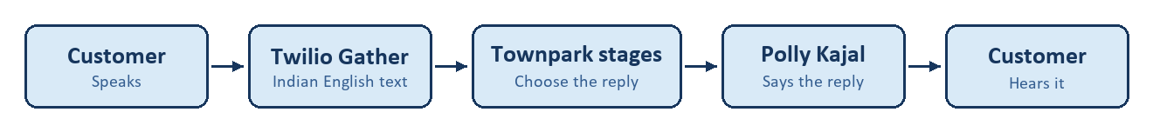
Figure 3. One phone turn. The customer speaks, and Polly speaks the reply.
Twilio listens with Gather, in Indian English, and sends the recognised text to /handle-speech. The Townpark stages choose the reply in the same way as on the localhost page. A fixed line is used as written. A free reply is written by Sarvam 105B. Twilio then has Polly Kajal-Neural speak that reply, and the loop continues until the call closes.
Hanging up on the phone does not write the localhost scorecard. That scorecard belongs to the Cursor page.
3. The shared conversation
Both paths move through the same stages. A clear yes at the greeting moves to qualification. Naming a home size moves into questions. Offering a visit moves to a day, then to one time.
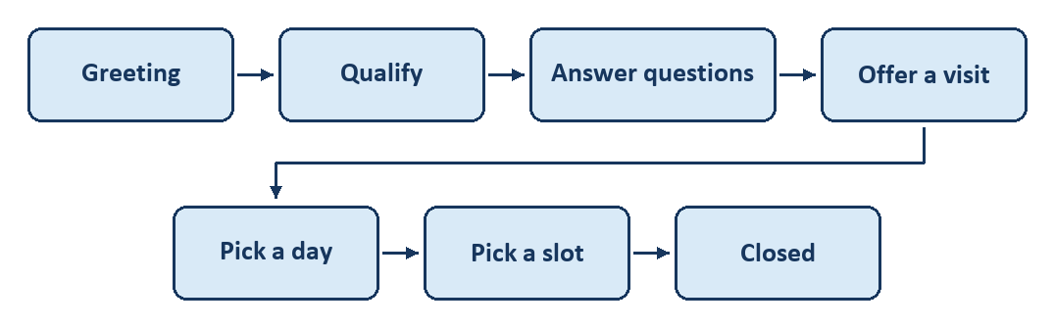
Figure 4. The order of the conversation. A clear no, or a request for more time, can close the call earlier.
The visit times are 10:00 AM, 11:30 AM, 4:00 PM, and 6:00 PM. A clear “not now” or “not interested” ends the call politely. Saying the customer needs time to decide, or to speak with family, also closes the call.
4. Side by side
 | Localhost, Version6 | Phone, Version4
Where it runs | This computer, port 8013 | Twilio, public /voice
Who hears the customer | Sarvam Saaras v4 | Twilio Gather, Indian English
Who writes the reply | Sarvam 105B, or a fixed line | Sarvam 105B, or a fixed line
Who speaks | Bulbul Ishita, or Neerja if needed | Polly Kajal-Neural
After the call ends | Opus 5.5 writes a scorecard | No localhost scorecard

The conversation can be improved on the localhost page without changing what the customer hears on the phone. The phone voice remains Polly Kajal-Neural until that path is changed on purpose.

