STEEL BEAM ESTIMATION
Current Hybrid Architecture Performance · Second to Sixth Drawing Sets
Version 10 · MODEL_VERSION 10.11.24 · Gate P2610E3_SECOND_TO_SIXTH_FULL_POPULATION_LIVE_VISION_HYBRID_ACCURACY_BENCHMARK_AND_REPORT_V1_0 · Decision PASS_WITH_LIMITATIONS · Benchmark mode LIVE_BENCHMARK
CURRENT HYBRID ARCHITECTURE PERFORMANCE — SECOND TO SIXTH SETS

Beam identification | Bar identification | Correct of detected bars | Diameter identification
85.12% | 48.17% | 36.50% | 77.84%

Steel / weight accuracy | Overall accuracy | HYBRID coverage | FALLBACK coverage
60.64% | 57.61% | 91.70% | 8.30%

This report measures the current hybrid architecture on Second through Sixth drawing sets. Claude Vision is the preferred semantic interpreter after validation. The deterministic engine remains the engineering calculation authority. First Set is excluded. This is not a historical improvement study and not a production-readiness claim.
1. Executive summary

Five drawing sets were discovered dynamically and scored with the QA.2A / QA.3.0 methodology. Model beams: 530. Ground-truth beams: 605. Matched IDs: 515. Vision usable (HYBRID): 486. Deterministic fallback: 44. Pooled overall accuracy is the mean of pooled beam identification, bar identification, correct-of-detected, and kg-pooled steel/weight accuracy. Diameter is reported separately.
2. Current hybrid architecture

DXF → Beam discovery → Deterministic geometry context → Claude Vision semantic interpretation → D.1 semantic authority contract → D.2 hybrid resolution → D.3 engineering binding → D.4 shadow engineering calculation → accuracy benchmark versus estimator truth.
VISION SEMANTICS (preferred after validation): target identity, layer, physical group detection, bar count, diameter, specification, MAIN/EXTRA role, support scope, stirrup identification. DETERMINISTIC ENGINEERING: spacers, geometry, cut length, development length, anchorage, hooks/bends, stirrup geometry/zones/spacing/quantity, piece generation, weight, BBS, workbook generation. Vision-preferred does not mean blindly accepted. Ambiguous matches are withheld, not forced.
3. Benchmark scope and population

Drawing set | Model beams | GT beams | Matched | Unmatched model | Unmatched GT | Truth source
Second Set | 65 | 67 | 64 | 1 | 2 | ESTIMATOR_EXCEL
Third Set | 61 | 63 | 57 | 4 | 4 | ESTIMATOR_EXCEL
Fourth Set | 118 | 143 | 112 | 6 | 22 | ESTIMATOR_EXCEL
Fifth Set | 143 | 187 | 143 | 0 | 42 | ESTIMATOR_EXCEL
Sixth Set | 143 | 145 | 139 | 4 | 6 | ESTIMATOR_EXCEL

First Set is excluded from all aggregate KPIs. Unmatched beams are recorded, not silently dropped.
4. Vision execution and hybrid coverage

Set | Eligible | Attempted | New live | Reused | Retried | API ok | Schema | Usable | HYBRID | FALLBACK
Second Set | 63 | 63 | 63 | 0 | 0 | 63 | 63 | 63 | 63 | 2
Third Set | 61 | 61 | 61 | 0 | 0 | 61 | 61 | 61 | 61 | 0
Fourth Set | 76 | 76 | 76 | 0 | 0 | 76 | 76 | 76 | 76 | 42
Fifth Set | 143 | 0 | 0 | 143 | 0 | 143 | 143 | 143 | 143 | 0
Sixth Set | 143 | 143 | 143 | 0 | 0 | 143 | 143 | 143 | 143 | 0

Fifth Set valid E.2 live Vision artefacts are reused when the current semantic contract, schema, source fingerprints and population match (VISION_REUSED_CURRENT_ARCHITECTURE). Second, Third, Fourth and Sixth use current live Claude (claude-sonnet-4-5) where a valid render exists. Individual Vision failures apply the D.1 fallback policy and are labelled FALLBACK, never HYBRID.
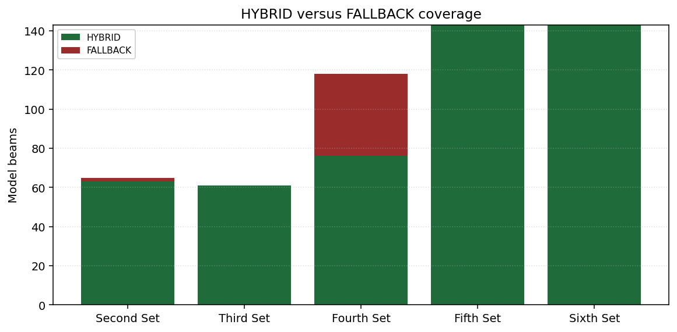
5. Accuracy by drawing set

Drawing set | Beam ID | Bar ID | Correct of detected | Diameter ID | Steel | Overall
Second Set | 95.52% | 65.28% | 31.35% | 78.97% | 87.95% | 70.03%
Third Set | 90.48% | 54.29% | 27.27% | 74.31% | 68.25% | 60.07%
Fourth Set | 78.32% | 40.43% | 41.32% | 75.26% | 54.29% | 53.59%
Fifth Set | 76.47% | 39.29% | 36.89% | 76.75% | 47.58% | 50.06%
Sixth Set | 95.86% | 59.83% | 39.38% | 81.85% | 83.18% | 69.56%

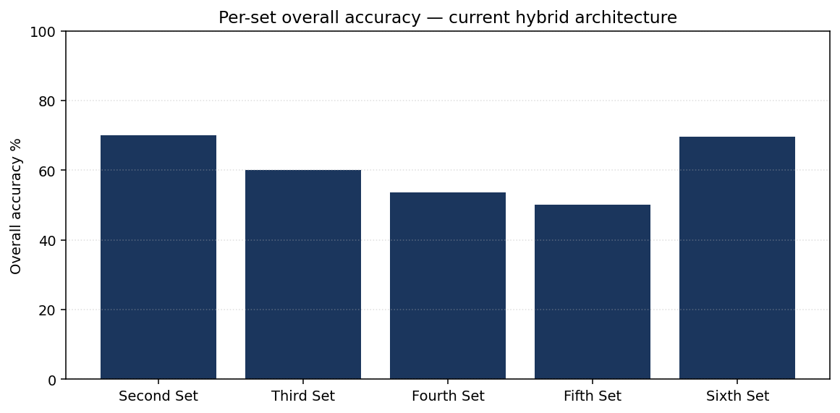
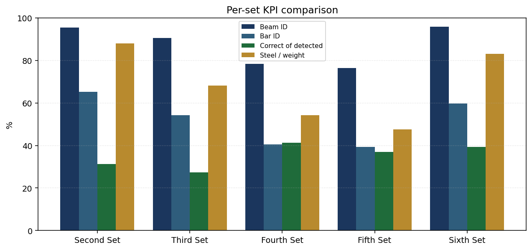
6. Pooled Second-to-Sixth performance

KPI | Pooled result | Raw counts
Beam identification | 85.12% | 515.0 / 605.0
Bar identification | 48.17% | 2008.0 / 4169.0
Correct of detected bars | 36.50% | 733.0 / 2008.0
Diameter identification | 77.84% | 1563.0 / 2008.0
Steel / weight accuracy | 60.64% | 90305.121 / 148910.644 kg
Overall accuracy | 57.61% | Mean of four pooled KPIs; diameter excluded

Headline pooled results sum raw numerators and denominators. Steel accuracy is computed after pooling kg. Set percentages are not averaged for the headline overall score.
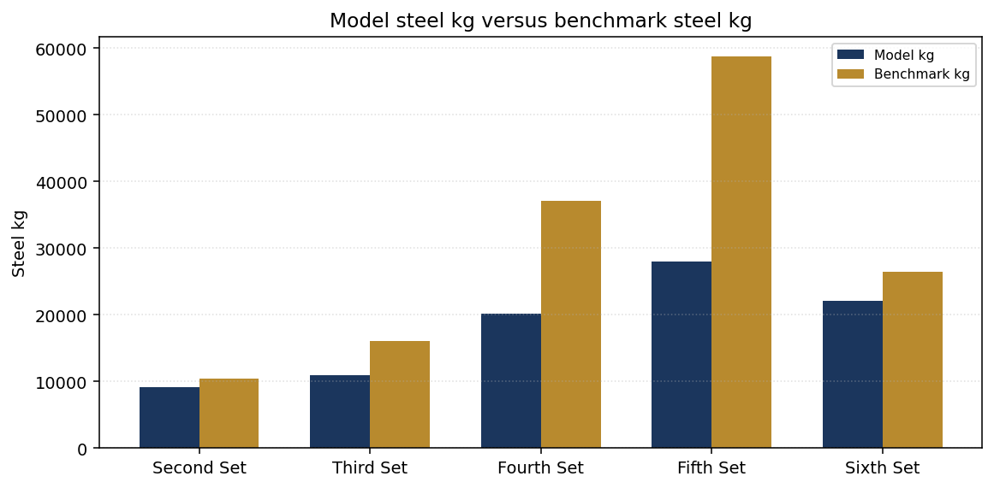
7. Semantic error profile

Matcher taxonomy | Pooled count
MISSING | 2161
MATCH | 733
WRONG_QUANTITY | 593
WRONG_DIAMETER | 445
EXTRA | 183
WRONG_ROLE | 134
PARTIAL_MATCH | 103
ACCEPTABLE_EXTRA | 89

MISSING bars are ground-truth lines the model did not identify. MATCH / WRONG_QUANTITY / WRONG_DIAMETER / WRONG_ROLE / PARTIAL_MATCH describe detected bars. EXTRA is a model line without a GT pair. Deterministic disagreement is not treated as proof that Vision is wrong.
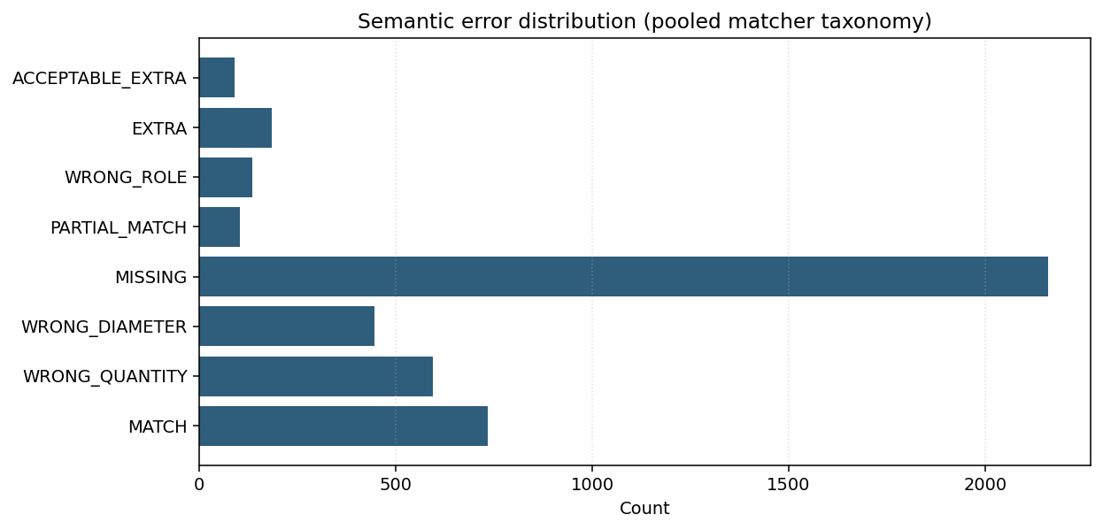
8. Engineering calculation profile

Engineering condition | Count
CUT_LENGTH_DERIVED_FALLBACK | 188
CUT_LENGTH_UNAVAILABLE | 0
STIRRUP_ENGINEERING_UNAVAILABLE | 69
PARTIAL_CALCULATION | 82
INCOMPATIBLE | 0
SPACER_ZERO | 242

Spacers remain deterministic-only. Stirrup identification may come from Vision; stirrup geometry, legs, zones, spacing, quantity, hooks, cut length and weight remain deterministic. Vision never invents stirrup engineering quantities. Semantic/engineering stirrup conflicts are recorded, not silently overwritten.
9. HYBRID / FALLBACK coverage

HYBRID_ONLY scores use the valid matched benchmark subset for Vision-usable beams. FALLBACK_ONLY uses beams that applied the D.1 deterministic fallback. Full-population scores are not replaced by HYBRID_ONLY steel accuracy. A zero cohort is reported as NOT APPLICABLE.
Cohort | Beam ID | Bar ID | Correct | Diameter | Steel | Overall
HYBRID_ONLY | 97.52% | 57.03% | 36.39% | 78.46% | 75.22% | 66.54%
FALLBACK_ONLY | 97.73% | 48.43% | 38.21% | 68.29% | 71.00% | 63.84%
FULL_POPULATION | 85.12% | 48.17% | 36.50% | 77.84% | 60.64% | 57.61%

10. Current workflow value

Positioning: model-assisted estimation. Estimator verification is required. No current time-and-motion study exists in this phase, so accuracy is not equivalent to time saved. Vision API success is not engineering accuracy. Fallback coverage is part of the measured system, not hidden Vision performance.
11. Methodology, sources and limitations

P2.6.10-E.3 uses QA.2A BeamMatcher / BarMatcher / MetricsEngine metric8 and the QA.3.0 four-KPI overall mean. Ground truth is evaluation-only (estimator Excel; Second–Third also have a validated QA.2B.1 context path where discovered). Truth is never used in runtime semantic resolution. Limitations: ESTIMATOR_WORKBOOK_MAPPING_LIMITATION, FIRST_SET_EXCLUDED, SHADOW_ONLY_NOT_PRODUCTION, FALLBACK_POPULATION_PRESENT. PRODUCTION_WRITE = false. ENGINEERING_CHANGES = NONE. Shadow-only; not production routing.

