Scraping URL: <https://www.regelleistung.net/ext/data/?lang=en>

Step1 :

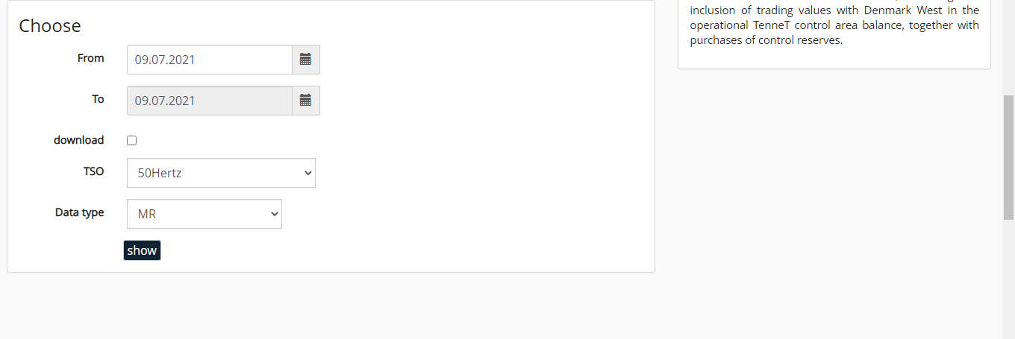

Select the drop down “TSO” and choose “Data type ”

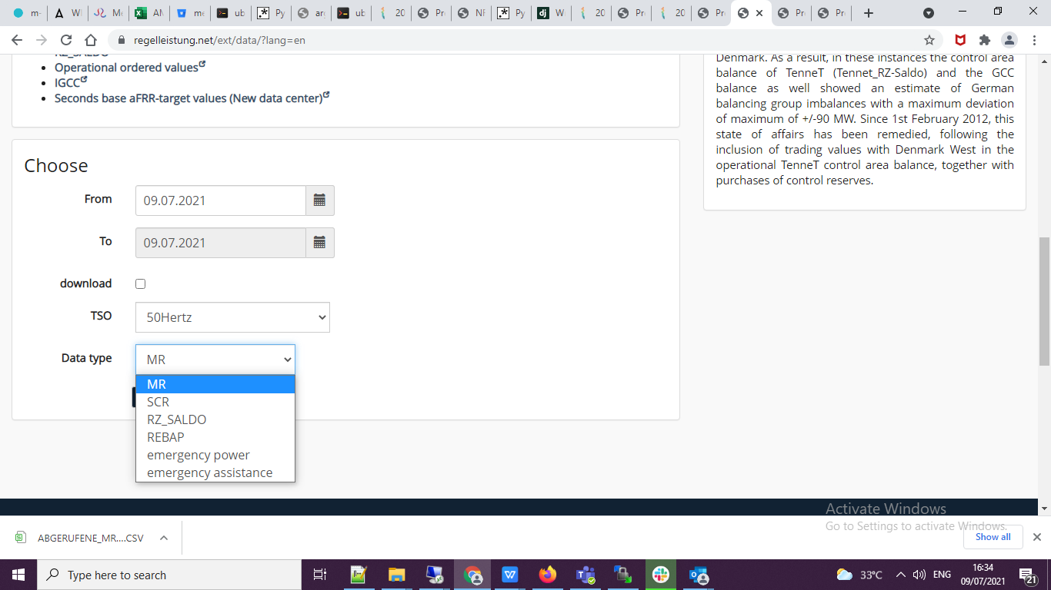

In that each drop down “TSO” has different “Data type ” downloaded the all drop down and merge it as a single file with the past 1 day data.