Software Requirements Specification (SRS)
Project: WealthWise – Wealth Management System
Version: 1.0
Authors: Madhusudhan P, Nishant Nag, Likith Kumar, Vasu Tripathi (WealthWise Team)
Date: 14-10-2026
Status: Draft for review

Revision history
Version | Date | Author | Change summary | Approval
1.0 | 2-10-2026 | WealthWise Team | Initial SRS with use-case diagrams and RTM | Pending

Approvals
Role | Name | Signature / Email | Date
Course Coordinator
Requirements Lead | Madhusudhan P
Project Team Member | Nishant Nag
Project Team Member | Likith Kumar
Project Team Member | Vasu Tripathi

Table of Contents
1. Introduction
2. Overall description
3. External interfaces
4. System features (detailed)
5. Non-functional requirements (detailed)
6. Quality attributes & Acceptance tests
7. UML Use-Case Diagrams
8. Requirements Traceability Matrix (RTM)

1. Introduction

1.1 Purpose
This document is the Software Requirements Specification (SRS) for WealthWise – Wealth Management System. It defines what WealthWise must do: its functional requirements, non-functional (quality) requirements, security objectives and requirements, external interfaces, and the acceptance criteria against which each requirement will be verified. It is the baseline for the Software Architecture and Design Specification (SAD) and the Software Test Plan (STP) of the project.

1.2 Scope
WealthWise is a web-based personal net-worth, loan and expense management system for Indian households. It brings a user’s assets, loans, EMI (Equated Monthly Instalment) repayment schedules and day-to-day income and expenses into one consistent record, and answers questions such as “What am I worth today?”, “How much of my home loan have I really repaid?”, “How much interest would a prepayment save?” and “Where does my money go each month?”.
In scope
- User registration, login and role-based access for two roles: Individual and Advisor.
- Asset management (gold, property, equity, mutual funds, EPF, PPF, fixed deposits, vehicles, cash, other) with valuation history.
- Loan management with automatically generated reducing-balance EMI schedules, EMI payment recording, overdue detection, and prepayment simulation and application.
- A transaction ledger with filtering and full-text search.
- Bank-statement CSV import with de-duplication and rule-based categorisation; receipt photo scanning (OCR) to create expenses.
- A document vault for loan papers, deeds and receipts.
- A dashboard (net worth trend, asset allocation, loan payoff progress, upcoming dues, cash flow, recurring expenses).
- Insights: a derived credit score, loan-product comparison, and a what-if net worth projection.
- Financial-year (April–March) reports and a downloadable PDF net worth statement.
- In-app EMI reminders and a news feed showing the effect of lending-rate changes on the user’s floating-rate loans.
- An advisor view of assigned clients.
Out of scope (deliberately simulated or excluded)
Real-world dependency | What WealthWise does instead
Credit bureau (CIBIL, Experian, Equifax) | Computes a 300–900 score derived only from repayment records held in WealthWise, labelled as such wherever it appears
Payment gateway or bank mandate | “Mark EMI paid” and “apply prepayment” record the event in the ledger; no money is moved
Account Aggregator / bank APIs | The user uploads a CSV statement downloaded from their own net banking
Market data feeds | Asset values are user-entered; valuation history is retained
Lender partnerships | A seeded catalogue of publicly advertised loan products and rate bands
Email / SMS delivery | Reminders are in-app only
WealthWise is a record-keeping and analysis tool. It gives no financial advice and stores no real bank credentials.

1.3 Audience
Developers, QA engineers, system integrators, the course instructor and assessment evaluators, and the WealthWise project team.

1.4 Definitions
Term | Meaning
API | Application Programming Interface (here, HTTP/JSON endpoints under /api)
AC | Acceptance Criterion
bps | Basis points (1 bps = 0.01 percentage point)
CSV | Comma-Separated Values file (bank statement export)
EMI | Equated Monthly Instalment of a loan
EPF / PPF | Employees’ Provident Fund / Public Provident Fund
FD | Fixed Deposit
FOIR | Fixed Obligation to Income Ratio (used in loan eligibility)
FR / NFR | Functional Requirement / Non-Functional Requirement
FY | Indian financial year, 1 April to 31 March
JWT | JSON Web Token (signed session token)
OCR | Optical Character Recognition
PAN | Permanent Account Number (Indian tax identifier, format ABCDE1234F)
RBI | Reserve Bank of India
RSS | Really Simple Syndication (news feed format)
RTM | Requirements Traceability Matrix
SO / SR | Security Objective / Security Requirement
TC | Test Case (defined in the STP)
UI | User Interface
CMP-xx / SEQ-xx | Component and sequence-diagram identifiers defined in the SAD

2. Overall description

2.1 Product perspective
WealthWise is a self-contained, browser-based full-stack web application. Users interact through a web UI; the UI calls the WealthWise HTTP API; the API applies authentication, authorisation and validation and delegates to business logic and data-access modules. Data is held in two stores: a relational database (PostgreSQL) as the system of record for users, assets, loans, EMI schedules, transactions and snapshots, and a document database (MongoDB) for schema-flexible material (raw statement imports, document metadata, per-asset valuation history and cached news). Uploaded files are kept in server-side file storage. The only external system contacted at run time is the public RBI press-release RSS feed. WealthWise does not integrate with banks, bureaus or payment systems (see §1.2).

2.2 Major product functions
- Register, log in, log out and maintain a signed session; enforce Individual / Advisor roles.
- Create, view, update and delete assets; keep a history of valuations.
- Create loans and generate the full EMI amortisation schedule automatically; edit, close or delete loans.
- Mark EMIs paid atomically (installment, ledger entry and loan closure together); detect overdue installments.
- Simulate and apply loan prepayments (reduce tenure or reduce EMI).
- Record and search income, expense, asset and loan transactions.
- Import bank-statement CSVs with preview, categorisation, de-duplication and atomic commit.
- Maintain keyword categorisation rules; scan receipts by OCR and confirm them as expenses.
- Store, tag, search and delete documents in a vault.
- Show a dashboard of net worth, allocation, payoff progress, dues, cash flow and recurring costs.
- Compute a derived credit score, compare loan products and project net worth under what-if scenarios.
- Produce financial-year reports and a PDF net worth statement.
- Generate in-app EMI reminders; show rate-related news and its impact on the user’s loans.
- Let advisors view their assigned clients.

2.3 User roles and characteristics
Role | Description | Characteristics
Individual User | A person managing their own household finances | Basic financial literacy; uses the system periodically to record data and review position; not expected to be technical
Advisor | A financial advisor with clients assigned to them | Has all Individual capabilities for their own account, plus a client overview and read access to assigned clients’ data; may force a refresh of the news feed
External system: RBI RSS feed | Public source of press releases | Read-only; may be unavailable

2.4 Operating environment
- Server: Node.js 20 or later running the Next.js 14 application; PostgreSQL 14 or later (16 recommended); MongoDB 6 or later (optional – document-store features degrade gracefully without it).
- Client: a current desktop or mobile web browser with JavaScript and cookies enabled. The specific list of supported browsers and versions is To be confirmed.
- Hosting / deployment environment: To be confirmed (the system is currently run on a developer machine or lab server).

2.5 Constraints
- Implemented in TypeScript on Next.js (React) with PostgreSQL and MongoDB, as chosen by the team.
- All monetary values are held with exact decimal arithmetic (NUMERIC(15,2)), never binary floating point.
- All credentials and secrets are supplied through environment variables; none may be hard-coded.
- Indian conventions apply: amounts in rupees (₹) with Indian digit grouping, dates in Indian formats on import, April–March financial year, PAN format ABCDE1234F.
- No real money movement, bureau scores or bank connections (see §1.2).
- Receipt OCR must run on the server with a bundled English language model (no third-party OCR service).

3. External interface requirements

3.1 User interfaces
- A responsive web UI with a persistent navigation bar: Dashboard, Assets, Loans, Ledger, Import, Vault, Insights, Reports, News, and (Advisor only) Clients; plus a notification bell and theme switch.
- Public pages: Login and Sign-up. All other pages require an authenticated session and redirect to Login otherwise.
- Forms display field-level validation messages returned by the API.
- Light and dark themes; the chosen theme persists in the browser.
- Monetary amounts use the ₹ symbol and Indian digit grouping (e.g. ₹92,00,000; ₹1.06 Cr) in a tabular (fixed-width digit) font.
- Charts always carry a legend, direct labels or an accompanying data table, so colour is never the only channel of information.

3.2 Hardware interfaces
WealthWise has no dedicated hardware. Users need a device capable of running a web browser. Receipt images are supplied as image files (for example a phone camera photo) through the browser’s file picker. Server hardware requirements are To be confirmed.

3.3 Software interfaces
Interface | Purpose | Notes
PostgreSQL (via pg driver, parameterised SQL) | System of record: users, assets, loans, EMI schedules, transactions, snapshots, rules, notifications, scores, loan products; stored functions, procedure, triggers and views | Required
MongoDB (native driver) | Collections: raw_imports, documents, asset_valuation_history, news_articles | Optional; system degrades gracefully when unreachable
Server file storage | Uploaded document and receipt files | Generated file names
RBI press-release RSS feed (https://www.rbi.org.in/pressreleases_rss.xml) | Source of news articles | Read-only; illustrative sample articles shown when unavailable
Tesseract OCR library (server-side, bundled English model) | Receipt text extraction | No external OCR service
PDF generation library | Net worth statement | Embedded fonts with ₹ glyph

3.4 Communications
- Browser ↔ server communication uses HTTP requests carrying JSON or multipart form data; the session is carried in the ww_session cookie.
- The session cookie is httpOnly, SameSite=Lax, and marked Secure in production.
- Use of HTTPS/TLS for the deployed system is required in production; the TLS termination point and certificate arrangement are To be confirmed with the deployment environment.
- Server ↔ RBI feed: outbound HTTP GET of the RSS document; failures are tolerated.

4. System features (detailed)
Each requirement below includes acceptance-criteria and test-case references. Functional requirement IDs follow FR-nn; acceptance criteria AC-nn (detailed in §6); test cases TC-nnn are defined in the STP.

4.1 Authentication and Access Control
Description: Allow people to create accounts and sign in; maintain a signed session; restrict features by role.
Req ID | Requirement (shall…) | Type | Priority | Source / Stakeholder | Acceptance criteria / Test case ref | Comments / Dependencies
FR-01 | The system shall allow a visitor to register with name (2–120 chars), email, password (min. 8 chars), role (Individual by default, or Advisor) and an optional PAN in the format ABCDE1234F; on success it shall create the account and start a session. | Functional | High | Users | AC-01 · TC-001, TC-002, TC-003, TC-004 | Email and PAN must be unique; SR-01
FR-02 | The system shall authenticate a user by email and password and, on success, issue a signed session token in a session cookie. | Functional | High | Users / Security | AC-02 · TC-005, TC-006 | SR-01, SR-02, SR-03
FR-03 | The system shall allow a signed-in user to log out, ending the session, and shall report the current signed-in user (or none) on request. | Functional | High | Users | AC-03 · TC-007 | —
FR-04 | The system shall restrict all application pages and APIs (other than sign-up, login, logout and current-user) to authenticated users, and restrict advisor-only functions (client overview, news refresh) to the Advisor role. | Functional | High | Security | AC-04 · TC-008, TC-009 | SR-04

4.2 Asset Management
Description: Record what the user owns and how its value changes over time.
Req ID | Requirement (shall…) | Type | Priority | Source / Stakeholder | Acceptance criteria / Test case ref | Comments / Dependencies
FR-05 | The system shall let a user create, list, view, update and delete assets of type gold, property, equity, mutual fund, EPF, PPF, FD, vehicle, cash or other, each with name, liquidity (liquid/illiquid, defaulted by type), purchase value, current value (both ≥ 0), purchase date, valuation date (not before the purchase date) and notes. | Functional | High | Users | AC-05 · TC-010, TC-011, TC-012, TC-014 | Deleting an asset keeps ledger history (link set to null)
FR-06 | The system shall record a valuation-history entry each time an asset is created or revalued, and show that history on the asset’s detail view. | Functional | Medium | Users | AC-06 · TC-013 | Requires document store; skipped if unavailable (NFR-04)

4.3 Loan and EMI Management
Description: Record loans, generate repayment schedules, track payments and dues, and model prepayments.
Req ID | Requirement (shall…) | Type | Priority | Source / Stakeholder | Acceptance criteria / Test case ref | Comments / Dependencies
FR-07 | The system shall let a user create a loan (type home, vehicle, personal, education, gold, business or credit card; lender; principal > 0; annual rate > 0 and ≤ 60 %; fixed or floating; tenure 1–480 months; start date) and shall automatically generate its complete reducing-balance EMI schedule in the same atomic operation. | Functional | High | Users | AC-07 · TC-015, TC-016 | NFR-02, NFR-03
FR-08 | The system shall list a user’s loans with payoff progress (installments paid, outstanding balance, next due date), show each loan’s amortisation schedule, allow loan terms to be edited (regenerating the schedule) only while no installment has been paid, and allow the loan status to be changed or the loan deleted. | Functional | High | Users | AC-08 · TC-017, TC-018 | Edit after payment refused with HTTP 409
FR-09 | The system shall let a user mark an unpaid EMI installment as paid; in one atomic operation it shall set the installment to paid with today’s date, record a matching loan-type ledger entry, and close the loan if no unpaid installments remain. A second payment of the same installment shall be refused. | Functional | High | Users | AC-09 · TC-019, TC-020, TC-021 | NFR-03; no money moves
FR-10 | The system shall mark past-due unpaid installments as overdue and present upcoming and overdue EMIs grouped as overdue, this week, this month and upcoming. | Functional | High | Users | AC-10 · TC-022 | Default look-ahead 45 days (max 365)
FR-11 | The system shall simulate a prepayment amount on a loan, comparing “reduce tenure” and “reduce EMI” modes (interest saved, new tenure/EMI) without changing data, and shall apply a chosen prepayment, optionally funded from one of the user’s assets, rejecting amounts greater than the outstanding balance or than the funding asset’s value. | Functional | Medium | Users | AC-11 · TC-023, TC-024, TC-025 | Funded prepayment leaves net worth unchanged

4.4 Transaction Ledger
Description: Keep a single ledger of income, expenses and asset/loan movements.
Req ID | Requirement (shall…) | Type | Priority | Source / Stakeholder | Acceptance criteria / Test case ref | Comments / Dependencies
FR-12 | The system shall let a user record a transaction (type income, expense, asset or loan; amount > 0; date; category; optional description; optional related asset or loan), list transactions filtered by type, date range and category (up to 500 per request), and delete a transaction. | Functional | High | Users | AC-12 · TC-026, TC-027 | —
FR-13 | The system shall provide full-text search over transaction descriptions and categories that matches word stems (e.g. “pharmacy” finds “Pharmacies”) and quoted phrases. | Functional | Medium | Users | AC-13 · TC-028 | —

4.5 Statement Import, Categorisation and Receipts
Description: Bring bank and receipt data into the ledger with minimal typing.
Req ID | Requirement (shall…) | Type | Priority | Source / Stakeholder | Acceptance criteria / Test case ref | Comments / Dependencies
FR-14 | The system shall import a bank-statement CSV (≤ 5 MB) in two steps: (1) a preview that locates the header row, maps columns by name for HDFC, ICICI, SBI, Axis and Kotak layouts, parses Indian dates and amounts, lists rejected rows with reasons, categorises rows and flags rows already imported; and (2) a commit that inserts the confirmed rows atomically, skipping duplicates, and reports inserted and skipped counts. Import history shall be viewable. | Functional | High | Users | AC-14 · TC-029, TC-030, TC-031, TC-032 | NFR-03; raw rows staged in document store when available
FR-15 | The system shall categorise transactions using keyword rules, where a user’s own rule takes precedence over system rules, then priority, then longest keyword; users shall be able to list, add and delete their own rules, and adding a rule shall re-categorise the user’s existing transactions. | Functional | Medium | Users | AC-15 · TC-029, TC-033 | Unmatched rows → “Uncategorized”
FR-16 | The system shall extract merchant, total amount and date from an uploaded receipt image (JPEG, PNG or WebP, ≤ 8 MB) by server-side OCR and suggest a category without saving anything; after the user confirms or corrects the fields, it shall record an expense, refuse a duplicate receipt (same merchant, amount and date), and optionally file the image in the document vault. | Functional | Medium | Users | AC-16 · TC-034, TC-035 | Vault filing is best-effort

4.6 Document Vault
Req ID | Requirement (shall…) | Type | Priority | Source / Stakeholder | Acceptance criteria / Test case ref | Comments / Dependencies
FR-17 | The system shall let a user upload documents (PDF, JPEG, PNG or WebP, ≤ 10 MB) with a title, tags and an optional link to a loan or asset; list them filtered by link, tag or search text with summary statistics; and delete them. When the document store is unreachable it shall state that the vault is unavailable rather than show an empty list. | Functional | Medium | Users | AC-17 · TC-036, TC-037, TC-038 | Requires document store

4.7 Dashboard and Analytics
Req ID | Requirement (shall…) | Type | Priority | Source / Stakeholder | Acceptance criteria / Test case ref | Comments / Dependencies
FR-18 | The system shall present a dashboard showing current net worth (assets, liabilities, net worth), the net worth trend with month-on-month change, asset allocation by type with percentage share, loan payoff progress, the next upcoming dues, 12-month income-versus-expense cash flow and recurring expenses (categories appearing in at least 3 distinct months). The net worth snapshot shall be refreshed automatically whenever assets, loans or EMI payment status change. | Functional | High | Users | AC-18 · TC-039, TC-010 | A new user sees zeros, not an error

4.8 Insights
Req ID | Requirement (shall…) | Type | Priority | Source / Stakeholder | Acceptance criteria / Test case ref | Comments / Dependencies
FR-19 | The system shall compute a derived credit score in the range 300–900 from the user’s WealthWise repayment records, using weighted factors (payment history, debt-to-assets, loan mix, history length, track record), keep a score history with factor breakdown, recompute it when EMI payment status changes, and label it everywhere as not a bureau (CIBIL/Experian/Equifax) score. | Functional | Medium | Users | AC-19 · TC-040 | Indicative only
FR-20 | The system shall, for a requested loan type, amount and tenure, compare products in the loan-product catalogue, pricing each for the user’s score, marking ineligible products with a reason, and ranking eligible products. | Functional | Low | Users | AC-20 · TC-041 | Seeded catalogue; not advice
FR-21 | The system shall project the user’s net worth over 6–360 months at an asset growth rate of 0–30 % a year, optionally with one of the user’s loans closed early, comparing the scenario against the baseline. | Functional | Low | Users | AC-21 · TC-042 | Default 60 months, 8 %

4.9 Reports
Req ID | Requirement (shall…) | Type | Priority | Source / Stakeholder | Acceptance criteria / Test case ref | Comments / Dependencies
FR-22 | The system shall produce a financial-year report (1 April – 31 March) for a selectable year, including income/expense summary, category spend, loan summary and indicative tax-deduction hints. | Functional | Medium | Users | AC-22 · TC-043 | Hints are indicative, not tax advice
FR-23 | The system shall generate a downloadable PDF net worth statement containing a summary, assets, active liabilities, the last 12 months of net worth and the current FY to date, with the user’s PAN masked. | Functional | Medium | Users | AC-23 · TC-044 | SR-09

4.10 Notifications and News
Req ID | Requirement (shall…) | Type | Priority | Source / Stakeholder | Acceptance criteria / Test case ref | Comments / Dependencies
FR-24 | The system shall generate in-app reminders for installments due within 7 days and for overdue installments, at most once per installment and kind; show the unread count; and let the user mark one or all notifications as read. | Functional | Medium | Users | AC-24 · TC-045 | No email/SMS
FR-25 | The system shall show a news feed (filterable by category) built from the RBI press-release RSS feed and cached; for an article describing a lending-rate change, it shall compute the change in EMI for the user’s floating-rate loans. If the feed or cache is unavailable, clearly labelled illustrative sample articles shall be shown. Advisors may force a feed refresh. | Functional | Low | Users | AC-25 · TC-046 | Impact figures indicative

4.11 Advisor Oversight
Req ID | Requirement (shall…) | Type | Priority | Source / Stakeholder | Acceptance criteria / Test case ref | Comments / Dependencies
FR-26 | The system shall show an Advisor a list of the clients assigned to them with each client’s latest net worth summary, and allow the Advisor to read an assigned client’s assets; access to any non-assigned user shall be refused. | Functional | Medium | Advisors | AC-26 · TC-047 | How clients are assigned to an advisor through the UI is To be confirmed (currently set in data)

5. Non-functional requirements (detailed)
NFRs below are measurable and tied to test cases. Numeric targets are team-defined targets for the reference test environment (seeded demo data: three users, twelve months of transactions) and will be baselined during testing.
Req ID | Requirement | Category | Priority | Acceptance criteria / Measurement
NFR-01 | The dashboard API (GET /api/dashboard) shall respond within 2 seconds for 90 % of requests, and receipt OCR (POST /api/receipts/scan) shall complete within 10 seconds for a typical receipt photo (≤ 2 MB), on the reference test environment. | Performance | Medium | 90th-percentile response time measured over 20 requests. Test: TC-054
NFR-02 | All monetary values shall be stored and computed with exact decimal arithmetic (2 decimal places). For every generated EMI schedule the principal components shall sum exactly to the loan principal and the final closing balance shall be exactly 0.00. | Reliability / Accuracy | High | ₹50,00,000 at 8.50 % for 240 months gives EMI ₹43,391.16 and Σ principal = ₹50,00,000.00. Test: TC-015, TC-055
NFR-03 | Multi-step operations (loan creation with schedule, EMI payment, statement-import commit, prepayment application) shall be atomic: on any failure no partial change shall remain. | Reliability | High | Fault-injection tests show 0 rows changed after a forced mid-operation failure. Test: TC-025, TC-032
NFR-04 | If the document store (MongoDB) is unreachable, authentication, assets, loans, EMI payment, ledger, dashboard and statement-import commit shall continue to work; affected features shall show an explicit “unavailable” state, and a failed connection shall not be retried for 60 seconds so requests do not stall. | Availability | High | With MongoDB stopped, all listed functions succeed and the vault reports unavailable. Test: TC-038, TC-056
NFR-05 | The UI shall support light and dark themes (choice persisted, no flash of the wrong theme), use Indian digit grouping for every amount, and never use colour as the only channel in charts (legend, labels or table always present). | Usability / Accessibility | Medium | Checklist review of all pages in both themes. Test: TC-057
NFR-06 | The code shall keep strict layering (UI components never query a database; route handlers contain no inline SQL), shall type-check with zero errors, and the automated test suite shall pass 100 %. | Maintainability | Medium | npm run typecheck = 0 errors; npm test = 0 failures; static review of layering. Test: TC-058
NFR-07 | All configuration and secrets (database URLs, JWT secret, token lifetime) shall be read from environment variables; the system shall run on Node.js 20+, PostgreSQL 14+ and optionally MongoDB 6+ after npm install, migration and seed. | Portability / Configurability | Medium | Fresh install on a clean machine following the setup steps succeeds; no secrets in source. Test: TC-053, TC-059
Scalability targets (concurrent users, data volumes beyond the demo set) are To be confirmed.

5.1 Security

5.1.1 Security Objectives
ID | Security objective
SO-01 | Confidentiality of personal financial data. A user’s assets, loans, transactions, documents and reports shall be accessible only to that user and, for read access, to the advisor to whom the user is assigned.
SO-02 | Integrity of financial records. Financial records shall not be corrupted by invalid input, injection, or partially completed operations.
SO-03 | Protection of credentials and sessions. Passwords and session tokens shall be protected so that they cannot be recovered, forged or stolen through the client.

5.1.2 Security Requirements
Req ID | Requirement (shall…) | Type | Priority | Acceptance criteria / Test case ref
SR-01 | The system shall store passwords only as bcrypt hashes with cost factor 12 and shall never store, log or return a plaintext password or the hash. | Security | High | Stored value is a bcrypt $2a$12$… hash; API responses contain no password fields. TC-048
SR-02 | The system shall issue sessions as HS256-signed JWTs (issuer wealthwise, configurable expiry, default 7 days) using a secret of at least 32 characters, delivered in an httpOnly, SameSite=Lax cookie that is Secure in production; expired, tampered or wrongly signed tokens shall be treated as no session. | Security | High | Cookie flags verified; logout clears cookie; altered or expired token → 401. TC-005, TC-007, TC-049
SR-03 | Login shall return the same message (“Invalid email or password.”) with comparable timing for an unknown email and for a wrong password. | Security | High | Identical 401 body for both cases. TC-006
SR-04 | Every API other than sign-up, login, logout and current-user shall return 401 without a valid session, and advisor-only APIs shall return 403 to Individual users; unauthenticated page requests shall redirect to the login page. | Security | High | TC-008, TC-009
SR-05 | Object-level authorisation shall be enforced in every data query by the owning user’s id, so that a user cannot read, modify, pay or delete another user’s records (reported as not found), and an advisor can read only assigned clients (403 otherwise). | Security | High | TC-047, TC-050
SR-06 | All input shall be validated at the API (schema) and at the database (constraints); invalid input shall be rejected with 422 and field-level errors, and every database query shall be parameterised (no string-built SQL). | Security | High | TC-011, TC-016, TC-027, TC-051
SR-07 | File uploads shall be restricted by type and size (statements: .csv ≤ 5 MB; receipts: JPEG/PNG/WebP ≤ 8 MB; vault: PDF/JPEG/PNG/WebP ≤ 10 MB) and stored under system-generated file names, never user-supplied paths. | Security | High | Wrong type → 415; oversize → 413. TC-031, TC-035, TC-037
SR-08 | Error responses shall never expose stack traces or raw database messages; unexpected errors shall return a generic 500 “Internal server error”. | Security | Medium | TC-052
SR-09 | Secrets shall be supplied only through environment variables (the application refuses to sign sessions with a JWT secret shorter than 32 characters), and the PAN shall be masked on the PDF statement. | Security | Medium | TC-044, TC-053

6. Quality attributes & Acceptance tests
- Exit criteria for acceptance: all High-priority functional and security requirements implemented and verified; no open Critical or High defects; no failed High-priority NFR; the RTM shows every requirement traced to at least one passed test case.
- Acceptance test suites: Authentication & Access, Assets, Loans & EMI, Ledger & Search, Import & Categorisation, Receipts, Vault, Dashboard, Insights, Reports, Notifications & News, Advisor, Security, Non-functional.

6.1 Detailed acceptance criteria (Given / When / Then)
AC ID | Req | Acceptance criterion
AC-01 | FR-01 | Given an unused email, when the visitor submits a valid name, email, 8+ character password and (optional) valid PAN, then the account is created (HTTP 201), the response contains id, name, email and role but no password, and a session cookie is set. Given an email already registered, then 409 is returned. A 7-character password or a PAN not matching ABCDE1234F returns 422 with a field error.
AC-02 | FR-02 | Given a registered user, when correct credentials are submitted, then 200 is returned with the user profile and an httpOnly ww_session cookie. When the password is wrong or the email unknown, then 401 “Invalid email or password.” is returned and no cookie is set.
AC-03 | FR-03 | Given a signed-in user, when they log out, then the session cookie is cleared and the current-user request returns user: null.
AC-04 | FR-04 | Given no session, when any protected API is called, then 401 is returned; when a protected page is requested, then the browser is redirected to /login. Given an Individual session, when the advisor client list or news refresh is called, then 403 is returned.
AC-05 | FR-05 | Given a signed-in user, when a valid asset is submitted, then 201 is returned and the asset appears in the list and in total assets. A valuation date before the purchase date or a negative value returns 422. When an asset is deleted, then it disappears and linked transactions remain with no asset link.
AC-06 | FR-06 | Given an existing asset and an available document store, when its current value is updated, then a new valuation-history entry with the new value and date is shown on the asset’s detail view.
AC-07 | FR-07 | Given valid loan data (₹50,00,000, 8.50 %, 240 months), when submitted, then 201 is returned and exactly 240 installments exist with EMI ₹43,391.16, Σ principal = principal and final balance 0.00. Rate 0 or > 60, or tenure 0 or > 480, returns 422.
AC-08 | FR-08 | Given a loan, when its schedule is opened, then every installment shows due date, EMI, principal, interest, closing balance and status, and the list shows paid count and outstanding. Given a loan with at least one paid installment, when its terms are edited, then 409 is returned and the schedule is unchanged.
AC-09 | FR-09 | Given an unpaid installment of the user’s loan, when it is marked paid, then status = paid with today’s date, one ledger entry of type loan (category “EMI Payment”) equal to the EMI exists, and the outstanding falls by the principal component. Paying it again returns 404. Paying the last unpaid installment sets the loan status to closed.
AC-10 | FR-10 | Given an unpaid installment whose due date has passed, when dues are requested, then it is marked overdue and appears in the overdue band; installments due in the next 7 days appear in “this week”.
AC-11 | FR-11 | Given an active loan, when a prepayment is simulated, then both modes are returned, reduce-tenure saves at least as much interest as reduce-EMI, and no data changes. When a prepayment funded from an asset is applied, then the outstanding and the asset value both fall by the amount and net worth is unchanged. An amount above the outstanding returns 422; an under-funded asset leaves all data unchanged.
AC-12 | FR-12 | Given a signed-in user, when a valid expense is recorded, then 201 is returned and it appears when filtering by type = expense, its date range and category. Amount ≤ 0 or a date not in YYYY-MM-DD returns 422.
AC-13 | FR-13 | Given a transaction “Apollo Pharmacy”, when the user searches “pharmacy”, then it is returned; a quoted phrase search returns only rows containing the phrase.
AC-14 | FR-14 | Given a valid bank CSV, when previewed, then each valid row shows date, description, amount, type and suggested category, invalid rows (e.g. 31/02) are listed with a reason, and rows already imported are flagged; nothing is written to the ledger. When committed, then 201 with inserted count; committing the same rows again inserts 0 and reports them as duplicates. A non-CSV, empty or > 5 MB file is rejected (415 / 422 / 413).
AC-15 | FR-15 | Given a system rule “AMAZON → Shopping”, when a user adds “AMAZON → Business Expense”, then that user’s matching transactions are re-categorised to Business Expense and other users are unaffected.
AC-16 | FR-16 | Given a clear receipt photo, when scanned, then merchant, amount, date, confidence and suggested category are returned and nothing is saved. When confirmed, then an expense is recorded (201); confirming the same receipt again returns 409. A GIF or > 8 MB image is rejected (415 / 413).
AC-17 | FR-17 | Given an available vault, when a PDF ≤ 10 MB with tags is uploaded, then 201 is returned and it can be found by tag and search text, and deleted. An unsupported type or > 10 MB file is rejected (415 / 413). Given the document store is down, then the vault reports “unavailable”.
AC-18 | FR-18 | Given a user with assets, loans and transactions, when the dashboard loads, then summary, trend, allocation, loan progress, dues, cash flow and recurring expenses are shown and consistent with the underlying records. Given a new user, then zero values are shown. When an asset is added, then today’s net worth snapshot changes accordingly.
AC-19 | FR-19 | Given a user with loans, when the score is requested, then a value within 300–900 with its factor breakdown and a “not a bureau score” disclaimer is returned; an overdue installment lowers the score.
AC-20 | FR-20 | Given a loan type, amount and tenure, when recommendations are requested, then products are returned ranked, and any product whose minimum score exceeds the user’s score is marked ineligible with a reason.
AC-21 | FR-21 | Given valid parameters, when a projection is requested, then baseline and scenario series are returned for the requested months. At 0 % growth, closing a loan early gains exactly its remaining interest. Months < 6 or > 360 returns 422; another user’s loan id returns 404.
AC-22 | FR-22 | Given transactions on 31 March and 1 April, when FY reports are viewed, then the 31 March transaction belongs to the earlier FY and the 1 April transaction to the later FY.
AC-23 | FR-23 | When the statement is downloaded, then a PDF (application/pdf, attachment) is returned containing the listed sections, with the PAN masked.
AC-24 | FR-24 | Given an overdue installment, when notifications are fetched twice, then exactly one overdue reminder exists for it; marking it read reduces the unread count by one; “mark all” sets the unread count to 0.
AC-25 | FR-25 | Given an article describing a +25 bps rate change, when its impact is requested, then the change in monthly EMI for each of the user’s floating-rate loans is returned; for an article with no rate change a note says so. If the feed is unreachable, sample articles labelled illustrative are shown. An Individual refreshing the feed gets 403.
AC-26 | FR-26 | Given an Advisor with assigned clients, when the client list is opened, then only assigned clients appear with their latest summary; reading an assigned client’s assets returns 200, a non-assigned user’s returns 403.

7. System models and diagrams

7.1 UML Use-Case diagrams
Three use-case diagrams are provided. Actors and use cases correspond directly to the functional requirements in §4. PlantUML source is given in Appendix A.
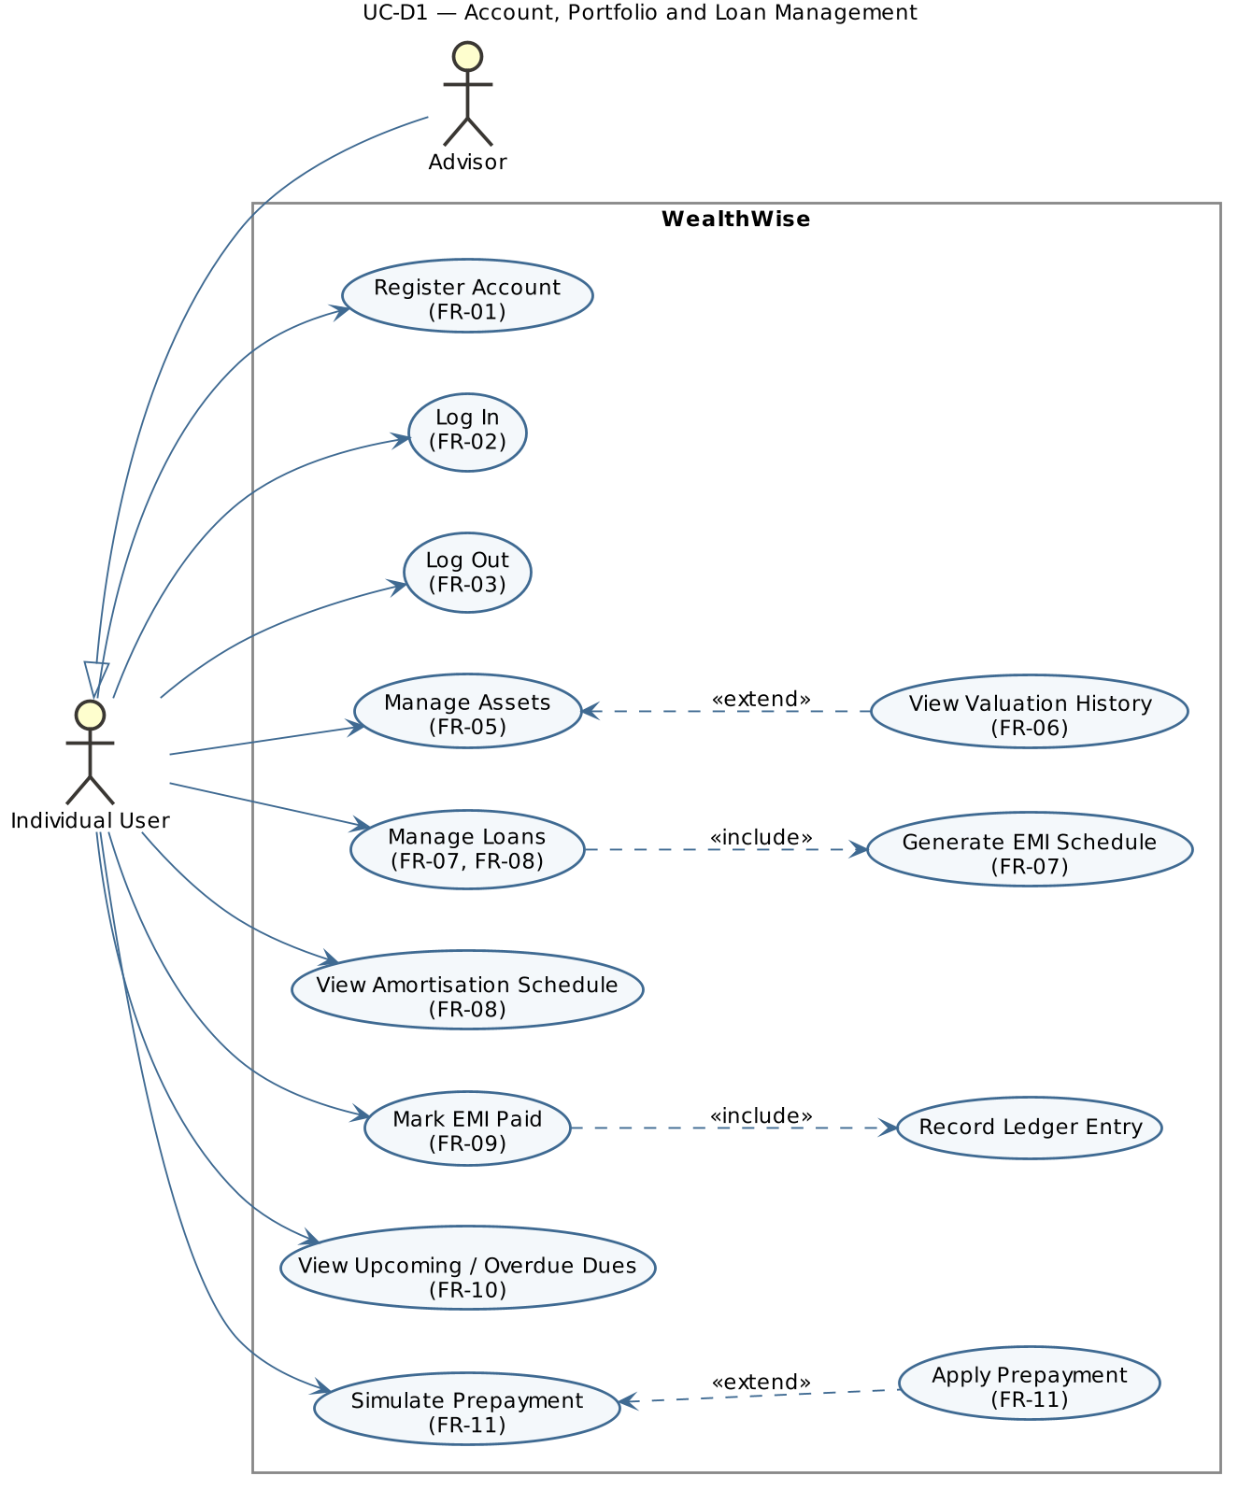
UC-D1 — Account, Portfolio and Loan Management
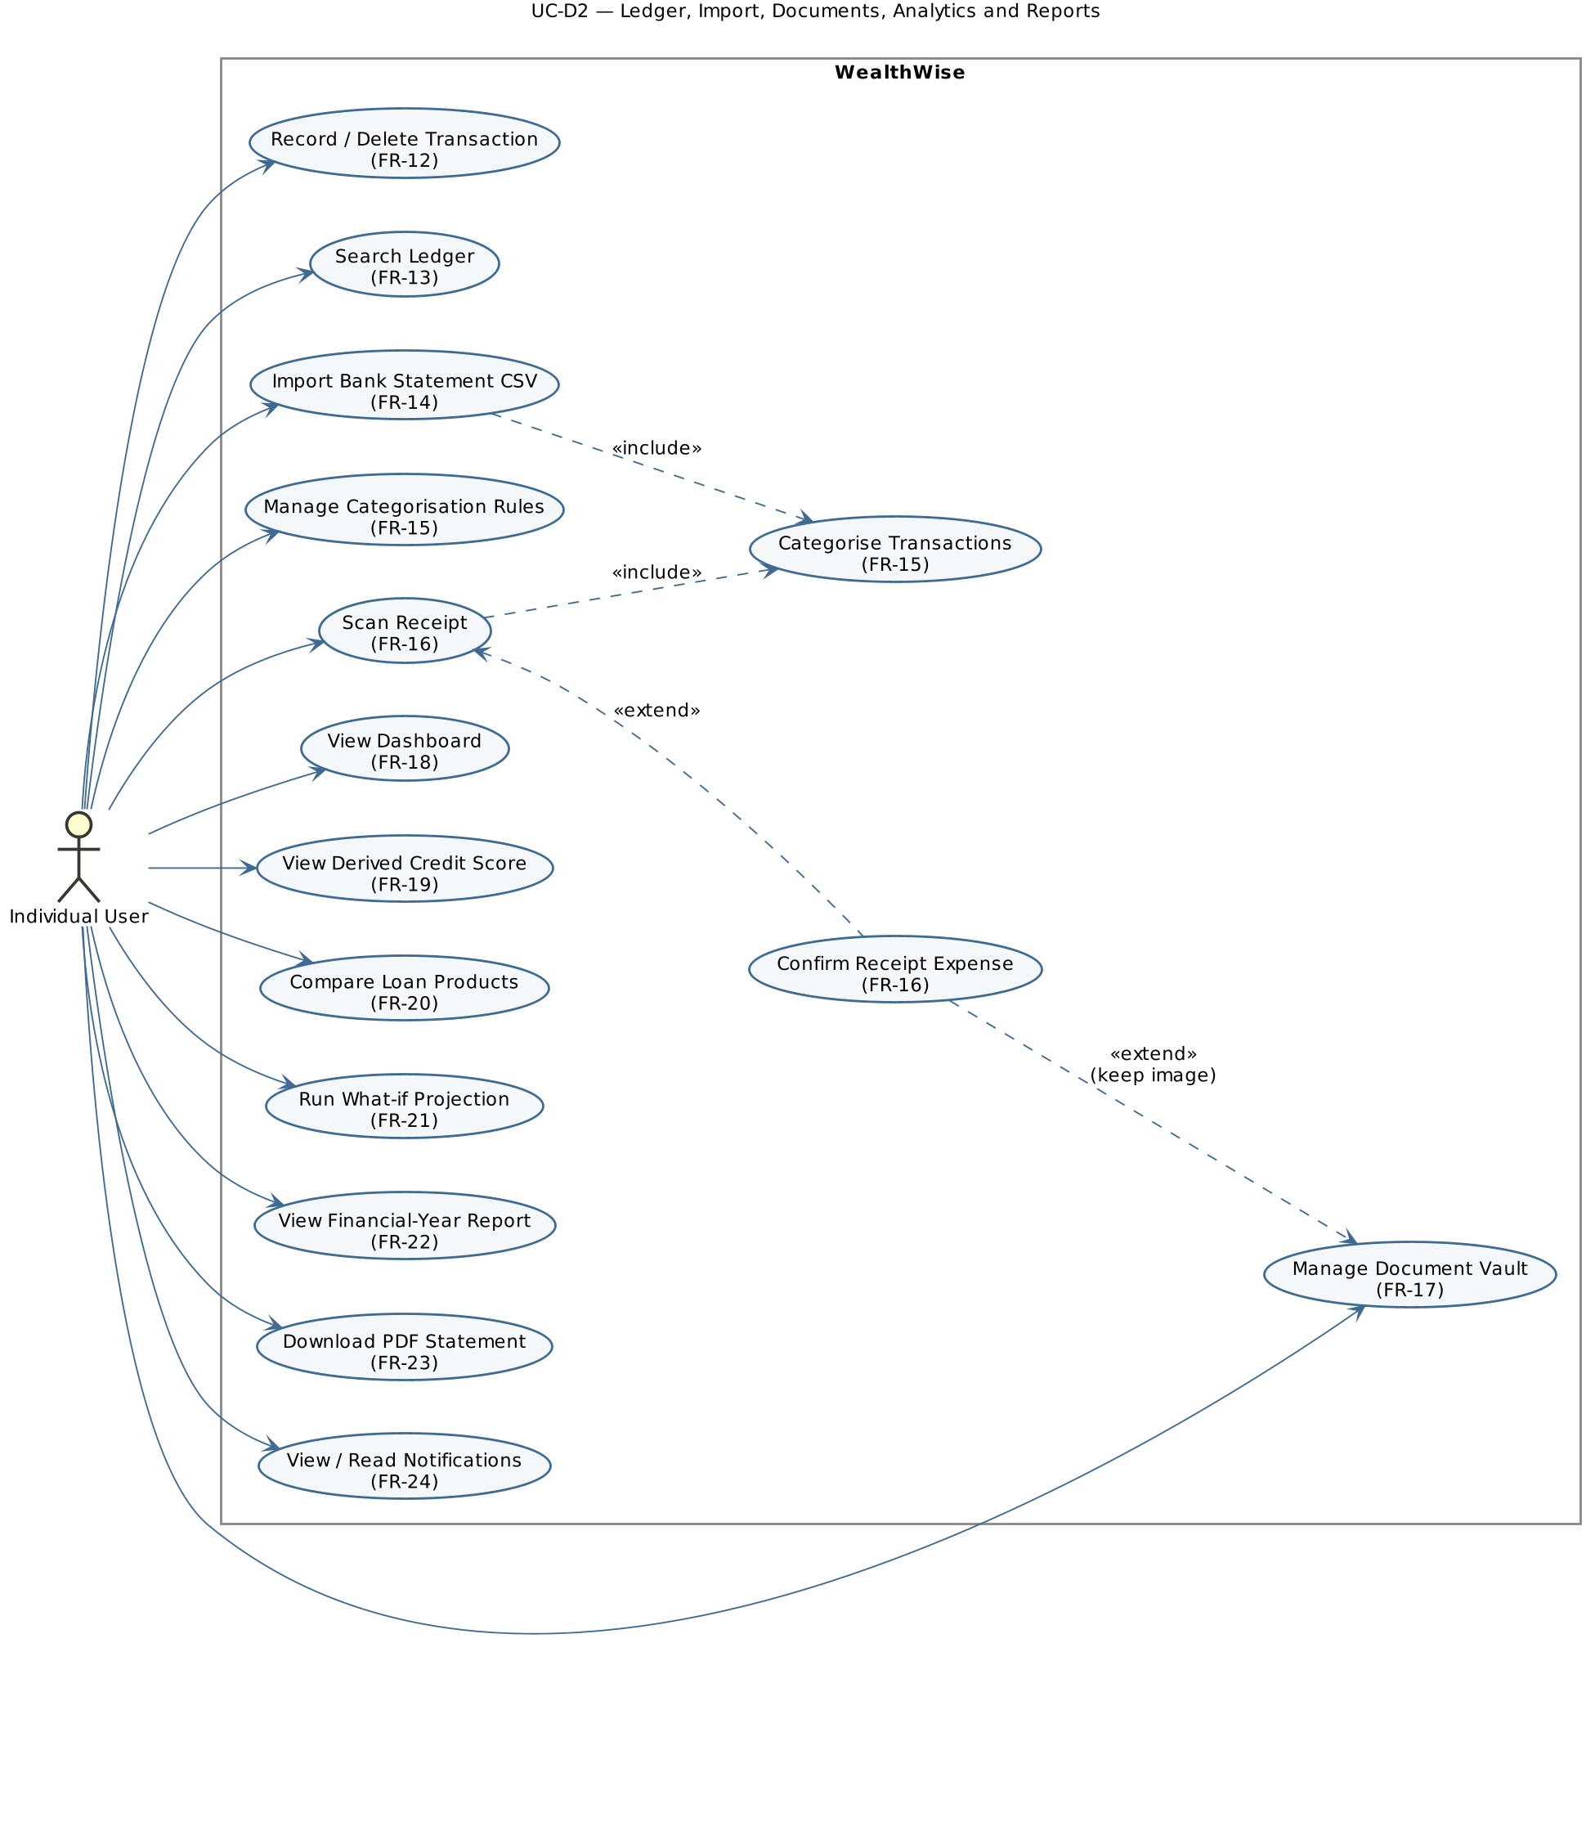
UC-D2 — Ledger, Import, Documents, Analytics and Reports
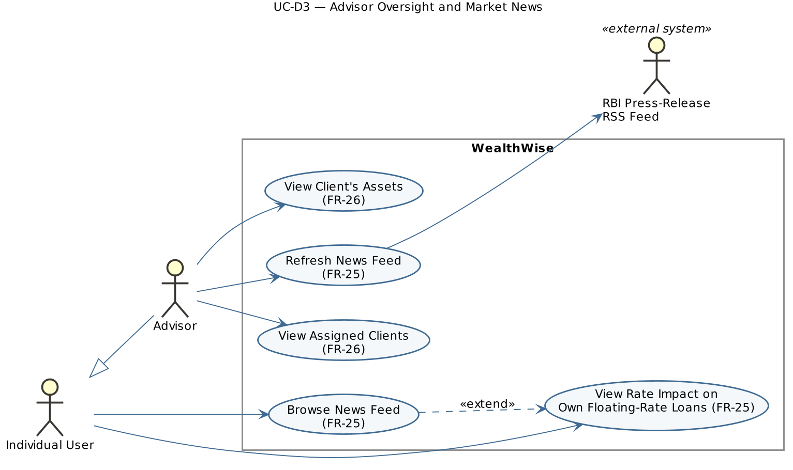
UC-D3 — Advisor Oversight and Market News

7.2 Use-case summary
Use case | Primary actor | Requirement(s)
Register / Log in / Log out | Individual User, Advisor | FR-01, FR-02, FR-03
Manage Assets; View Valuation History | Individual User | FR-05, FR-06
Manage Loans; View Amortisation Schedule | Individual User | FR-07, FR-08
Mark EMI Paid (includes Record Ledger Entry) | Individual User | FR-09
View Upcoming / Overdue Dues | Individual User | FR-10
Simulate / Apply Prepayment | Individual User | FR-11
Record Transaction; Search Ledger | Individual User | FR-12, FR-13
Import Bank Statement (includes Categorise) ; Manage Rules | Individual User | FR-14, FR-15
Scan Receipt; Confirm Receipt Expense | Individual User | FR-16
Manage Document Vault | Individual User | FR-17
View Dashboard | Individual User | FR-18
View Credit Score; Compare Loan Products; Run Projection | Individual User | FR-19, FR-20, FR-21
View FY Report; Download PDF Statement | Individual User | FR-22, FR-23
View / Read Notifications | Individual User | FR-24
Browse News; View Rate Impact; Refresh News | Individual User; Advisor; RBI feed | FR-25
View Assigned Clients; View Client Assets | Advisor | FR-26
FR-04 (access control) is a cross-cutting constraint on every use case rather than a use case of its own.

8. Requirements Traceability Matrix (RTM)
Status: N = Not yet tested, P = Passed, A = Accepted. Design references point to the SAD (component CMP-xx, sequence SEQ-xx, API section).
Req ID | Requirement short | Section ref / Design Spec | Module | Test case(s) | Status (N/P/A) | Comments
FR-01 | Register account | 4.1 / SAD 4.3.1 | CMP-03 Authentication | TC-001–TC-004 | N
FR-02 | Log in, issue session | 4.1 / SAD SEQ-01, 4.3.1 | CMP-03 Authentication | TC-005, TC-006 | N
FR-03 | Log out / current user | 4.1 / SAD 4.3.1 | CMP-03 Authentication | TC-007 | N
FR-04 | Role-based access | 4.1 / SAD 3.9 | CMP-02 API Layer, CMP-03 | TC-008, TC-009 | N
FR-05 | Asset CRUD | 4.2 / SAD 4.3.2 | CMP-04 Assets | TC-010–TC-012, TC-014 | N
FR-06 | Valuation history | 4.2 / SAD 3.4 | CMP-04 Assets | TC-013 | N | Needs MongoDB
FR-07 | Loan + EMI schedule | 4.3 / SAD SEQ-02, 4.3.3 | CMP-05 Loans & EMI | TC-015, TC-016 | N
FR-08 | Loan list, schedule, edit | 4.3 / SAD 4.3.3 | CMP-05 Loans & EMI | TC-017, TC-018 | N
FR-09 | Mark EMI paid | 4.3 / SAD SEQ-03, 4.3.3 | CMP-05 Loans & EMI | TC-019–TC-021 | N
FR-10 | Dues & overdue | 4.3 / SAD 3.4 | CMP-05, CMP-10 | TC-022 | N
FR-11 | Prepayment simulate/apply | 4.3 / SAD 4.3.3 | CMP-11 Insights | TC-023–TC-025 | N
FR-12 | Record / filter transactions | 4.4 / SAD 4.3.5 | CMP-06 Ledger | TC-026, TC-027 | N
FR-13 | Full-text search | 4.4 / SAD 3.6 | CMP-06 Ledger | TC-028 | N
FR-14 | CSV import | 4.5 / SAD SEQ-04, 4.3.4 | CMP-07 Import | TC-029–TC-032 | N
FR-15 | Categorisation rules | 4.5 / SAD 4.3.4 | CMP-07 Import | TC-029, TC-033 | N
FR-16 | Receipt OCR | 4.5 / SAD 4.3.4 | CMP-08 Receipt OCR | TC-034, TC-035 | N
FR-17 | Document vault | 4.6 / SAD 4.3.6 | CMP-09 Vault | TC-036–TC-038 | N | Needs MongoDB
FR-18 | Dashboard | 4.7 / SAD 4.3.6 | CMP-10 Dashboard | TC-039, TC-010 | N
FR-19 | Derived credit score | 4.8 / SAD 3.4 | CMP-11 Insights | TC-040 | N
FR-20 | Loan recommendations | 4.8 / SAD 3.4 | CMP-11 Insights | TC-041 | N
FR-21 | What-if projection | 4.8 / SAD 3.4 | CMP-11 Insights | TC-042 | N
FR-22 | FY report | 4.9 / SAD 3.4 | CMP-12 Reporting | TC-043 | N
FR-23 | PDF statement | 4.9 / SAD 3.4 | CMP-12 Reporting | TC-044 | N
FR-24 | EMI reminders | 4.10 / SAD 3.4 | CMP-13 Notifications | TC-045 | N
FR-25 | News & rate impact | 4.10 / SAD 3.4 | CMP-14 News | TC-046 | N
FR-26 | Advisor client view | 4.11 / SAD 3.4 | CMP-15 Advisor | TC-047 | N
NFR-01 | Response time targets | 5 / SAD 3.1 | CMP-10, CMP-08 | TC-054 | N | Targets to baseline
NFR-02 | Exact money arithmetic | 5 / SAD 3.6 | CMP-05, DS-01 | TC-015, TC-055 | N
NFR-03 | Atomic operations | 5 / SAD 3.6 | CMP-05, CMP-07, CMP-11 | TC-025, TC-032 | N
NFR-04 | Graceful degradation | 5 / SAD 3.7 | CMP-16, DS-02 | TC-038, TC-056 | N
NFR-05 | Usability / accessibility | 5 / SAD 4.5 | CMP-01 Web UI | TC-057 | N
NFR-06 | Maintainability | 5 / SAD 3.5 | All | TC-058 | N
NFR-07 | Configurability | 5 / SAD 3.6 | All | TC-053, TC-059 | N
SR-01 | Password hashing | 5.1 / SAD 3.9 | CMP-03 | TC-048 | N
SR-02 | Signed session cookie | 5.1 / SAD 3.9, SEQ-01 | CMP-03 | TC-005, TC-007, TC-049 | N
SR-03 | No account enumeration | 5.1 / SAD SEQ-01 | CMP-03 | TC-006 | N
SR-04 | Authentication & role checks | 5.1 / SAD 3.9 | CMP-02, CMP-03 | TC-008, TC-009 | N
SR-05 | Object-level authorisation | 5.1 / SAD 3.9 | CMP-16, CMP-15 | TC-047, TC-050 | N
SR-06 | Validation & parameterised SQL | 5.1 / SAD 3.9 | CMP-02, CMP-16 | TC-011, TC-016, TC-027, TC-051 | N
SR-07 | Upload restrictions | 5.1 / SAD 3.9 | CMP-07, CMP-08, CMP-09 | TC-031, TC-035, TC-037 | N
SR-08 | Safe error responses | 5.1 / SAD 4.4 | CMP-02 | TC-052 | N
SR-09 | Secrets & PAN masking | 5.1 / SAD 3.9 | CMP-03, CMP-12 | TC-044, TC-053 | N
Coverage: 26 FRs, 7 NFRs, 3 security objectives and 9 security requirements; every requirement is traced to at least one test case. No orphan requirements.

Appendix A — PlantUML source of use-case diagrams
@startuml UC-D1
' (shared skinparams omitted)
left to right direction
title UC-D1 — Account, Portfolio and Loan Management
actor "Individual User" as U
actor "Advisor" as A
U <|-- A
rectangle "WealthWise" {
usecase "Register Account\n(FR-01)" as UC1
usecase "Log In\n(FR-02)" as UC2
usecase "Log Out\n(FR-03)" as UC3
usecase "Manage Assets\n(FR-05)" as UC5
usecase "View Valuation History\n(FR-06)" as UC6
usecase "Manage Loans\n(FR-07, FR-08)" as UC7
usecase "Generate EMI Schedule\n(FR-07)" as UC7b
usecase "View Amortisation Schedule\n(FR-08)" as UC8
usecase "Mark EMI Paid\n(FR-09)" as UC9
usecase "Record Ledger Entry" as UC9b
usecase "View Upcoming / Overdue Dues\n(FR-10)" as UC10
usecase "Simulate Prepayment\n(FR-11)" as UC11
usecase "Apply Prepayment\n(FR-11)" as UC11b
}
U --> UC1
U --> UC2
U --> UC3
U --> UC5
U --> UC7
U --> UC8
U --> UC9
U --> UC10
U --> UC11
UC5 <.. UC6 : <<extend>>
UC7 ..> UC7b : <<include>>
UC9 ..> UC9b : <<include>>
UC11 <.. UC11b : <<extend>>
@enduml
@startuml UC-D2
' (shared skinparams omitted)
left to right direction
title UC-D2 — Ledger, Import, Documents, Analytics and Reports
actor "Individual User" as U
rectangle "WealthWise" {
usecase "Record / Delete Transaction\n(FR-12)" as T1
usecase "Search Ledger\n(FR-13)" as T2
usecase "Import Bank Statement CSV\n(FR-14)" as I1
usecase "Categorise Transactions\n(FR-15)" as I2
usecase "Manage Categorisation Rules\n(FR-15)" as I3
usecase "Scan Receipt\n(FR-16)" as R1
usecase "Confirm Receipt Expense\n(FR-16)" as R2
usecase "Manage Document Vault\n(FR-17)" as V1
usecase "View Dashboard\n(FR-18)" as D1
usecase "View Derived Credit Score\n(FR-19)" as S1
usecase "Compare Loan Products\n(FR-20)" as S2
usecase "Run What-if Projection\n(FR-21)" as S3
usecase "View Financial-Year Report\n(FR-22)" as P1
usecase "Download PDF Statement\n(FR-23)" as P2
usecase "View / Read Notifications\n(FR-24)" as N1
}
U --> T1
U --> T2
U --> I1
U --> I3
U --> R1
U --> V1
U --> D1
U --> S1
U --> S2
U --> S3
U --> P1
U --> P2
U --> N1
I1 ..> I2 : <<include>>
R1 ..> I2 : <<include>>
R1 <.. R2 : <<extend>>
R2 ..> V1 : <<extend>>\n(keep image)
@enduml
@startuml UC-D3
' (shared skinparams omitted)
left to right direction
title UC-D3 — Advisor Oversight and Market News
actor "Individual User" as U
actor "Advisor" as A
actor "RBI Press-Release\nRSS Feed" as RBI <<external system>>
U <|-- A
rectangle "WealthWise" {
usecase "View Assigned Clients\n(FR-26)" as A1
usecase "View Client's Assets\n(FR-26)" as A2
usecase "Browse News Feed\n(FR-25)" as N1
usecase "View Rate Impact on\nOwn Floating-Rate Loans (FR-25)" as N2
usecase "Refresh News Feed\n(FR-25)" as N3
}
A --> A1
A --> A2
A --> N3
U --> N1
U --> N2
N3 --> RBI
N1 ..> N2 : <<extend>>
@enduml

