Software Architecture and Design Specification
Project: WealthWise – Wealth Management System
Version: 1.1
Authors: Madhusudhan P, Nishant Nag, Likith Kumar, Vasu Tripathi (WealthWise Team)
Date: 31-10-2026
Status: Final

Revision History
Version | Date | Author | Change Summary
1.0 | 14-10-2026 | WealthWise Team | Initial architecture and design derived from SRS v1.0
1.1 | 31-10-2026 | WealthWise Team | Final version describing the delivered system: PostgreSQL as the only database (MongoDB removed); financial calculations as pure TypeScript services with atomic database transactions (no stored functions, procedure or triggers); private file storage with authenticated download; advisor chosen by the client; API tables, diagrams, risks and open issues updated

Approvals
Role | Name | Signature/Date
Course Coordinator
Architecture Lead | Nishant Nag
Requirements Lead | Madhusudhan P
Test Lead | Likith Kumar
Security & Traceability Lead | Vasu Tripathi

1. Introduction
1.1 Purpose
This document specifies the architecture and design of WealthWise – Wealth Management System. It explains how the system is structured to satisfy the requirements in the WealthWise SRS v1.1 (FR-01 to FR-26, NFR-01 to NFR-07, SO-01 to SO-03, SR-01 to SR-09).
1.2 Scope
Covers the complete WealthWise web application: the browser UI, the HTTP API layer, the domain/service components (authentication, assets, loans and EMIs, ledger, statement import and categorisation, receipt OCR, document vault, dashboard, insights, reports, notifications, news and advisor oversight), the data-access layer, and the data stores (PostgreSQL and private server file storage). Hosting infrastructure is outside the scope of this version (To be confirmed).
1.3 Audience
Developers, QA engineers, security reviewers, the course instructor and evaluators, and future maintainers of WealthWise.
1.4 Definitions
API, EMI, FY, JWT, OCR, PAN, RSS, RTM, TLS, ADR (Architecture Decision Record), STRIDE (Spoofing, Tampering, Repudiation, Information disclosure, Denial of service, Elevation of privilege), DAL (Data-Access Layer), CMP-xx (component identifier), DS-xx (data store identifier), SEQ-xx (sequence diagram identifier). Other terms are as defined in SRS §1.4.

2. Document Overview
2.1 How to use this document
Section 3 describes the architecture: goals and constraints, stakeholders, the component diagram and component responsibilities, the architecture pattern, technology and data stores, risks, traceability and security architecture. Section 4 describes the design: sequence diagrams for key workflows, API design, error handling, logging and monitoring, UX, and open issues. Requirement IDs are taken unchanged from the SRS; test-case IDs refer to the STP.
2.2 Related Documents
WealthWise SRS v1.1; WealthWise Software Test Plan (STP) v1.1; Requirements Traceability Matrix (SRS §8 and STP §13); DEVIATIONS.md and the deviations/ folder in the repository (design changes made during development, each explained); database migrations in db/migrations/.

3. Architecture
3.1 Goals & Constraints
Goals:
- Correctness of money – exact decimal storage (NUMERIC(15,2)) and whole-paise arithmetic; each financial calculation (EMI, schedule, prepayment, projection, score) is defined once, in a pure, unit-tested service module, so every screen and report shows the same figure (NFR-02).
- Atomicity – multi-step financial operations either complete fully or not at all (NFR-03).
- Confidentiality and per-user isolation of financial data (SO-01, SR-04, SR-05).
- Resilience – the core keeps working when an optional dependency (vault file storage, the external news feed) fails; only the affected feature degrades (NFR-04).
- Explainability and maintainability – strict layering and hand-written, parameterised SQL so every query is visible and reviewable (NFR-06).
- Responsiveness for interactive pages (NFR-01).
Constraints:
- TypeScript on Next.js 14 (React 18) and Node.js 20+; PostgreSQL 14+ (16 recommended).
- No ORM: PostgreSQL accessed through the pg driver with parameterised SQL.
- Secrets only from environment variables (NFR-07, SR-09).
- No integration with banks, credit bureaus or payment gateways (SRS §1.2).
- Server-side OCR with a bundled language model; no external OCR service.
- Deployment/hosting environment and TLS termination: To be confirmed.
3.2 Stakeholders & Concerns
Stakeholder | Concerns
Individual users | Accuracy of figures, privacy of financial data, ease of use, availability
Advisors | Accurate client overview; access limited to their own clients
Developers (WealthWise team) | Modularity, clear layering, testability, simple local setup
QA / test team | Deterministic behaviour, testable error codes, seedable test data
Course instructor / evaluators | Traceability from requirements to design to tests; sound design justification
Security reviewers | Authentication, authorisation, input handling, secrets management

3.3 Component (UML) Diagram
Figure ARCH-01 shows the layered component architecture. Figure DM-01 is the UML class diagram of the core domain entities held in PostgreSQL. PlantUML sources are in Appendix 5.4.
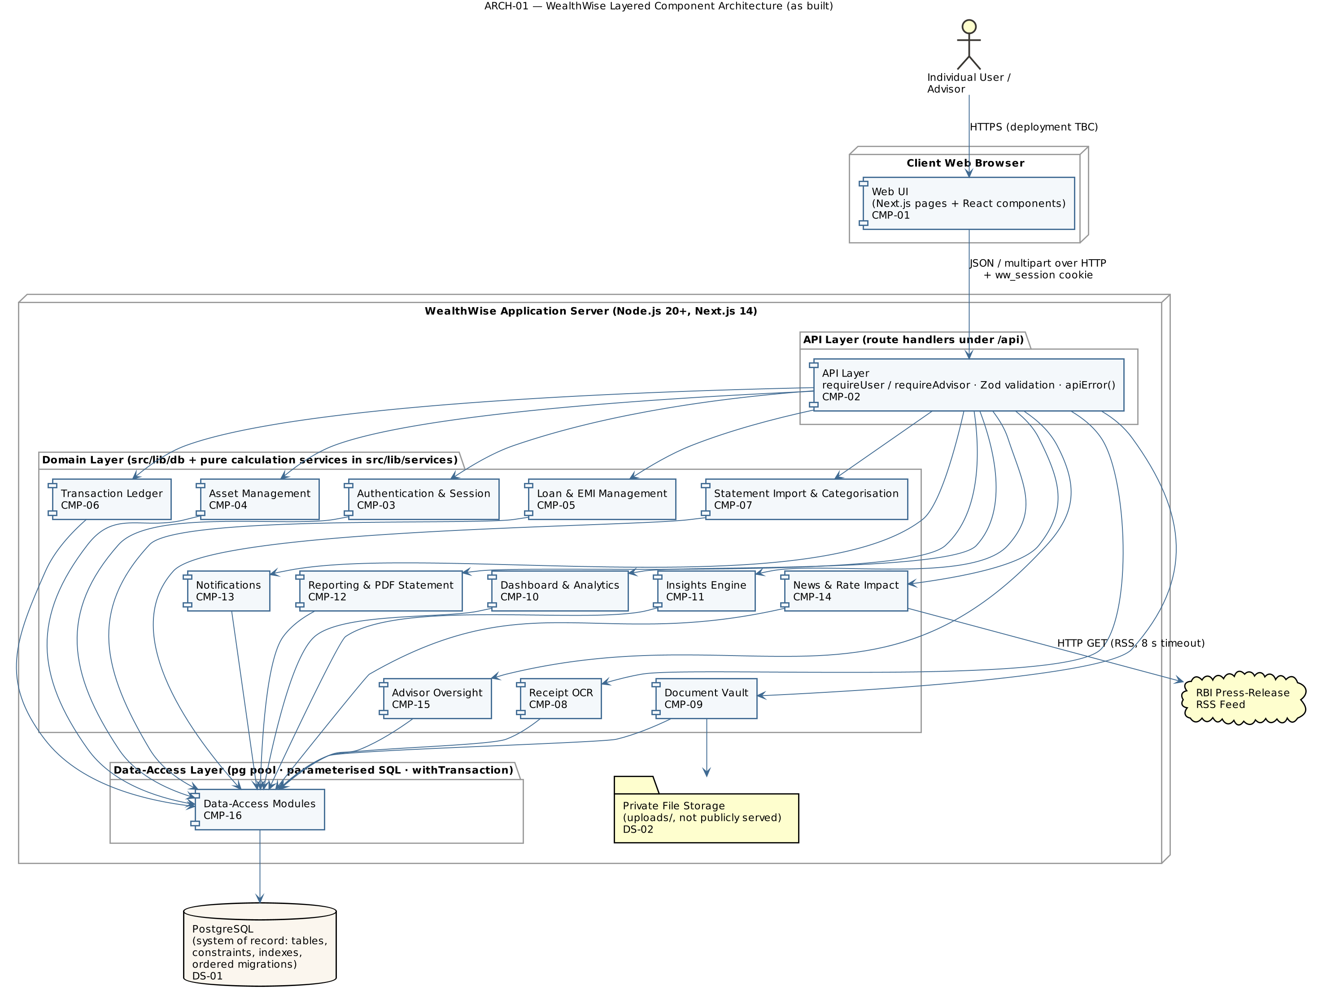
ARCH-01 — WealthWise layered component architecture
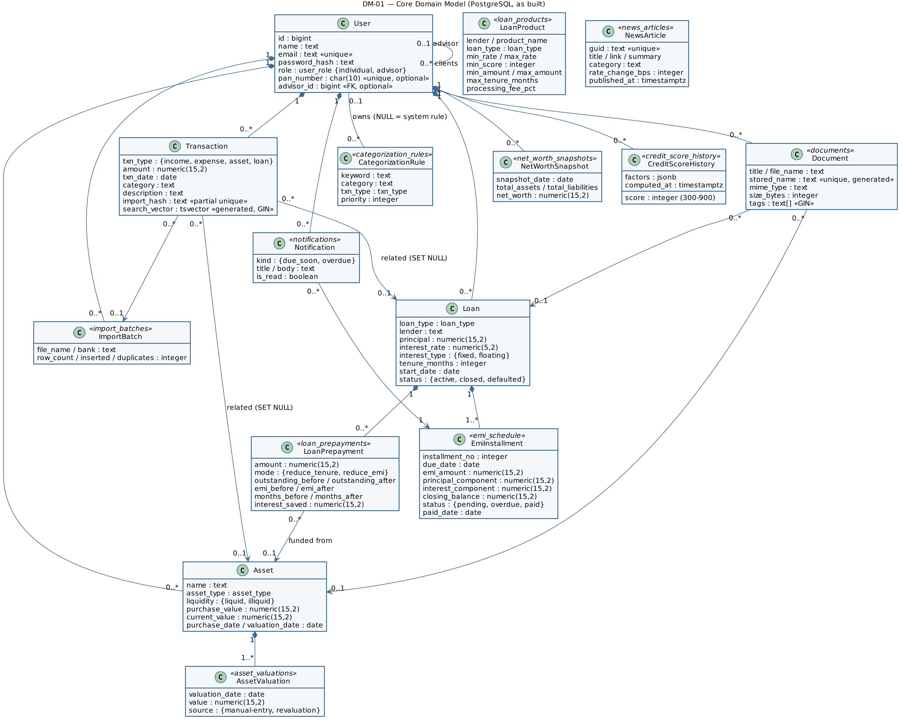
DM-01 — Core domain model (UML class diagram)

3.4 Component Descriptions
ID | Component | Responsibility | Inputs | Outputs | Dependencies | Related requirements
CMP-01 | Web UI (Next.js pages and React components) | Renders all pages (login, sign-up, dashboard, assets, loans and loan detail, dues, ledger, import, receipts, vault, insights, projection, reports, news, advisor); server-side layout redirects signed-out users to /login; theme switch; notification bell; calls only /api/* | User actions; API JSON responses | HTTP requests; rendered pages, charts, PDF download | CMP-02, CMP-03 (session read) | FR-01–FR-26, NFR-05
CMP-02 | API Layer (route handlers under /api) | Single entry point for every operation: authenticate the caller, check role, validate input with Zod schemas, call the domain component, map every error to a safe HTTP status via one error funnel | HTTP requests (JSON or multipart) with ww_session cookie | JSON responses with status codes 200/201/401/403/404/409/413/415/422/500/503 | CMP-03–CMP-16 | FR-04, SR-04, SR-06, SR-07, SR-08
CMP-03 | Authentication & Session | Sign-up, login, logout, current user; bcrypt hashing; HS256 JWT signing and verification; cookie options; requireUser, requireAdvisor | Credentials; session cookie | Signed token; current-user claims (id, email, name, role); 401/403 errors | CMP-16 (users), env JWT_SECRET, JWT_EXPIRES_IN | FR-01–FR-04, SR-01–SR-04, SR-09
CMP-04 | Asset Management | Asset CRUD with liquidity; appends a valuation-history row on create and on revaluation (same transaction); history deleted with the asset; linked transactions keep their history (link set to NULL) | Asset data | Asset records; valuation history | CMP-16; DS-01 (assets, asset_valuations) | FR-05, FR-06
CMP-05 | Loan & EMI Management | Loan CRUD and status; schedule from generateSchedule() (services/emi.ts, whole-paise reducing-balance maths) inserted with the loan in one transaction; refuses edits after a payment or prepayment (409); schedule retrieval; atomic EMI payment (installment, ledger entry, loan closure); overdue marking (markOverdue); dues grouped by urgency | Loan data; installment id | Loans with payoff summary (outstanding = balance before the next unpaid EMI); schedules; payment result | CMP-16; DS-01 | FR-07–FR-10, NFR-02, NFR-03
CMP-06 | Transaction Ledger | Manual transactions; filtered listing; full-text search on a generated tsvector column with a GIN index (websearch_to_tsquery); delete | Transaction data; filters; search text | Transaction lists | CMP-16; DS-01 | FR-12, FR-13
CMP-07 | Statement Import & Categorisation | CSV parsing in services/csv-parser.ts (header detection, column aliases for HDFC/ICICI/SBI/Axis/Kotak, day-first dates, Indian amounts, row rejection with reason, MD5 import hash); preview with suggested categories and duplicate flags; atomic commit with de-duplication by a partial unique index; batch history; keyword rules (categorize(): own rule, then priority, then longest keyword) and re-categorisation of existing rows when a rule is added | CSV file; confirmed rows; rules | Preview; commit counts; rules | CMP-16; DS-01 (import_batches, categorization_rules) | FR-14, FR-15, NFR-03, SR-07
CMP-08 | Receipt OCR | Server-side OCR (tesseract.js, English model loaded from node_modules, no network); extractReceiptFields() picks merchant, Grand Total (not Sub Total) and date; suggests a category; confirm step refuses duplicates (409), records the expense and optionally files the image in the vault (best-effort) | Receipt image; confirmed fields | Extracted fields and confidence; created expense | CMP-07 (categorize), CMP-09, CMP-16 | FR-16, NFR-01, SR-07
CMP-09 | Document Vault | Type detected from the file’s first bytes (PDF/JPEG/PNG/WebP), size ≤ 10 MB; file saved under a random generated name in private storage; metadata and tags in PostgreSQL; links to the user’s own loan or asset; listing, tag/text search, stats, authenticated download (/api/vault/{id}/file, nosniff, no-store) and delete; 503 “unavailable” when storage cannot be written | Multipart file and metadata | Document metadata; stats; file bytes | DS-01 (documents), DS-02 | FR-17, NFR-04, SR-05, SR-07
CMP-10 | Dashboard & Analytics | Single dashboard request: summary, then independent reads run concurrently (trend, allocation with window-function shares, loan progress, next dues, 12-month cash flow, recurring expenses via HAVING); today’s net worth snapshot upserted on each load | User id | Dashboard JSON; dues list | CMP-05, CMP-16; DS-01 | FR-10, FR-18, NFR-01
CMP-11 | Insights Engine | Pure services: credit-score.ts (five weighted factors, 300–900), prepayment.ts (reduce tenure / reduce EMI, reusing existing due dates), recommend.ts (score-based pricing and ranking), projection.ts (month-by-month net worth). Data modules gather inputs; prepayment is applied in one transaction with the loan and funding asset locked; score history stored when it changes | Loan id, amounts, modes, parameters | Score and factors; simulations; recommendations; projection series | CMP-05, CMP-16; DS-01 | FR-11, FR-19–FR-21, NFR-03
CMP-12 | Reporting & PDF Statement | FY helpers (services/fy.ts: 1 April – 31 March) and FY report queries (summary, category spend, monthly figures, EMI principal/interest per loan, indicative 80C / 24(b) / 80E hints); PDF statement built with pdfkit (Helvetica, amounts as “Rs.”), PAN masked to the last four characters | User id; FY start year | FY report JSON; PDF file | CMP-10, CMP-16; DS-01; pdfkit | FR-22, FR-23, SR-09
CMP-13 | Notifications | Generates EMI reminders on read (due within 7 days, or overdue) with INSERT … ON CONFLICT DO NOTHING on UNIQUE (installment_id, kind), lists notifications with unread count, marks one or all read | User id; notification id | Notifications list; unread count | CMP-16; DS-01 | FR-24
CMP-14 | News & Rate Impact | Fetches the RBI RSS feed (8 s timeout), parses and classifies articles and repo-rate changes (services/news.ts), caches them in PostgreSQL (refreshed when older than 6 h; not retried for 60 s after a failure), falls back to clearly labelled sample articles; computes EMI impact on the user’s floating-rate loans | Category filter; article id | Feed; per-loan impact | DS-01 (news_articles), RBI RSS feed | FR-25, NFR-04
CMP-15 | Advisor Oversight | Individual chooses or removes an advisor by email (Advisor role only); advisor-only client list with live net worth summary, active loans and overdue EMIs; read-only client detail (assets, loans) only for assigned clients (advisorOwnsClient, otherwise 403) | Session; advisor email; client id | Client summaries; client assets and loans | CMP-03, CMP-04, CMP-05, CMP-16 | FR-26, SR-05
CMP-16 | Data-Access Layer | Shared pg pool (src/lib/db/postgres.ts); one module per entity under src/lib/db/; parameterised SQL only; ownership (user_id) in every WHERE clause; withTransaction() helper (BEGIN/COMMIT/ROLLBACK on a single pooled client); ordered migration runner | Calls from domain components | Typed rows | DS-01 | NFR-02–NFR-04, SR-05, SR-06
Data stores: DS-01 PostgreSQL; DS-02 private server file storage (uploads/). External system: RBI press-release RSS feed.

3.5 Chosen Architecture Pattern and Rationale
Pattern: Layered architecture within a single deployable full-stack web application (modular monolith). Requests flow strictly downward: Web UI (CMP-01) → API Layer (CMP-02) → domain/service components (CMP-03–CMP-15) → Data-Access Layer (CMP-16) → data stores. No UI component issues a database query and no route handler contains inline SQL (NFR-06).
Rationale:
- Clear separation of concerns: authentication, validation and error mapping are concentrated in one layer, so they cannot be skipped by individual features.
- Financial logic (EMI schedule, prepayment, projection, credit score, loan pricing, FY dates, CSV and receipt parsing) lives in pure TypeScript service modules with no database access. Each calculation has one definition, shared by every page and report, and is unit-tested without a database. Steps that change several rows run in one database transaction (withTransaction()), so atomicity is kept (NFR-03).
- A single Next.js application keeps the UI and API in one TypeScript code base, which suits a four-person team and simple local setup.
- Single database: all data, including valuation history, document metadata and the news cache, is held in PostgreSQL. This keeps installation, backups, CI and ownership checks uniform (one user_id pattern everywhere). The second (document) database planned in v1.0 was dropped because it added setup work without adding a feature; see deviations/NFR-04-no-document-store.md.
Rejected alternatives: Microservices – unnecessary operational complexity for the scale of WealthWise. ORM-based data access – would hide the SQL and make atomicity and performance harder to reason about. Stored functions, procedures and triggers for the financial logic (the v1.0 design) – replaced by TypeScript services so the logic can be unit-tested and reviewed in one language; the deviation notes in the repository record each change.

3.6 Technology Stack & Data Stores
Layer | Technology
Language | TypeScript 5
Web framework / UI | Next.js 14 (App Router; server and client components), React 18, Tailwind CSS 3; charts drawn with HTML/CSS bars and inline SVG
Runtime | Node.js 20+
Validation | Zod 3
Authentication | bcryptjs (cost 12), jose (HS256 JWT)
Relational database | PostgreSQL 14+ (16 recommended) via pg with parameterised SQL
File storage | Private uploads/ directory (configurable with UPLOAD_DIR), excluded from Git
OCR | tesseract.js with bundled English model (@tesseract.js-data/eng)
PDF | pdfkit with the built-in Helvetica font
Testing | Node.js built-in test runner via tsx: unit suite (npm test, includes security and layering tests) and database suite (npm run test:db)
CI | GitHub Actions on every push and pull request: type-check, unit tests, migrations, database tests and production build against PostgreSQL 16
Tooling | npm scripts for migrations (db:migrate), demo data (db:seed), type-checking and tests
Deployment / hosting | To be confirmed
DS-01 PostgreSQL – system of record. Tables: users, assets, asset_valuations, loans, emi_schedule, loan_prepayments, transactions, import_batches, categorization_rules, documents, net_worth_snapshots, credit_score_history, loan_products (seeded illustrative catalogue), notifications, news_articles, plus schema_migrations. Enum types for categorical fields; NUMERIC(15,2) for all money; CHECK, UNIQUE and foreign-key constraints mirror the API validation; ON DELETE CASCADE from users to their data and from loans to their schedules and prepayments; ON DELETE SET NULL from transactions to assets/loans and from documents to loans/assets. Indexes: partial index on unpaid installments, partial unique index on (user_id, import_hash) for import de-duplication, generated tsvector column with a GIN index for full-text search, GIN index on document tags, unique (installment_id, kind) for reminders. No stored functions, procedures, triggers or views: queries live in the data-access modules. Schema changes are applied by ordered migration files (001–011), each in its own transaction and recorded in schema_migrations.
DS-02 Private file storage. Vault documents and filed receipt images, saved under random generated names (<uuid>.<ext>) in uploads/ (outside public/, ignored by Git). Files are read only through the authenticated download route, which accepts only generated names, so a stored name can never point outside the folder.

3.7 Risks & Mitigations
ID | Risk | Mitigation / status
RISK-01 | Vault storage folder missing, full or not writable | Upload returns 503 “vault unavailable”; receipt confirmation still records the expense; core features never touch the file storage (NFR-04)
RISK-02 | RBI feed unreachable or format changes | 8 s fetch timeout; cached copy in PostgreSQL; no retry for 60 s after a failure; labelled illustrative sample articles as fallback; refresh restricted to advisors
RISK-03 | Unauthorised access to uploaded files | Resolved: files kept outside the public folder and served only by GET /api/vault/{id}/file to their owner (other users get 404)
RISK-04 | No login rate limiting or lockout, allowing password guessing | bcrypt cost slows each attempt; open issue OI-04: add rate limiting
RISK-05 | Any visitor can choose the Advisor role at sign-up | Advisors can only read clients explicitly assigned to them, so data exposure is limited; open issue OI-05: restrict advisor registration
RISK-06 | OCR misreads receipts | Two-step scan-then-confirm design; nothing is saved without user confirmation
RISK-07 | Calculation drift in long schedules | Whole-paise integer arithmetic, NUMERIC storage; final installment absorbs rounding; unit tests pin values (NFR-02)
RISK-09 | A required file is missed when changes are copied between branches | CI runs type-check, both test suites and a build on every PR; the STP execution checks every API end to end (this caught two missing route files, fixed before release)
RISK-08 | Deployment without HTTPS would expose the session cookie | Secure cookie flag in production; HTTPS required for deployment (To be confirmed)

3.8 Traceability to Requirements
Requirement | Component(s) | Design element
FR-01 Register | CMP-03, CMP-02 | API 4.3.1 POST /api/auth/signup
FR-02 Login | CMP-03 | SEQ-01 Login; API 4.3.1 POST /api/auth/login
FR-03 Logout / current user | CMP-03 | API 4.3.1 POST /api/auth/logout, GET /api/auth/me
FR-04 Access control | CMP-02, CMP-03, CMP-01 | §3.9; requireUser / requireAdvisor; layout redirect
FR-05 Asset CRUD | CMP-04 | API 4.3.2 /api/assets
FR-06 Valuation history | CMP-04, DS-01 | API 4.3.2 GET /api/assets/{id}; asset_valuations
FR-07 Loan + schedule | CMP-05 | SEQ-02; API 4.3.3 POST /api/loans
FR-08 Loan list / schedule / edit | CMP-05 | API 4.3.3 GET/PUT/PATCH/DELETE /api/loans/{id}, GET /api/loans/{id}/schedule
FR-09 Pay EMI | CMP-05 | SEQ-03; API 4.3.3 POST /api/emi/{id}/pay
FR-10 Dues / overdue | CMP-05, CMP-10 | GET /api/dues; markOverdue(), upcomingDues()
FR-11 Prepayment | CMP-11, CMP-05 | API 4.3.3 POST /api/loans/{id}/prepay/simulate, GET/POST /api/loans/{id}/prepay; services/prepayment.ts
FR-12 Transactions | CMP-06 | API 4.3.5 /api/transactions
FR-13 Search | CMP-06 | GET /api/transactions?search=; GIN full-text index
FR-14 CSV import | CMP-07 | SEQ-04; API 4.3.4 /api/imports/*
FR-15 Categorisation rules | CMP-07 | API 4.3.4 /api/rules
FR-16 Receipt OCR | CMP-08 | API 4.3.4 /api/receipts/scan, /api/receipts/confirm
FR-17 Vault | CMP-09, DS-02 | API 4.3.6 /api/vault, /api/vault/{id}/file
FR-18 Dashboard | CMP-10 | API 4.3.6 GET /api/dashboard; snapshot upsert on load
FR-19 Credit score | CMP-11 | GET /api/insights/score
FR-20 Recommendations | CMP-11 | POST /api/insights/recommend
FR-21 Projection | CMP-11 | GET /api/insights/projection
FR-22 FY report | CMP-12 | GET /api/reports/fy
FR-23 PDF statement | CMP-12 | GET /api/reports/statement
FR-24 Reminders | CMP-13 | GET/POST /api/notifications
FR-25 News | CMP-14 | GET /api/news, POST /api/news/refresh, GET /api/news/{id}/impact
FR-26 Advisor | CMP-15 | /api/advisor/me; GET /api/advisor/clients; GET /api/advisor/clients/{id}
NFR-01 Performance | CMP-10, CMP-08 | Concurrent dashboard reads; partial and composite indexes
NFR-02 Exact money | CMP-05, DS-01 | NUMERIC(15,2); generateSchedule() whole-paise rounding rule
NFR-03 Atomicity | CMP-16, CMP-05, CMP-07, CMP-11 | withTransaction(); applyPrepayment(); SEQ-02, SEQ-03, SEQ-04
NFR-04 Degradation | CMP-09, CMP-14 | 503 “vault unavailable”; news cache, 60 s retry suppression, sample fallback
NFR-05 Usability | CMP-01 | §4.5 UX design
NFR-06 Maintainability | All | §3.5 layering
NFR-07 Configurability | CMP-03, CMP-16 | Environment variables (§3.9)

3.9 Security Architecture
Threat modelling (STRIDE):
Threat | Example in WealthWise | Architectural control | SR
Spoofing | Forged or stolen session; password guessing | HS256-signed JWT verified on every request (issuer checked); httpOnly cookie unreadable by scripts; bcrypt cost 12; uniform login failure message | SR-01, SR-02, SR-03
Tampering | Altered amounts, SQL injection, malformed imports | Zod validation at CMP-02 plus database constraints; all SQL parameterised; import rows re-validated on commit | SR-06
Repudiation | Disputed EMI payment or import | Every payment writes a ledger entry; imports carry batch id and hash; prepayments recorded in loan_prepayments. A dedicated audit log is To be confirmed | —
Information disclosure | Reading another user’s data; leaking internals; PAN exposure | Ownership condition in every query’s WHERE clause; advisor access only to assigned clients; generic 500 errors; PAN masked on PDF; secrets only in environment | SR-05, SR-08, SR-09
Denial of service | Very large uploads; long-running imports | Upload size limits; maximum 5,000 rows per commit; listing limits (≤ 500 transactions) | SR-07
Elevation of privilege | Individual calling advisor APIs; advisor reading a non-client | requireAdvisor() returns 403; advisorOwnsClient() returns 403 for non-assigned users; advisor access is read-only | SR-04, SR-05
Security requirement → component trace:
SR | Enforced in | Mechanism
SR-01 | CMP-03 | hashPassword / verifyPassword (bcrypt, 12 rounds); responses expose only id, name, email, role
SR-02 | CMP-03 | signSession / verifySession (jose, HS256, issuer wealthwise, expiry from JWT_EXPIRES_IN); cookie ww_session with httpOnly, SameSite=Lax, Secure in production
SR-03 | CMP-03 | Same HttpError(401) message for both failure paths; dummy bcrypt comparison for unknown users (SEQ-01)
SR-04 | CMP-02, CMP-03, CMP-01 | requireUser() (401), requireAdvisor() (403) at the start of each handler; authenticated layout redirects to /login
SR-05 | CMP-16, CMP-15, CMP-09 | … AND user_id = $n in every read/update/delete; advisorOwnsClient(); ownership checked under row locks in applyPrepayment(); vault files downloadable only by their owner
SR-06 | CMP-02, CMP-16, DS-01 | Zod schemas; CHECK / NOT NULL / UNIQUE constraints; ($n IS NULL OR col = $n) pattern for optional filters
SR-07 | CMP-07, CMP-08, CMP-09 | .csv name check for statements; image/PDF type detected from the file’s first bytes (detectType()), not from its name; byte limits (5 / 8 / 10 MB); generated storage names
SR-08 | CMP-02 | apiError() maps Zod (422 with field errors), HttpError (its status) and database errors (23505→409, 23514→422, 23503→422); everything else → generic 500
SR-09 | CMP-03, CMP-12 | JWT_SECRET (≥ 32 chars enforced), database URLs from environment; .env excluded from version control; PAN masking in PDF
Transport security (TLS) is required for production deployment; its configuration depends on the hosting environment (To be confirmed).

4. Design

4.1 Design Overview
WealthWise is designed as a layered Next.js application. Each page in the authenticated area is wrapped by a layout that verifies the session on the server before rendering. Interactive components call the JSON API. Every API handler follows the same template: (1) authenticate (requireUser / requireAdvisor), (2) validate the request body or query with a Zod schema, (3) call a domain function, (4) return ok(data, status), and (5) route any thrown error through apiError(). Domain functions that change several rows use withTransaction(). Financial computations are pure functions in src/lib/services, so results are identical wherever they are displayed and are unit-tested in isolation. Two-step flows (statement import, receipt OCR) separate a read-only preview from an atomic commit so that the user always confirms before data is written.

4.2 UML Sequence Diagrams
Four sequence diagrams cover the most important WealthWise workflows. PlantUML sources are in Appendix 5.4.
SEQ-01 – User login and session establishment (FR-02, SR-01–SR-03)
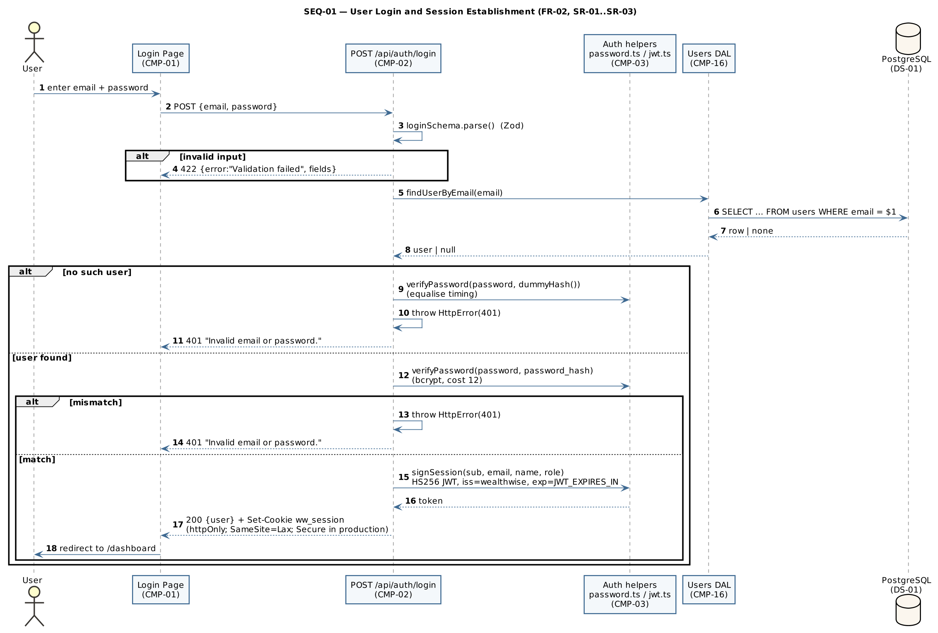
SEQ-01 — Login
SEQ-02 – Create loan with automatic EMI schedule (FR-07, NFR-02, NFR-03)
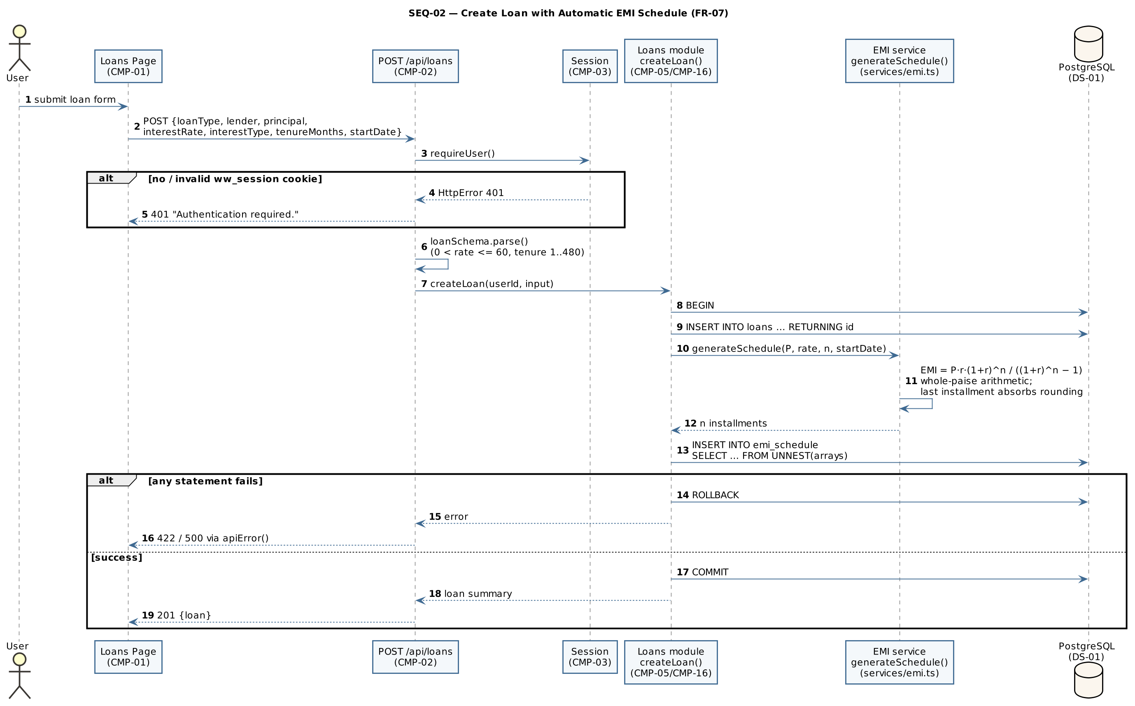
SEQ-02 — Create loan
SEQ-03 – Mark EMI installment paid (FR-09, NFR-03, SR-05)
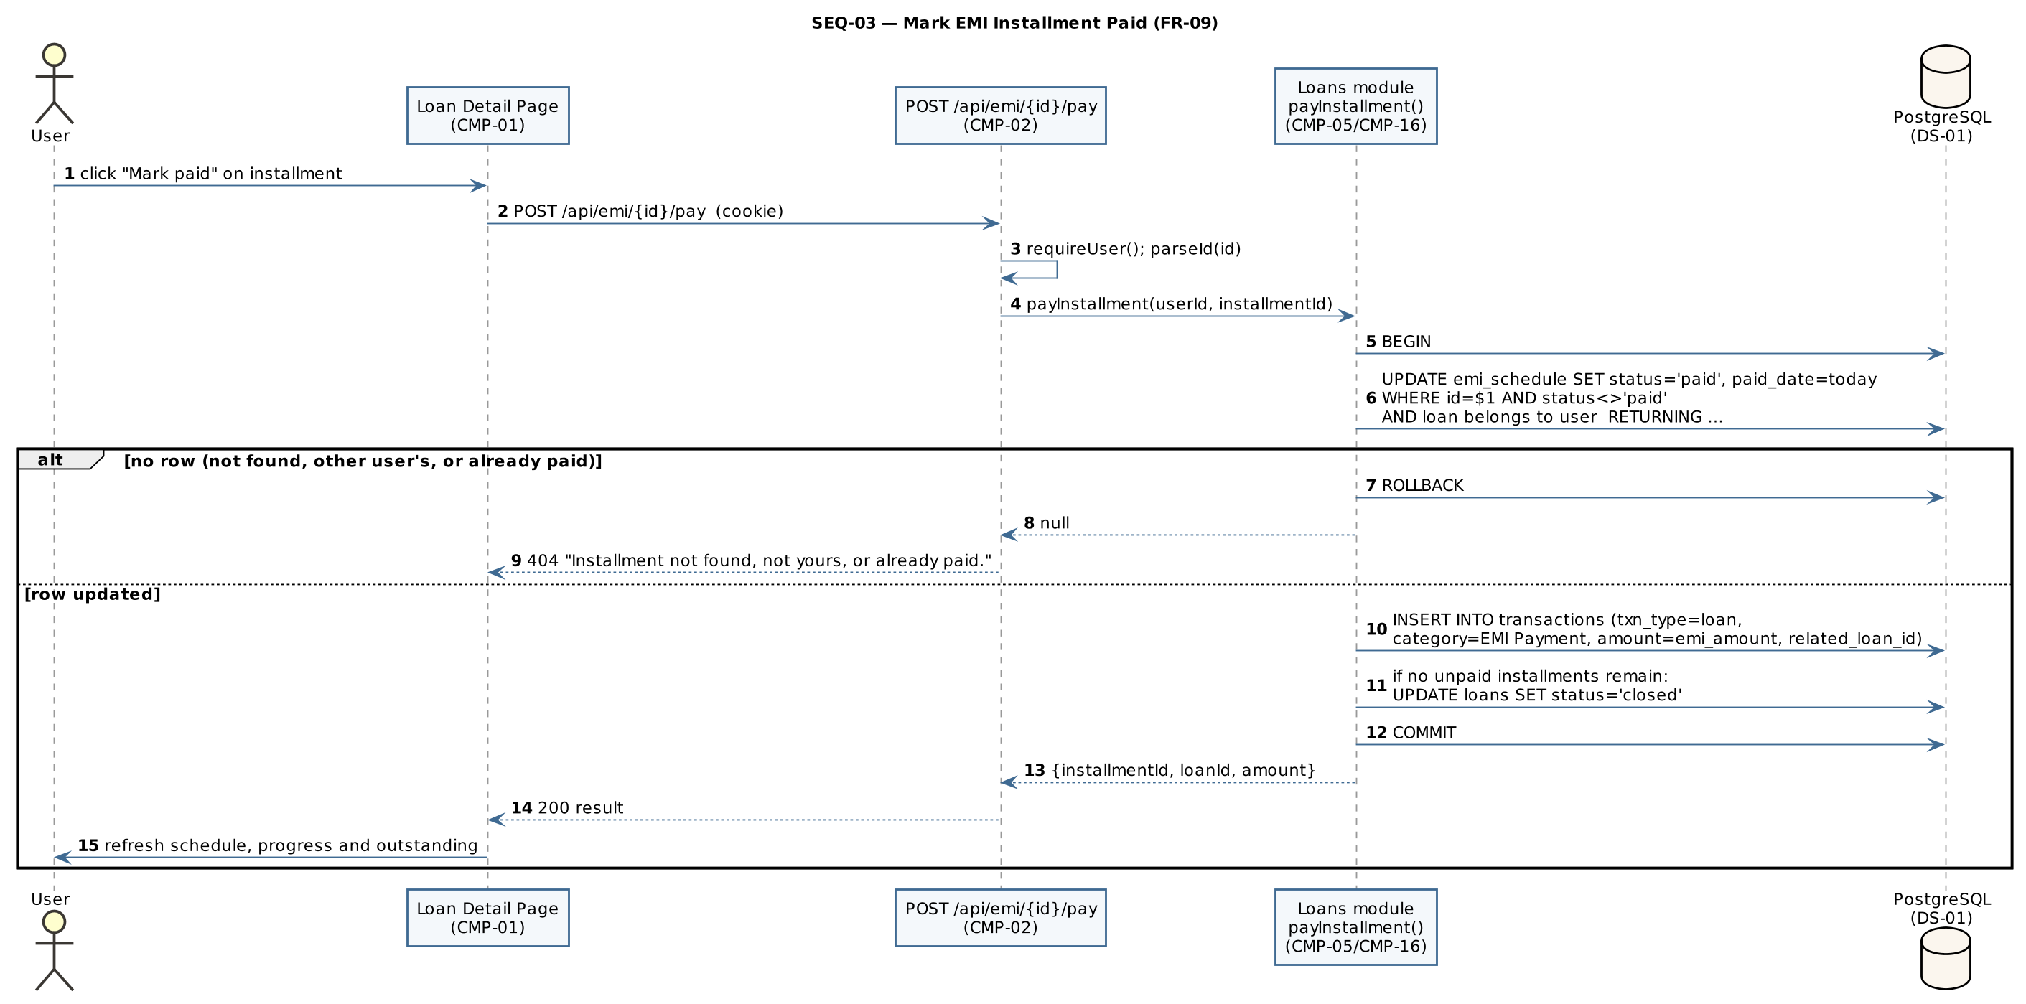
SEQ-03 — Pay EMI
SEQ-04 – Bank-statement CSV import: preview and commit (FR-14, FR-15, NFR-03)
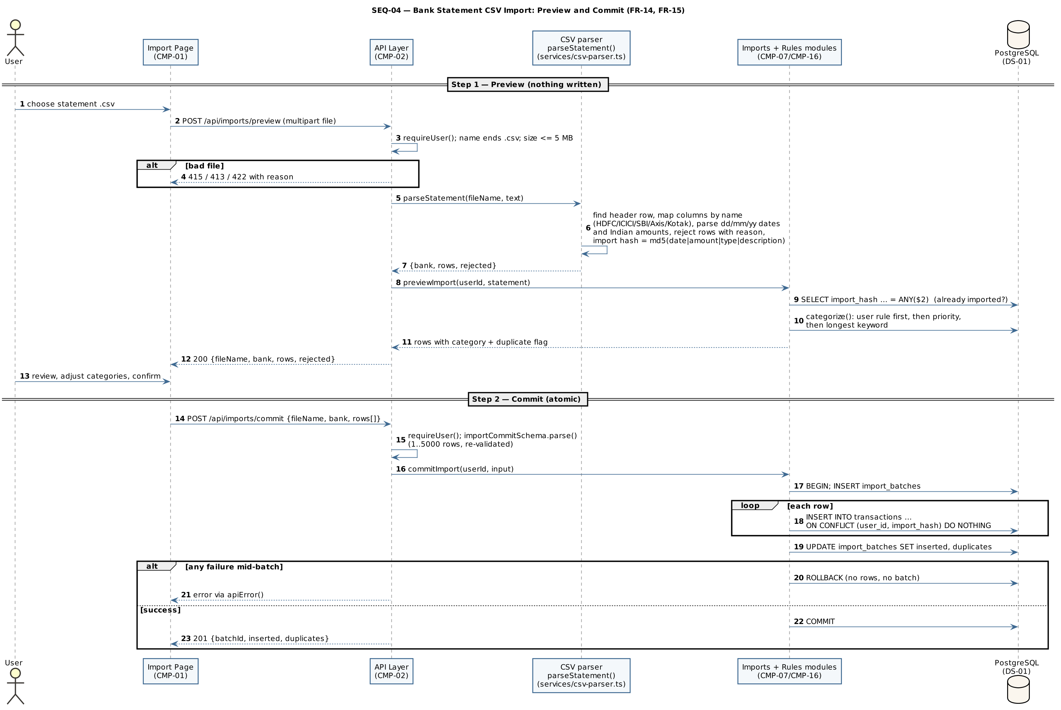
SEQ-04 — Statement import

4.3 API Design
All endpoints are under /api, exchange JSON unless stated (multipart for uploads), and are authenticated by the ww_session cookie. Common error responses: 401 “Authentication required.” (no/invalid session), 403 (role not permitted or client not assigned), 404 (resource not found or not owned – another user’s records are always reported as not found), 409 (duplicate or business-rule conflict), 413 (file too large), 415 (unsupported file type), 503 (vault storage or news feed unavailable), 422 {error:"Validation failed", fields:{…}} or a rule/constraint violation, 500 “Internal server error”. The complete endpoint inventory is in Appendix 5.5.

4.3.1 Authentication & Session component (CMP-03)
Endpoint | Method | Purpose | Request | Response | Auth | Errors
/api/auth/signup | POST | Register and start session (FR-01) | {name, email, password, role?, panNumber?} | 201 {user:{id,name,email,role}} + Set-Cookie: ww_session | Public | 409 email exists; 422 validation
/api/auth/login | POST | Authenticate (FR-02) | {email, password} | 200 {user} + Set-Cookie: ww_session | Public | 401 “Invalid email or password.”; 422
/api/auth/logout | POST | End session (FR-03) | — | 200 {ok:true}; cookie cleared | Public | —
/api/auth/me | GET | Current user (FR-03) | — | 200 {user} or {user:null} | Public | —

4.3.2 Asset Management component (CMP-04)
Endpoint | Method | Purpose | Request | Response | Auth | Errors
/api/assets | GET | List my assets | — | 200 {assets:[…]} | User | 401
/api/assets | POST | Create asset; record first valuation | {name, assetType, liquidity?, purchaseValue, currentValue, purchaseDate, valuationDate, notes?} | 201 {asset} | User | 401; 422
/api/assets/{id} | GET | Asset with valuation history | — | 200 {asset, valuationHistory} | Owner | 401; 404
/api/assets/{id} | PUT | Update / revalue (adds a history point when value or date changes) | as POST | 200 {asset} | Owner | 401; 404; 422
/api/assets/{id} | DELETE | Delete asset and its history; linked transactions keep their history | — | 200 {ok:true} | Owner | 401; 404

4.3.3 Loan & EMI Management component (CMP-05, with CMP-11 for prepayment)
Endpoint | Method | Purpose | Request | Response | Auth | Errors
/api/loans | GET | List loans with payoff summary | — | 200 {loans:[…]} | User | 401
/api/loans | POST | Create loan + schedule atomically (FR-07) | {loanType, lender, principal, interestRate, interestType, tenureMonths, startDate} | 201 {loan} | User | 401; 422
/api/loans/{id} | GET / PUT / PATCH / DELETE | Read; edit terms (regenerates schedule); set status; delete | PUT: as POST; PATCH: {status: active\|closed\|defaulted} | 200 {loan} / {ok:true} | Owner | 401; 404; 409 has paid installments or a prepayment; 422
/api/loans/{id}/schedule | GET | Amortisation schedule (FR-08) | — | 200 {loan, schedule:[…]} | Owner | 401; 404
/api/emi/{id}/pay | POST | Mark installment paid (FR-09) | — | 200 {installmentId, loanId, amount, loanClosed} | Owner | 401; 404 not found / not yours / already paid
/api/dues | GET | Upcoming and overdue EMIs (FR-10) | query days? (default 45, max 365) | 200 {markedOverdue, dues:[…]} | User | 401
/api/loans/{id}/prepay/simulate | POST | Compare both prepayment modes (read-only) | {amount} | 200 {loanId, outstanding, reduceTenure, reduceEmi} | Owner | 401; 404; 422
/api/loans/{id}/prepay | GET | Prepayments made on the loan | — | 200 {prepayments:[…]} | Owner | 401
/api/loans/{id}/prepay | POST | Apply prepayment atomically (FR-11) | {amount, mode: reduce_tenure\|reduce_emi, fundingAssetId?} | 201 {prepaymentId, emiAfter, monthsAfter, interestSaved, …} | Owner (checked under row lock) | 401; 404; 422 not active / ≥ outstanding / funding asset too small

4.3.4 Statement Import, Categorisation and Receipt components (CMP-07, CMP-08)
Endpoint | Method | Purpose | Request | Response | Auth | Errors
/api/imports/preview | POST | Parse, categorise, flag duplicates; nothing saved | multipart file (.csv ≤ 5 MB) | 200 {fileName, bank, rows, rejected} | User | 401; 413; 415; 422 no file / no header row
/api/imports/commit | POST | Atomic insert of confirmed rows | {fileName, bank, rows:[{txnDate, description, amount, txnType, category}]} (1–5000) | 201 {batchId, inserted, duplicates} | User | 401; 422
/api/imports/batches | GET | Import history | — | 200 {batches:[…]} | User | 401
/api/rules | GET / POST | List my and system rules; add a rule and re-categorise my matching transactions | POST {keyword, category, txnType} | 200 {rules} / 201 {rule, recategorised} | User | 401; 409 duplicate; 422
/api/rules/{id} | DELETE | Delete my own rule | — | 200 {ok:true} | Owner | 401; 404 not found or system rule
/api/receipts/scan | POST | OCR only, nothing saved (FR-16) | multipart file (JPEG/PNG/WebP ≤ 8 MB) | 200 {merchant, amount, date, confidence, text, suggestedCategory} | User | 401; 413; 415; 422 unreadable
/api/receipts/confirm | POST | Record expense; optionally file image in vault | multipart merchant, amount, date, category, saveToVault, file? | 201 {transactionId, vault:{saved, documentId?, message?}} | User | 401; 409 duplicate receipt; 422

4.3.5 Transaction Ledger component (CMP-06)
Endpoint | Method | Purpose | Request | Response | Auth | Errors
/api/transactions | GET | Filter and search ledger (FR-12, FR-13) | query type?, from?, to?, category?, search?, limit? (≤ 500) | 200 {transactions:[…]} | User | 401; 422
/api/transactions | POST | Record transaction | {txnType, amount, txnDate, category, description?, relatedAssetId?, relatedLoanId?} | 201 {transaction} | User | 401; 422
/api/transactions/{id} | DELETE | Delete transaction | — | 200 {ok:true} | Owner | 401; 404

4.3.6 Vault and Dashboard components (CMP-09, CMP-10)
Endpoint | Method | Purpose | Request | Response | Auth | Errors
/api/vault | GET | List / filter / search my documents | query tag?, q?, loanId?, assetId? | 200 {documents, stats:{count, totalBytes, byTag}} | User | 401; 422
/api/vault | POST | Upload document | multipart file, title, tags, loanId?, assetId? | 201 {document} | User | 401; 413; 415; 422; 503 storage unavailable
/api/vault/{id} | DELETE | Delete record and file | — | 200 {deleted:true} | Owner | 401; 404
/api/vault/{id}/file | GET | Authenticated download (?download=1 for attachment) | — | 200 file bytes (nosniff, no-store) | Owner | 401; 404
/api/dashboard | GET | All dashboard data in one request (FR-18) | — | 200 {summary, trend, allocation, loans, dues, cashflow, recurring} | User | 401

4.3.7 Insights, Reports, Notifications, News and Advisor components (CMP-11 – CMP-15)
Endpoint | Method | Purpose | Request | Response | Auth | Errors
/api/insights/score | GET | Derived score with factors and history (FR-19) | — | 200 {score, band, factors, disclaimer, history} | User | 401
/api/insights/recommend | POST | Rank catalogue products for my score (FR-20) | {loanType, amount, tenureMonths} | 200 {score, offers, note} | User | 401; 422
/api/insights/projection | GET | What-if projection (FR-21) | query months (6–360), growthPct (0–30), monthlySurplus?, closeLoanId? | 200 {assumptions, loans, baseline, scenario} | User | 401; 404 loan not mine; 422
/api/reports/fy | GET | FY report (FR-22) | query year? (FY start year) | 200 report + availableYears | User | 401; 422
/api/reports/statement | GET | PDF net worth statement (FR-23) | — | 200 application/pdf attachment, Cache-Control: no-store | User | 401
/api/notifications | GET / POST | List reminders (creating new ones); mark read (FR-24) | POST {id} or {all:true} | 200 {unread, notifications} / {changed} | User | 401; 422
/api/news | GET | News feed (FR-25) | query category? | 200 {source, notice, articles} | User | 401; 422
/api/news/{id}/impact | GET | EMI change on my floating-rate loans | — | 200 {article, impacts, note} | User | 401; 404
/api/news/refresh | POST | Force feed refresh | — | 200 {refreshed} | Advisor | 401; 403; 503 feed unavailable
/api/advisor/me | GET / PUT / DELETE | My advisor; choose by email; remove (FR-26) | PUT {email} | 200 {advisor} | Individual | 401; 403 advisor account; 404 no such advisor; 422
/api/advisor/clients | GET | Assigned clients with summaries | — | 200 {clients} | Advisor | 401; 403
/api/advisor/clients/{id} | GET | Assigned client’s assets and loans | — | 200 {client, assets, loans} | Advisor | 401; 403 not your client

4.4 Error Handling, Logging & Monitoring
Error handling. Every route handler wraps its work in try/catch and passes errors to one funnel, apiError() (src/lib/api.ts), which returns: 422 with field errors for Zod validation failures; the carried status and message for an HttpError (401, 403, 404, 409, 413, 415, 422, 503); 409 for unique violations (23505); 422 for check (23514) and foreign-key (23503) violations; and a generic 500 “Internal server error” for anything else (SR-08). GET /api/health is the only exception: it answers 503 with its own body so monitoring tools can read it. Multi-row operations roll back fully on any error (NFR-03). Vault storage and news-feed failures return explicit “unavailable” responses (503) instead of failing other features (NFR-04). The layering and error-funnel rules are enforced by tests/unit/architecture.test.ts.
Logging. Unhandled errors are written to the server console with an [api] prefix; OCR and health-check failures are logged with their own prefixes. Passwords, password hashes and tokens are never logged (SR-01; verified in TC-048). Structured log format, log retention and a central log store are To be confirmed.
Monitoring. No monitoring service is configured in this version; GET /api/health reports database connectivity. Proposed metrics for deployment: API error rate by status code, dashboard response time (NFR-01), OCR duration, vault storage errors and RBI feed refresh failures. Tooling is To be confirmed.

4.5 UX Design
- Calm, low-glare visual design with light and dark themes; the choice is saved in the browser and applied by a small script before first paint, so there is no flash of the wrong theme (NFR-05).
- Navigation bar with all modules and a notification bell with the unread count; the Advisor page shows “choose my advisor” to Individuals and the client list to Advisors.
- All rupee amounts with Indian digit grouping (₹92,00,000.00; compact ₹1.06 Cr / ₹18.52 L) in tabular figures.
- Charts: asset-allocation bar with a labelled legend, income-vs-expense bars with a legend, loan progress bars with text values, SVG projection line chart with a legend and a yearly table. Colour is never the only channel.
- Two-step confirm flows for imports, receipts and prepayments; inline field-level validation messages; explicit empty and “unavailable” states.
- Derived figures (credit score, loan comparison, rate impact, projection, tax hints) are labelled as indicative and not advice.
- A usability checklist for every page in both themes is kept in docs/usability-checklist.md.

4.6 Open Issues & Next Steps
ID | Open issue / next step | Status
OI-01 | Hosting environment, HTTPS/TLS termination and backup policy | To be confirmed
OI-02 | Formal supported-browser list (verified on Chrome and Edge) | To be confirmed
OI-03 | Serve vault files through an authenticated endpoint (RISK-03) | Closed in v1.1 – GET /api/vault/{id}/file
OI-04 | Add login rate limiting / temporary lockout (RISK-04) | Open
OI-05 | Restrict self-registration as Advisor (RISK-05) | Open (client-side assignment UI delivered in v1.1)
OI-06 | Structured logging, audit log and monitoring tooling (§4.4) | Open
OI-07 | Future enhancements: Account Aggregator integration, email/SMS reminders, PostgreSQL row-level security, partitioning of transactions by FY | Future

5. Appendices
5.1 Glossary: see §1.4 and SRS §1.4.
5.2 References: ISO/IEC/IEEE 42010 (architecture description); IEEE 29148 (requirements); OWASP Top 10 and OWASP ASVS; NIST SP 800-63B (authentication); WealthWise SRS v1.1; WealthWise STP v1.1.
5.3 Tools: PlantUML (UML diagrams), Graphviz, VS Code, Git, npm.
5.4 PlantUML source
ARCH-01 (component diagram):
@startuml ARCH-01
' (shared skinparams omitted)
title ARCH-01 — WealthWise Layered Component Architecture (as built)
actor "Individual User /\nAdvisor" as user
node "Client Web Browser" {
[Web UI\n(Next.js pages + React components)\nCMP-01] as UI
}
node "WealthWise Application Server (Node.js 20+, Next.js 14)" {
package "API Layer (route handlers under /api)" {
[API Layer\nrequireUser / requireAdvisor · Zod validation · apiError()\nCMP-02] as API
}
package "Domain Layer (src/lib/db + pure calculation services in src/lib/services)" {
[Authentication & Session\nCMP-03] as AUTH
[Asset Management\nCMP-04] as ASSET
[Loan & EMI Management\nCMP-05] as LOAN
[Transaction Ledger\nCMP-06] as LEDGER
[Statement Import & Categorisation\nCMP-07] as IMPORT
[Receipt OCR\nCMP-08] as OCR
[Document Vault\nCMP-09] as VAULT
[Dashboard & Analytics\nCMP-10] as DASH
[Insights Engine\nCMP-11] as INS
[Reporting & PDF Statement\nCMP-12] as REP
[Notifications\nCMP-13] as NOTIF
[News & Rate Impact\nCMP-14] as NEWS
[Advisor Oversight\nCMP-15] as ADV
}
package "Data-Access Layer (pg pool · parameterised SQL · withTransaction)" {
[Data-Access Modules\nCMP-16] as DAL
}
folder "Private File Storage\n(uploads/, not publicly served)\nDS-02" as FS
}
database "PostgreSQL\n(system of record: tables,\nconstraints, indexes,\nordered migrations)\nDS-01" as PG
cloud "RBI Press-Release\nRSS Feed" as RBI
user --> UI : HTTPS (deployment TBC)
UI --> API : JSON / multipart over HTTP\n+ ww_session cookie
API --> AUTH
API --> ASSET
API --> LOAN
API --> LEDGER
API --> IMPORT
API --> OCR
API --> VAULT
API --> DASH
API --> INS
API --> REP
API --> NOTIF
API --> NEWS
API --> ADV
ASSET --> DAL
LOAN --> DAL
LEDGER --> DAL
IMPORT --> DAL
OCR --> DAL
VAULT --> DAL
DASH --> DAL
INS --> DAL
REP --> DAL
NOTIF --> DAL
NEWS --> DAL
ADV --> DAL
AUTH --> DAL
VAULT --> FS
DAL --> PG
NEWS --> RBI : HTTP GET (RSS, 8 s timeout)
AUTH -[hidden]down- DASH
ASSET -[hidden]down- INS
LOAN -[hidden]down- REP
LEDGER -[hidden]down- NOTIF
IMPORT -[hidden]down- NEWS
DASH -[hidden]down- OCR
INS -[hidden]down- VAULT
REP -[hidden]down- ADV
@enduml
DM-01 (domain class diagram):
@startuml DM-01
' (shared skinparams omitted)
title DM-01 — Core Domain Model (PostgreSQL, as built)
hide empty methods
class User {
id : bigint
name : text
email : text <<unique>>
password_hash : text
role : user_role {individual, advisor}
{field} pan_number : char(10) <<unique, optional>>
advisor_id : bigint <<FK, optional>>
}
class Asset {
name : text
asset_type : asset_type
liquidity : {liquid, illiquid}
{field} purchase_value : numeric(15,2)
{field} current_value : numeric(15,2)
purchase_date / valuation_date : date
}
class AssetValuation <<asset_valuations>> {
valuation_date : date
{field} value : numeric(15,2)
source : {manual-entry, revaluation}
}
class Loan {
loan_type : loan_type
lender : text
{field} principal : numeric(15,2)
{field} interest_rate : numeric(5,2)
interest_type : {fixed, floating}
tenure_months : integer
start_date : date
status : {active, closed, defaulted}
}
class EmiInstallment <<emi_schedule>> {
installment_no : integer
due_date : date
{field} emi_amount : numeric(15,2)
{field} principal_component : numeric(15,2)
{field} interest_component : numeric(15,2)
{field} closing_balance : numeric(15,2)
status : {pending, overdue, paid}
paid_date : date
}
class LoanPrepayment <<loan_prepayments>> {
{field} amount : numeric(15,2)
mode : {reduce_tenure, reduce_emi}
outstanding_before / outstanding_after
emi_before / emi_after
months_before / months_after
{field} interest_saved : numeric(15,2)
}
class Transaction {
txn_type : {income, expense, asset, loan}
{field} amount : numeric(15,2)
txn_date : date
category : text
description : text
import_hash : text <<partial unique>>
search_vector : tsvector <<generated, GIN>>
}
class ImportBatch <<import_batches>> {
file_name / bank : text
row_count / inserted / duplicates : integer
}
class CategorizationRule <<categorization_rules>> {
keyword : text
category : text
txn_type : txn_type
priority : integer
}
class Document <<documents>> {
title / file_name : text
stored_name : text <<unique, generated>>
mime_type : text
size_bytes : integer
tags : text[] <<GIN>>
}
class NetWorthSnapshot <<net_worth_snapshots>> {
snapshot_date : date
total_assets / total_liabilities
{field} net_worth : numeric(15,2)
}
class CreditScoreHistory <<credit_score_history>> {
score : integer (300–900)
factors : jsonb
computed_at : timestamptz
}
class Notification <<notifications>> {
kind : {due_soon, overdue}
title / body : text
is_read : boolean
}
class LoanProduct <<loan_products>> {
lender / product_name
loan_type : loan_type
min_rate / max_rate
min_score : integer
min_amount / max_amount
max_tenure_months
processing_fee_pct
}
class NewsArticle <<news_articles>> {
guid : text <<unique>>
title / link / summary
category : text
rate_change_bps : integer
published_at : timestamptz
}
User "0..1 advisor" -- "0..* clients" User
User "1" *-- "0..*" Asset
Asset "1" *-- "1..*" AssetValuation
User "1" *-- "0..*" Loan
Loan "1" *-- "1..*" EmiInstallment
Loan "1" *-- "0..*" LoanPrepayment
LoanPrepayment "0..*" --> "0..1" Asset : funded from
User "1" *-- "0..*" Transaction
Transaction "0..*" --> "0..1" Asset : related (SET NULL)
Transaction "0..*" --> "0..1" Loan : related (SET NULL)
Transaction "0..*" --> "0..1" ImportBatch
User "1" *-- "0..*" ImportBatch
User "0..1" -- "0..*" CategorizationRule : owns (NULL = system rule)
User "1" *-- "0..*" Document
Document "0..*" --> "0..1" Loan
Document "0..*" --> "0..1" Asset
User "1" *-- "0..*" NetWorthSnapshot
User "1" *-- "0..*" CreditScoreHistory
User "1" *-- "0..*" Notification
Notification "0..*" --> "1" EmiInstallment
@enduml
SEQ-01:
@startuml SEQ-01
' (shared skinparams omitted)
title SEQ-01 — User Login and Session Establishment (FR-02, SR-01..SR-03)
autonumber
actor User
participant "Login Page\n(CMP-01)" as UI
participant "POST /api/auth/login\n(CMP-02)" as API
participant "Auth helpers\npassword.ts / jwt.ts\n(CMP-03)" as AS
participant "Users DAL\n(CMP-16)" as DAL
database "PostgreSQL\n(DS-01)" as PG
User -> UI : enter email + password
UI -> API : POST {email, password}
API -> API : loginSchema.parse() (Zod)
alt invalid input
API --> UI : 422 {error:"Validation failed", fields}
end
API -> DAL : findUserByEmail(email)
DAL -> PG : SELECT ... FROM users WHERE email = $1
PG --> DAL : row | none
DAL --> API : user | null
alt no such user
API -> AS : verifyPassword(password, dummyHash())\n(equalise timing)
API -> API : throw HttpError(401)
API --> UI : 401 "Invalid email or password."
else user found
API -> AS : verifyPassword(password, password_hash)\n(bcrypt, cost 12)
alt mismatch
API -> API : throw HttpError(401)
API --> UI : 401 "Invalid email or password."
else match
API -> AS : signSession(sub, email, name, role)\nHS256 JWT, iss=wealthwise, exp=JWT_EXPIRES_IN
AS --> API : token
API --> UI : 200 {user} + Set-Cookie ww_session\n(httpOnly; SameSite=Lax; Secure in production)
UI -> User : redirect to /dashboard
end
end
@enduml
SEQ-02:
@startuml SEQ-02
' (shared skinparams omitted)
title SEQ-02 — Create Loan with Automatic EMI Schedule (FR-07)
autonumber
actor User
participant "Loans Page\n(CMP-01)" as UI
participant "POST /api/loans\n(CMP-02)" as API
participant "Session\n(CMP-03)" as SES
participant "Loans module\ncreateLoan()\n(CMP-05/CMP-16)" as DAL
participant "EMI service\ngenerateSchedule()\n(services/emi.ts)" as EMI
database "PostgreSQL\n(DS-01)" as PG
User -> UI : submit loan form
UI -> API : POST {loanType, lender, principal,\ninterestRate, interestType, tenureMonths, startDate}
API -> SES : requireUser()
alt no / invalid ww_session cookie
SES --> API : HttpError 401
API --> UI : 401 "Authentication required."
end
API -> API : loanSchema.parse()\n(0 < rate <= 60, tenure 1..480)
API -> DAL : createLoan(userId, input)
DAL -> PG : BEGIN
DAL -> PG : INSERT INTO loans ... RETURNING id
DAL -> EMI : generateSchedule(P, rate, n, startDate)
EMI -> EMI : EMI = P·r·(1+r)^n / ((1+r)^n − 1)\nwhole-paise arithmetic;\nlast installment absorbs rounding
EMI --> DAL : n installments
DAL -> PG : INSERT INTO emi_schedule\nSELECT ... FROM UNNEST(arrays)
alt any statement fails
DAL -> PG : ROLLBACK
DAL --> API : error
API --> UI : 422 / 500 via apiError()
else success
DAL -> PG : COMMIT
DAL --> API : loan summary
API --> UI : 201 {loan}
end
@enduml
SEQ-03:
@startuml SEQ-03
' (shared skinparams omitted)
title SEQ-03 — Mark EMI Installment Paid (FR-09)
autonumber
actor User
participant "Loan Detail Page\n(CMP-01)" as UI
participant "POST /api/emi/{id}/pay\n(CMP-02)" as API
participant "Loans module\npayInstallment()\n(CMP-05/CMP-16)" as DAL
database "PostgreSQL\n(DS-01)" as PG
User -> UI : click "Mark paid" on installment
UI -> API : POST /api/emi/{id}/pay (cookie)
API -> API : requireUser(); parseId(id)
API -> DAL : payInstallment(userId, installmentId)
DAL -> PG : BEGIN
DAL -> PG : UPDATE emi_schedule SET status='paid', paid_date=today\nWHERE id=$1 AND status<>'paid'\nAND loan belongs to user RETURNING ...
alt no row (not found, other user's, or already paid)
DAL -> PG : ROLLBACK
DAL --> API : null
API --> UI : 404 "Installment not found, not yours, or already paid."
else row updated
DAL -> PG : INSERT INTO transactions (txn_type=loan,\ncategory=EMI Payment, amount=emi_amount, related_loan_id)
DAL -> PG : if no unpaid installments remain:\nUPDATE loans SET status='closed'
DAL -> PG : COMMIT
DAL --> API : {installmentId, loanId, amount}
API --> UI : 200 result
UI -> User : refresh schedule, progress and outstanding
end
@enduml
SEQ-04:
@startuml SEQ-04
' (shared skinparams omitted)
title SEQ-04 — Bank Statement CSV Import: Preview and Commit (FR-14, FR-15)
autonumber
actor User
participant "Import Page\n(CMP-01)" as UI
participant "API Layer\n(CMP-02)" as API
participant "CSV parser\nparseStatement()\n(services/csv-parser.ts)" as IS
participant "Imports + Rules modules\n(CMP-07/CMP-16)" as DAL
database "PostgreSQL\n(DS-01)" as PG
== Step 1 — Preview (nothing written) ==
User -> UI : choose statement .csv
UI -> API : POST /api/imports/preview (multipart file)
API -> API : requireUser(); name ends .csv; size <= 5 MB
alt bad file
API --> UI : 415 / 413 / 422 with reason
end
API -> IS : parseStatement(fileName, text)
IS -> IS : find header row, map columns by name\n(HDFC/ICICI/SBI/Axis/Kotak), parse dd/mm/yy dates\nand Indian amounts, reject rows with reason,\nimport hash = md5(date|amount|type|description)
IS --> API : {bank, rows, rejected}
API -> DAL : previewImport(userId, statement)
DAL -> PG : SELECT import_hash ... = ANY($2) (already imported?)
DAL -> PG : categorize(): user rule first, then priority,\nthen longest keyword
DAL --> API : rows with category + duplicate flag
API --> UI : 200 {fileName, bank, rows, rejected}
User -> UI : review, adjust categories, confirm
== Step 2 — Commit (atomic) ==
UI -> API : POST /api/imports/commit {fileName, bank, rows[]}
API -> API : requireUser(); importCommitSchema.parse()\n(1..5000 rows, re-validated)
API -> DAL : commitImport(userId, input)
DAL -> PG : BEGIN; INSERT import_batches
loop each row
DAL -> PG : INSERT INTO transactions ...\nON CONFLICT (user_id, import_hash) DO NOTHING
end
DAL -> PG : UPDATE import_batches SET inserted, duplicates
alt any failure mid-batch
DAL -> PG : ROLLBACK (no rows, no batch)
API --> UI : error via apiError()
else success
DAL -> PG : COMMIT
API --> UI : 201 {batchId, inserted, duplicates}
end
@enduml
5.5 Complete API endpoint inventory (53 operations on 39 routes)
Endpoint | Methods | Component | Auth | Requirement
/api/health | GET | CMP-16 | Public | NFR-07
/api/auth/signup | POST | CMP-03 | Public | FR-01
/api/auth/login | POST | CMP-03 | Public | FR-02
/api/auth/logout | POST | CMP-03 | Public | FR-03
/api/auth/me | GET | CMP-03 | Public | FR-03
/api/assets | GET, POST | CMP-04 | User | FR-05
/api/assets/{id} | GET, PUT, DELETE | CMP-04 | Owner | FR-05, FR-06
/api/loans | GET, POST | CMP-05 | User | FR-07, FR-08
/api/loans/{id} | GET, PUT, PATCH, DELETE | CMP-05 | Owner | FR-08
/api/loans/{id}/schedule | GET | CMP-05 | Owner | FR-08
/api/loans/{id}/prepay/simulate | POST | CMP-11 | Owner | FR-11
/api/loans/{id}/prepay | GET, POST | CMP-11 | Owner | FR-11
/api/emi/{id}/pay | POST | CMP-05 | Owner | FR-09
/api/dues | GET | CMP-05 / CMP-10 | User | FR-10
/api/transactions | GET, POST | CMP-06 | User | FR-12, FR-13
/api/transactions/{id} | DELETE | CMP-06 | Owner | FR-12
/api/imports/preview | POST | CMP-07 | User | FR-14
/api/imports/commit | POST | CMP-07 | User | FR-14
/api/imports/batches | GET | CMP-07 | User | FR-14
/api/rules | GET, POST | CMP-07 | User | FR-15
/api/rules/{id} | DELETE | CMP-07 | Owner | FR-15
/api/receipts/scan | POST | CMP-08 | User | FR-16
/api/receipts/confirm | POST | CMP-08 | User | FR-16
/api/vault | GET, POST | CMP-09 | User | FR-17
/api/vault/{id} | DELETE | CMP-09 | Owner | FR-17
/api/vault/{id}/file | GET | CMP-09 | Owner | FR-17
/api/dashboard | GET | CMP-10 | User | FR-18
/api/insights/score | GET | CMP-11 | User | FR-19
/api/insights/recommend | POST | CMP-11 | User | FR-20
/api/insights/projection | GET | CMP-11 | User | FR-21
/api/reports/fy | GET | CMP-12 | User | FR-22
/api/reports/statement | GET | CMP-12 | User | FR-23
/api/notifications | GET, POST | CMP-13 | User | FR-24
/api/news | GET | CMP-14 | User | FR-25
/api/news/{id}/impact | GET | CMP-14 | User | FR-25
/api/news/refresh | POST | CMP-14 | Advisor | FR-25
/api/advisor/me | GET, PUT, DELETE | CMP-15 | Individual | FR-26
/api/advisor/clients | GET | CMP-15 | Advisor | FR-26
/api/advisor/clients/{id} | GET | CMP-15 | Advisor (assigned client) | FR-26

