Software Architecture and Design Specification
Project: WealthWise – Wealth Management System
Version: 1.0
Authors: Vasu Tripathi , Madhusudhan P, Likith Kumar, Nishant Nag (WealthWise Team)
Date: 14-10-2026
Status: Draft

Revision History
Version | Date | Author | Change Summary
1.0 | 14-10-2026 | WealthWise Team | Initial architecture and design derived from SRS v1.0

Approvals
Role | Name | Signature/Date
Course Coordinator
Architecture Lead | Nishant Nag
Requirements Lead | Madhusudhan P
Test Lead | Likith Kumar
Security & Traceability Lead | Vasu Tripathi

1. Introduction
1.1 Purpose
This document specifies the architecture and design of WealthWise – Wealth Management System. It explains how the system is structured to satisfy the requirements in the WealthWise SRS v1.0 (FR-01 to FR-26, NFR-01 to NFR-07, SO-01 to SO-03, SR-01 to SR-09).
1.2 Scope
Covers the complete WealthWise web application: the browser UI, the HTTP API layer, the domain/service components (authentication, assets, loans and EMIs, ledger, statement import and categorisation, receipt OCR, document vault, dashboard, insights, reports, notifications, news and advisor oversight), the data-access layer, and the data stores (PostgreSQL, MongoDB and server file storage). Hosting infrastructure is outside the scope of this version (To be confirmed).
1.3 Audience
Developers, QA engineers, security reviewers, the course instructor and evaluators, and future maintainers of WealthWise.
1.4 Definitions
API, EMI, FY, JWT, OCR, PAN, RSS, RTM, TLS, ADR (Architecture Decision Record), STRIDE (Spoofing, Tampering, Repudiation, Information disclosure, Denial of service, Elevation of privilege), DAL (Data-Access Layer), CMP-xx (component identifier), DS-xx (data store identifier), SEQ-xx (sequence diagram identifier). Other terms are as defined in SRS §1.4.

2. Document Overview
2.1 How to use this document
Section 3 describes the architecture: goals and constraints, stakeholders, the component diagram and component responsibilities, the architecture pattern, technology and data stores, risks, traceability and security architecture. Section 4 describes the design: sequence diagrams for key workflows, API design, error handling, logging and monitoring, UX, and open issues. Requirement IDs are taken unchanged from the SRS; test-case IDs refer to the STP.
2.2 Related Documents
WealthWise SRS v1.0; WealthWise Software Test Plan (STP) v1.0; Requirements Traceability Matrix (SRS §8 and STP §13); WealthWise data dictionary (generated from the database catalogue).

3. Architecture
3.1 Goals & Constraints
Goals:
- Correctness of money – exact decimal arithmetic and financial calculations (EMI, schedules, net worth, prepayment) computed once, in the database, so every screen and report shows the same figure (NFR-02).
- Atomicity – multi-step financial operations either complete fully or not at all (NFR-03).
- Confidentiality and per-user isolation of financial data (SO-01, SR-04, SR-05).
- Resilience – the relational core keeps working when the optional document store or the external news feed is unavailable (NFR-04).
- Explainability and maintainability – strict layering and hand-written, parameterised SQL so every query is visible and reviewable (NFR-06).
- Responsiveness for interactive pages (NFR-01).
Constraints:
- TypeScript on Next.js 14 (React 18) and Node.js 20+; PostgreSQL 14+ (16 recommended); MongoDB 6+ optional.
- No ORM: PostgreSQL accessed through the pg driver; MongoDB through its native driver.
- Secrets only from environment variables (NFR-07, SR-09).
- No integration with banks, credit bureaus or payment gateways (SRS §1.2).
- Server-side OCR with a bundled language model; no external OCR service.
- Deployment/hosting environment and TLS termination: To be confirmed.
3.2 Stakeholders & Concerns
Stakeholder | Concerns
Individual users | Accuracy of figures, privacy of financial data, ease of use, availability
Advisors | Accurate client overview; access limited to their own clients
Developers (WealthWise team) | Modularity, clear layering, testability, simple local setup
QA / test team | Deterministic behaviour, testable error codes, seedable test data
Course instructor / evaluators | Traceability from requirements to design to tests; sound design justification
Security reviewers | Authentication, authorisation, input handling, secrets management

3.3 Component (UML) Diagram
Figure ARCH-01 shows the layered component architecture. Figure DM-01 is the UML class diagram of the core domain entities held in PostgreSQL. PlantUML sources are in Appendix 5.4.
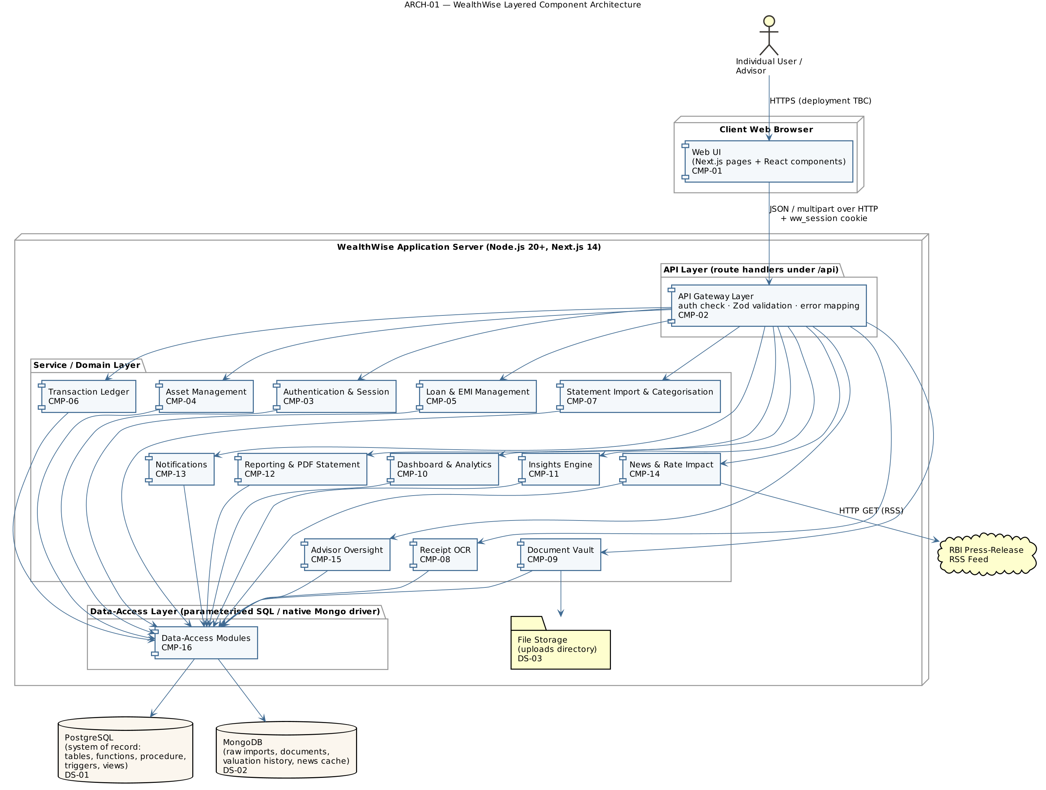
ARCH-01 — WealthWise layered component architecture
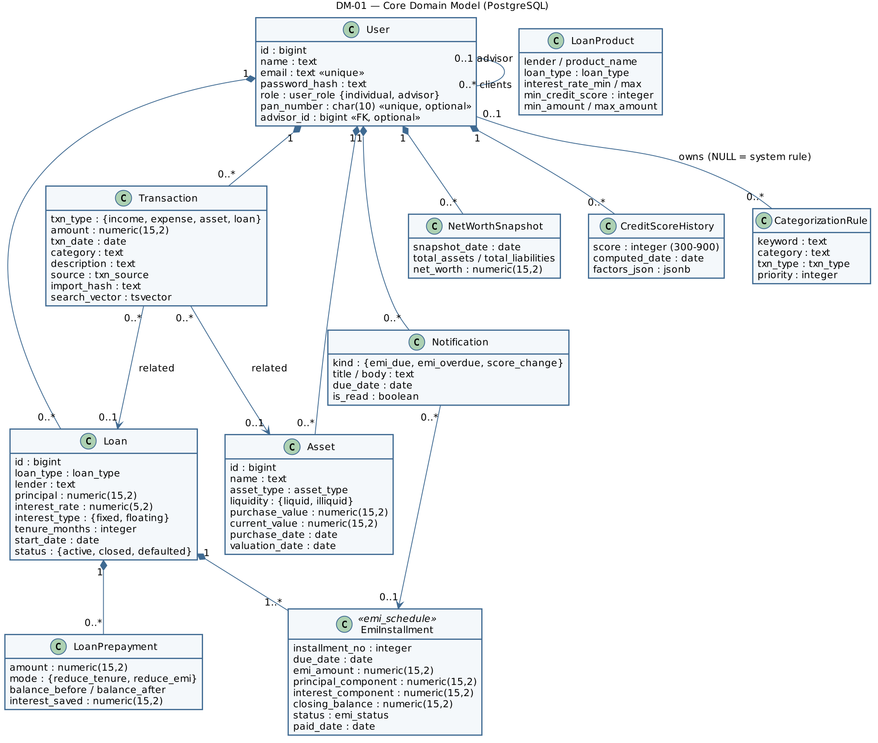
DM-01 — Core domain model (UML class diagram)

3.4 Component Descriptions
ID | Component | Responsibility | Inputs | Outputs | Dependencies | Related requirements
CMP-01 | Web UI (Next.js pages and React components) | Renders all pages (login, sign-up, dashboard, assets, loans, ledger, import, vault, insights, reports, news, advisor clients); server-side check redirects signed-out users to /login; calls only /api/* | User actions; API JSON responses | HTTP requests; rendered pages, charts, PDF download | CMP-02, CMP-03 (session read) | FR-01–FR-26, NFR-05
CMP-02 | API Layer (route handlers under /api) | Single entry point for every operation: authenticate the caller, check role, validate input with Zod schemas, call the domain component, map every error to a safe HTTP status via one error funnel | HTTP requests (JSON or multipart) with ww_session cookie | JSON responses with status codes 200/201/401/403/404/409/413/415/422/500/503 | CMP-03–CMP-16 | FR-04, SR-04, SR-06, SR-07, SR-08
CMP-03 | Authentication & Session | Sign-up, login, logout, current user; bcrypt hashing; HS256 JWT signing and verification; cookie options; requireUser, requireAdvisor, resolveTargetUserId | Credentials; session cookie | Signed token; current-user claims (id, email, name, role); 401/403 errors | CMP-16 (users), env JWT_SECRET, JWT_EXPIRES_IN | FR-01–FR-04, SR-01–SR-04, SR-09
CMP-04 | Asset Management | Asset CRUD with liquidity; appends valuation history on create and revaluation; deletes history with the asset | Asset data | Asset records; valuation history | CMP-16; DS-01; DS-02 (asset_valuation_history) | FR-05, FR-06
CMP-05 | Loan & EMI Management | Loan CRUD and status; atomic creation with fn_generate_emi_schedule; refuses regeneration after payments (WW409); schedule retrieval; atomic EMI payment; overdue marking (fn_mark_overdue_emis) | Loan data; installment id | Loans with payoff summary; schedules; payment result | CMP-16; DS-01 functions fn_calculate_emi, fn_generate_emi_schedule, fn_loan_outstanding | FR-07–FR-10, NFR-02, NFR-03
CMP-06 | Transaction Ledger | Manual transactions; filtered listing; full-text search on a generated tsvector column with a GIN index (websearch_to_tsquery); delete | Transaction data; filters; search text | Transaction lists | CMP-16; DS-01 | FR-12, FR-13
CMP-07 | Statement Import & Categorisation | CSV parsing (header detection, column aliases for HDFC/ICICI/SBI/Axis/Kotak, Indian dates and amounts, row rejection), import hash, preview, atomic commit with de-duplication, batch history; keyword rules and fn_categorize / fn_recategorize_user | CSV file; confirmed rows; rules | Preview; commit counts; rules | CMP-16; DS-01; DS-02 (raw_imports) | FR-14, FR-15, NFR-03, SR-07
CMP-08 | Receipt OCR | Server-side Tesseract OCR with bundled English model; extracts merchant, total, date (and GSTIN); suggests category; confirm step creates expense and optionally files the image | Receipt image; confirmed fields | Extracted fields and confidence; created expense | CMP-07 (fn_categorize), CMP-09, CMP-16 | FR-16, NFR-01, SR-07
CMP-09 | Document Vault | MIME allow-list and size check; stores file under a generated name in file storage; metadata, tags and checksum in MongoDB; listing, search, stats and delete; reports “unavailable” when MongoDB is down | Multipart file and metadata | Document metadata; stats | DS-02 (documents), DS-03 | FR-17, NFR-04, SR-07
CMP-10 | Dashboard & Analytics | Single dashboard request running independent reads concurrently over reporting views (v_net_worth_summary, v_asset_allocation, v_loan_payoff_progress, v_upcoming_emi_dues, v_monthly_cashflow, v_recurring_expenses) and the net worth trend; net worth snapshots maintained by triggers | User id | Dashboard JSON; dues list | CMP-16; DS-01 views and triggers | FR-10, FR-18, NFR-01
CMP-11 | Insights Engine | Derived credit score (fn_compute_credit_score, statement-level triggers); prepayment simulation (fn_simulate_prepayment) and application (sp_apply_prepayment procedure with row locks); loan-product recommendations (fn_recommend_loan_products); what-if projection (fn_project_net_worth) | Loan id, amounts, modes, parameters | Score and factors; simulations; recommendations; projection series | CMP-16; DS-01 | FR-11, FR-19–FR-21, NFR-03
CMP-12 | Reporting & PDF Statement | FY report from v_fy_* views (with indicative tax hints); PDF net worth statement with embedded fonts and masked PAN | User id; FY start year | FY report JSON; PDF file | CMP-16; DS-01; PDF library | FR-22, FR-23, SR-09
CMP-13 | Notifications | Generates EMI reminders on read (fn_generate_emi_reminders, idempotent via partial unique index), lists notifications with unread count, marks read | User id; notification id | Notifications list; unread count | CMP-16; DS-01 | FR-24
CMP-14 | News & Rate Impact | Fetches and parses the RBI RSS feed, classifies rate-change articles, caches in MongoDB, falls back to labelled sample articles; computes EMI impact on the user’s floating-rate loans | Category filter; article id | Feed; per-loan impact | DS-02 (news_articles), DS-01, RBI RSS feed | FR-25, NFR-04
CMP-15 | Advisor Oversight | Advisor-only client list with latest snapshot per client; client-scoped reads only for assigned clients (advisorOwnsClient) | Advisor session; client id | Client summaries; client assets | CMP-03, CMP-16 | FR-26, SR-05
CMP-16 | Data-Access Layer | One module per entity; parameterised SQL only; withTransaction() helper (BEGIN/COMMIT/ROLLBACK on a single pooled client); MongoDB connection with 60-second failure caching | Calls from domain components | Typed rows / documents | DS-01, DS-02 | NFR-02–NFR-04, SR-05, SR-06
Data stores: DS-01 PostgreSQL; DS-02 MongoDB; DS-03 server file storage (uploads directory). External system: RBI press-release RSS feed.

3.5 Chosen Architecture Pattern and Rationale
Pattern: Layered architecture within a single deployable full-stack web application (modular monolith). Requests flow strictly downward: Web UI (CMP-01) → API Layer (CMP-02) → domain/service components (CMP-03–CMP-15) → Data-Access Layer (CMP-16) → data stores. No UI component issues a database query and no route handler contains inline SQL (NFR-06).
Rationale:
- Clear separation of concerns: authentication, validation and error mapping are concentrated in one layer, so they cannot be skipped by individual features.
- Financial logic that must be exact and atomic (EMI schedule generation, net worth refresh, prepayment, credit score) is placed in the database as stored functions, a procedure, triggers and views. This gives one definition of each calculation, shared by the dashboard, reports, PDF and news impact.
- A single Next.js application keeps the UI and API in one TypeScript code base, which suits a four-person team and simple local setup.
- Polyglot persistence: PostgreSQL holds highly relational, constrained financial data; MongoDB holds irregular, schema-flexible data (raw statement rows, per-asset-type valuation metadata, document metadata, news), which would otherwise need a wide sparse table or an entity-attribute-value design.
Rejected alternatives: Microservices – unnecessary operational complexity for the scale of WealthWise. ORM-based data access – would hide the SQL that implements the core financial logic and make atomicity and performance harder to reason about.

3.6 Technology Stack & Data Stores
Layer | Technology
Language | TypeScript 5
Web framework / UI | Next.js 14 (App Router; server and client components), React 18, Tailwind CSS 3, Recharts 2 (charts)
Runtime | Node.js 20+
Validation | Zod 3
Authentication | bcryptjs (cost 12), jose (HS256 JWT)
Relational database | PostgreSQL 14+ (16 recommended) via pg with parameterised SQL
Document database | MongoDB 6+ via the native mongodb driver (optional at run time)
OCR | tesseract.js with bundled English model (@tesseract.js-data/eng)
PDF | pdfkit with embedded DejaVu fonts
Testing | Node.js built-in test runner via tsx (unit and database suites against a separate test database)
Tooling | npm scripts for migrations, seeding, type-checking and documentation generation
Deployment / hosting | To be confirmed
DS-01 PostgreSQL – system of record. Tables: users, assets, loans, emi_schedule, transactions, net_worth_snapshots, loan_products, credit_score_history, categorization_rules, loan_prepayments, notifications. Enum types for categorical fields; NUMERIC(15,2) for all money; CHECK, UNIQUE and foreign-key constraints mirror the API validation; ON DELETE CASCADE from loans to their schedules and ON DELETE SET NULL from transactions to assets/loans. Reporting views (v_net_worth_summary, v_upcoming_emi_dues, v_asset_allocation, v_loan_payoff_progress, v_monthly_cashflow, v_category_spend, v_recurring_expenses, v_fy_*). Stored functions and a procedure implement EMI, schedule, outstanding, net worth refresh, categorisation, prepayment, score, recommendations, projection and reminders. Triggers refresh the net worth snapshot when assets, loans or EMI status change and rescore credit on payment-status changes. Indexes include a partial index for unpaid installments, a partial unique index on (user_id, import_hash) for import de-duplication, and a GIN index for full-text search. Schema changes are applied by ordered migration files, each in its own transaction.
DS-02 MongoDB – schema-flexible documents. Collections: raw_imports (staged raw statement rows and batch status), asset_valuation_history (per-asset valuation points with type-specific metadata), documents (vault metadata, tags, checksum), news_articles (cached feed). Optional: when unreachable, dependent features degrade as described in NFR-04.
DS-03 File storage. Uploaded vault documents and kept receipt images, stored under random generated file names.

3.7 Risks & Mitigations
ID | Risk | Mitigation / status
RISK-01 | MongoDB unavailable at run time | Core features depend only on PostgreSQL; failed connection cached for 60 s; explicit “unavailable” states (NFR-04)
RISK-02 | RBI feed unreachable or format changes | Cached copy in MongoDB; labelled illustrative sample articles as fallback; refresh restricted to advisors
RISK-03 | Uploaded files are stored inside the publicly served uploads directory; a file is protected only by its unguessable generated name | Open issue OI-03: serve vault files through an authenticated download endpoint
RISK-04 | No login rate limiting or lockout, allowing password guessing | bcrypt cost slows each attempt; open issue OI-04: add rate limiting
RISK-05 | Any visitor can choose the Advisor role at sign-up | Advisors can only read clients explicitly assigned to them, so data exposure is limited; open issue OI-05: restrict advisor registration
RISK-06 | OCR misreads receipts | Two-step scan-then-confirm design; nothing is saved without user confirmation
RISK-07 | Calculation drift in long schedules | Exact NUMERIC arithmetic; final installment absorbs rounding; automated tests pin values (NFR-02)
RISK-08 | Deployment without HTTPS would expose the session cookie | Secure cookie flag in production; HTTPS required for deployment (To be confirmed)

3.8 Traceability to Requirements
Requirement | Component(s) | Design element
FR-01 Register | CMP-03, CMP-02 | API 4.3.1 POST /api/auth/signup
FR-02 Login | CMP-03 | SEQ-01 Login; API 4.3.1 POST /api/auth/login
FR-03 Logout / current user | CMP-03 | API 4.3.1 POST /api/auth/logout, GET /api/auth/me
FR-04 Access control | CMP-02, CMP-03, CMP-01 | §3.9; requireUser / requireAdvisor; layout redirect
FR-05 Asset CRUD | CMP-04 | API 4.3.2 /api/assets
FR-06 Valuation history | CMP-04, DS-02 | API 4.3.2 GET /api/assets/{id}
FR-07 Loan + schedule | CMP-05 | SEQ-02; API 4.3.3 POST /api/loans
FR-08 Loan list / schedule / edit | CMP-05 | API 4.3.3 GET/PUT/PATCH/DELETE /api/loans/{id}, GET /api/loans/{id}/schedule
FR-09 Pay EMI | CMP-05 | SEQ-03; API 4.3.3 POST /api/emi/{id}/pay
FR-10 Dues / overdue | CMP-05, CMP-10 | GET /api/dues; v_upcoming_emi_dues
FR-11 Prepayment | CMP-11 | API 4.3.3 POST /api/loans/{id}/prepay/simulate, POST /api/loans/{id}/prepay
FR-12 Transactions | CMP-06 | API 4.3.5 /api/transactions
FR-13 Search | CMP-06 | GET /api/transactions?search=; GIN full-text index
FR-14 CSV import | CMP-07 | SEQ-04; API 4.3.4 /api/imports/*
FR-15 Categorisation rules | CMP-07 | API 4.3.4 /api/rules
FR-16 Receipt OCR | CMP-08 | API 4.3.4 /api/receipts/scan, /api/receipts/confirm
FR-17 Vault | CMP-09 | API 4.3.6 /api/vault
FR-18 Dashboard | CMP-10 | API 4.3.6 GET /api/dashboard; net worth triggers
FR-19 Credit score | CMP-11 | GET /api/insights/score
FR-20 Recommendations | CMP-11 | POST /api/insights/recommend
FR-21 Projection | CMP-11 | GET /api/insights/projection
FR-22 FY report | CMP-12 | GET /api/reports/fy
FR-23 PDF statement | CMP-12 | GET /api/reports/statement
FR-24 Reminders | CMP-13 | GET/POST /api/notifications
FR-25 News | CMP-14 | GET /api/news, POST /api/news/refresh, GET /api/news/{id}/impact
FR-26 Advisor | CMP-15 | GET /api/advisor/clients; GET /api/assets?userId=
NFR-01 Performance | CMP-10, CMP-08 | Concurrent dashboard reads; partial and composite indexes
NFR-02 Exact money | CMP-05, DS-01 | NUMERIC(15,2); fn_generate_emi_schedule rounding rule
NFR-03 Atomicity | CMP-16, CMP-05, CMP-07, CMP-11 | withTransaction(); sp_apply_prepayment; SEQ-02, SEQ-03, SEQ-04
NFR-04 Degradation | CMP-16, CMP-09, CMP-14 | Mongo failure caching; “unavailable” responses
NFR-05 Usability | CMP-01 | §4.5 UX design
NFR-06 Maintainability | All | §3.5 layering
NFR-07 Configurability | CMP-03, CMP-16 | Environment variables (§3.9)

3.9 Security Architecture
Threat modelling (STRIDE):
Threat | Example in WealthWise | Architectural control | SR
Spoofing | Forged or stolen session; password guessing | HS256-signed JWT verified on every request (issuer checked); httpOnly cookie unreadable by scripts; bcrypt cost 12; uniform login failure message | SR-01, SR-02, SR-03
Tampering | Altered amounts, SQL injection, malformed imports | Zod validation at CMP-02 plus database constraints; all SQL parameterised; import rows re-validated on commit | SR-06
Repudiation | Disputed EMI payment or import | Every payment writes a ledger entry; imports carry batch id and hash; prepayments recorded in loan_prepayments. A dedicated audit log is To be confirmed | —
Information disclosure | Reading another user’s data; leaking internals; PAN exposure | Ownership condition in every query’s WHERE clause; advisor access only to assigned clients; generic 500 errors; PAN masked on PDF; secrets only in environment | SR-05, SR-08, SR-09
Denial of service | Very large uploads; long-running imports | Upload size limits; maximum 5,000 rows per commit; listing limits (≤ 500 transactions) | SR-07
Elevation of privilege | Individual calling advisor APIs or passing ?userId= | requireAdvisor() returns 403; resolveTargetUserId() refuses other ids for individuals | SR-04, SR-05
Security requirement → component trace:
SR | Enforced in | Mechanism
SR-01 | CMP-03 | hashPassword / verifyPassword (bcrypt, 12 rounds); responses expose only id, name, email, role
SR-02 | CMP-03 | signSession / verifySession (jose, HS256, issuer wealthwise, expiry from JWT_EXPIRES_IN); cookie ww_session with httpOnly, SameSite=Lax, Secure in production
SR-03 | CMP-03 | Same ServiceError(401) message for both failure paths; dummy bcrypt comparison for unknown users (SEQ-01)
SR-04 | CMP-02, CMP-03, CMP-01 | requireUser() (401), requireAdvisor() (403) at the start of each handler; authenticated layout redirects to /login
SR-05 | CMP-16, CMP-15 | … AND user_id = $n in every read/update/delete; advisorOwnsClient(); ownership checked under row locks inside sp_apply_prepayment
SR-06 | CMP-02, CMP-16, DS-01 | Zod schemas; CHECK / NOT NULL / UNIQUE constraints; ($n IS NULL OR col = $n) pattern for optional filters
SR-07 | CMP-07, CMP-08, CMP-09 | Extension / MIME allow-lists; byte limits (5 / 8 / 10 MB); generated storage names
SR-08 | CMP-02 | apiError() maps Zod, auth, service and database errors (23505→409, 23514→422, 23503→422, WWnnn→nnn); everything else → generic 500
SR-09 | CMP-03, CMP-12 | JWT_SECRET (≥ 32 chars enforced), database URLs from environment; .env excluded from version control; PAN masking in PDF
Transport security (TLS) is required for production deployment; its configuration depends on the hosting environment (To be confirmed).

4. Design

4.1 Design Overview
WealthWise is designed as a layered Next.js application. Each page in the authenticated area is wrapped by a layout that verifies the session on the server before rendering. Interactive components call the JSON API. Every API handler follows the same template: (1) authenticate (requireUser / requireAdvisor), (2) validate the request body or query with a Zod schema, (3) call a domain function, (4) return ok(data, status), and (5) route any thrown error through apiError(). Domain functions that change several rows use withTransaction(). Financial computations run inside PostgreSQL so that results are identical wherever they are displayed. Two-step flows (statement import, receipt OCR) separate a read-only preview from an atomic commit so that the user always confirms before data is written.

4.2 UML Sequence Diagrams
Four sequence diagrams cover the most important WealthWise workflows. PlantUML sources are in Appendix 5.4.
SEQ-01 – User login and session establishment (FR-02, SR-01–SR-03)
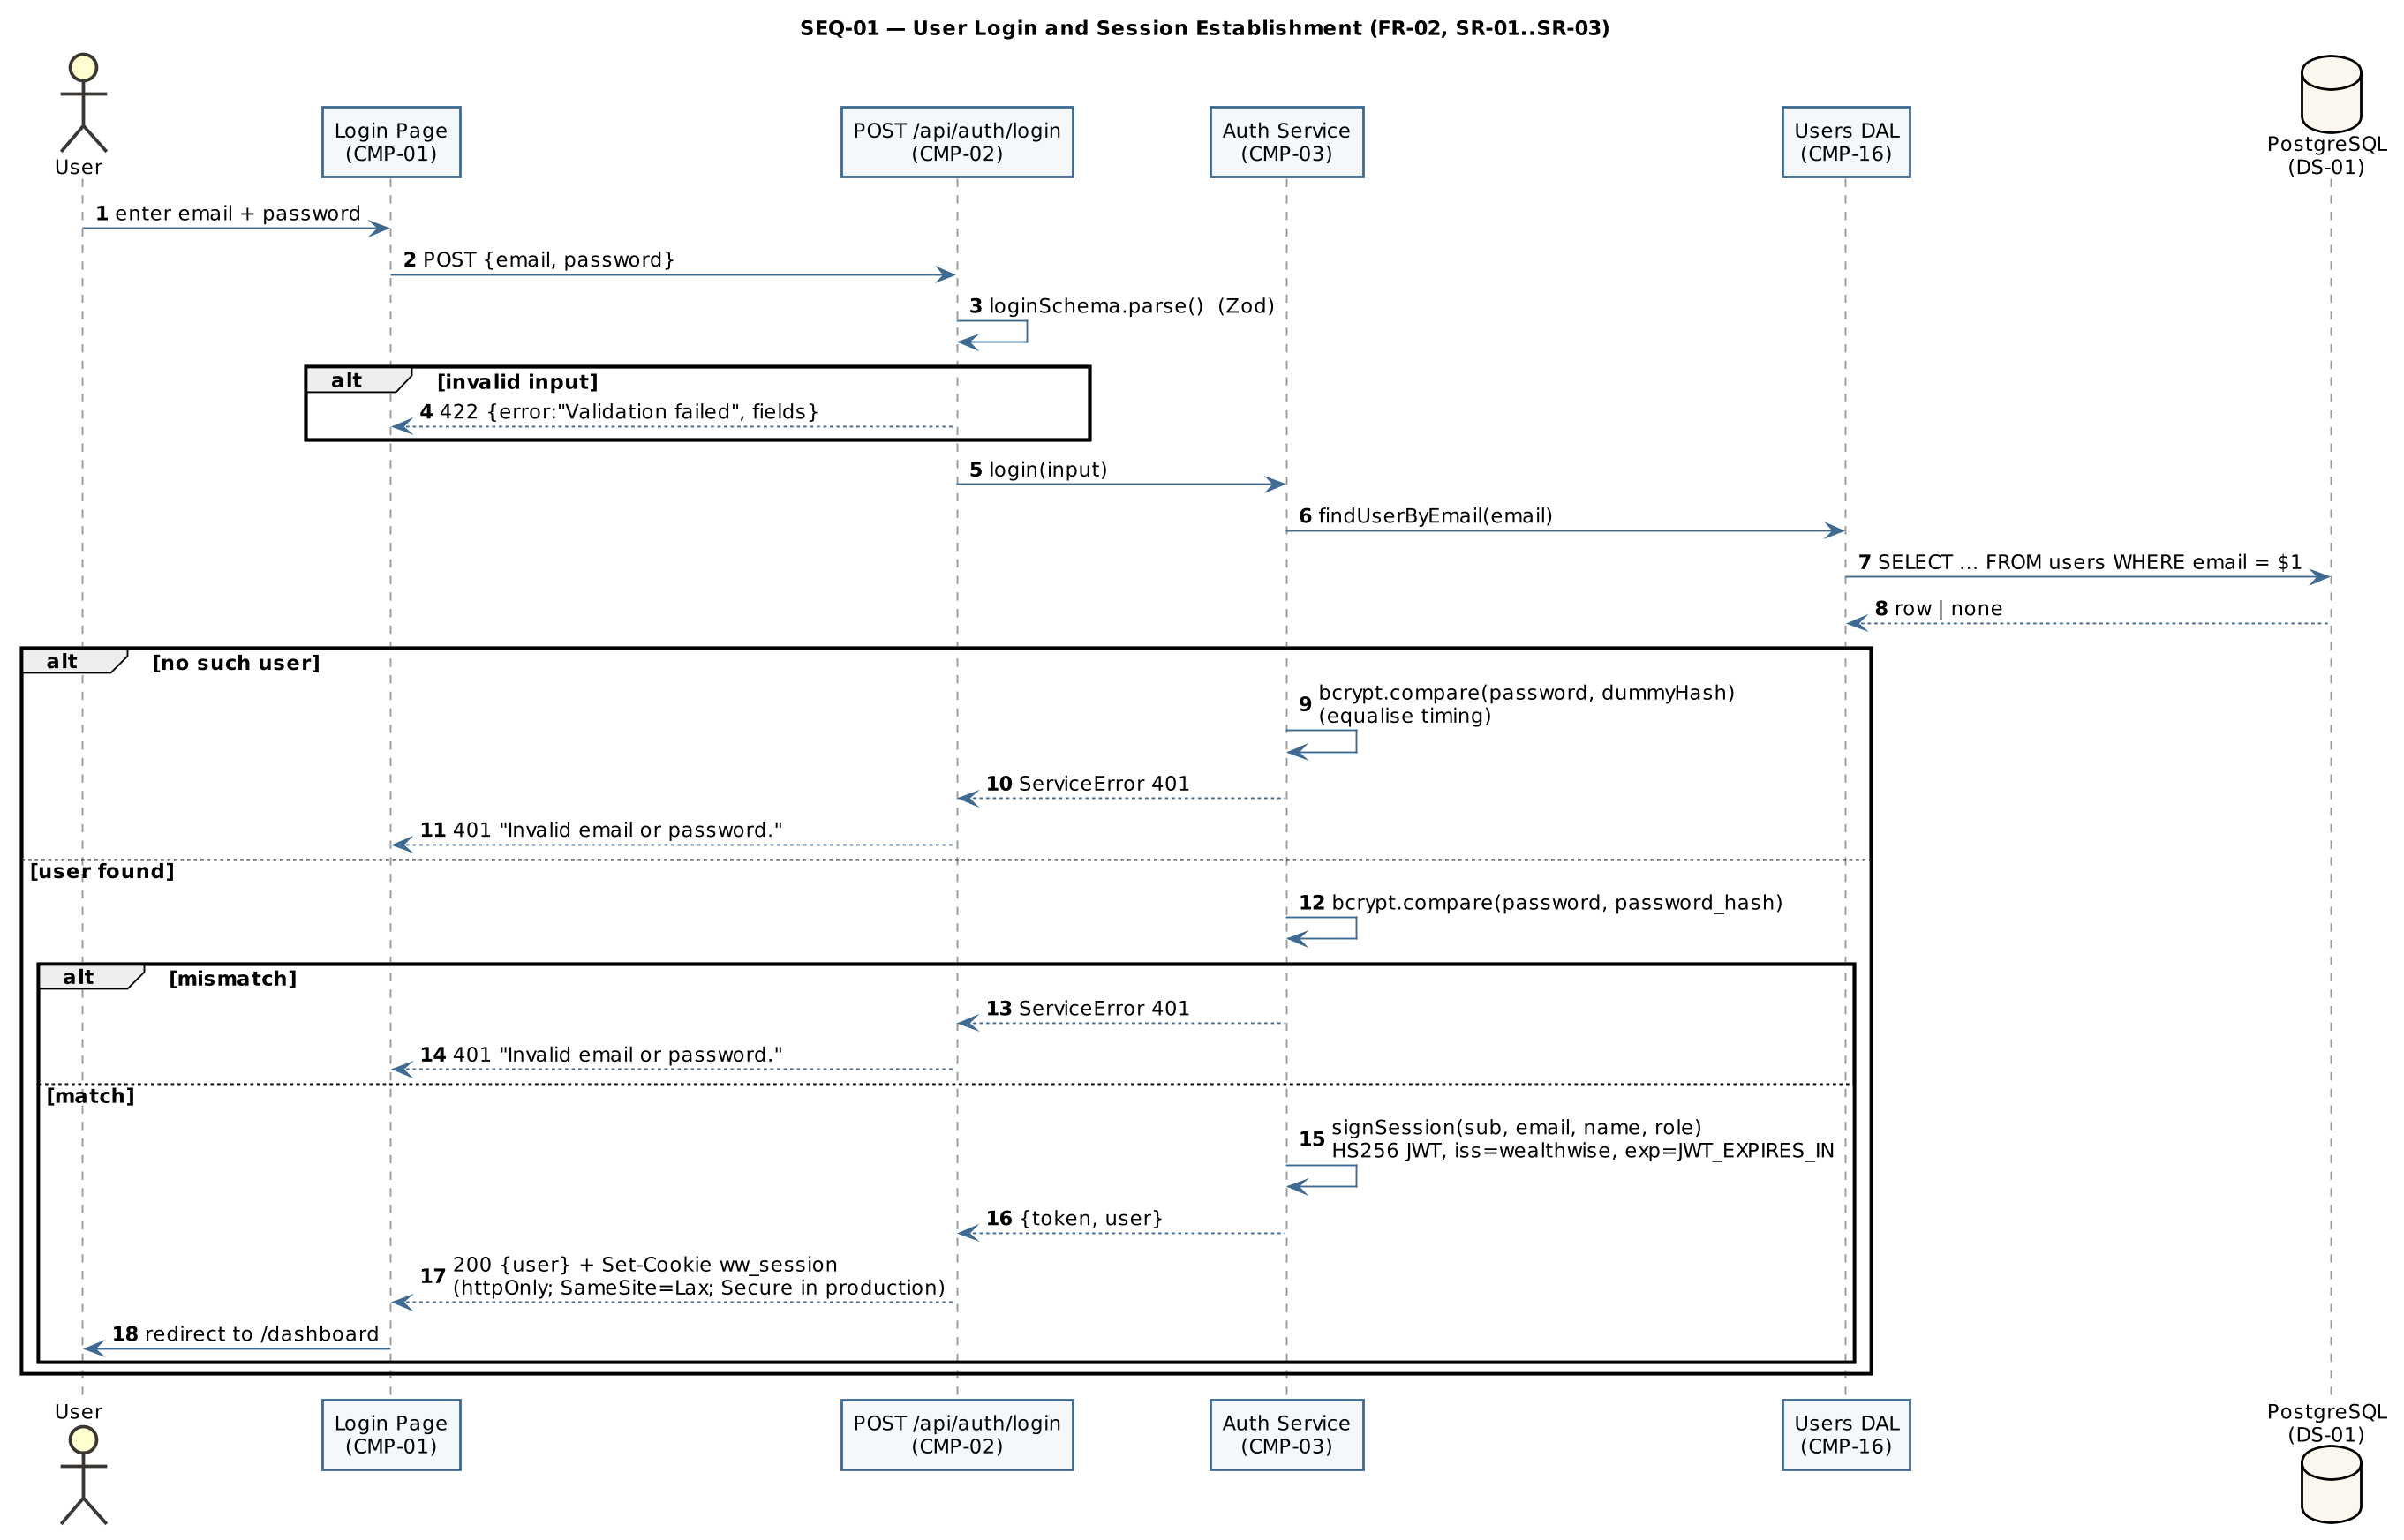
SEQ-01 — Login
SEQ-02 – Create loan with automatic EMI schedule (FR-07, NFR-02, NFR-03)
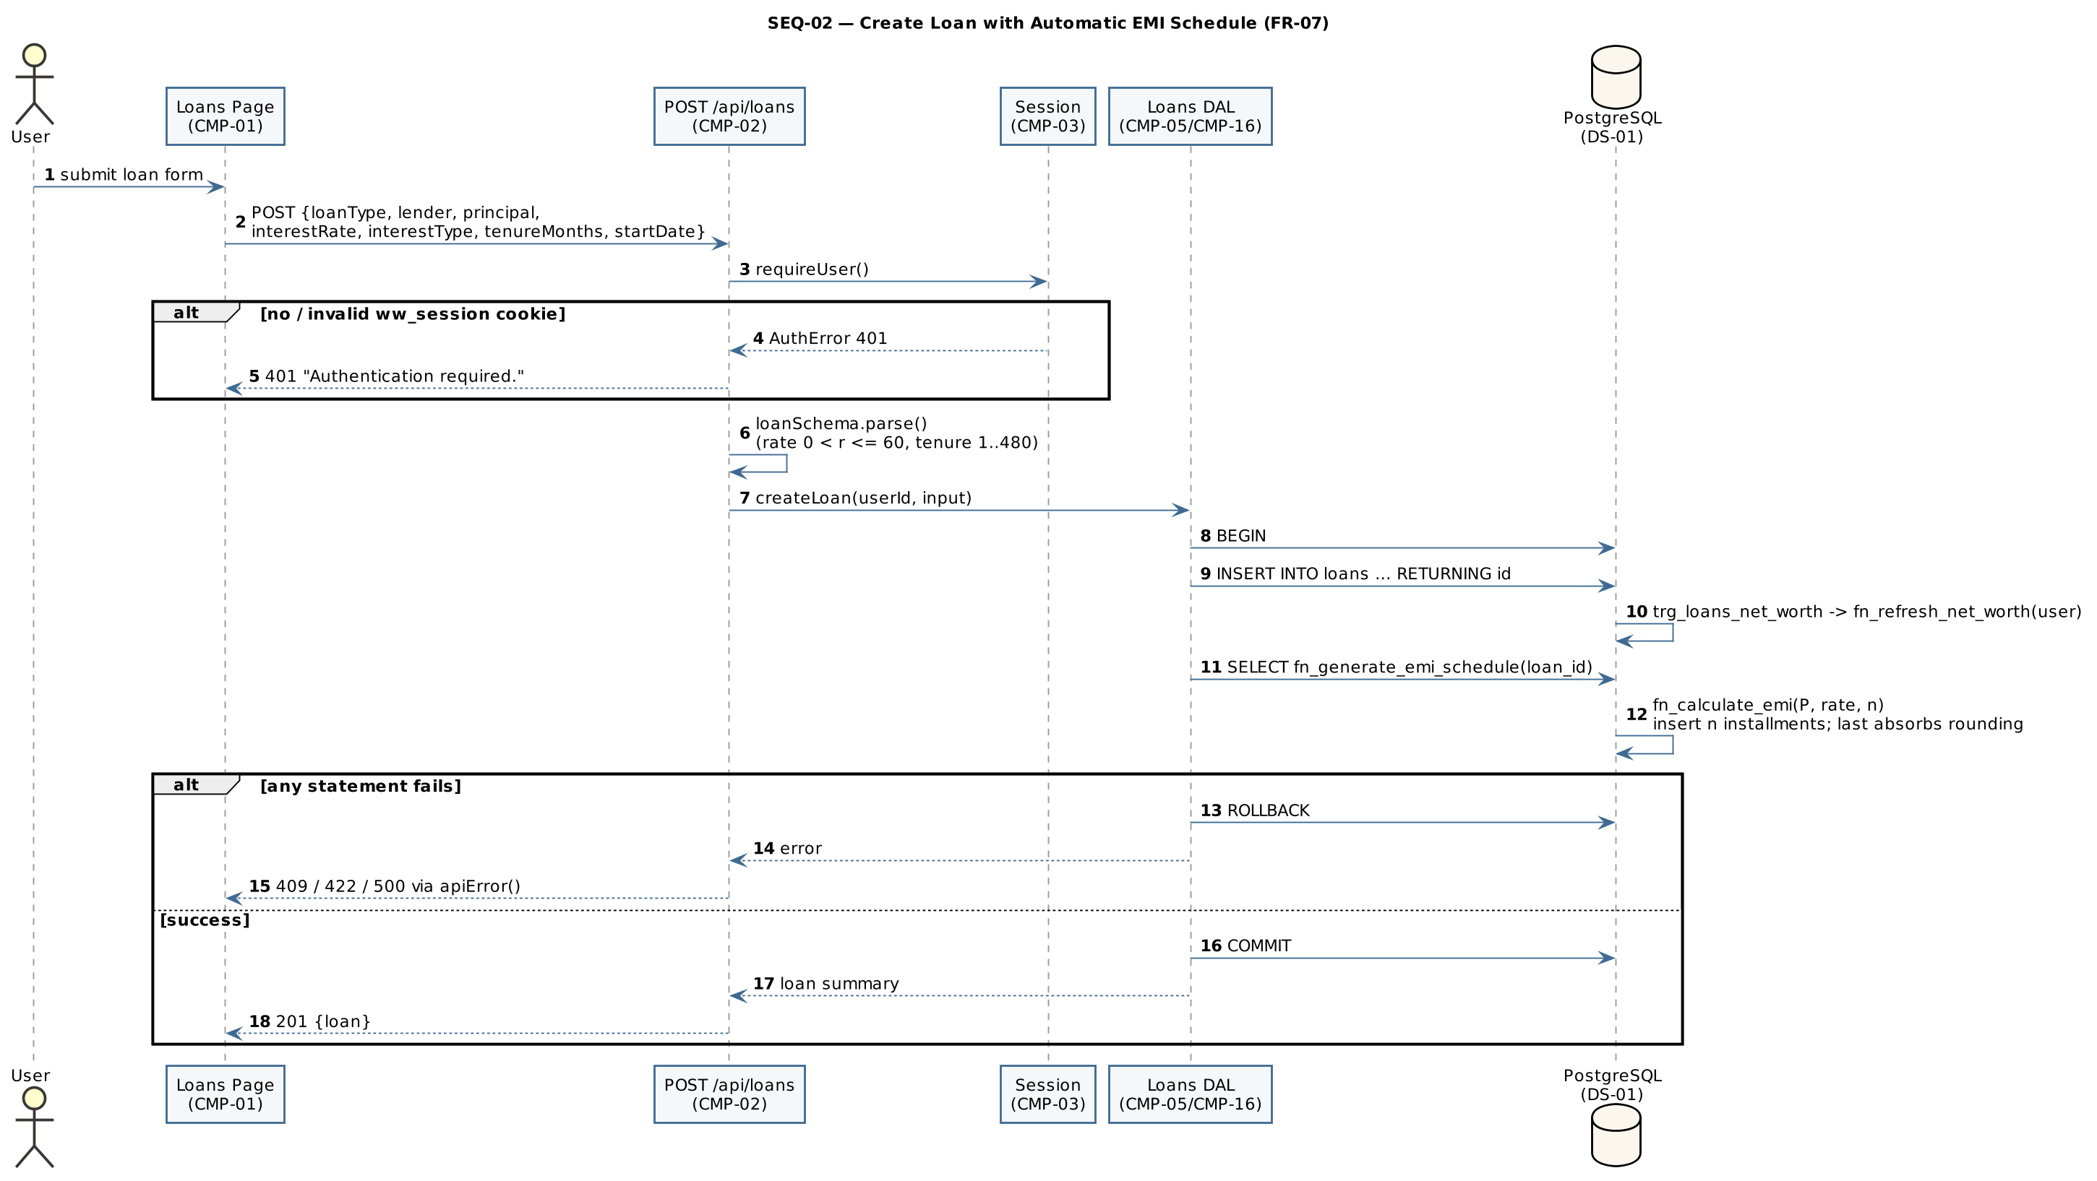
SEQ-02 — Create loan
SEQ-03 – Mark EMI installment paid (FR-09, NFR-03, SR-05)
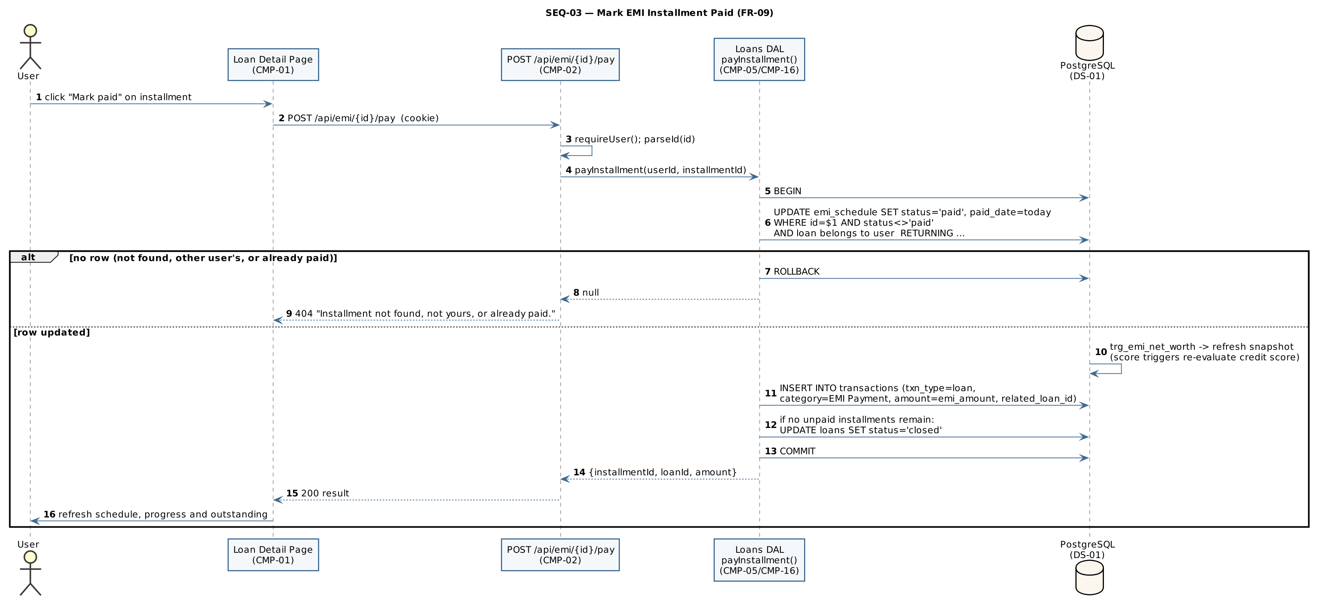
SEQ-03 — Pay EMI
SEQ-04 – Bank-statement CSV import: preview and commit (FR-14, FR-15, NFR-03)
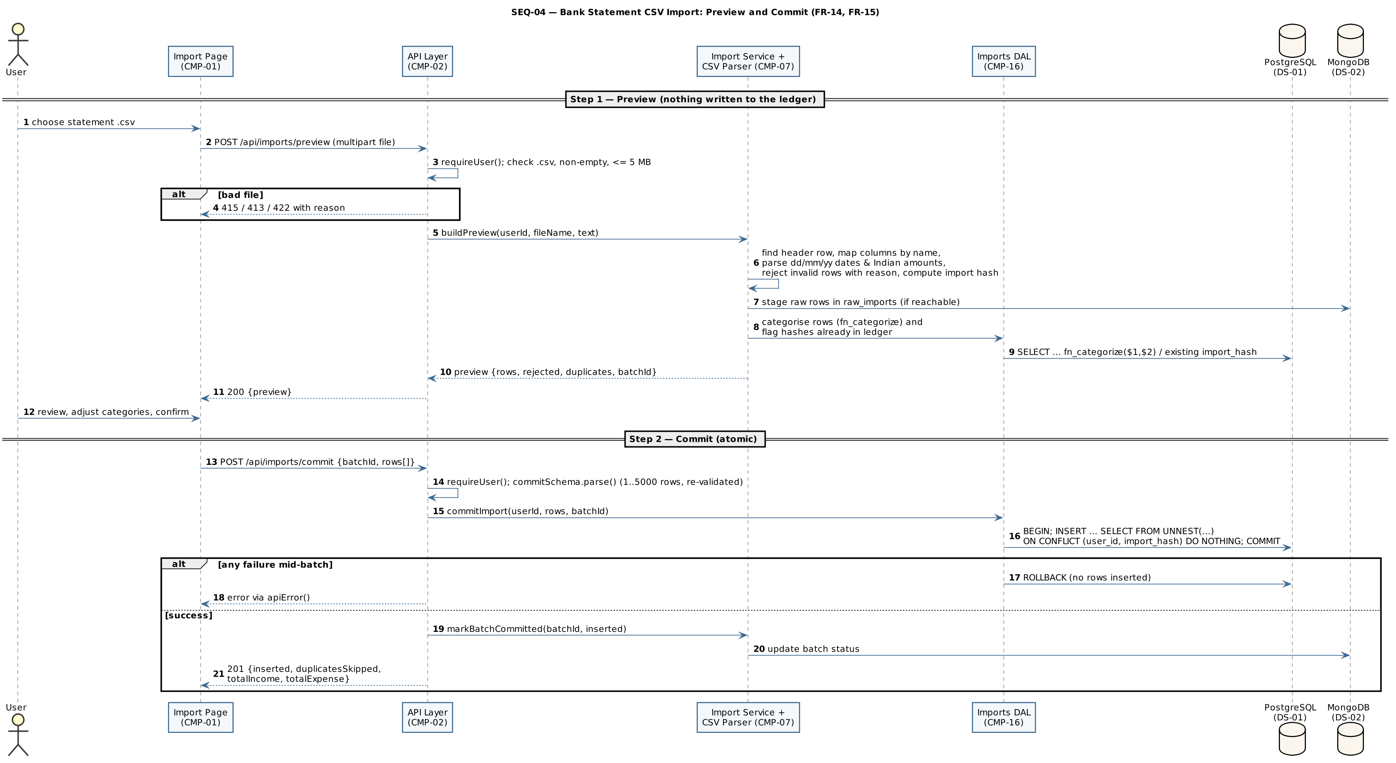
SEQ-04 — Statement import

4.3 API Design
All endpoints are under /api, exchange JSON unless stated (multipart for uploads), and are authenticated by the ww_session cookie. Common error responses: 401 “Authentication required.” (no/invalid session), 403 (role not permitted, invalid id, or client not assigned), 404 (resource not found or not owned), 409 (duplicate or business-rule conflict), 413 (file too large), 415 (unsupported file type), 503 (dependent service such as MongoDB or the news feed unavailable), 422 {error:"Validation failed", fields:{…}} or constraint violation, 500 “Internal server error”. The complete endpoint inventory is in Appendix 5.5.

4.3.1 Authentication & Session component (CMP-03)
Endpoint | Method | Purpose | Request | Response | Auth | Errors
/api/auth/signup | POST | Register and start session (FR-01) | {name, email, password, role?, panNumber?} | 201 {user:{id,name,email,role}} + Set-Cookie: ww_session | Public | 409 email exists; 422 validation
/api/auth/login | POST | Authenticate (FR-02) | {email, password} | 200 {user} + Set-Cookie: ww_session | Public | 401 “Invalid email or password.”; 422
/api/auth/logout | POST | End session (FR-03) | — | 200 {ok:true}; cookie cleared | Public | —
/api/auth/me | GET | Current user (FR-03) | — | 200 {user} or {user:null} | Public | —

4.3.2 Asset Management component (CMP-04)
Endpoint | Method | Purpose | Request | Response | Auth | Errors
/api/assets | GET | List assets (own, or assigned client’s via ?userId=) | query userId? | 200 {assets:[…]} | User; advisor for client | 401; 403 not own / not assigned
/api/assets | POST | Create asset; record first valuation | {name, assetType, liquidity?, purchaseValue, currentValue, purchaseDate, valuationDate?, notes?} | 201 {asset} | User | 401; 422
/api/assets/{id} | GET | Asset with valuation history | — | 200 {asset, valuationHistory} | Owner | 401; 403 invalid id; 404
/api/assets/{id} | PUT | Update / revalue | as POST | 200 {asset} | Owner | 401; 404; 422
/api/assets/{id} | DELETE | Delete asset and its history | — | 200 {ok:true} | Owner | 401; 404

4.3.3 Loan & EMI Management component (CMP-05, with CMP-11 for prepayment)
Endpoint | Method | Purpose | Request | Response | Auth | Errors
/api/loans | GET | List loans with payoff summary | — | 200 {loans:[…]} | User | 401
/api/loans | POST | Create loan + schedule atomically (FR-07) | {loanType, lender, principal, interestRate, interestType, tenureMonths, startDate} | 201 {loan} | User | 401; 422
/api/loans/{id} | GET / PUT / PATCH / DELETE | Read; edit terms (regenerates schedule); set status {status}; delete | PUT: as POST; PATCH: {status: active\|closed\|defaulted} | 200 {loan} / {ok:true} | Owner | 401; 404; 409 schedule has payments; 422
/api/loans/{id}/schedule | GET | Amortisation schedule (FR-08) | — | 200 {loan, schedule:[…]} | Owner | 401; 404
/api/emi/{id}/pay | POST | Mark installment paid (FR-09) | — | 200 {installmentId, loanId, amount} | Owner | 401; 404 not found / not yours / already paid
/api/dues | GET | Upcoming and overdue EMIs (FR-10) | query days? (default 45, max 365) | 200 {markedOverdue, dues:[…]} | User | 401
/api/loans/{id}/prepay/simulate | POST | Compare both prepayment modes (read-only) | {amount} | 200 {simulation} | Owner | 401; 404; 422
/api/loans/{id}/prepay | POST | Apply prepayment (FR-11) | {amount, mode, fromAssetId?} | 201 result | Owner (checked under row lock) | 401; 404; 409 loan not active; 422 exceeds outstanding / under-funded

4.3.4 Statement Import, Categorisation and Receipt components (CMP-07, CMP-08)
Endpoint | Method | Purpose | Request | Response | Auth | Errors
/api/imports/preview | POST | Parse, stage, categorise, flag duplicates | multipart file (.csv ≤ 5 MB) | 200 {preview:{batchId, rows, rejected, …}} | User | 401; 413; 415; 422 empty / no header row
/api/imports/commit | POST | Atomic insert of confirmed rows | {batchId?, rows:[{txnDate, description, amount, txnType, category, importHash}]} (1–5000) | 201 {inserted, duplicatesSkipped, totalIncome, totalExpense} | User | 401; 422
/api/imports/batches | GET | Import history and per-bank statistics | — | 200 {mongoConfigured, batches, statsByBank} | User | 401
/api/rules | GET / POST | List rules; add rule and re-categorise | POST {keyword, category, txnType?, priority?} | 200 {rules} / 201 {rule, recategorised} | User | 401; 409 duplicate; 422
/api/rules/{id} | DELETE | Delete own rule | — | 200 {ok:true} | Owner | 401; 404 not found or system rule
/api/receipts/scan | POST | OCR only, nothing saved (FR-16) | multipart file (JPEG/PNG/WebP ≤ 8 MB) | 200 {confidence, text, fields:{merchant, amount, date, category, …}} | User | 401; 413; 415; 422
/api/receipts/confirm | POST | Create expense; optionally file image | multipart merchant, amount, txnDate, category, keepImage, file? | 201 {transaction, filedInVault} | User | 401; 409 duplicate receipt; 422

4.3.5 Transaction Ledger component (CMP-06)
Endpoint | Method | Purpose | Request | Response | Auth | Errors
/api/transactions | GET | Filter and search ledger (FR-12, FR-13) | query type?, from?, to?, category?, search?, limit? (≤ 500) | 200 {transactions:[…]} | User | 401
/api/transactions | POST | Record transaction | {txnType, amount, txnDate, category?, description?, relatedAssetId?, relatedLoanId?} | 201 {transaction} | User | 401; 422
/api/transactions/{id} | DELETE | Delete transaction | — | 200 {ok:true} | Owner | 401; 404

4.3.6 Vault and Dashboard components (CMP-09, CMP-10)
Endpoint | Method | Purpose | Request | Response | Auth | Errors
/api/vault | GET | List / filter / search documents | query refType?, refId?, tag?, search? | 200 {available, mongoConfigured, documents, stats} | User | 401
/api/vault | POST | Upload document | multipart file, title, tags, refType?, refId? | 201 {document} | User | 401; 413; 415; 422 empty file; 503 vault needs MongoDB
/api/vault/{id} | DELETE | Delete document | — | 200 {ok:true} | Owner | 401; 404; 503
/api/dashboard | GET | All dashboard data in one request (FR-18) | — | 200 {summary, trend, allocation, loans, dues, cashflow, recurring} | User | 401

4.4 Error Handling, Logging & Monitoring
Error handling. Every route handler wraps its work in try/catch and passes errors to one funnel, apiError(), which returns: 422 with field errors for validation failures; the carried status for authentication and service errors; the embedded status for database business-rule errors raised with custom SQLSTATEs WWnnn (e.g. WW404, WW409, WW422) together with a user-safe message and hint; 409 for unique violations (23505); 422 for check (23514) and foreign-key (23503) violations; and a generic 500 “Internal server error” for anything else (SR-08). Upload handlers return 413/415 before reading content. Multi-row operations roll back fully on any error (NFR-03). When MongoDB is unreachable, dependent features return explicit “unavailable” responses instead of failing (NFR-04).
Logging. Unhandled errors are written to the server console with an [api] prefix; a failed retroactive re-categorisation is logged without failing the request. Passwords, password hashes and tokens are never logged (SR-01). Structured log format, log retention and a central log store are To be confirmed.
Monitoring. No monitoring service is configured in this version. Proposed metrics for deployment: API error rate by status code, dashboard response time (NFR-01), OCR duration, MongoDB availability and RBI feed refresh failures. Tooling is To be confirmed.

4.5 UX Design
- Calm, low-glare visual design with light and dark themes; theme preference saved in the browser and applied before first paint (NFR-05).
- Navigation bar with all modules; the Clients entry appears only for Advisors; a notification bell shows the unread count.
- All rupee amounts in a tabular monospaced font with Indian digit grouping (₹92,00,000; ₹1.06 Cr).
- Charts: line/area for net worth trend, separate panel for assets vs liabilities, horizontal stacked bar for allocation (up to seven categorical colours plus “Other”), grouped bars for income vs expense. Every chart has a legend, labels or table; colours validated for colour-vision deficiency.
- Two-step confirm flows for imports and receipts; inline field-level validation messages; explicit empty and “unavailable” states.
- Derived figures (credit score, rate impact, tax hints) are labelled as indicative and not advice.

4.6 Open Issues & Next Steps
ID | Open issue / next step
OI-01 | Hosting environment, HTTPS/TLS termination and backup policy – To be confirmed
OI-02 | Supported browser list – To be confirmed
OI-03 | Serve vault files through an authenticated endpoint instead of the public uploads directory (RISK-03)
OI-04 | Add login rate limiting / temporary lockout (RISK-04)
OI-05 | Restrict self-registration as Advisor and provide a UI to assign clients to advisors (RISK-05; SRS FR-26 note)
OI-06 | Structured logging, audit log and monitoring tooling (§4.4)
OI-07 | Future enhancements: Account Aggregator integration, email/SMS reminders, PostgreSQL row-level security, partitioning of transactions by FY

5. Appendices
5.1 Glossary: see §1.4 and SRS §1.4.
5.2 References: ISO/IEC/IEEE 42010 (architecture description); IEEE 29148 (requirements); OWASP Top 10 and OWASP ASVS; NIST SP 800-63B (authentication); WealthWise SRS v1.0; WealthWise STP v1.0.
5.3 Tools: PlantUML (UML diagrams), Graphviz, VS Code, Git, npm.
5.4 PlantUML source
ARCH-01 (component diagram):
@startuml ARCH-01
' (shared skinparams omitted)
title ARCH-01 — WealthWise Layered Component Architecture
actor "Individual User /\nAdvisor" as user
node "Client Web Browser" {
[Web UI\n(Next.js pages + React components)\nCMP-01] as UI
}
node "WealthWise Application Server (Node.js 20+, Next.js 14)" {
package "API Layer (route handlers under /api)" {
[API Gateway Layer\nauth check · Zod validation · error mapping\nCMP-02] as API
}
package "Service / Domain Layer" {
[Authentication & Session\nCMP-03] as AUTH
[Asset Management\nCMP-04] as ASSET
[Loan & EMI Management\nCMP-05] as LOAN
[Transaction Ledger\nCMP-06] as LEDGER
[Statement Import & Categorisation\nCMP-07] as IMPORT
[Receipt OCR\nCMP-08] as OCR
[Document Vault\nCMP-09] as VAULT
[Dashboard & Analytics\nCMP-10] as DASH
[Insights Engine\nCMP-11] as INS
[Reporting & PDF Statement\nCMP-12] as REP
[Notifications\nCMP-13] as NOTIF
[News & Rate Impact\nCMP-14] as NEWS
[Advisor Oversight\nCMP-15] as ADV
}
package "Data-Access Layer (parameterised SQL / native Mongo driver)" {
[Data-Access Modules\nCMP-16] as DAL
}
folder "File Storage\n(uploads directory)\nDS-03" as FS
}
database "PostgreSQL\n(system of record:\ntables, functions, procedure,\ntriggers, views)\nDS-01" as PG
database "MongoDB\n(raw imports, documents,\nvaluation history, news cache)\nDS-02" as MDB
cloud "RBI Press-Release\nRSS Feed" as RBI
user --> UI : HTTPS (deployment TBC)
UI --> API : JSON / multipart over HTTP\n+ ww_session cookie
API --> AUTH
API --> ASSET
API --> LOAN
API --> LEDGER
API --> IMPORT
API --> OCR
API --> VAULT
API --> DASH
API --> INS
API --> REP
API --> NOTIF
API --> NEWS
API --> ADV
ASSET --> DAL
LOAN --> DAL
LEDGER --> DAL
IMPORT --> DAL
OCR --> DAL
VAULT --> DAL
DASH --> DAL
INS --> DAL
REP --> DAL
NOTIF --> DAL
NEWS --> DAL
ADV --> DAL
AUTH --> DAL
VAULT --> FS
DAL --> PG
DAL --> MDB
NEWS --> RBI : HTTP GET (RSS)
AUTH -[hidden]down- DASH
ASSET -[hidden]down- INS
LOAN -[hidden]down- REP
LEDGER -[hidden]down- NOTIF
IMPORT -[hidden]down- NEWS
DASH -[hidden]down- OCR
INS -[hidden]down- VAULT
REP -[hidden]down- ADV
@enduml
DM-01 (domain class diagram):
@startuml DM-01
' (shared skinparams omitted)
title DM-01 — Core Domain Model (PostgreSQL)
hide empty methods
class User {
id : bigint
name : text
email : text <<unique>>
password_hash : text
role : user_role {individual, advisor}
{field} pan_number : char(10) <<unique, optional>>
advisor_id : bigint <<FK, optional>>
}
class Asset {
id : bigint
name : text
asset_type : asset_type
liquidity : {liquid, illiquid}
{field} purchase_value : numeric(15,2)
{field} current_value : numeric(15,2)
purchase_date : date
valuation_date : date
}
class Loan {
id : bigint
loan_type : loan_type
lender : text
{field} principal : numeric(15,2)
{field} interest_rate : numeric(5,2)
interest_type : {fixed, floating}
tenure_months : integer
start_date : date
status : {active, closed, defaulted}
}
class EmiInstallment <<emi_schedule>> {
installment_no : integer
due_date : date
{field} emi_amount : numeric(15,2)
{field} principal_component : numeric(15,2)
{field} interest_component : numeric(15,2)
{field} closing_balance : numeric(15,2)
status : emi_status
paid_date : date
}
class LoanPrepayment {
{field} amount : numeric(15,2)
mode : {reduce_tenure, reduce_emi}
balance_before / balance_after
{field} interest_saved : numeric(15,2)
}
class Transaction {
txn_type : {income, expense, asset, loan}
{field} amount : numeric(15,2)
txn_date : date
category : text
description : text
source : txn_source
import_hash : text
search_vector : tsvector
}
class NetWorthSnapshot {
snapshot_date : date
total_assets / total_liabilities
{field} net_worth : numeric(15,2)
}
class CreditScoreHistory {
{field} score : integer (300–900)
computed_date : date
factors_json : jsonb
}
class CategorizationRule {
keyword : text
category : text
txn_type : txn_type
priority : integer
}
class Notification {
kind : {emi_due, emi_overdue, score_change}
title / body : text
due_date : date
is_read : boolean
}
class LoanProduct {
lender / product_name
loan_type : loan_type
interest_rate_min / max
min_credit_score : integer
min_amount / max_amount
}
User "0..1 advisor" -- "0..* clients" User
User "1" *-- "0..*" Asset
User "1" *-- "0..*" Loan
Loan "1" *-- "1..*" EmiInstallment
Loan "1" *-- "0..*" LoanPrepayment
User "1" *-- "0..*" Transaction
Transaction "0..*" --> "0..1" Asset : related
Transaction "0..*" --> "0..1" Loan : related
User "1" *-- "0..*" NetWorthSnapshot
User "1" *-- "0..*" CreditScoreHistory
User "0..1" -- "0..*" CategorizationRule : owns (NULL = system rule)
User "1" *-- "0..*" Notification
Notification "0..*" --> "0..1" EmiInstallment
@enduml
SEQ-01:
@startuml SEQ-01
' (shared skinparams omitted)
title SEQ-01 — User Login and Session Establishment (FR-02, SR-01..SR-03)
autonumber
actor User
participant "Login Page\n(CMP-01)" as UI
participant "POST /api/auth/login\n(CMP-02)" as API
participant "Auth Service\n(CMP-03)" as AS
participant "Users DAL\n(CMP-16)" as DAL
database "PostgreSQL\n(DS-01)" as PG
User -> UI : enter email + password
UI -> API : POST {email, password}
API -> API : loginSchema.parse() (Zod)
alt invalid input
API --> UI : 422 {error:"Validation failed", fields}
end
API -> AS : login(input)
AS -> DAL : findUserByEmail(email)
DAL -> PG : SELECT ... FROM users WHERE email = $1
PG --> DAL : row | none
alt no such user
AS -> AS : bcrypt.compare(password, dummyHash)\n(equalise timing)
AS --> API : ServiceError 401
API --> UI : 401 "Invalid email or password."
else user found
AS -> AS : bcrypt.compare(password, password_hash)
alt mismatch
AS --> API : ServiceError 401
API --> UI : 401 "Invalid email or password."
else match
AS -> AS : signSession(sub, email, name, role)\nHS256 JWT, iss=wealthwise, exp=JWT_EXPIRES_IN
AS --> API : {token, user}
API --> UI : 200 {user} + Set-Cookie ww_session\n(httpOnly; SameSite=Lax; Secure in production)
UI -> User : redirect to /dashboard
end
end
@enduml
SEQ-02:
@startuml SEQ-02
' (shared skinparams omitted)
title SEQ-02 — Create Loan with Automatic EMI Schedule (FR-07)
autonumber
actor User
participant "Loans Page\n(CMP-01)" as UI
participant "POST /api/loans\n(CMP-02)" as API
participant "Session\n(CMP-03)" as SES
participant "Loans DAL\n(CMP-05/CMP-16)" as DAL
database "PostgreSQL\n(DS-01)" as PG
User -> UI : submit loan form
UI -> API : POST {loanType, lender, principal,\ninterestRate, interestType, tenureMonths, startDate}
API -> SES : requireUser()
alt no / invalid ww_session cookie
SES --> API : AuthError 401
API --> UI : 401 "Authentication required."
end
API -> API : loanSchema.parse()\n(rate 0 < r <= 60, tenure 1..480)
API -> DAL : createLoan(userId, input)
DAL -> PG : BEGIN
DAL -> PG : INSERT INTO loans ... RETURNING id
PG -> PG : trg_loans_net_worth -> fn_refresh_net_worth(user)
DAL -> PG : SELECT fn_generate_emi_schedule(loan_id)
PG -> PG : fn_calculate_emi(P, rate, n)\ninsert n installments; last absorbs rounding
alt any statement fails
DAL -> PG : ROLLBACK
DAL --> API : error
API --> UI : 409 / 422 / 500 via apiError()
else success
DAL -> PG : COMMIT
DAL --> API : loan summary
API --> UI : 201 {loan}
end
@enduml
SEQ-03:
@startuml SEQ-03
' (shared skinparams omitted)
title SEQ-03 — Mark EMI Installment Paid (FR-09)
autonumber
actor User
participant "Loan Detail Page\n(CMP-01)" as UI
participant "POST /api/emi/{id}/pay\n(CMP-02)" as API
participant "Loans DAL\npayInstallment()\n(CMP-05/CMP-16)" as DAL
database "PostgreSQL\n(DS-01)" as PG
User -> UI : click "Mark paid" on installment
UI -> API : POST /api/emi/{id}/pay (cookie)
API -> API : requireUser(); parseId(id)
API -> DAL : payInstallment(userId, installmentId)
DAL -> PG : BEGIN
DAL -> PG : UPDATE emi_schedule SET status='paid', paid_date=today\nWHERE id=$1 AND status<>'paid'\nAND loan belongs to user RETURNING ...
alt no row (not found, other user's, or already paid)
DAL -> PG : ROLLBACK
DAL --> API : null
API --> UI : 404 "Installment not found, not yours, or already paid."
else row updated
PG -> PG : trg_emi_net_worth -> refresh snapshot\n(score triggers re-evaluate credit score)
DAL -> PG : INSERT INTO transactions (txn_type=loan,\ncategory=EMI Payment, amount=emi_amount, related_loan_id)
DAL -> PG : if no unpaid installments remain:\nUPDATE loans SET status='closed'
DAL -> PG : COMMIT
DAL --> API : {installmentId, loanId, amount}
API --> UI : 200 result
UI -> User : refresh schedule, progress and outstanding
end
@enduml
SEQ-04:
@startuml SEQ-04
' (shared skinparams omitted)
title SEQ-04 — Bank Statement CSV Import: Preview and Commit (FR-14, FR-15)
autonumber
actor User
participant "Import Page\n(CMP-01)" as UI
participant "API Layer\n(CMP-02)" as API
participant "Import Service +\nCSV Parser (CMP-07)" as IS
participant "Imports DAL\n(CMP-16)" as DAL
database "PostgreSQL\n(DS-01)" as PG
database "MongoDB\n(DS-02)" as MG
== Step 1 — Preview (nothing written to the ledger) ==
User -> UI : choose statement .csv
UI -> API : POST /api/imports/preview (multipart file)
API -> API : requireUser(); check .csv, non-empty, <= 5 MB
alt bad file
API --> UI : 415 / 413 / 422 with reason
end
API -> IS : buildPreview(userId, fileName, text)
IS -> IS : find header row, map columns by name,\nparse dd/mm/yy dates & Indian amounts,\nreject invalid rows with reason, compute import hash
IS -> MG : stage raw rows in raw_imports (if reachable)
IS -> DAL : categorise rows (fn_categorize) and\nflag hashes already in ledger
DAL -> PG : SELECT ... fn_categorize($1,$2) / existing import_hash
IS --> API : preview {rows, rejected, duplicates, batchId}
API --> UI : 200 {preview}
User -> UI : review, adjust categories, confirm
== Step 2 — Commit (atomic) ==
UI -> API : POST /api/imports/commit {batchId, rows[]}
API -> API : requireUser(); commitSchema.parse() (1..5000 rows, re-validated)
API -> DAL : commitImport(userId, rows, batchId)
DAL -> PG : BEGIN; INSERT ... SELECT FROM UNNEST(...)\nON CONFLICT (user_id, import_hash) DO NOTHING; COMMIT
alt any failure mid-batch
DAL -> PG : ROLLBACK (no rows inserted)
API --> UI : error via apiError()
else success
API -> IS : markBatchCommitted(batchId, inserted)
IS -> MG : update batch status
API --> UI : 201 {inserted, duplicatesSkipped,\ntotalIncome, totalExpense}
end
@enduml
5.5 Complete API endpoint inventory (46 operations)
Endpoint | Methods | Component | Auth | Requirement
/api/auth/signup | POST | CMP-03 | Public | FR-01
/api/auth/login | POST | CMP-03 | Public | FR-02
/api/auth/logout | POST | CMP-03 | Public | FR-03
/api/auth/me | GET | CMP-03 | Public | FR-03
/api/assets | GET, POST | CMP-04 | User (advisor for assigned client on GET) | FR-05, FR-26
/api/assets/{id} | GET, PUT, DELETE | CMP-04 | Owner | FR-05, FR-06
/api/loans | GET, POST | CMP-05 | User | FR-07, FR-08
/api/loans/{id} | GET, PUT, PATCH, DELETE | CMP-05 | Owner | FR-08
/api/loans/{id}/schedule | GET | CMP-05 | Owner | FR-08
/api/loans/{id}/prepay/simulate | POST | CMP-11 | Owner | FR-11
/api/loans/{id}/prepay | POST | CMP-11 | Owner | FR-11
/api/emi/{id}/pay | POST | CMP-05 | Owner | FR-09
/api/dues | GET | CMP-05 / CMP-10 | User | FR-10
/api/transactions | GET, POST | CMP-06 | User | FR-12, FR-13
/api/transactions/{id} | DELETE | CMP-06 | Owner | FR-12
/api/imports/preview | POST | CMP-07 | User | FR-14
/api/imports/commit | POST | CMP-07 | User | FR-14
/api/imports/batches | GET | CMP-07 | User | FR-14
/api/rules | GET, POST | CMP-07 | User | FR-15
/api/rules/{id} | DELETE | CMP-07 | Owner | FR-15
/api/receipts/scan | POST | CMP-08 | User | FR-16
/api/receipts/confirm | POST | CMP-08 | User | FR-16
/api/vault | GET, POST | CMP-09 | User | FR-17
/api/vault/{id} | DELETE | CMP-09 | Owner | FR-17
/api/dashboard | GET | CMP-10 | User | FR-18
/api/insights/score | GET | CMP-11 | User | FR-19
/api/insights/recommend | POST | CMP-11 | User | FR-20
/api/insights/projection | GET | CMP-11 | User | FR-21
/api/reports/fy | GET | CMP-12 | User | FR-22
/api/reports/statement | GET | CMP-12 | User | FR-23
/api/notifications | GET, POST | CMP-13 | User | FR-24
/api/news | GET | CMP-14 | User | FR-25
/api/news/refresh | POST | CMP-14 | Advisor | FR-25
/api/news/{id}/impact | GET | CMP-14 | User | FR-25
/api/advisor/clients | GET | CMP-15 | Advisor | FR-26

